1. Conditional Rendering in React

Conditional rendering lets you render components or elements based on a condition

//ternary operator

//logical AND

//if-else inside functions

1. Prevent Rendering

Return null from a component

Implement Conditional Rendering ->

//App.js

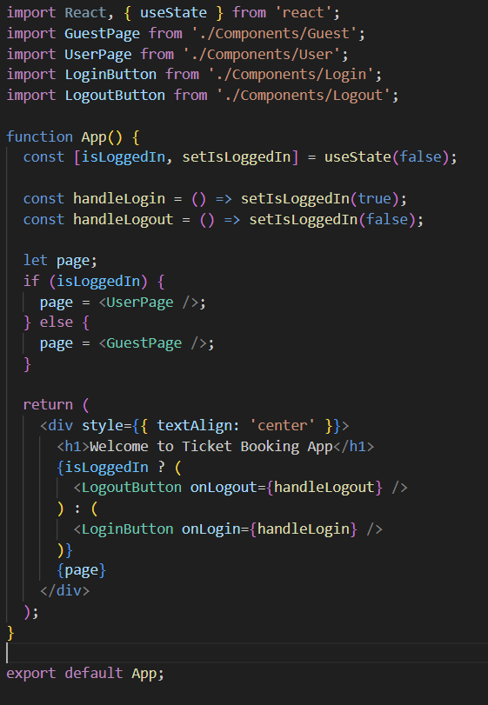

//Guest.js

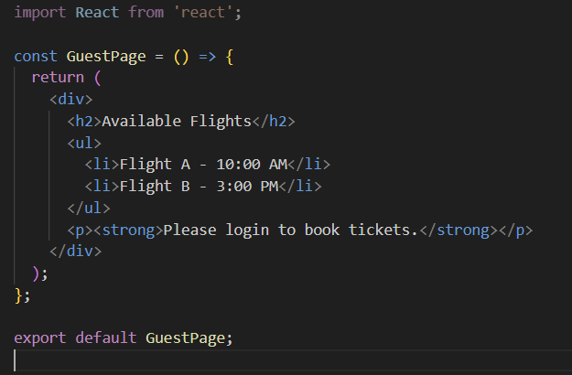

//User.js

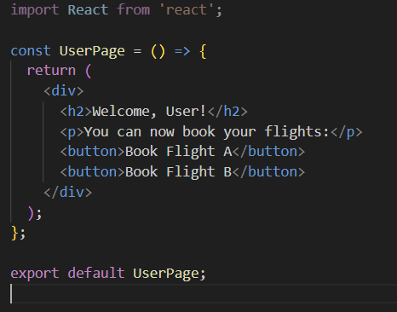

//Login.js

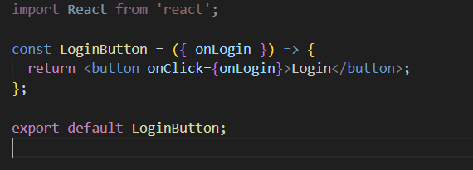

//Logout.js

