1. Conditional Rendering Techniques

//using if statement

//using ternary operator

//using logical AND

//using element variables

1. Rendering Multiple Components

React allows returning multiple components in a parent component or inside fragments

1. List Component

A component that renders a list of items using Array.map()

1. Keys

Used to uniquely identify list items to optimize rendering

1. React map() Function

map() is used to transform arrays into JSX elements efficiently

Implement the “bloggerapp” ->

//App.js

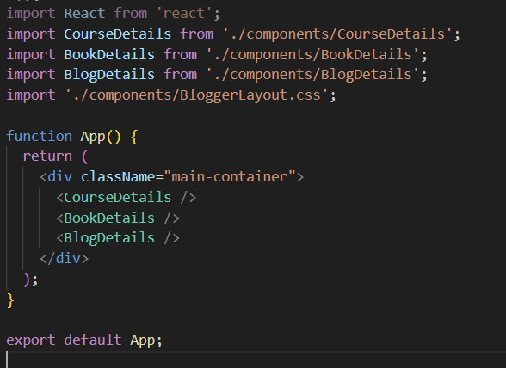

//BookDetails.js

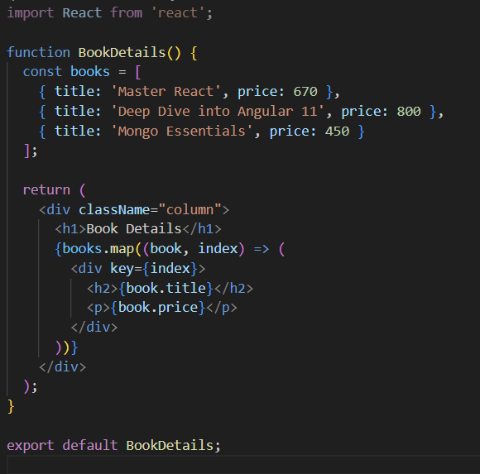

//BlogDetails.js

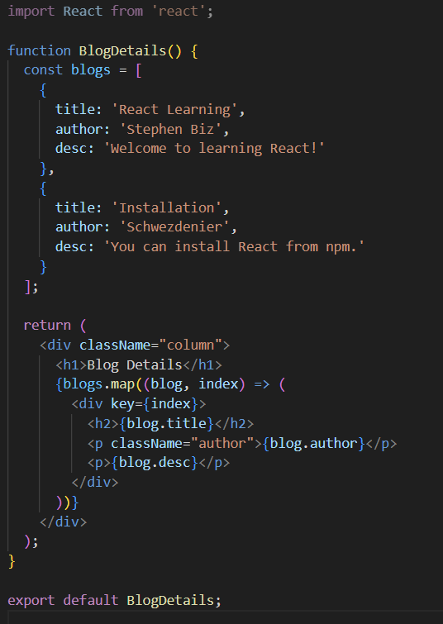

//CourseDetails.js

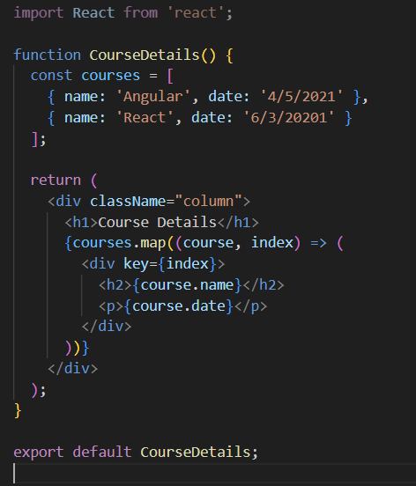

//BloggerLayout.css

