1. Features of ES6

//let and const

//arrow functions

//classes

//map and set

1. var and let

var -> function-scoped, allows redeclaration

let -> block-scoped, no redeclaration

1. const in javascript

declares a constant block-scoped variable

1. set and map

set -> a collection of unique values

map -> a collection of key-value pairs

Implementing map(), arrow functions and destructing ->

//ListofPlayers.js

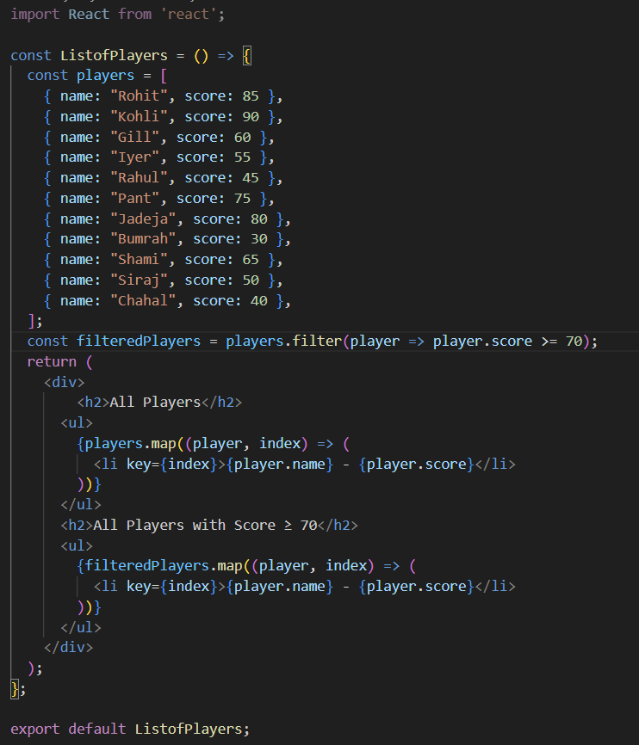

//IndianPlayers.js

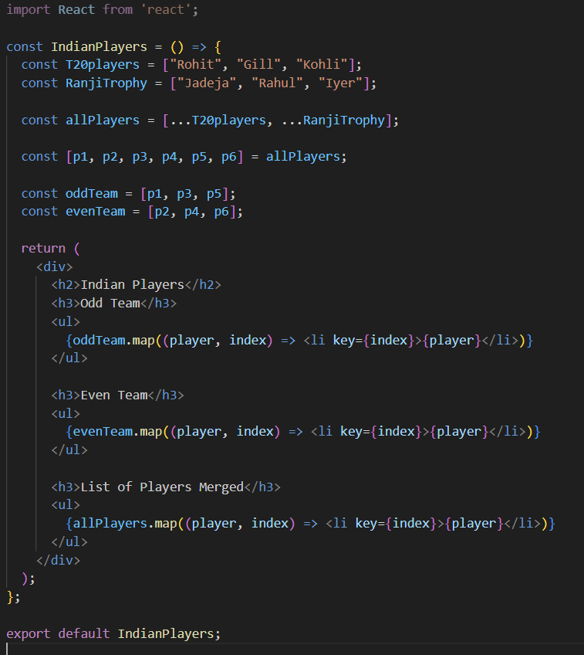

//App.js

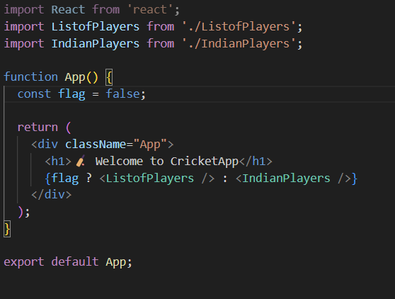

//flag = true



//flag = false

