//git version



//username



//email



//add notepad++ to environment variable and set as default editor





//create git repository

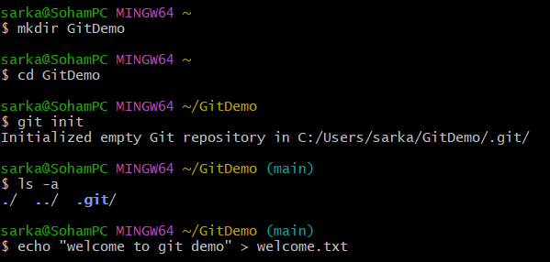

//create file and add to local repository

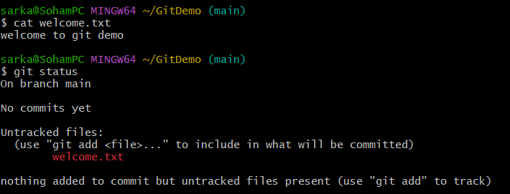

//connect remote to gitlab repository





