//explain .gitignore

We can ignore unwanted files and folders using .gitignore

//initialize a git repository

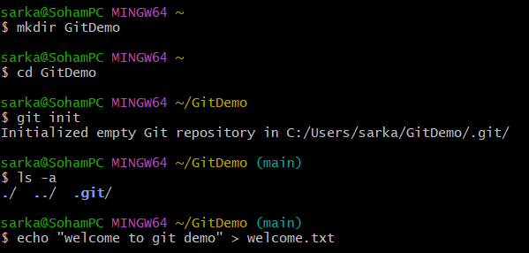





//create and update .gitignore



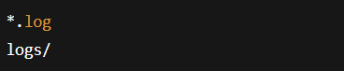

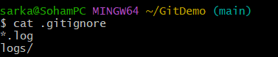

//verify

