Branching ->

//new branch “GitNewBranch”



//list all branches

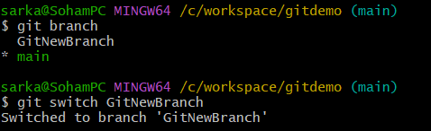

//switch to new branch and add files

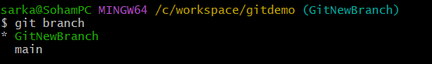



//commit changes

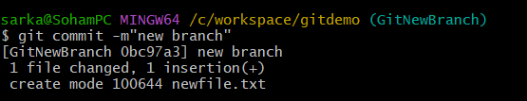

//git status



Merging ->

//switch to main

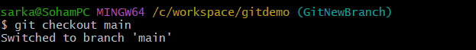

//differences between main and branch

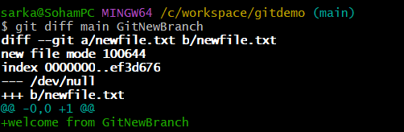

//merge source branch to trunk

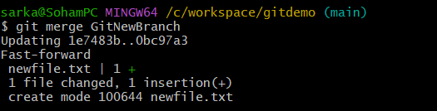

//observe the logging after merging

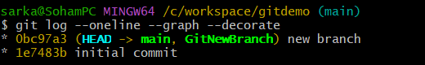

//delete branch and observe git status

