//verify if master is in clean state

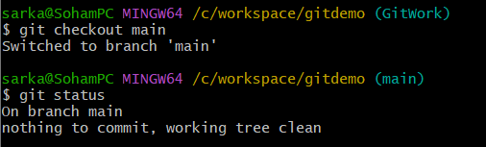

//create branch “GitWork” and add file “hello.xml”

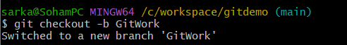



//update the content of “hello.xml”



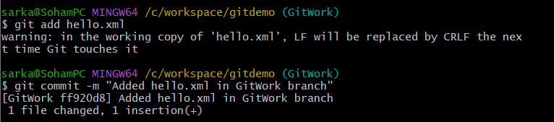

//switch to master



//add “hello.xml” in master and update the content





//commit the changes

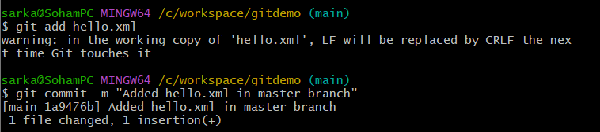

//observe the log

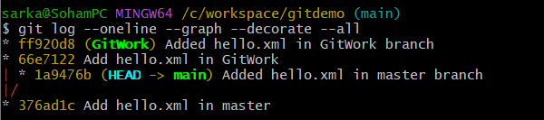

//check the differences

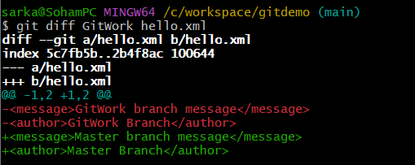

//merge using p4merge

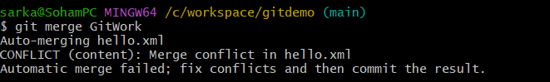

//observe the git mark up

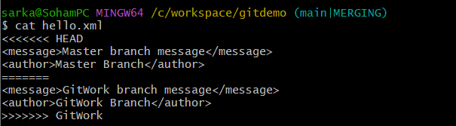

//use 3-way merge tool to resolve the conflict

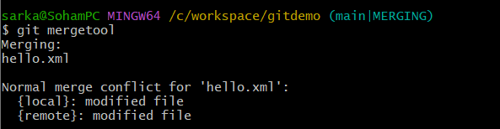

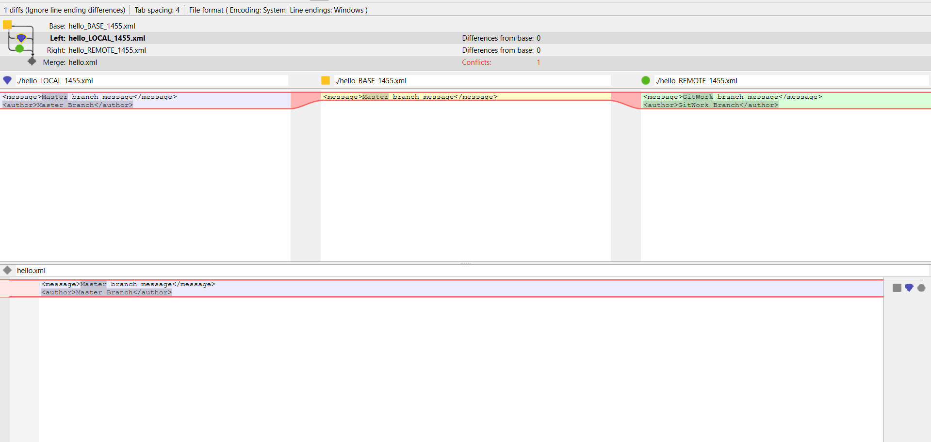

//commit the changes

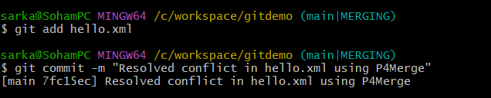

//observe git status

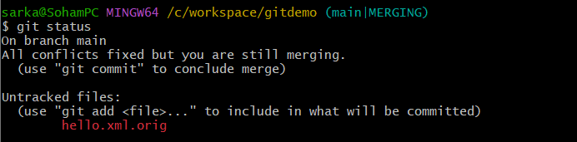

//add .gitignore



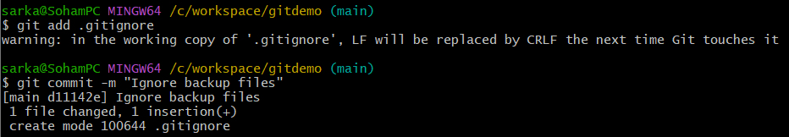

//show branches

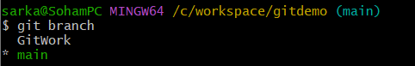

//delete the branch



//observe the final log

