//verify if master is in clean state

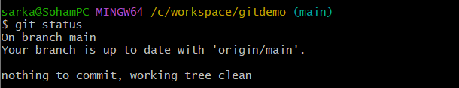

//show all branches

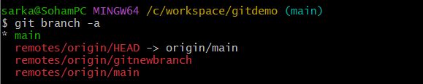

//pull remote git repository

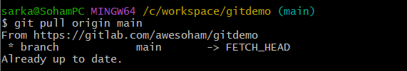

//push the changes to the remote repository

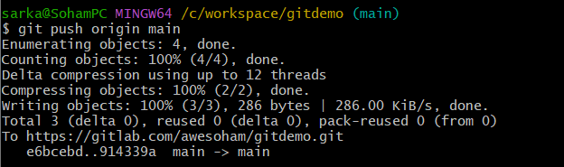

//observe changes

