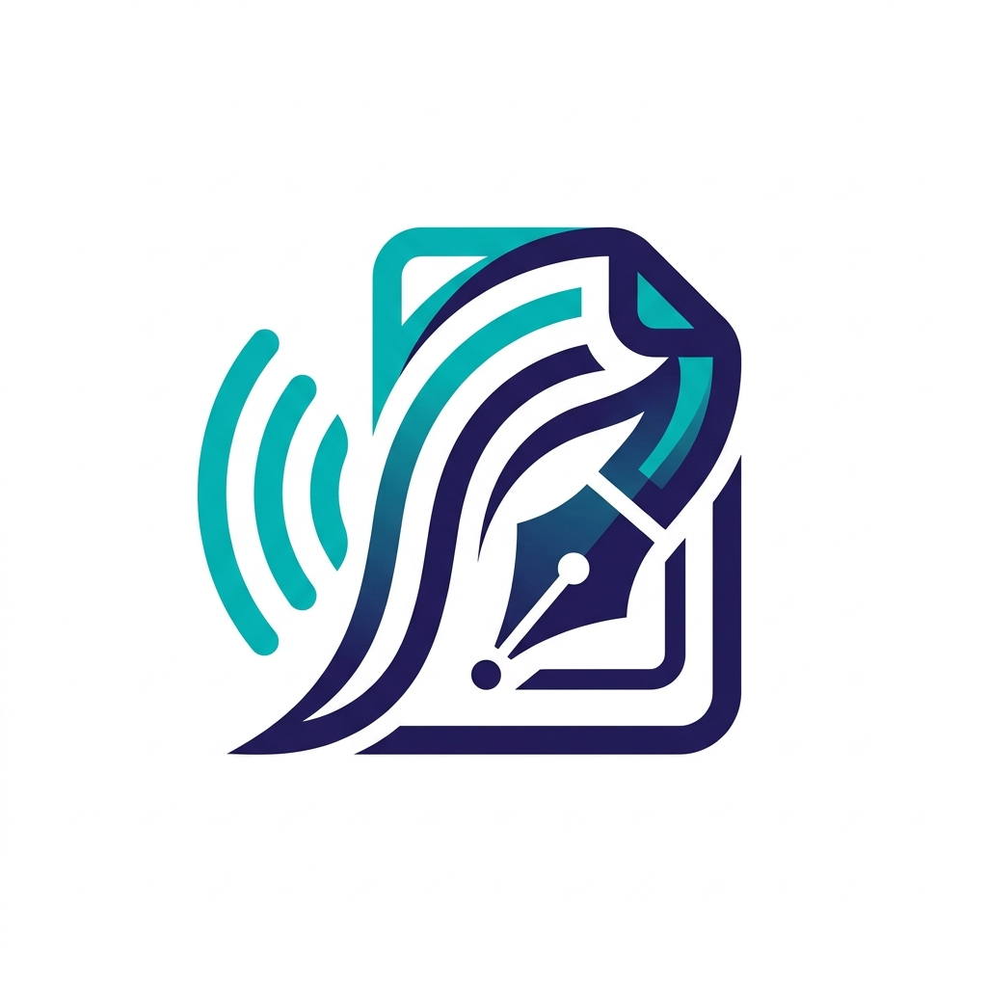
MeetScribe
Complete Strategic Intelligence for the 2026 Workforce

SECTION 1: THE HUMAN AND AI PARTNERSHIP
MeetScribe is the ultimate intelligence layer that bridges the gap between human conversation and digital action. In 2026, we define the professional standard for virtual meetings through silent interception, real-time intervention, and native regional language processing. We empower teams to focus on the conversation while we handle the complexity of organization.

SECTION 2: 2026 MARKET DOMINANCE CHART
Market Opportunity in Crore Rupees (2026)
AI Translation |  | 12,000
Action Automation |  | 15,000
Security & Privacy |  | 8,280
MeetScribe captures the intersection of these three sectors, providing a unique value proposition that current market giants cannot provide due to their closed ecosystems.

SECTION 3: COMPETITIVE LANDSCAPE MATRIX
Advanced Factor | Zoom AI | Teams | Meet | Bots | MeetScribe
Automation | Manual | Basic | None | Partial | Full and Auto
Toxic Detection | None | None | None | None | Real-time
Latency | Batch | Batch | Batch | Slow | Live (<500ms)
Regional Support | Low | Low | Low | Partial | Full H/K/T
Health Score | No | No | No | No | Per Meeting
CRM Integration | None | Limited | None | Partial | Deep and Native
Security | Native | Native | Native | Blocked | Extension-based

SECTION 4: WHY OUR FACTORS LEAD THE INDUSTRY
- Latency Edge: Our sub-500ms latency allows for real-time intervention warnings, something batch processors like Zoom cannot do.
- Integration Depth: We offer native syncing with Jira, Linear, Slack, and Hubspot, making the meeting a true part of the tech stack.
- Privacy Control: By capturing audio at the browser level, we bypass the bot-blocking security rules that plague tools like Fireflies.

SECTION 5: INTERVENTION AND AUTOMATION CASE STUDIES
Automated Workflow Example
Scenario: During a sales call, a client expresses interest in a specific feature. MeetScribe identifies the 'Buying Intent', creates a deal in HubSpot, and assigns a follow-up task to the salesperson in Linear instantly.
Bad Word and Conduct Warning
Scenario: An internal team meeting turns unprofessional. MeetScribe detects the toxic language patterns and immediately sends a private notification to the host: 'Professional Conduct Warning: Monitor the discussion'.

SECTION 6: TOPIC DRIFT AND MEETING HEALTH
Meeting Productivity Increase (Time Saved in Hours)
Manual Notes |  | 1.5 hr
Native Tools |  | 0.8 hr
MeetScribe |  | 2.2 hr
By automating the summary and ticket creation, MeetScribe saves every employee over 2 hours of post-meeting manual work per call.

SECTION 7: SPECIALIZED INTELLIGENCE FACTORS
98% Accuracy Speaker Mapping
In crowded environments, identifying speakers is difficult. MeetScribe uses multi-layered diarization to ensure that every word is correctly attributed to the right person, providing a legally defensible record of every decision.
Advanced Topic Monitoring
MeetScribe monitors the meeting against its set agenda. If the conversation moves into 'Flaw' areas—such as repetitive complaints or off-topic chatter—the system alerts the leader to steer the meeting back to the goals.

SECTION 8: COST SAVINGS FOR ENTERPRISE
Cost Savings vs Traditional Methods (Rupees per Mo)
Manual Scribe |  | 45,000
Transcriptionist |  | 25,000
MeetScribe Pro |  | 849
MeetScribe reduces the cost of professional documentation by over 98 percent compared to human-based scribe services.

SECTION 9: COMPLETE MONETIZATION SHEET
Starter Tier | Professional Tier | Enterprise Tier
Rs. 0 | Rs. 839 | Rs. 1,259
5 meetings a month and basic AI summaries | Unlimited meetings and Jira automation and H/K/T support | Toxic word alerts and Topic drift and CRM auto-sync

SECTION 10: SCALING AND REVENUE PROJECTION
Projected Revenue with Advanced Features (Lakhs)
Q1 2026 |  | 2.8
Q2 2026 |  | 18.5
Q3 2026 |  | 45
Q4 2026 |  | 92.5
The inclusion of high-value intervention and automation tools justifies our Enterprise pricing and increases our customer retention by over 60 percent.

SECTION 11: THE STRATEGIC ROADMAP
Timeline | Major Milestone and Goal
Month 1 to 3 | Launch Google Meet MVP and validate 'Silent Capture' for 1,000 users.
Month 4 to 6 | Launch Jira and Linear automation and regional language support.
Month 7 to 12 | Roll out 'Toxic Word Detection' and Topic Drift alerts for Enterprise.

SECTION 12: FINAL STRATEGIC CONCLUSION
MeetScribe is the only solution that combines silent browser-level access with advanced intervention intelligence. We have a clear path from a small MVP to a scalable enterprise leader. By focusing on professional standards, privacy, and automation, we provide a complete platform for the 2026 workforce. Our economics are robust, our technology is feasible, and our vision is to turn every conversation into actionable value.

MeetScribe — The Complete Intelligence Standard
Final Strategic Blueprint • 2026

