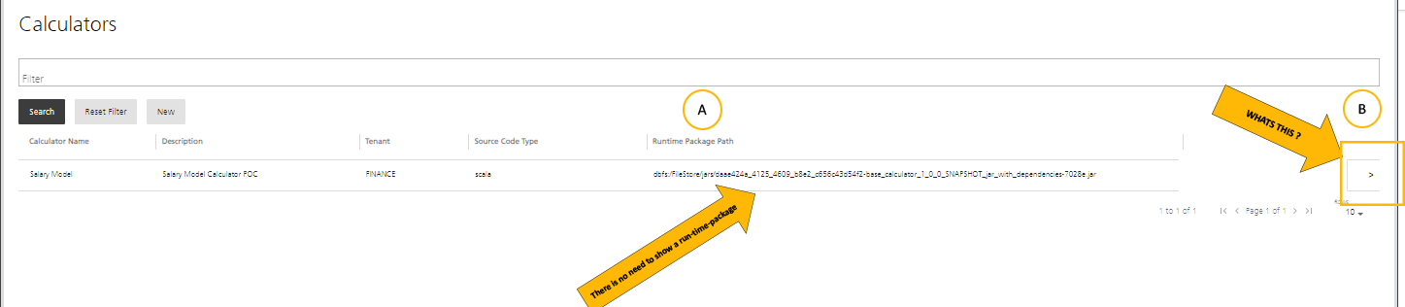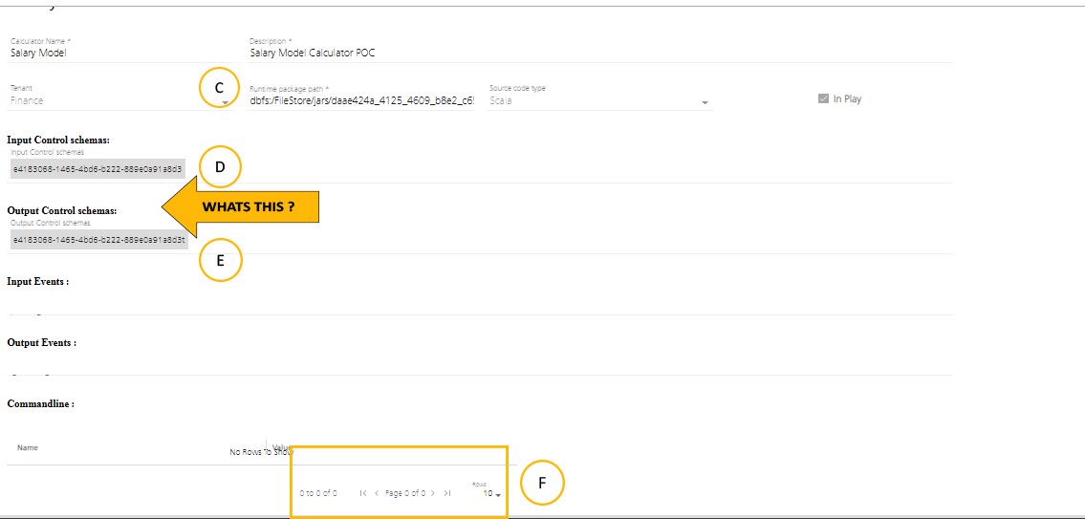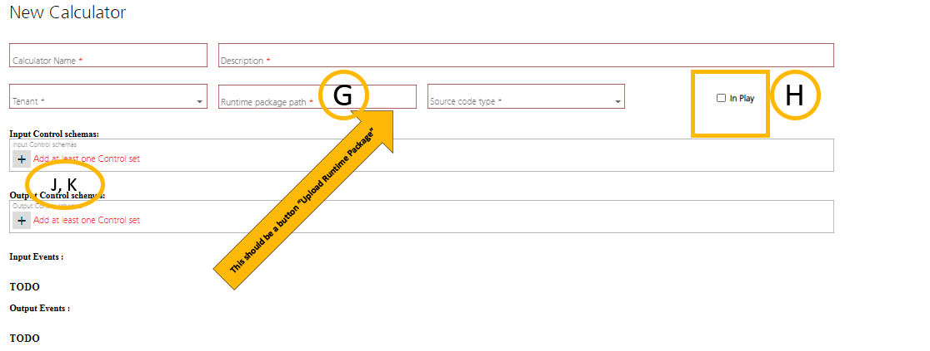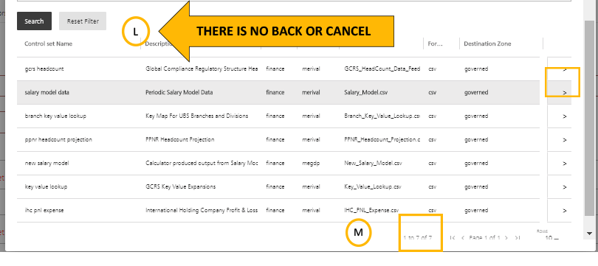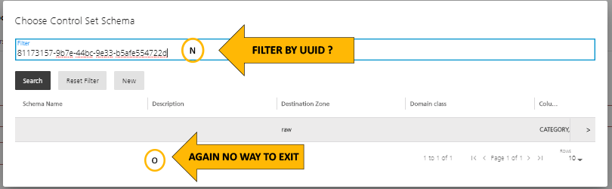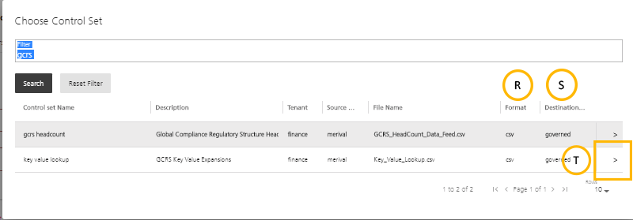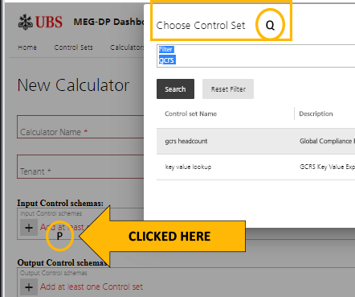

Comments

* A: Overall the UI patterns leveraged is non-conventional and conforms to known know GUI I have ever seen. Find a working UI like the one form DataBricks or say Amazon or other well known, well formed UI pattern to leverage as reference and start copying it rather than making it up as we go. NO GUIs are truly intuitive but instead are conventional so that users already familiar with UIs do not have to learn your pattern.
* B: The scale of the UI (size of boxes text fonts is 3 times too BIG, scale it down.
* C: Package Path is of no use remove it, and do not solicit it in the forms. Replace this space with UPLOAD JAR/PACKAGE so they can add the package to the store if needed.
* D: NO visualization of IDs or UUIDs as they are internal, no one would ever know or care about them, use proper names and zones and versions and the like
* E: same as above
* F: Needless multipage formatting when there can be no more than one page, if the solicitation process is multiple-pages its needs to be a proper WIZARD
* G: no need for this path don’t visualize it , like I said before, they do need to be able to either upload the jar or indicate where or how the jar can be found through nexus.
* H: When Clicked this CSS or GUI component becomes illegible (can’t tell if its checked or not), change it to something useful
* I:
* J: This will be a scrolling list of proper names, controlsets and zones and possibly versions with a “+” or “-“ button or something, it should not be a linear list in a text box as it will on average have around 10 to 20 items in it per calculator.
* K: same as above
* L: As with most if not all of these wizard screens there is no way to cancel out or go back.
* M: 1 of 7 items on page, why? They can see that there are both 7 items and that there are no additional pages of items
* N: Filter by UUID or ID? Who would know such a thing….How about the proper name of the ControlSet, its version, … other, it’s LIKE(NAME) or CONTAINS(WORD) ?
* O: Again no way of exit, clicking outside of form is not a structured or accepted pattern in 20th century GUIs, its referred to as ‘*loss of focus’* and not ‘*return to previous’*
* P: I clicked add schema, this should be a combination of scrolling list of previous selections and a “-“ “+” to add or remove already selected schemas listed by PROPER CONTROLSET NAME PROPER SCHEMA NAME and ZONE. And possibly VERSION
* Q: Click add schema, but now its telling me to filer on control sets? WHAT? They should be filling in a search form that allows controlsets within their tenant and zone selection of that controlset, it then shows the available existing schemas for that controlset, or allows adding (authoring a new schema) in a particular zone for that same selected controlset. The reality here is that we are attempting to pound normal scope/select/drill or author operations into this poor GUI pattern, change the pattern, this is why it’s all so unintuitive across all the forms in the application.
* R: They will not care about format, instead show VERSION
* S: They will not care about destination, REMOVE IT
* T: Again with the odd GUI pattern, this is both non conformant and non-intuitive, replace it with a standard double click and remove the single select focus as it activated nothing.