San Isidro College
School of Information Technology

Digital Reservation System for Streamlined Access to Facilities and Equipment in San Isidro College
A Research Proposal Submitted in Partial Fulfillment of the Requirements for
RESEARCH 1

By
Christian Jay A. Panchacala
Rynn Frances P. Cabillon
Clarence Clyde Mantiza
Randolf Comonlay
John Paul D.Leones

Submitted to: Engr. Sharon A. Ordoyo, MIT,
MIMDecember 22, 2025
Chapter 1
INTRODUCTION

This chapter presents the background of the study, the problem, needs analysis findings, objectives, scope and delimitations, and significance of the study.

1.1 Context of the Study
In the modern era, digital transformation has reshaped how organizations across all sectors manage their operations. From healthcare and hospitality to government agencies and corporate offices, the adoption of web-based systems for scheduling, resource management, and administrative tasks has become a global standard [1]. Facility booking and reservation systems, in particular, have evolved from manual logbooks and paper forms to sophisticated online platforms that offer real-time availability, automated notifications, and centralized data management [2]. Organizations that implement digital solutions for resource scheduling experience up to 30% improvement in operational efficiency and significant reductions in administrative overhead [3]. This shift reflects a broader trend toward automation, transparency, and data-driven decision-making, which is no longer exclusive to large corporations but is increasingly accessible to small and medium-sized institutions, including schools and colleges.
In the Philippines, the government has been actively promoting digital transformation across various sectors through initiatives such as the Philippine Digital Transformation Strategy 2022–2028, aiming to accelerate adoption of digital technologies in both public and private institutions [4]. In the education sector, the Department of Education and the Commission on Higher Education have encouraged schools and universities to integrate technology into administrative and academic operations, particularly following the shift to blended learning during the COVID-19 pandemic [5]. Despite these national efforts, many private colleges and smaller institutions in the country continue to rely on traditional, paper-based systems for administrative tasks such as enrollment, records management, and facility reservations. This digital divide is often attributed to limited financial resources, lack of technical infrastructure, and resistance to organizational change [6]. As a result, inefficiencies persist in areas where automation could significantly improve service delivery and stakeholder satisfaction.
San Isidro College is no exception to this trend, as its current facility booking system remains paper-based and heavily reliant on physical transactions. The facility booking process involves multiple stakeholders, including faculty members, department heads, administrative staff, non-teaching personnel, and the Human Resources office. Requesters must physically visit the HR office to obtain a use-of-facilities request form. After completing the form manually, it must be submitted back for processing. The approval process lacks transparency, as notifications are often overlooked. Consequently, requesters must return to the HR office in person to verify whether their booking has been approved, rejected, or is still pending.
Across various industries, digital reservation and booking systems have dramatically outperformed traditional paper-based processes. In hospitality, online booking platforms are now standard for hotel and venue reservations, enabling real-time availability checks and instant confirmations [7]. In healthcare, appointment scheduling systems reduce patient wait times and improve clinic efficiency [8]. Similarly, in the education sector, Oklahoma State University library moved from paper forms to a custom online interface for reserving study rooms, streamlining booking efficiency and simplifying administration [9]. Academic hall-reservation projects using MERN-stack portals with real-time availability and dynamic room allocation have significantly reduced manual effort and minimized booking conflicts [10]. Digital reservation systems also improve sports facility management, as demonstrated by university venues adopting online portals to enhance booking efficiency [11]. Public sector examples further confirm these benefits; for instance, Lagos State Parks improved staff productivity and reduced delays with online booking [12]. These diverse implementations show a clear opportunity for a modern, automated solution at San Isidro College.

1.2 The Problem

The facility booking process at San Isidro College is still paper-based and requires manual, in-person transactions, which can cause delays, workflow disruptions, and limited transparency. Requesters must physically obtain and submit forms, and approval updates can only be checked through repeated visits to the Human Resources office. Secondly, the lack of a centralized digital system slows the booking process as checking free schedules is difficult and time-consuming. Paper-based records also make it difficult to track facility usage or generate reports for informed decision-making.
Although studies such as those conducted by Jasim et al. (2020), Kraft and Bolves (2020), and Timotheou et al. (2022) show that digital platforms and notification systems can improve administrative efficiency and user engagement, SIC has yet to fully adopt such solutions. This gap presents the opportunity to implement an automated facility booking system that streamlines processes, improves transparency, and enhances overall facility management.
1.3 Needs Analysis Results
To validate the identified problems and assess the demand for a web-based facility booking system, a needs analysis survey was conducted among SIC Personnel (Teaching and Non-teaching). A total of 10 respondents participated in the survey, which was divided into three sections: Current System Challenges, Need for Improvement, and Expected Features & Usability. Responses were measured using a 5-point Likert scale (1 = Strongly Disagree, 5 = Strongly Agree). Despite the limited number of respondents, all participants were actual users of the existing facility booking process, either as requesters or coordinators. As such, their responses are based on direct experience with the current system. The consistency of responses across survey items and the strong agreement observed in key problem areas indicate that the findings reliably reflect recurring operational issues within the institution. The complete survey form can be found in Appendix A. The results are presented below:
Section A: Current System Challenges
The results indicate that respondents generally agree that the current facility booking process is inefficient and inconvenient. Mean scores for Statements 1 to 4 range from 3.6 to 4.0, interpreted as Agree, indicating that the existing manual process is time-consuming, inconvenient, and disruptive to work schedules. Statement 5 obtained the highest mean score, interpreted as Strongly Agree, highlighting scheduling and usage conflicts as a major concern. Overall, these findings confirm that the current manual system presents substantial operational challenges that negatively affect the efficiency and productivity of faculty and staff, thereby strongly justifying the need for a digital, real-time facility reservation system.
Statements | Average Score
1. The current facility booking process is time-consuming. | 3.9
2. Going to the facility in charge multiple times to submit and check booking requests is inconvenient. | 3.9
3. It is difficult to know the real-time availability of facilities. | 4
4. The current booking process disrupts my work schedule or teaching time. | 3.6
5. I have experienced scheduling or usage conflicts during my time in the facility. | 4.3
Section B: Need for Improvement
The results of Section B reveal a very positive perception toward the implementation of an online facility booking system. All five statements obtained mean scores ranging from 4.6 to 4.8, which are interpreted as Strongly Agree. These findings indicate that respondents firmly believe that system automation will improve work efficiency, reduce administrative workload, and enhance convenience through remote access and automated notifications. The highest mean scores were recorded for the ability to view facility availability online and the reduction of administrative workload. These results show the importance of transparency and automation in improving operational efficiency. The strong agreement across all items demonstrates that respondents are not only aware of the limitations of the current system but are also highly receptive to technological solutions.

Statements | Average Score
1. An online facility booking system would significantly improve my work efficiency. | 4.6
2. Having email or system notifications for booking status updates would be beneficial. | 4.7
3. Being able to view facility availability online before requesting would save time. | 4.8
4. An automated booking system would reduce administrative workload for facilities in charge. | 4.8
5. The ability to submit booking requests remotely (without going to the facility in charge) is important to me. | 4.7
Section C: Expected Features & Usability
The results of Section C indicate that respondents are highly receptive to using a web-based facility booking system. Mean scores range from 4.0 to 4.3, showing general agreement with all statements and strong agreement regarding comfort with web-based applications. Users prefer features such as a calendar view for facility availability, automated confirmations and reminders, and a system that is easy to use. These findings suggest that the system will likely be well accepted, provided it incorporates these key features.
Statements | Average Score
1. I would use an online facility booking system if it were made available. | 4.0
2. A calendar view showing facility availability would be helpful. | 4.0
3. I would like to receive automated confirmations and reminders for my bookings | 4.1
4. I am comfortable using web-based applications for administrative tasks. | 4.3
1.4. Research Objectives
1.4.1 General Objective
To design, develop, and implement a web-based Facility Booking System for San Isidro College that modernizes the facility reservation process by providing an efficient, transparent, and user-friendly platform where users can submit booking and equipment requests without manual procedures, while administrators can efficiently manage approvals and monitor facility utilization.
1.4.2 Specific Objectives
- To design an intuitive and accessible interface that allows users to submit facility booking and equipment requisition requests and provide necessary personal information, minimizing errors and ensuring ease of use.
- To develop a functional web-based application with core features including: booking and equipment request form submission; administrative dashboard for viewing, approving, or rejecting requests; and calendar management for facilities and equipment
- To implement an automated notification system that sends email alerts to users at key stages of the booking process (submission confirmation, approval, rejection,), reducing the need for follow-up visits.
- To create an administrative dashboard that enables administrators to monitor facility usage, generate utilization reports, and make data-driven decisions regarding facility management.
- To ensure system security and data integrity by restricting access to the admin account, implementing secure authentication for the administrator, and maintaining proper data backup mechanisms, achieving reliable uptime during school operational hours.

To provide user training and documentation including user manuals, and hands-on training sessions for at least 20 potential users to ensure smooth adoption and effective utilization of the new system.

1.5. Research Questions

This study seeks to determine the impact of implementing a web-based Facility Booking System at San Isidro College on key operational and user-related outcomes. Specifically, it aims to answer the following research questions:

1.How does the implementation of automated conflict-checking and real-time facility availability affect operational efficiency by reducing scheduling conflicts and double-bookings?

2.How does the use of automated email notifications and an administrative dashboard affect the administrative workload and processing time of facility booking approvals compared to the manual, paper-based system?

3.What is the level of user satisfaction and perceived usability of the web-based Facility Booking System, as measured using the System Usability Scale (SUS)?

4.How does the availability of centralized booking records and utilization reports support data-driven facility management and decision-making by administrators?

1.6. Significance of the Study
The primary purpose of this capstone study is to design, develop, and implement a web-based Facility Booking System for San Isidro College that will modernize and streamline the facility reservation process. By replacing the current manual, paper-based approach, the system aims to eliminate inefficiencies, reduce administrative workload, and provide an accessible, user-friendly, and automated platform for managing facility bookings.
The proposed Facility Booking System will function as a centralized web application where authorized personnel including faculty members, department heads, and administrative staff can view real-time facility availability, submit booking requests, track the status of approvals, and
receive automated notifications. All of these functions can be performed without the need for physical visits to the HR office, promoting convenience and efficiency.
Additionally, the system will feature an intuitive calendar-based interface that displays the real time availability of all bookable facilities, enabling users to make informed decisions before submitting their requests. By centralizing facility management and providing automation, the system is expected to improve operational efficiency, minimize scheduling conflicts, and support data-driven decision-making by administrators.

1.7. Scope and Delimitations
1.7.1 Scope
The scope of this project covers the design, development, and implementation of a web-based Facility Booking System for San Isidro College. The system aims to streamline and modernize the manual, paper-based facility reservation process, improving operational efficiency and user convenience while reducing administrative workload.
Functional Scope:
- User Management:
- Requesters – Internal clients like faculty, staff, department heads, and external clients can submit facility and equipment requests via online forms without logging in.
- System Administrator – A single admin account will manage the system, review requests, approve or reject bookings, and generate reports.
- Facility Coverage: Manage bookings for major school facilities, including: gymnasium auditorium, function halls, conference rooms, and specialized classrooms that require advance reservations.
- Booking Operations: requesters can submit, view, and cancel booking requests, admin can approve, reject, and automated conflict checking to prevent double-bookings.
- Calendar and Scheduling: Daily, weekly, and monthly views of facility availability and filters by facility type, date range, and availability status.
- Notifications: Submission confirmation, approval or rejection, reminders 24 hours before scheduled bookings, and cancellations.
- Reporting: Facility utilization rates, department-wise booking statistics, peak usage times, most requested facilities, and approval and rejection rates.
- Search and Filter: Search bookings by date, facility, department, status, or requester name.

Technical Scope:
The system will be a web-based application accessible via modern browsers (Chrome, Firefox, Edge, Safari) on desktop and mobile devices. It will be built using HTML, CSS, JavaScript, and PHP, with Firebase as the database. The system will integrate with the school’s email server to provide automated notifications for booking activities.
Firebase is the chosen because due to its real-time synchronization capabilities and database flexibility which allows real-time updates, so multiple users can see facility availability instantly, preventing double-bookings. Its NoSQL database structure makes it easy to handle different types of bookings and user requests and allows efficient querying for overlapping date/time ranges, which makes the conflict-checking logic fast and reliable. Firebase also simplifies deployment and supports automated notifications, making it a practical choice for a responsive, web-based booking system.
Target Users:
- Requesters: Faculty, staff, and department heads submitting booking or equipment requests via online forms
- Administrator: Single admin account managing approvals and reports

Project Duration
The project, from system development to deployment and evaluation, will be completed within one semester, including user testing and feedback collection to ensure system usability and effectiveness.
1.7.2 Delimitations
While the proposed Facility Booking System aims to address the main challenges of the current manual process, the following delimitations are acknowledged:
Functional Delimitations:
- The system focuses only on major facilities requiring advance booking and does not manage regular classroom schedules, equipment inventory, or catering services.
- Booking requests are submitted via web forms only; there is no login for requesters and no dedicated mobile application beyond responsive web access.
- Financial transactions or rental fees are not processed through the system; any payments must follow existing school finance procedures.
- Advanced features such as recurring bookings, waiting lists, or integration with external calendar apps (Google Calendar, Outlook) are excluded in the initial version, but may be considered for future enhancements.
Technical and Operational Delimitations:
- The system requires internet access for requesters; network outages may limit access, though administrators can use the system via the school network.
- Historical records from the previous paper-based system may not be fully migrated due to incomplete or inconsistent data.
- Scalability beyond the current expected user load is not extensively tested.
- Integration with external systems (e.g., student portals, accounting software) is outside the scope.
- Post-deployment maintenance and long-term support depend on designated school personnel; the development team provides initial support and training only.
- Success depends on user adoption and compliance with institutional policies for facility usage; organizational change management is the responsibility of school administration.
These delimitations establish clear boundaries for the project, allowing the development team to focus on delivering a functional, high-quality solution that addresses the core challenges identified in the needs analysis. Future enhancements can expand features, integrations, and scalability as needed.
1.Existing Process Flow (As-Is Flowchart):
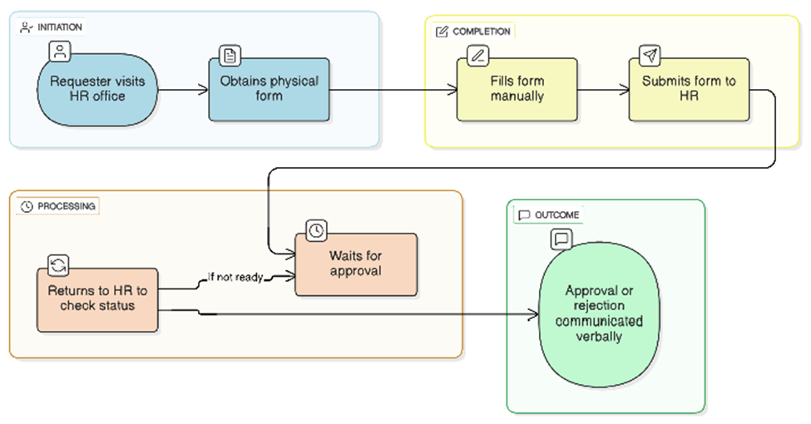

3.Proposed Process Flow (To-Be Flowchart):
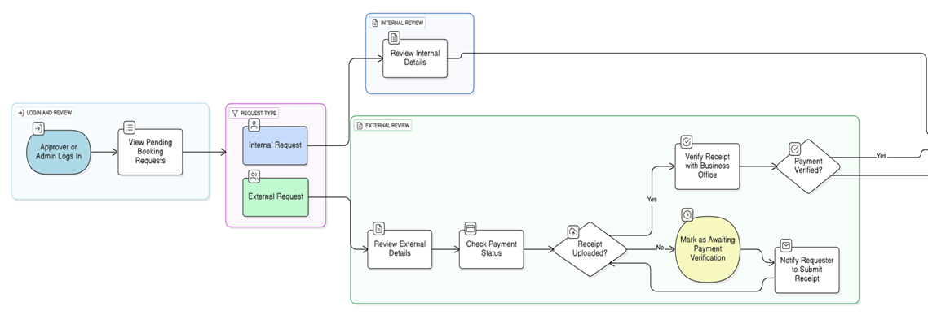
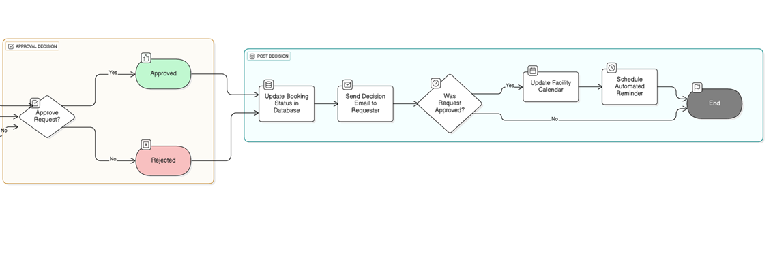
3.Conceptual Framework (IPO Model):
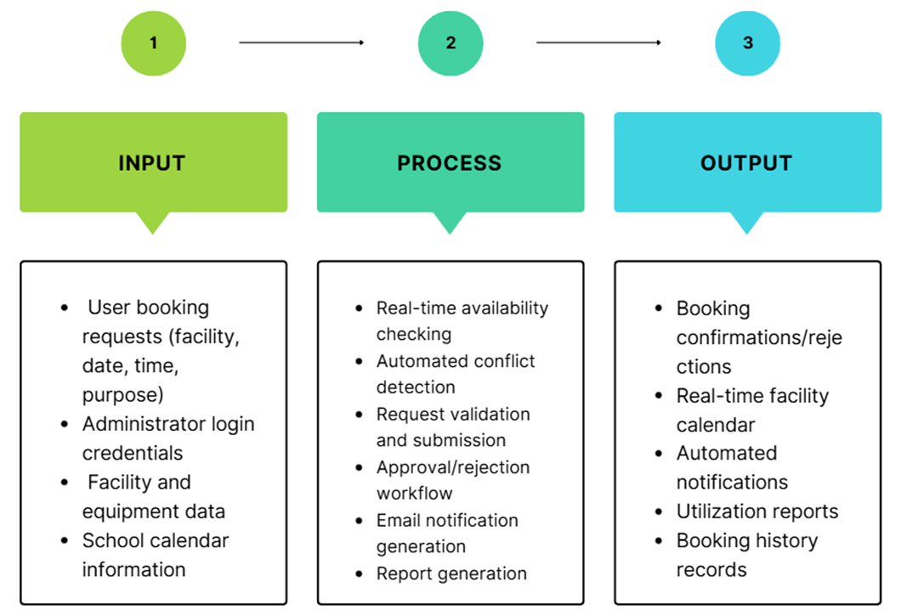

Chapter 2
REVIEW OF RELATED LITERATURE
This chapter reviews recent literature on web-based reservation systems, facility management platforms, usability, and security mechanisms in educational institutions, focusing on studies published within the last ten years to ensure relevance to current technological trends. It examines features, architectures, and technical implementations of existing systems, including real-time availability tracking, automated notifications, database-driven management, and user interface design, highlighting both strengths and limitations. By analyzing both international and local studies, this review establishes the theoretical and empirical foundation for the proposed web-based Facility Booking System for San Isidro College, identifies gaps in current solutions, and demonstrates the need for a tailored system that enhances operational efficiency, streamlines administrative processes, and improves user experience.

2.1 Manual Paper-Based Booking Systems
Before the adoption of digital systems, educational institutions relied on manual facility booking methods, such as paper forms, logbooks, or phone reservations. These practices were prone to scheduling conflicts, double-bookings, and delays in approval due to human error (TEM Journal, 2025). Administrators had to manually track reservations, which often resulted in inefficient resource allocation and poor visibility of facility usage. While manual systems required minimal technical skills, their limitations in coordination, transparency, and reporting highlighted the need for more efficient solutions.

These challenges directly inform the proposed system, which eliminates paper forms, reduces human error, and provides transparent, real-time booking updates through centralized digital management.

2.2 Existing Digital Facility Booking Systems
Digital facility booking systems have become increasingly adopted in schools and universities to address the limitations of manual scheduling. These systems typically offer centralized platforms that allow users to view facility availability, submit booking requests, and receive real-time approval updates electronically (TEM Journal, 2025; German et al., 2021).
In the Philippine context, Vega and Generoso (2025) implemented eReserve, an online system that improved record management, reduced booking delays, and enhanced communication between users and administrators. Centralized access to facility data and standardized booking procedures enabled better coordination, improved operational efficiency, and minimized scheduling conflicts.
Despite these benefits, many existing systems present challenges, such as complex authentication processes, limited accessibility for non-technical users, and insufficient automation of notifications. These gaps indicate the need for a simplified, user-friendly facility booking system that balances functionality with accessibility, especially in smaller institutions like San Isidro College.

Building on these findings, the proposed system combines centralized access and real-time updates with a simplified, user-friendly interface and automated notifications to ensure accessibility and usability for all personnel at San Isidro College.

2.3 Technical Architecture of Web-Based Booking Systems
The effectiveness of web-based booking systems depends heavily on their technical architecture. Most modern systems utilize database-driven designs that support real-time storage, retrieval, and updating of reservation data, preventing double-bookings and maintaining data integrity (German et al., 2021).
Integration of frontend and backend components ensures smooth user interactions and automated processes. Frontend interfaces often provide interactive forms and calendar-based views, while backend logic handles validation, scheduling constraints, and automated workflows. Real-time availability updates and notifications are typically implemented via server-side processing and messaging integrations (TEM Journal, 2025).
Local studies, such as Lee, Jung, and Hwang (2022), emphasize that centralized database management and real-time synchronization significantly improve system reliability and operational efficiency. These technical foundations are crucial for building scalable, responsive, and accurate web-based facility booking systems.
In addition to real-time scheduling, web-based booking systems commonly incorporate reporting and record management functionalities that enable administrators to generate summaries of facility usage, booking frequency, approval rates, and peak utilization periods. Database-driven reporting tools allow institutions to store and query historical reservation data, supporting data-driven decision-making and long-term resource planning [10]. Studies show that automated reporting reduces manual record compilation, improves transparency, and assists administrators in monitoring facility performance and identifying operational inefficiencies [10,14]. In the Philippine context, Vega and Generoso demonstrated that integrated reporting features in an online reservation system improved administrative oversight and facilitated informed decisions regarding scheduling priorities and facility maintenance [14]. These reporting capabilities enhance the overall effectiveness of web-based booking systems by transforming reservation records into actionable institutional insights.
Inspired by these architectural insights, the proposed system uses a database-driven design with integrated reporting and real-time updates to prevent booking conflicts and support data-informed facility management at San Isidro College.
2.4 Usability and User Experience in Web-Based Booking Systems
Usability and user experience are critical to the adoption of web-based booking systems, especially for users with varying technical skills. Research shows that systems with intuitive interfaces, clear navigation, and minimal input requirements are more likely to be consistently used (PMC, 2021).
Key usability features include calendar-based interfaces, simplified booking forms, automated confirmations, and real-time feedback on facility availability. Mobile responsiveness and accessibility through standard web browsers further enhance user convenience and adoption (Vega & Generoso, 2025).
Prioritizing ease of use and accessibility ensures that both technical and non-technical users can efficiently interact with the system, reducing errors, minimizing scheduling conflicts, and maximizing utilization of institutional resources. Guided by these usability principles, the proposed system prioritizes a clear, interactive interface, simplified booking forms, and automated feedback to ensure smooth and consistent use by faculty and staff.

2.5 Security and Access Control in Web-Based Booking Systems
Security and access control are integral to web-based facility booking systems, which manage sensitive user information, facility schedules, and administrative approvals. Effective systems implement authentication mechanisms that restrict access based on user roles, ensuring that only authorized users can perform specific functions.
Role-based access control (RBAC) is commonly used to differentiate privileges, allowing students or staff to submit booking requests while restricting approval, reporting, and modification functions to administrators (German et al., 2021). This approach prevents unauthorized changes, reduces misuse of facilities, and maintains accountability in the booking process.
Local implementations, such as eReserve by Vega and Generoso (2025), demonstrate the importance of controlled access, secure data handling, and activity monitoring to protect institutional information. However, overly complex authentication can reduce usability for non-technical users. Effective systems must therefore balance security with user-friendliness, ensuring secure storage, appropriate access control, and monitoring mechanisms without compromising the user experience.
The proposed system applies role-based access to balance security with usability, allowing users to submit requests freely while maintaining controlled administrative oversight appropriate for San Isidro College.
Theoretical Framework Diagram
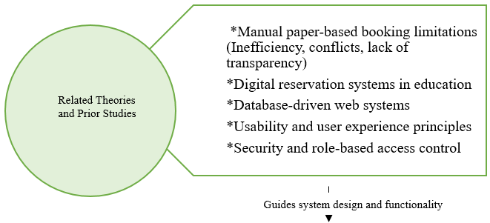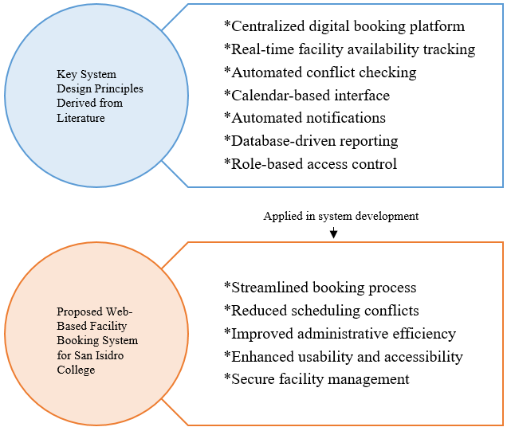

Chapter 3
METHODOLOGY
This chapter outlines the research methodology employed in the design and development of an Online Facilities and Equipment Booking System for San Isidro College (SIC). The methodology is strategically guided by the project objectives to create a functional, efficient, and user-friendly web-based system that comprehensively addresses the challenges inherent in the current manual, paper-based process. The study adopts a Design and Development research approach utilizing iterative processes, ensuring that the resulting system meets the operational needs of SIC while incorporating user feedback and modern software development practices.

3.0 Research Design

Type of Study:

This study is classified as a design and development research project, which falls under the domain of applied research. The primary focus is on creating and evaluating a practical solution in the form of a web-based facility booking system that directly addresses the operational challenges identified at San Isidro College. Unlike purely theoretical research, this applied approach ensures that the outcomes have immediate, tangible benefits for the institution's administrative processes and stakeholder experience.
Approach Used:
The project utilizes a Design and Development (D&D) methodology, systematically integrating elements of the System Development Life Cycle (SDLC) to ensure a structured and comprehensive development process.
The first phase involves Planning and Analysis, wherein the research team gathers requirements and develops a thorough understanding of the current workflow. This includes documenting the existing manual booking procedures, identifying stakeholders involved in the approval chain, and cataloging the types of facilities and equipment available for reservation. Requirements gathered during this phase encompass functional specifications such as user registration and authentication, booking request submission, real-time availability checking, automated conflict detection, multi-level approval workflows, notification systems, and comprehensive reporting capabilities.
The second phase encompasses System Design, which involves creating detailed interface layouts and database structures. This phase produces essential documentation including entity-relationship diagrams that illustrate data relationships, data flow diagrams that map information movement throughout the system, use case diagrams that depict user interactions, and system architecture flowcharts that outline the technical infrastructure. These visual representations serve as blueprints for the development team and facilitate clear communication with stakeholders regarding system functionality.
The third phase is Implementation and Development, during which the research team codes the web-based application according to the specifications established in previous phases. This involves front-end development for user interfaces, back-end programming for business logic, database implementation, and integration of all system components into a cohesive platform.
The fourth phase focuses on Testing and Evaluation, wherein the team verifies functionality, usability, and performance of the developed system. Testing tools and methodologies include unit testing frameworks to validate individual components, integration testing to ensure seamless module interaction, user acceptance testing with actual stakeholders, performance benchmarking to assess system responsiveness under various load conditions, and usability evaluation using standardized instruments such as the System Usability Scale (SUS) to measure user satisfaction and ease of use.
The final phase addresses Deployment and Maintenance, which involves making the system operational within the institutional environment and providing comprehensive documentation along with user training. This phase ensures sustainable system adoption and establishes protocols for ongoing technical support and future enhancements.

3.1 Data Gathering
Data gathering will be conducted systematically to inform system design and ensure that the developed system meets the specific needs of San Isidro College. This phase is critical in establishing a user-centered foundation for the entire development process.
Sources of Data:
Primary data will be collected through two principal methods. First, structured interviews will be conducted with the head of facility booking that is directly involved in the reservation process. These interviews aim to develop a comprehensive understanding of current processes, identify operational bottlenecks, and document existing approval workflows. The insights gained will inform the system's workflow design and ensure alignment with institutional procedures.
Second, surveys and questionnaires will be distributed to faculty members, administrative staff, and department heads who regularly utilize facility booking services. These instruments are designed to assess user needs, identify desired features, and document pain points experienced with the current manual system. The quantitative and qualitative data collected will guide interface design decisions and feature prioritization.
Population and Sampling:
San Isidro College has a total population of approximately 90 teaching personnel and 45 non-teaching staff, resulting in a combined population of 135 potential system users. For the final system evaluation, the study will employ purposive sampling to select 30 respondents (approximately 22% of the total population), comprising 20 faculty members and 10 administrative/non-teaching staff who regularly engage with the facility booking process. This sample size was determined using Slovin's formula with a 15% margin of error and ensures adequate representation of both user groups. The purposive sampling technique was chosen to ensure that respondents have direct experience with facility booking, thereby providing relevant and actionable feedback for system evaluation.

Permission and Ethics:
Ethical considerations have been carefully addressed throughout the data gathering process. Ethical clearance was secured from school authorities prior to conducting interviews and distributing surveys, ensuring institutional approval and compliance with research protocols. Participation in all data collection activities was entirely voluntary, with respondents fully informed of the study's purpose and their right to withdraw at any time. A formal letter of permission was provided to all participants, documenting consent and outlining data usage policies.
Tools for Data Gathering:
Data collection will be facilitated through several carefully selected tools. Google Forms will serve as the primary platforms for survey data collection, enabling efficient distribution and automated response compilation. Structured interview guides have been developed to maintain consistency across all interview sessions, ensuring comparable data quality regardless of the interviewer or respondent. Additionally, detailed notes and audio recordings, obtained with explicit consent from participants, will support qualitative analysis and ensure accurate representation of respondent perspectives.
Deliverables from this Phase:
Upon completion of the data gathering phase, several key deliverables will be produced. These include a comprehensive list of functional requirements derived from stakeholder input, detailed user feedback regarding interface design preferences, notification system requirements, and reporting needs, as well as a thorough identification of key pain points in the current booking process that the new system must address.

3.2 Data Pre-Processing
Before system development commences, all collected data will undergo rigorous processing to ensure accuracy, relevance, and actionability. This pre-processing phase serves as a critical bridge between raw data collection and informed system design.
Steps:
The pre-processing methodology consists of three sequential steps. The first step involves data cleaning, wherein incomplete survey responses, inconsistent interview data, and any anomalous entries are identified and appropriately addressed. This ensures that only reliable, high-quality data informs subsequent design decisions.
The second step encompasses categorization, during which responses are systematically grouped according to functional requirements, usability feedback, and system expectations. This organization facilitates efficient analysis and enables the research team to identify relationships between different categories of user input.
The third step focuses on analysis, wherein patterns are identified, common requests are documented, and critical requirements are distinguished from supplementary features. This analytical process directly informs system design priorities and ensures that development efforts address the most pressing user needs.
Tools/Techniques for Processing Data:
Several tools and techniques will support the pre-processing activities. Google Sheets will serve as primary platforms for data cleaning, organization, and quantitative analysis, enabling efficient manipulation of survey data and creation of summary statistics. Qualitative coding methodologies will be applied to interview responses, enabling systematic extraction of actionable insights, thematic identification, and nuanced understanding of stakeholder perspectives that purely quantitative methods might overlook.
Expected Deliverables:
The data pre-processing phase will yield three essential deliverables. First, a finalized list of system requirements will be produced, representing the definitive specifications that will guide development activities. Second, a prioritized feature list will be established based on user needs and technical feasibility, ensuring that development resources are allocated to maximize user value. Third, comprehensive documentation of workflows and approval processes will be created, providing the detailed procedural models necessary for accurate system representation of institutional operations.

3.3 System Development Methods
Based on the data gathered, the following processes will be undertaken:
Process | Purpose | Tools/Materials | Expected Deliverables
System Design | Develop user interface layouts, database schema, and workflow diagrams | Figma / Adobe XD for mockups, VS Code for code scaffolding | Wireframes, design mockups, ER diagrams
Database Development | Store facility data, user accounts, and booking records | Firebase, Firestore for real-time data | Functional database supporting CRUD operations
Web Development | Implement front-end and back-end functionality | HTML5, CSS3, JavaScript, PHP, VS Code | Web application with login, booking, approval, notifications
Conflict Checking | Prevent double-bookings by automatically detecting schedule overlaps | Firebase queries, PHP logic, calendar view | Requests are validated before approval; conflict notifications sent to user
Notification System | Automate communication on booking status | Firebase Cloud Messaging or email integration (SMTP) | Automated emails/alerts for submissions, approvals, & rejections
Testing & Evaluation | Validate usability, performance, and security | Browser testing, usability surveys, role-based test accounts | Tested and validated system ready for deployment
Deployment & Training | Make system operational and train users | School server / cloud hosting, training materials | Live system with trained end-users and documentation

1. Software Development Life Cycle (SDLC) Model:

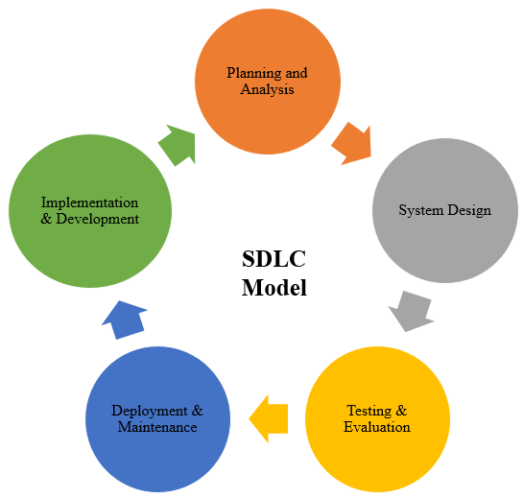
2. System Architecture Diagram:
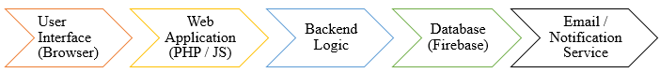

3. Network Architecture: 4. Use Case Diagram:

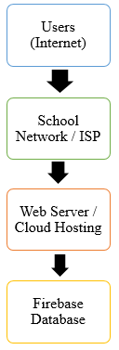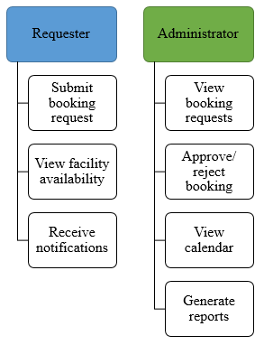

5.Detailed System Flowcharts (By Role):

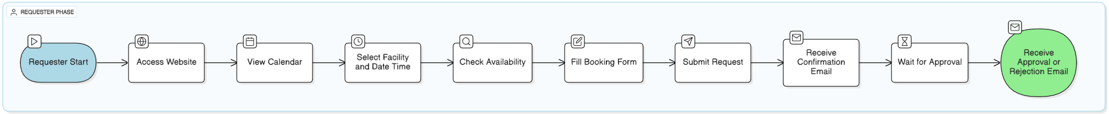
A. REQUESTER FLOWCHART:

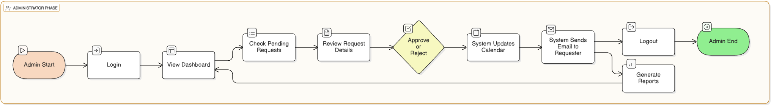
B. Administrator Flowchart:

6.Database Schema / Entity Relationship Diagram (ERD):
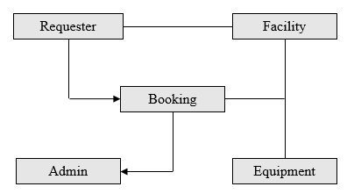
7.Sequence Diagram:
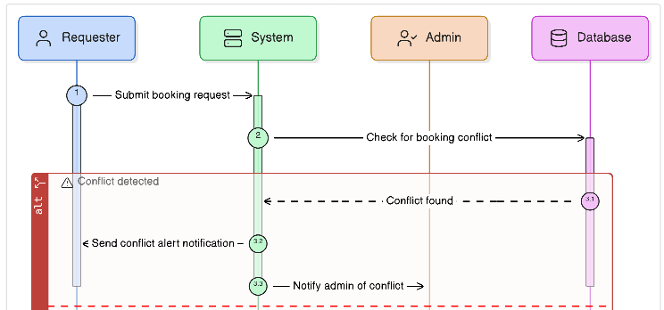

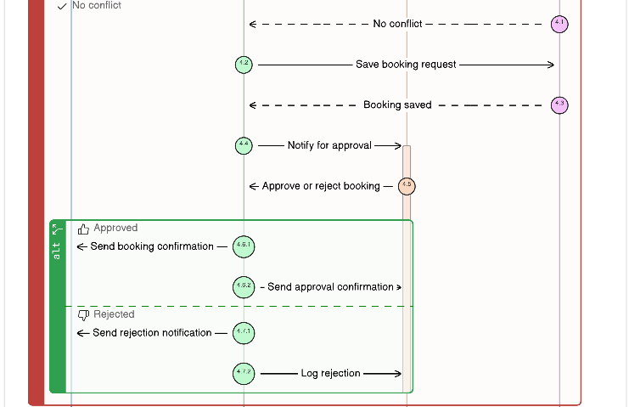
8.Activity Diagram:
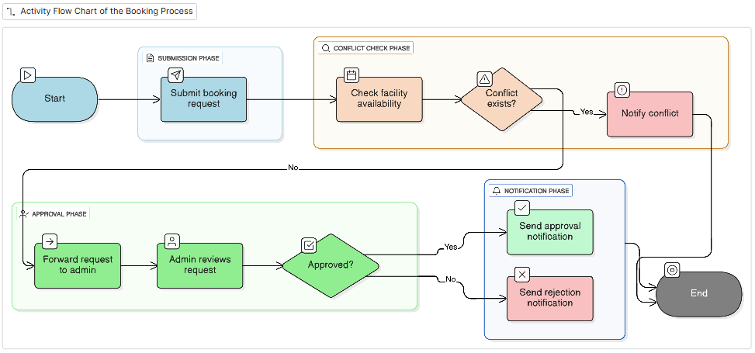

9.Data Gathering Procedure Flowchart:

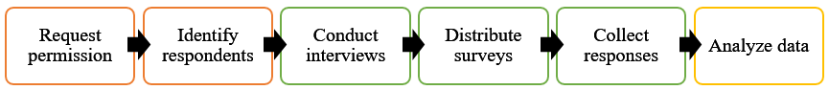

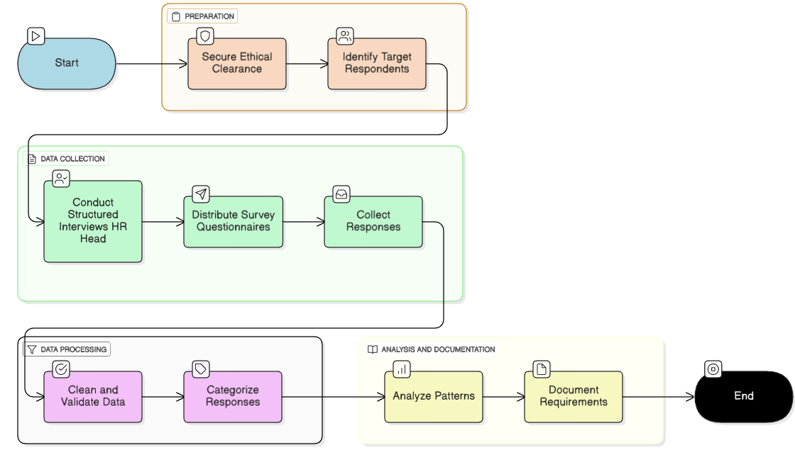

Appendices
Appendix A. User Needs Analysis Survey Form
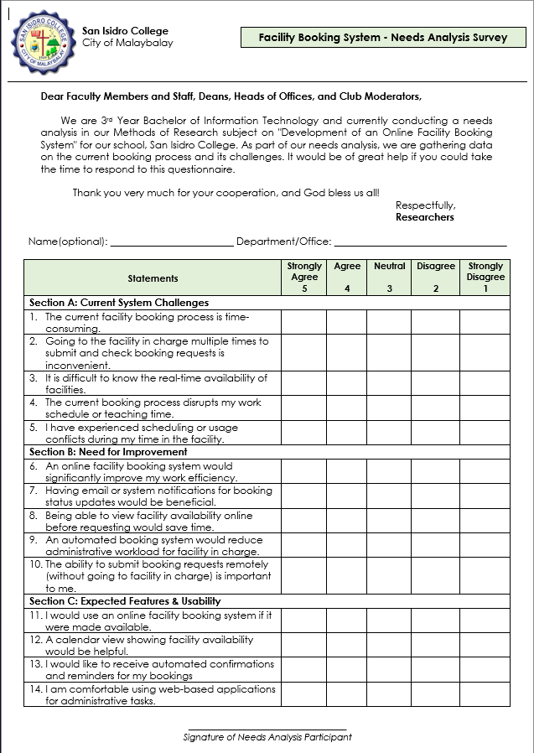

Survey Results
Section A: Current System Challenges
 | Q1 | Q2 | Q3 | Q4 | Q5
Personell_1 | 4 | 4 | 5 | 5 | 5
Personell_2 | 4 | 4 | 5 | 5 | 5
Personell_3 | 4 | 4 | 4 | 4 | 4
Personell_4 | 4 | 4 | 4 | 3 | 4
Personell_5 | 5 | 4 | 4 | 3 | 4
Personell_6 | 5 | 4 | 3 | 3 | 4
Personell_7 | 5 | 5 | 5 | 5 | 5
Personell_8 | 3 | 4 | 3 | 2 | 4
Personell_9 | 2 | 2 | 3 | 2 | 3
Personell_10 | 3 | 4 | 4 | 4 | 5
Average | 3.9 | 3.9 | 4 | 3.6 | 4.3
Section B: Need for Improvement
 | Q1 | Q2 | Q3 | Q4 | Q5
Personell_1 | 5 | 5 | 5 | 5 | 5
Personell_2 | 5 | 5 | 5 | 5 | 5
Personell_3 | 5 | 5 | 5 | 5 | 5
Personell_4 | 5 | 5 | 5 | 5 | 5
Personell_5 | 4 | 5 | 5 | 5 | 5
Personell_6 | 4 | 4 | 5 | 5 | 4
Personell_7 | 5 | 5 | 5 | 5 | 5
Personell_8 | 4 | 4 | 4 | 4 | 5
Personell_9 | 4 | 4 | 4 | 4 | 3
Personell_10 | 5 | 5 | 5 | 5 | 5
Average | 4.6 | 4.7 | 4.8 | 4.8 | 4.7

Section C: Expected Features & Usability
 | Q1 | Q2 | Q3 | Q4
Personell_1 | 5 | 5 | 5 | 5
Personell_2 | 5 | 5 | 5 | 5
Personell_3 | 5 | 5 | 5 | 5
Personell_4 | 5 | 5 | 5 | 5
Personell_5 | 5 | 5 | 5 | 5
Personell_6 | 5 | 5 | 5 | 4
Personell_7 | 5 | 5 | 5 | 5
Personell_8 | 5 | 5 | 5 | 5
Personell_9 | 4 | 4 | 4 | 3
Personell_10 | 5 | 5 | 5 | 5
Average | 4.9 | 4.9 | 4.9 | 4.7

References
[1] Vial, G. 2019. Understanding digital transformation: A review and a research agenda. The Journal of Strategic Information Systems, 28, 2 (2019), 118–144.
[2] Laudon, K. C., and Laudon, J. P. 2020. Management information systems: Managing the digital firm (16th ed.). Pearson.
[3] McKinsey & Company. 2021. The next normal: The recovery will be digital. McKinsey Global Institute.
[4] Department of Information and Communications Technology. 2022. Philippine Digital Transformation Strategy 2022–2028. Republic of the Philippines.
[5] Toquero, C. M. 2020. Challenges and opportunities for higher education amid the COVID-19 pandemic: The Philippine context. Pedagogical Research, 5, 4 (2020), em0063.
[6] Bueno, D. C. 2020. Digital literacy and competency of Filipino teachers: Basis for a professional development program. International Journal of Educational Management and Development Studies, 1, 1 (2020), 45–63.
[7] Buhalis, D., and Law, R. 2008. Progress in information technology and tourism management: 20 years on and 10 years after the Internet—The state of eTourism research. Tourism Management, 29, 4 (2008), 609–623.
[8] Gupta, D., and Denton, B. 2008. Appointment scheduling in health care: Challenges and opportunities. IIE Transactions, 40, 9 (2008), 800–819.
[9] Perera, H., Senevirathne, S., and Silva, T. 2024. Study room reservation system modernization at Oklahoma State University Library. Oklahoma State University.
[10] Ahmad, S., Khan, M., and Rahman, A. 2023. Development of a MERN-stack based hall reservation system for academic institutions. International Journal of Computer Applications, 185, 12 (2023), 1–8.
[11] Li, J., Zhang, W., and Chen, L. 2017. Design and implementation of an online booking system for university sports facilities. Journal of Sports Facility Management, 12, 3 (2017), 45–53.
[12] Adeyemi, A. O., and Ogunleye, K. 2022. Impact of online booking systems on public park management efficiency: A case study of Lagos State Parks. Journal of Public Administration and Governance, 12, 2 (2022), 45–62.
[13] F. Jasim, et al. 2020. Digital education: Intensifying Emirati students’ performance in the long run through hologram technology. In *Proceedings of the International Conference on Advanced Education and Technology*. ACM, New York, NY, USA, 1–6.
[14] R. Kraft and A. Bolves. 2020. Can technology transform communication between schools, teachers, and parents? Evidence from a randomized field trial. *American Economic Journal: Economic Policy* 12, 1 (2020), 1–44.
[15] S. Timotheou, O. Miliou, Y. Dimitriadis, S. V. Sobrino, N. Giannoutsou, R. Cachia, A. M. Monés, and A. Ioannou. 2023. Impacts of digital technologies on education and factors influencing schools’ digital capacity and transformation: A literature review. *Education and Information Technologies* 28, 6 (2023), 6695–6726. https://doi.org/10.1007/s10639-022-11431-8
[16] TEM Journal. 2025. Web-based facility and room reservation systems in higher education institutions. TEM Journal, 14, 3 (2025), 2293–2301.
[17] German, J. D., Yap, D. C. G., and Binoya, G. O. 2021. Design and development of an integrated room reservation system for higher education institutions. In Proceedings of the IEEE 8th International Conference on Industrial Engineering and Applications (ICIEA 2021). IEEE.
[18] Lee, J. M., Jung, I. H., and Hwang, K. 2022. Design and implementation of database for shared facility reservation system in school. Journal of Positive School Psychology, 6, 8 (2022), 7033–7041.
[19] Vega, M. M., and Generoso II, M. J. I. A. 2025. eReserve: An online facility reservation system of one Philippine higher education institution. Asia Pacific Journal of Multidisciplinary Studies and Development, 13, 1, Part 2 (2025).
[20] Chong Jun Lynn, E., Jothi, N., and Al-Qasem Al-Hadi, I. A. 2024. U-Reserve: Development of a facility reservation system for UCSI University. In ICAROB 2024 Conference Proceedings, 524–531.
[21] IEEE. 2018. Assessing user experience and adoption of web-based reservation systems. IEEE Xplore (2018).
[22] Ayedh, A. T. M., Abdul Wahab, A. W., and Mohd Yamani Idna Idris, M. 2023. Systematic literature review on security access control policies and techniques based on privacy requirements in a BYOD environment: State of the art and future directions. Applied Sciences, 13, 14 (2023), 8048.
[23] Odiaga, G. 2023. Review of the security challenges in web-based systems. World Journal of Advanced Engineering Technology and Sciences, 8 (2023), 204–216. DOI: 10.30574/wjaets.2023.8.2.0099.
[24] Sarkar, R., and Saha, P. 2020. IoT-enabled digital reservation system for educational institutions. In Proceedings of the IEOM Society International Conference (2020).
[25] Hashim, F., Noor, N., and Ramli, R. 2023. Web-based resource booking with real-time notifications in universities. International Journal of Research in Engineering and Science, 13, 7 (2023), 738–742.
[26] Chan, T. C. 2022. School Facility I.Q. Inventory (SFIQI): An essential tool for school facility management. Educational Planning, 29, 3 (2022), 65–78.
[27] Chkheidze, S. 2023. Facility management in education. American International Journal of Business Management (2023).
[28] PMC. 2021. Usability evaluation of web-based applications: Methods and best practices. PMC Central (2021).
[29] CMS Conferences. 2022. User acceptance and interface design in web-based systems. In Proceedings of the CMS Conference 2022, 123–134.

