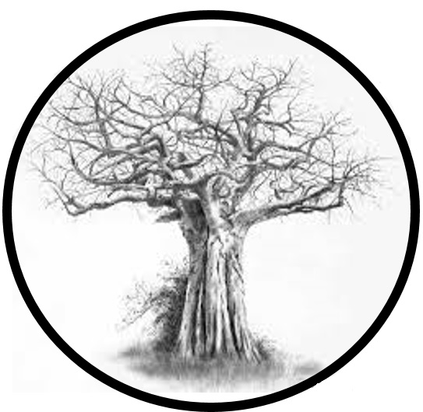

PLANT US & WE’LL GROW

**BAOBAB**