CrowdfngingBook_report

# Instructions:

Create a report in Microsoft Word, and answer the following questions:

* Given the provided data, what are three conclusions that we can draw about crowdfunding campaigns?
* What are some limitations of this dataset?
* What are some other possible tables and/or graphs that we could create, and what additional value would they provide?

## Conclusions

Most crowdfunding campaigns are for the theater category.

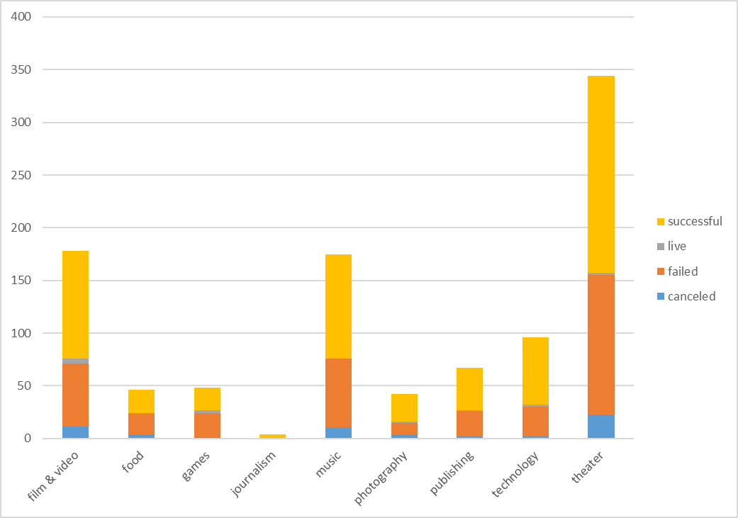

Success in crowdfounding campaigns tends to peak towards the end of the second quarter and the start of the third quarter. Success increases from May to July and then rapidly decreases in August to then stabilize for the rest of the year.

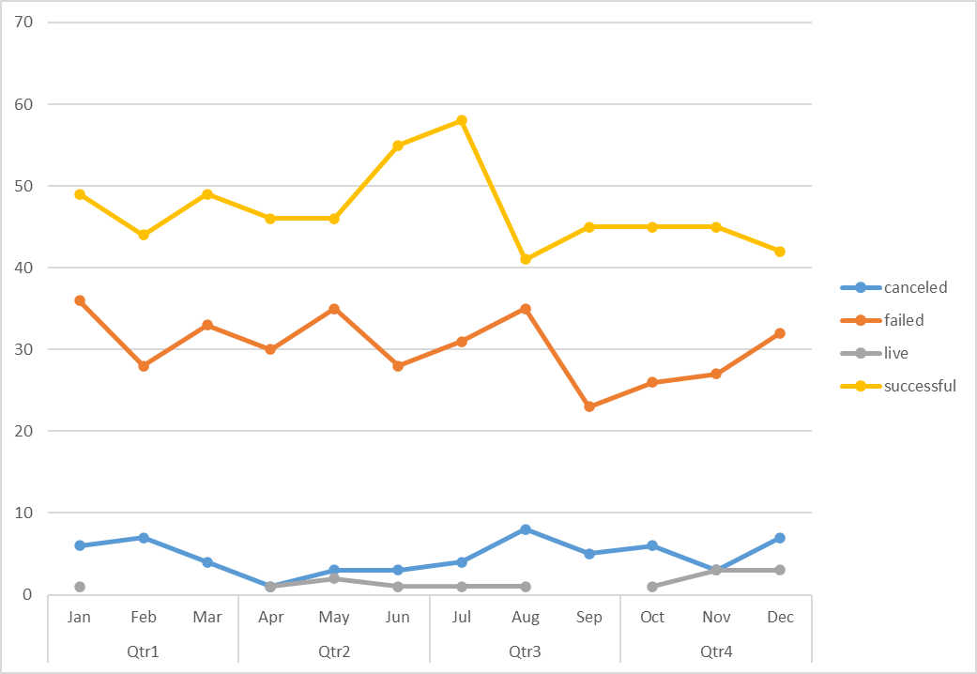

For the science fiction subcategories there are more failed crowdfunding campaigns than successful ones.

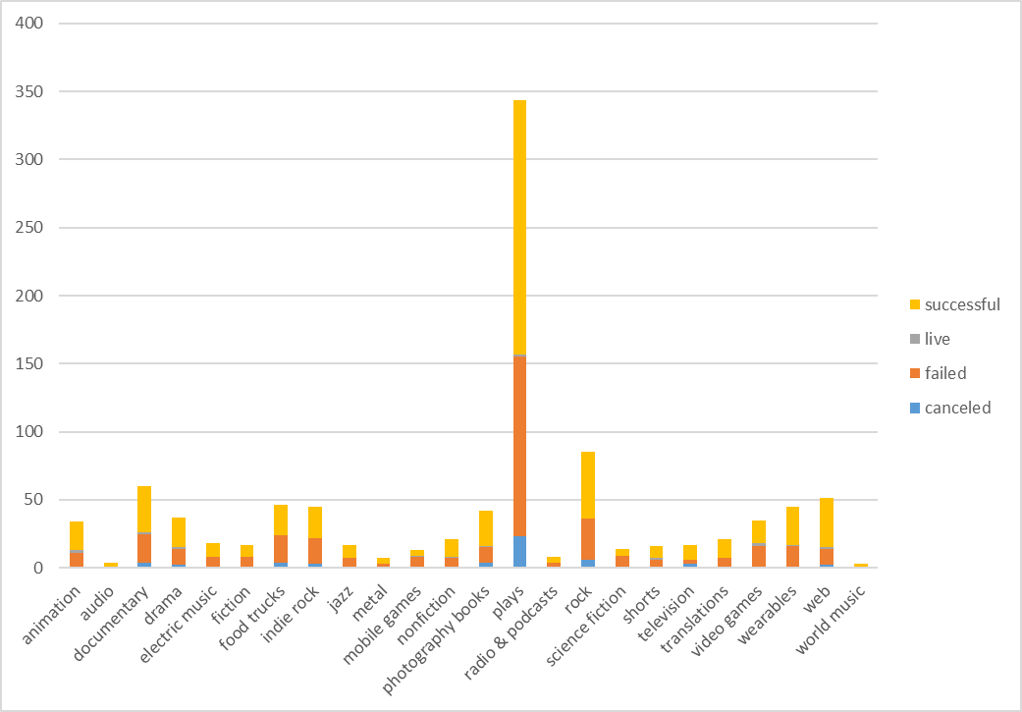

## Limitations of dataset

All theater campaigns are sub-categorized as plays, it would be more useful to find a better way to categorize these campaigns so that we can draw better conclusions from this category.

There are a total of 7 countries being analyzed in this data, however 763 out of the total 1000 crowdfunding campaigns are from the United States suggesting that this could be biased towards the US culture.

## Possible tables or graphs to create

We could create a success to failure ratio of campaigns by category and it would provide value to prioritize future crowdfunding campaigns based on higher chances of it being successful. Then we could filter our previous outcome across time graphs to see when that specific category was most successful.

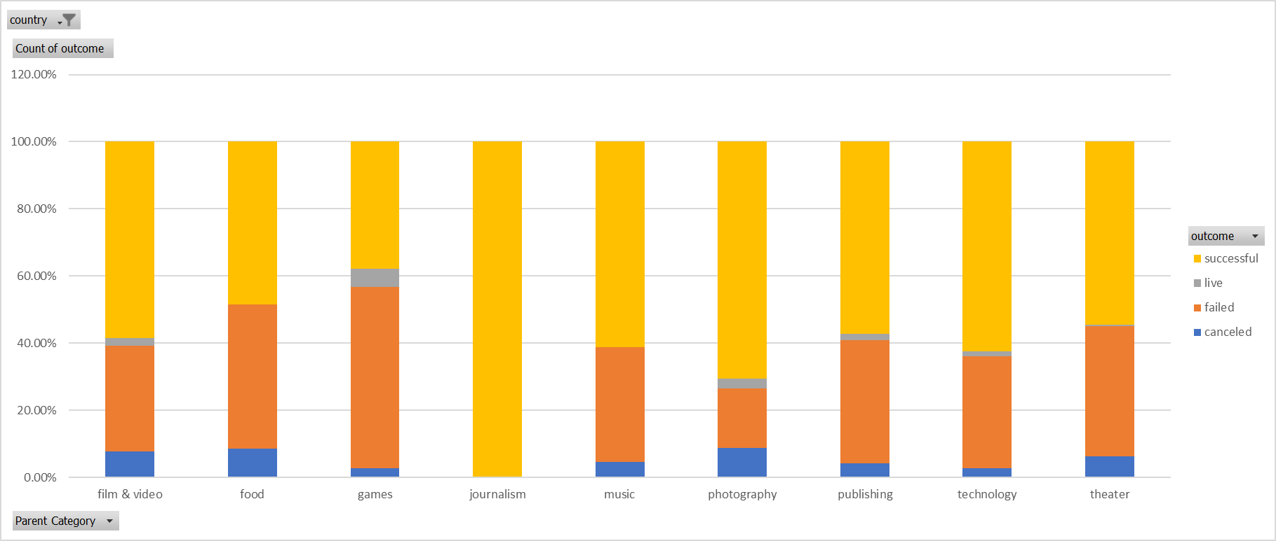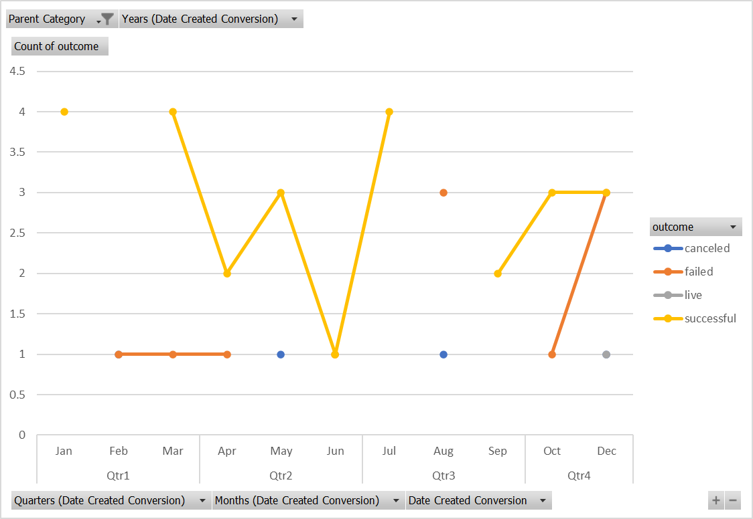

## Statistical Analysis

As you can see in a boxplot, the data and the graph are heavily skewed which means that the median is a better representation of the data for both successful and failed campaigns in this case.

Also, we can see there is more variability in successful campaigns which makes sense simply because there is more data, there are more successful campaigns and its always been the case to see more variability where there is more data.

Thank you.