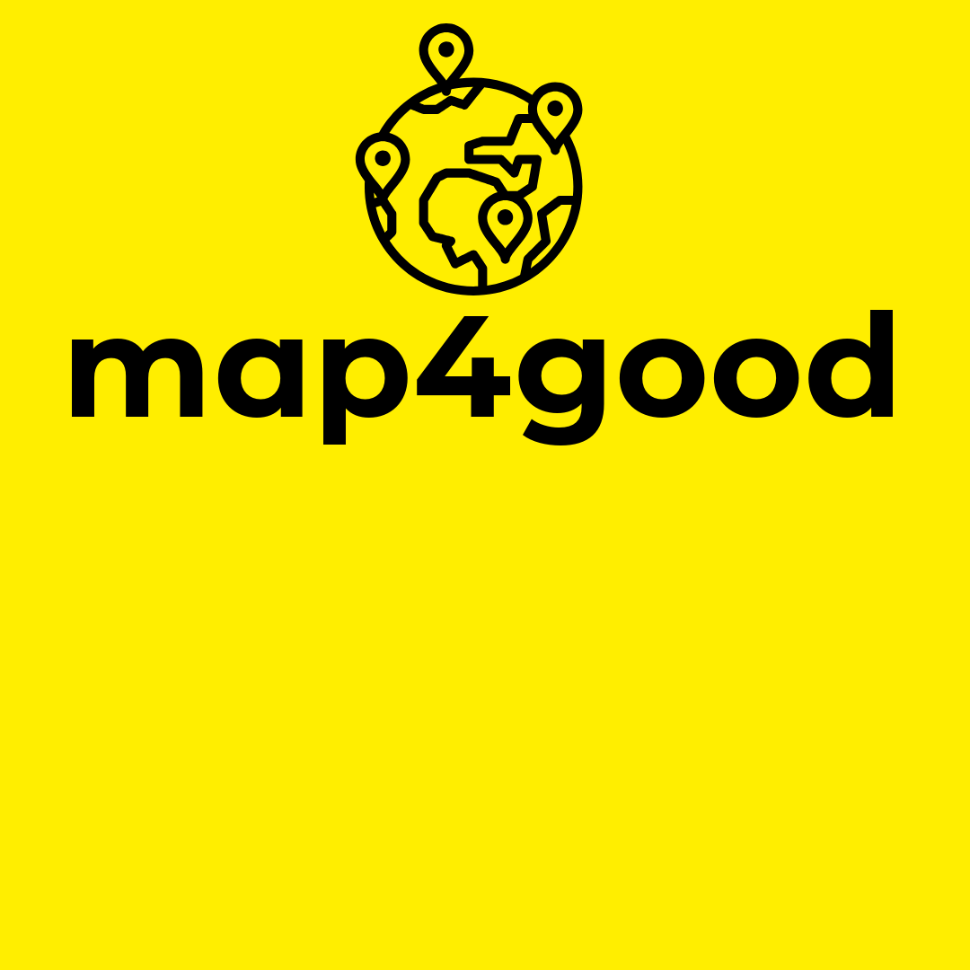

**“Mapping a better tomorrow: Connecting people,**

**Spreading hope.”**

**Team Members**:

1. Kartikay Tewari
2. Ashish Chacko Oomman

# Project Date:

# 1-12-2024

**Team Name**:

ROUTE NO 1

# Hackathon Name:

# Hack Frost Winter Hackathon 2024

TABLE OF CONTENTS

1. Executive Summary
2. Introduction
3. Problem Statement
4. Vision & Mission
5. Target Audience
6. Research & Insights
7. Key Features
8. Technology Stack
9. Wireframes & Prototypes
10. Data Flow & Database Design
11. Technical Architecture
12. Security & Privacy
13. Challenges & Solutions
14. Testing & Quality Assurance
15. Deployment & Maintenance
16. Future Roadmap
17. Conclusion
18. References & Acknowledgments

**Executive Summary**

Map4Good is an innovative, map-based application designed to address the lack of accessibility to local charitable events and resources in India. By leveraging geospatial technology, the platform connects individuals with nearby health drives, food distribution events, and blood donation drives, fostering community engagement and resource optimization.

The application’s key features include real-time mapping, event notifications, and user-friendly interfaces tailored to various audiences. Built with cutting-edge technologies, it ensures scalability, security, and privacy.

Through Map4Good, we aim to empower communities, bridge resource gaps, and contribute to the greater good, making charitable efforts more visible and accessible for everyone.

### **Introduction**

In an era where technology has become a powerful enabler of social change, there remains a significant gap in the accessibility and visibility of charitable initiatives. Many individuals and organizations conduct food distribution drives, blood donation camps, and health initiatives, yet these efforts often struggle to reach their intended audience effectively. This disconnect limits their impact and hinders community participation.

**Map4Good** aims to bridge this gap by creating a centralized, map-based platform tailored for India. The application not only highlights nearby charitable activities but also provides a seamless way for users to discover, participate in, and benefit from these initiatives. By leveraging the power of geospatial mapping and real-time updates, Map4Good connects individuals, non-profits, and volunteers, fostering a sense of collective action for societal well-being.

This document provides a detailed overview of the project, from its conception to execution, outlining the research, design, technical framework, and future roadmap. It captures our mission to drive meaningful social impact through technology, ensuring that help reaches those who need it the most.

**Problem Statement**

India is home to numerous charitable initiatives, ranging from blood donation drives and food distribution events to health camps and disaster relief efforts. However, despite the abundance of goodwill, many of these initiatives face challenges in reaching their intended beneficiaries and engaging volunteers effectively. Key issues contributing to this problem include:

1. **Lack of Visibility:** Information about local charitable events is often scattered across various platforms or restricted to word-of-mouth, making it difficult for people to discover and participate.
2. **Inefficient Resource Utilization:** Many events struggle to match resources (like donations, volunteers, or medical supplies) with real-time needs due to a lack of centralized coordination.
3. **Geographic Barriers:** People are often unaware of charitable activities happening in their vicinity, leading to missed opportunities for assistance or participation.
4. **Limited Technological Integration:** While technology has advanced, there is no dedicated, user-friendly platform focused on mapping charitable activities in a way that is accessible to diverse audiences.

These challenges hinder the effectiveness of charitable initiatives, leaving many in need unserved and many potential volunteers uninvolved.

**Map4Good** seeks to address these issues by creating a centralized, map-based application that enhances visibility, streamlines coordination, and bridges the gap between charitable initiatives and the communities they aim to serve.

### **Vision & Mission**

#### **Vision**

To create a simple yet impactful map-based platform that enhances accessibility to charitable initiatives, enabling individuals and organizations to connect for the greater good.

#### **Mission**

Our mission is to build a user-friendly map application that:

1. Provides basic map features for navigation and location discovery.
2. Highlights nearby charitable activities, such as food distribution events, blood donation camps, and health drives.
3. Serves as a bridge between communities and charitable organizations, fostering participation and engagement.
4. Ensures a straightforward and accessible interface, making it easy for anyone to navigate and contribute to social causes.

With this platform, **Map4Good** aims to combine everyday map functionality with tools for promoting and participating in charitable efforts, simplifying the process of giving and receiving help.

### **Target Audience**

The **Map4Good** platform is designed to serve a diverse group of users, each with unique needs and motivations. The primary target audience includes:

#### 1. **Individuals Seeking Help**

* People looking for nearby charitable services such as food distribution centers, health camps, or blood donation drives.
* Vulnerable groups, including low-income families, students, and the elderly, who may benefit from accessible and localized support.

#### 2. **Volunteers and Donors**

* Individuals who want to contribute to social causes by volunteering their time, skills, or resources.
* Donors seeking nearby events or initiatives to provide financial or material support.

#### 3. **Charitable Organizations and NGOs**

* Non-profits and community organizations that organize events like donation drives or health check-up camps and need a platform to promote them.
* Groups that aim to increase their outreach and optimize participation in their initiatives.

#### 4. **General Users**

* Everyday users looking for a simple map application with basic features, who may also discover opportunities to engage in charitable activities.

#### 5. **Local Authorities and Community Leaders**

* Municipalities or local leaders who want to coordinate community services and promote neighbourhood engagement effectively.

By catering to these groups, **Map4Good** ensures a holistic approach to connecting people, fostering community participation, and maximizing the impact of charitable efforts.

### **Research & Insights**

For the "Map4Good" project, the accurate detection of user and event locations is critical to its functionality. Here’s a detailed exploration of how location data can be leveraged, inspired by industry practices:

#### **1. Device-Based Location Data**

To estimate a user’s location, modern devices utilize a combination of hardware and software inputs. Below are the primary methods:

* **GPS (Global Positioning System):**  
  Provides precise latitude and longitude coordinates by connecting to a network of satellites. It’s the cornerstone of accurate location services.
* **Device Sensors:**  
  Integrated sensors enhance location accuracy:
  + **Accelerometer & Gyroscope:** Detect device movement and orientation.
  + **Magnetometer:** Assists in determining direction using Earth’s magnetic field.
  + **Barometer:** Helps estimate altitude by measuring atmospheric pressure.
* **Mobile Network Signals:**  
  Utilizes data such as Cell ID, Location Area Code (LAC), and Cell Identity (CI) from cellular towers to approximate a device’s location, especially in areas with weak GPS signals.
* **Wi-Fi Signals:**  
  Detects nearby Wi-Fi networks by analyzing MAC addresses and SSIDs. This method is especially effective in urban areas with dense Wi-Fi access points.

#### **2. Google Location Accuracy (GLA)**

When enabled, GLA improves location estimation by combining multiple data sources, including:

* GPS coordinates.
* Signals from Wi-Fi access points and mobile networks.
* Data from device sensors (as described above).

GLA ensures that the application can provide accurate real-time information, even in challenging environments like urban canyons or indoors.

#### **3. Crowdsourced Data**

Crowdsourcing aggregates anonymous location data from multiple users to derive insights such as:

* **Traffic Density and Patterns:** Identifying congestion or free-flowing roads.
* **Event Popularity:** Estimating the number of attendees at nearby charitable events based on active devices.

For **Map4Good**, crowdsourced data could highlight busy donation centers, ensuring users are directed to less crowded or underserved events.

#### **4. IP Address-Based Location Estimation**

When high accuracy is unnecessary, IP-based geolocation can approximate a user’s general area. This method is less precise but offers the advantage of working without requiring additional permissions from the user.

#### **5. Relevance to "Map4Good"**

**Map4Good** can leverage these methods to provide a seamless user experience:

* **Real-Time Location Tracking:** Utilizing GPS and sensors to identify users’ current locations and display nearby events.
* **Crowdsourced Event Insights:** Aggregating anonymous data to highlight popular or high-need events.
* **Accessibility in Rural Areas:** Relying on mobile network signals and IP-based geolocation where other inputs are unavailable.

#### **6. Privacy Considerations**

Given the sensitive nature of location data, **Map4Good** must prioritize privacy by:

* Collecting anonymized data where possible.
* Using temporary identifiers for tracking, similar to GLA.
* Providing users with control over location permissions.

This research forms the foundation for designing a reliable and ethical location-based system for **Map4Good**, tailored to India’s diverse geographical and technological landscape. Let me know if you’d like further refinement!

**Key Features**

### **Core Navigation Features**

1. **Real-Time Location Tracking**
   * Displays the user's current location using GPS.
   * Continuously updates as the user moves.
2. **Search Functionality**
   * Find specific addresses, places, or landmarks.
   * In **Map4Good**, this can be extended to locate **charitable drives** (e.g., blood donation, health camps).
3. **Turn-by-Turn Directions**
   * Provide detailed instructions for driving, walking, and cycling.
   * Offer **custom routes** to include stops at charitable places.
4. **Route Optimization**
   * Suggest the fastest or shortest route based on traffic conditions.
   * **Map4Good Addition:** Show routes that pass by ongoing charitable events or high-need areas.
5. **Offline Mode**
   * Allow users to download maps and use navigation without an internet connection.
   * **Map4Good Addition:** Enable downloading offline data for nearby charitable events.
6. **Live Traffic Updates**
   * Show real-time traffic conditions to help users avoid congestion.
   * Highlight areas where **events like food distribution might cause temporary traffic changes**.
7. **Landmark-Based Navigation**
   * Provide directions using nearby landmarks for better guidance.
   * Include notable **charity-related landmarks** such as community centers or NGOs.
8. **Multiple Stops and Waypoints**
   * Plan routes with multiple stops.
   * **Map4Good Addition:** Let users add charitable places as planned stops.

### **Personalization Features**

1. **User Profiles**
   * Allow users to create accounts for saving preferences and history.
   * **Map4Good Addition:** Let users save frequently visited charitable locations or events.
2. **Search Filters**
   * Narrow down results based on user preferences (e.g., type of transport).
   * **Map4Good Addition:** Add filters for specific **types of charity events** (e.g., medical, food, or donation drives).
3. **Language Support**
   * Provide multilingual support for broader accessibility in India.
   * Include major Indian languages like Hindi, Tamil, Bengali, etc.
4. **Custom Notifications**
   * Notify users about delays, diversions, or nearby points of interest.
   * **Map4Good Addition:** Send notifications about **nearby events** or when a user is approaching a charitable location.

### C:\Users\Admin\AppData\Local\Microsoft\Windows\INetCache\Content.Word\MOB.PNG

### **Interactive Features**

1. **Event Submissions**
   * Enable users or organizations to **add their events** to the map.
   * Ensure submissions are moderated to maintain credibility.
2. **Crowdsourced Updates**
   * Allow users to report traffic jams, roadblocks, or event-related disruptions.
   * In **Map4Good**, users can report **changes in event status** (e.g., canceled or extended drives).
3. **Event Popularity Metrics**
   * Show live attendance numbers or wait times at popular locations.
   * Highlight high-need events to encourage participation.
4. **Gamification Elements**
   * Reward users for attending events or making frequent contributions (e.g., badges or leaderboards).

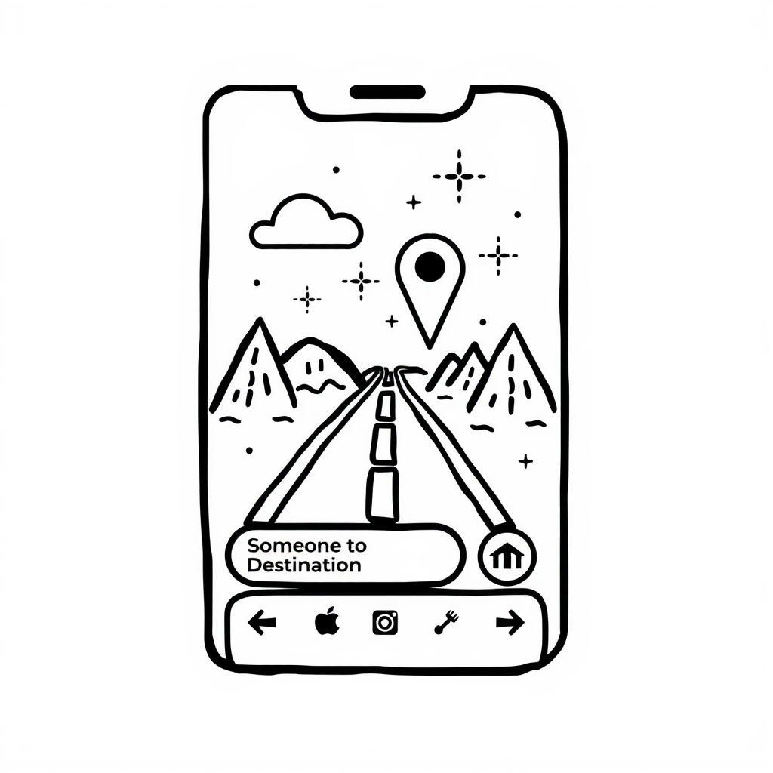

### **Map and Visualization Features**

1. **Dynamic Map Layers**
   * Offer layers for traffic, terrain, and satellite views.
   * **Map4Good Addition:** Add a dedicated **charity events layer** to highlight event locations.
2. **Nearby Suggestions**
   * Suggest points of interest based on the user’s current location.
   * **Map4Good Addition:** Recommend **nearby charitable opportunities**.
3. **Heatmaps**
   * Show density maps for traffic or popular locations.
   * **Map4Good Addition:** Use heatmaps to indicate **areas with ongoing charity drives or high-need zones**.

### **Accessibility and Safety Features**

1. **Voice-Guided Navigation**
   * Provide voice directions in multiple languages.
   * **Map4Good Addition:** Include event-specific prompts (e.g., “You’re approaching a blood donation drive on your route”).
2. **Emergency Assistance**
   * Offer a one-tap option to locate nearby police stations or hospitals.
   * **Map4Good Addition:** Highlight **emergency relief centers** during natural disasters or crises.
3. **Accessible Routes**
   * Suggest routes suitable for differently-abled users.
   * Highlight **charity events catering to special needs groups**.

### **Social and Community Features**

1. **Social Sharing**
   * Let users share routes or event details with others.
   * Encourage users to promote **charitable drives on social media**.
2. **Event Reviews and Ratings**
   * Allow users to leave feedback on charitable events to help others choose where to participate.
3. **Collaboration with NGOs**
   * Partner with NGOs and local bodies to ensure accurate event data.
   * Highlight official drives and events organized by credible sources.

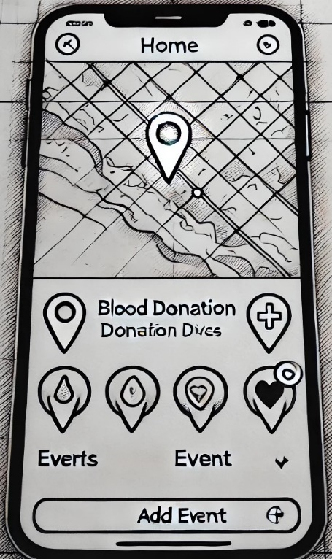

**Technology Stack**

#### **1. Frontend (User Interface)**

* **HTML5, CSS3, JavaScript**: These core technologies are used to build the structure, styling, and interactivity of the web application, ensuring that it is responsive and user-friendly.
* **React.js**: A popular JavaScript library for building fast and interactive user interfaces. React helps in creating reusable UI components, enabling efficient rendering and dynamic updates of the map and other content.
* **Bootstrap**: A front-end framework used to design a responsive layout, ensuring the application works smoothly across various devices (desktops, tablets, mobile phones).

#### **2. Backend (Server-Side)**

* **Node.js**: A JavaScript runtime that allows for the development of fast, scalable server-side applications. It is used to handle requests, process data, and interact with the database efficiently.
* **Express.js**: A web framework for Node.js that simplifies the creation of APIs and handles routing, middleware, and other essential backend functionalities.

#### **3. Database**

* **MongoDB**: A NoSQL database that stores data in a flexible, JSON-like format, making it ideal for handling the dynamic and varying data associated with charitable events (locations, schedules, participant details). It scales well and ensures efficient data retrieval.

#### **4. Mapping and Geospatial Features**

* **Google Maps API**: The Google Maps API is used to integrate map-based functionalities, including location tracking, geolocation services, event markers, and interactive map features for discovering nearby charitable activities.
* **Leaflet.js**: An open-source JavaScript library for interactive maps, used as an alternative or supplement to Google Maps, providing lightweight and customizable map features.

#### **5. Authentication & Security**

* **OAuth2.0 / JWT (JSON Web Tokens)**: Secure methods for user authentication and authorization, ensuring that only authorized users can manage or view sensitive data related to charitable events.
* **Bcrypt.js**: Used for hashing and securing user passwords during registration and login processes.

#### **6. Cloud & Deployment**

* **Amazon Web Services (AWS)**: AWS services such as S3 for file storage, EC2 for hosting, and RDS for managed database solutions may be used to ensure scalability and reliability.
* **Heroku / DigitalOcean**: These cloud platforms offer easy deployment solutions for hosting the application and managing backend services.
* **GitHub**: Used for version control and collaboration during development, allowing for smooth integration and code management.

#### **7. Testing & Quality Assurance**

* **Jest / Mocha**: Testing frameworks for unit and integration testing of both frontend and backend code to ensure stability and functionality.
* **Postman**: Used for API testing and ensuring that communication between the frontend and backend is seamless.

#### **8. Additional Tools**

* **Figma / Adobe XD**: Used for designing wireframes and prototypes of the user interface, ensuring a user-friendly and intuitive design.
* **Webpack**: A module bundler that optimizes the bundling of JavaScript and assets, improving application performance.

**Wireframes & Prototypes**

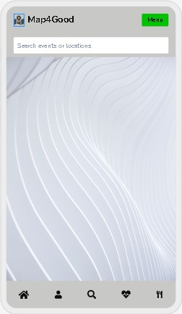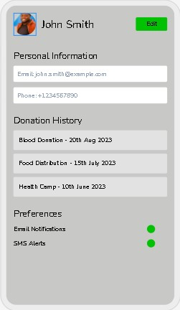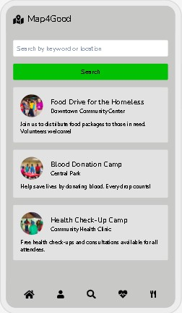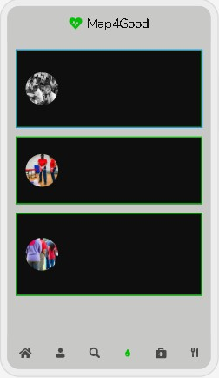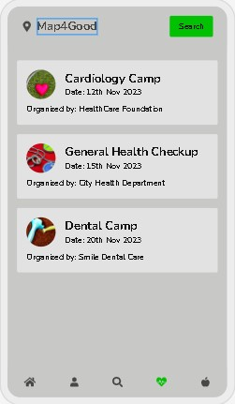

**Challenges and Solutions**

### **1. Data Collection and Accuracy**

* **Challenge**:  
  Collecting and maintaining accurate, up-to-date information about charitable events and organizations can be difficult. Incorrect or outdated data could undermine the app's utility.
* **Solution**:
  + Partner with verified NGOs, community organizations, and government bodies for accurate data.
  + Implement a **crowdsourcing feature** where users can submit updates, with a moderation system to verify submissions.
  + Use APIs from trusted sources like Google Maps and local charitable databases to enhance reliability.

### **2. User Engagement**

* **Challenge**:  
  Getting users to adopt the app and actively engage with its features, especially in underserved areas or among non-tech-savvy audiences.
* **Solution**:
  + Simplify the UI/UX for accessibility, ensuring the app is easy to use for people with basic tech knowledge.
  + Use gamification (e.g., badges for donations or volunteering) to encourage user participation.
  + Promote the app through social media campaigns, local events, and partnerships with schools and colleges.

### **3. Limited Technical Resources**

* **Challenge**:  
  As a hackathon project, there might be constraints in terms of time, development expertise, and infrastructure.
* **Solution**:
  + Start with a **Minimum Viable Product (MVP)** that focuses on the core features (basic map + charitable listings).
  + Leverage free or low-cost cloud platforms (e.g., AWS Free Tier, Google Firebase) for hosting and backend.
  + Use open-source libraries and frameworks for faster development.

### **4. Scalability Issues**

* **Challenge**:  
  As the user base and data grow, the system might face performance bottlenecks or server downtime.
* **Solution**:
  + Design the architecture with scalability in mind (e.g., microservices architecture).
  + Use cloud-based solutions like AWS, Azure, or Google Cloud to scale resources on-demand.
  + Implement caching mechanisms (e.g., Redis) to improve performance.

### **5. Security and Privacy**

* **Challenge**:  
  Users may be reluctant to share personal data due to privacy concerns. There is also the risk of data breaches.
* **Solution**:
  + Use secure protocols (HTTPS, data encryption) to protect user data.
  + Follow best practices for user authentication, such as two-factor authentication (2FA).
  + Clearly state your **privacy policy** and allow users to opt out of data collection.

### **6. Integration with Maps and APIs**

* **Challenge**:  
  Integration with mapping services (e.g., Google Maps) and third-party APIs could pose technical challenges.
* **Solution**:
  + Use well-documented and reliable APIs like Google Maps API, Mapbox, or OpenStreetMap for mapping services.
  + Test API integrations thoroughly and handle errors gracefully (e.g., fallback options if an API call fails).

### **7. Sustainability and Maintenance**

* **Challenge**:  
  Post-hackathon, maintaining and updating the app might be challenging if there’s no dedicated team or funding.
* **Solution**:
  + Open-source the project to allow the community to contribute.
  + Approach NGOs or government bodies to fund and support the project.
  + Implement automated tools for monitoring and updates (e.g., periodic server health checks, database cleanup scripts).

### **8. User Safety**

* **Challenge**:  
  Events like blood donation drives or food distributions may be incorrectly listed, leading to inconvenience or even harm.
* **Solution**:
  + Include a verification system for event organizers.
  + Allow users to report incorrect or fraudulent listings.
  + Display disclaimers encouraging users to verify event details independently.

### **9. Multilingual Support**

* **Challenge**:  
  India has multiple languages, and limiting the app to just one could alienate potential users.
* **Solution**:
  + Use localization libraries and frameworks to support multiple languages.
  + Focus on major regional languages during the initial rollout (e.g., Hindi, Tamil, Bengali, etc.).
  + Use AI-powered translation tools like Google Translate API for quick multilingual implementation.

### **10. Internet Accessibility**

* **Challenge**:  
  Many target users may have limited or no access to the internet.
* **Solution**:
  + Enable **offline features**, such as viewing saved maps and listings.
  + Optimize the app for low-bandwidth usage by compressing images and minimizing API calls.
  + Offer a lightweight version of the app or an SMS-based service for key features.

### **11. Legal and Regulatory Compliance**

* **Challenge**:  
  There could be regulations regarding data usage, mapping services, and partnerships with NGOs.
* **Solution**:
  + Consult with legal experts to ensure compliance with laws like the **Information Technology Act, 2000** in India.
  + Use licensed mapping tools and obtain necessary permissions from charitable organizations.

### **12. Competition**

* **Challenge**:  
  Similar apps might exist, making it harder to differentiate **Map4Good**.
* **Solution**:
  + Focus on unique features like charitable mapping, crowdsourced updates, or hyperlocal targeting.
  + Highlight the app’s social impact and use it as a differentiator in marketing campaigns.

**Future Roadmap**

#### **Short-Term Goals (0–6 months)**

* Launch the MVP with basic map and charitable event listings.
* Gather user feedback to fix issues and improve usability.
* Partner with NGOs and community organizations for accurate data.
* Simplify UI and start adding multilingual support.
* Promote the app through social media and local campaigns.

#### **Mid-Term Goals (6–18 months)**

* Add offline access, event notifications, and volunteer coordination features.
* Integrate AI for personalized event suggestions and fraud detection.
* Build community features like user rewards and shared success stories.
* Provide data dashboards for NGOs to analyze impact and participation.

#### **Long-Term Goals (18+ months)**

* Expand to rural areas and improve scalability for larger user bases.
* Add donations, real-time updates, and advanced search filters.
* Partner with government bodies and tech companies for support.
* Introduce monetization strategies and secure CSR funding.
* Adapt the app for international use, starting with similar social contexts.

#### **Future Vision**

To transform **Map4Good** into a global platform for connecting individuals with charitable causes, fostering compassion, and creating measurable social impact.

**Conclusion**

**Map4Good** is a purpose-driven application designed to empower individuals by connecting them with nearby charitable events and opportunities. By combining a user-friendly mapping interface with features like event notifications, volunteer coordination, and crowdsourced updates, the app aims to make it easier for people to contribute to their communities.

The project addresses challenges like data accuracy, user engagement, and scalability with innovative solutions, including AI integration and partnerships with NGOs. With a clear roadmap, from launching a Minimum Viable Product to expanding globally, **Map4Good** envisions becoming a comprehensive platform fostering social impact and compassion.

This initiative not only highlights the power of technology in solving real-world problems but also inspires collaboration, empathy, and a shared commitment to societal well-being. Through its thoughtful design and sustainable approach, **Map4Good** aims to create lasting change, bringing people together for the greater good.