[1]

Comparison of LMS and Gamma Algorithms for Echo Cancellation

Yebowen Hu, *Department of Electrical and Computer Engineering, University of Florida*

*Abstract*—This project is to design a finite impulse response(FIR) filter and an infinite impulse response(IIR) filter to filter out speech signals from a corrupted speech audio signals. Two inputs are desired corrupted speech and music sounds. FIR filter is designed by implementing least mean square(LMS) algorithm while the IIR filter is designed by implementing Gamma algorithm. In this paper, step-size and model order will be decided due to the quality of outputs sound. Mean Square Error(MSE) and Echo Return Loss Enhancement(ERLE) will be used for performance evaluation.

*Index Terms*—-adaptive FIR filter & IIR filter, LMS, Gamma, Performance Comparison.

# INTRODUCTION

T

HIS paper is about comparison of two different filter performance for echo cancellation. For solving this echo cancellation problem, corrupted speech signals are seemed as desired signal and the input signal for training is music signals. So, during the process when we filter out the music from corrupted speech, the error signal which has been extracted is the speech signals that I need. For the best performance of filter, the filer order, training step size should be determined at first. Then I compare those error signals by listening and comparing the value of ERLE.

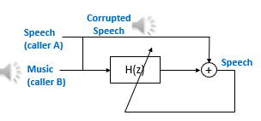

Fig. 1. The basic Map for interference cancelling

# Methodology

Adaptive filter method is one kind of model based supervised learning method. A set of input samples are given as:

$samples\left(i\right)=\left\{x_{i},d_{i}\right\}$ (2.1)

xi is the ith input sample and di is the ith desired sample. After we get the input signals, linear regression function need to be determined as:

$y\left(i\right)=\sum_{k=1}^{M}{w_{k}x\left(i-k\right)+b}$ (2.2)

M is the filter order, w is weight for predict y(i). y(i ) is the predicted value. After making this prediction, error need to be calculated for update learning weight. The error calculation function is shown in Eq(2.3):

$e\left(i\right)=d\left(i\right)-y(i)$ (2.3)

Error signal will be storage in an array after this step. Every time after going through the whole length of signals, I evaluation learning quality by mean square error(MSE) calculated from error signals.

In process of solving echo cancellation problem, LMS and Gamma algorithm has its own way to update step size or weights which will be declared at later content. MSE and weights tracker will be shown by changing the step-size and the filter order. In this paper, input signal will be scan through 20 times iteration for better training performance. ESM will be calculated in ever iteration and been plot as learning curve.

## Least Means Square(LMS) Algorithm for FIR

Least mean squares(LMS) algorithms are a class of adaptive filter used to mimic a desired filter by finding the filter coefficients that relate to producing the least mean square of the error signal [1].

$w_{k}\left(i+1\right)=w_{k}\left(i\right)-μ\frac{∂J\left(w\right)}{∂w_{k}}=w_{k}\left(i\right)+2μe\left(i\right)x\left(i\right) (2.4)$

µ is the learning rate and 2 µ is the step-size. We update weights in every iteration which is range in [0, N-M]. For weight track evaluation, I allocate every weights through iteration. Step- size is determined by 0< µ <1/max(λ). λ is the vector of eigenvalues of the auto-correlation matrix R.

$R=X.T*X$ (2.5)

## Gamma Algorithm for IIR Filter

For FIR filter can only remember M+1 samples, some applications which requires larger memory will not fit in this method. In this case, we would like to have an impulse response that rakes into account samples much further into the past. This is an infinite impulse filter(IIR). In IIR filters, Gamma filter is an IIR filter with restricted feedback architecture [2]. The Gamma filter is defined in the time domain as:

$y\left(n\right)=\sum_{k=0}^{M}{w_{k}x_{k}\left(n\right) (2.6)}$

where

$$x_{k}\left(n\right)=\left(1-μ\right)x_{k}\left(n-1\right)+μx_{k-1}\left(n-1\right), k=1,…,M$$

X(n) is the input signal and y(n) is the output signal. Both weight (w1, w2, w3…. wk) and $μ$ are adaptive.

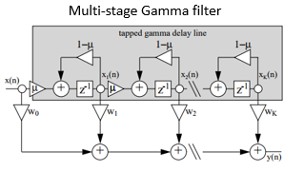

Fig. 2. Multi-Stage Gamma filter structure

The adaptive function of weight and $μ$ are shown in Eq (2.7)

$\left\{\begin{matrix}∇w_{k}=-η_{1}\frac{∂J(x;w,μ )}{∂w_{k}} \\ ∇μ=-η_{2}\frac{∂J(x;w,μ)}{∂μ}\end{matrix}\right.$ (2.7)

$η_{1}$ and $η_{2}$ are step size parameters.

In this project I am going to use a fixed $μ$ to simplify the implementation process.

## Echo Return Loss Enhancement(ERLE)

For evaluate error signal, I use ERLE to qualify the error signal.

$ERLE=10\log_{10}{(\frac{\frac{1}{N}\sum_{i=1}^{N}{d_{i}^{2}}}{\frac{1}{N}\sum_{i=1}^{N}{e_{i}^{2}}})}$ (2.8)

Variable filter order and step size can be determined by compare the value of ERLE for each method.

# Results and Evaluation

Separately discuss FIR and IIR filter performance with variable filter order and step size. Determine the optimize parameters for each filter.

## FIR Filter (LMS Algorithm)

### Evaluate ERLE based on filter order

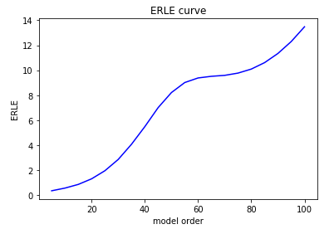

Fig. 3. ERLE curve

The line shown in Fig. 3 is the ERLE curve by scan the filter order from 5 to 100 in step of 5. In this case, learning step size s = 0.001 which is among range of (0, 1/max (λ)).

For response signal, the ERLE lager shows a better performance of filter. So, we can infer from the figure that when filter order is as large as 100, the ERLE value is the largest. Depend on this, the best filter order might be equal or larger than the 100.

As TA mentioned at info session, the best filter order may lager than 200, so I test ERLE by changing filter order from [5, 400] at step of 50 to find the best filter order. With unknown reason the python report memory error when I choose the 0.001 as my step size. So, in this test, smaller step size=0.0005 is be used.

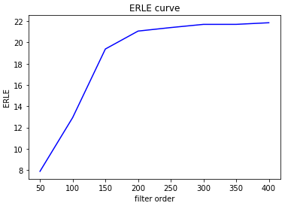

Fig. 4. ERLE curve. The filter order ranging from [50,400]

As we can infer from the figure, the ERLE is approaching around 22 when the filter order is larger than 300. So, I will use filter order M=300 in the later evaluation of weight over different step size for find the best step size with fixed filter order M=300.

### Weight tracks over different step size

In this part, I am going to shows the plot of weight tracks by set the step size= [0.0001, 0.0003, 0.0005, 0.0006, 0.0008]

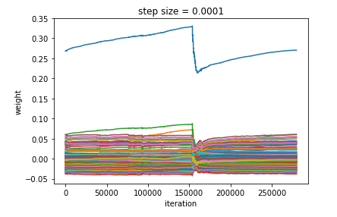

(a)

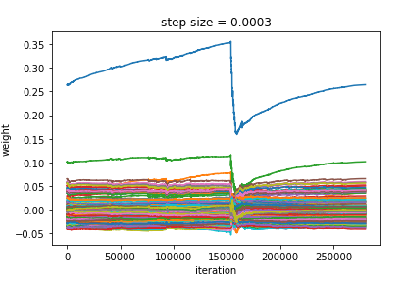

(b)

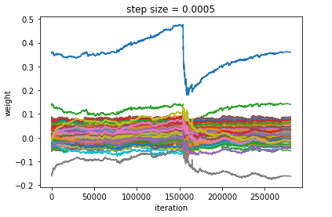

(c)

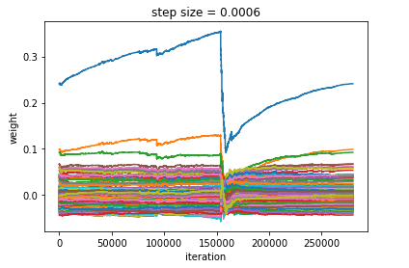

(d)

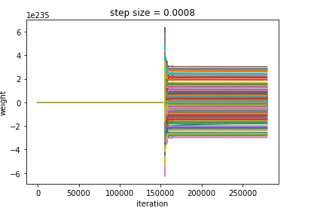

(e)

Fig. 5. Weight tracks

As the figure shown in (e), the weights are strange by comparing to other figures. After play the error signal output from this filter, I can only hear noise or silence. I think this might because the step size is too large for 20 iterations to training the weight which may cause the large number of audio signals lost. So, I will only analysis figure (a), (b), (c), (d) in Fig. 5 which can output normal sounds.

In these four figures, (d) shows the most concentrate weight changing along with times of iteration. But it is not that clear to determine the step size = 0.0006 is the best step size in this filter order.

So again, I calculate the value of ERLE for each step size.

As it is shown in TABLE I, when set the step size to 0.0006 the value of ERLE is the largest.

TABLE I

ERLE FOR EACH STEP SIZE

|  |  |  |  |  |
| --- | --- | --- | --- | --- |
| stepsize | 0.0001 | 0.0003 | 0.0005 | 0.0006 |
| ERLE | 18.33 | 20.61 | 21.69 | 22.07 |

### Learning curve

Since we already find out when the filter order M=300, the step size=0.0006 have the best performance. But I can also calculate the mean square error to verify this conclusion.

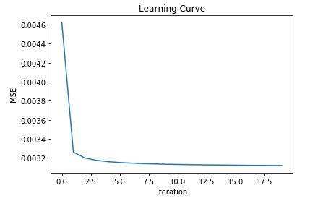

###### Stepsize = 0.0001

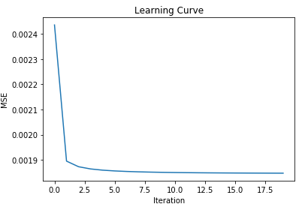

###### Stepsize = 0.0003

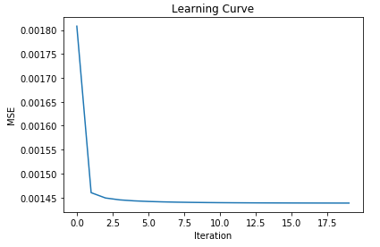

###### Stepsize = 0.0005

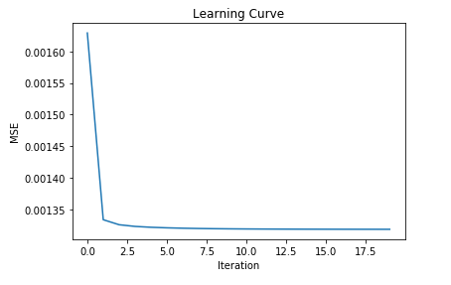

###### Stepsize = 0.0006

Fig. 6. Learning curve. MSE changed curve in 20 iterations.

Without surprise, the learning curve shows when the step size = 0.0006, learning rate is the fastest and MSE error maintains to a relatively lowest level.

## IIR filter (Gamma Algorithm)

### ERLE as function of the number of taps

In this part, I plot the ERLE of the Gamma filter after adaptation as a function of the number of taps, for a fixed feedback parameter in the tap delay line = 0.2. As the number of taps changing from 5 to 100 by step of 5. The trend of value of ERLE is shown in Fig. 7.

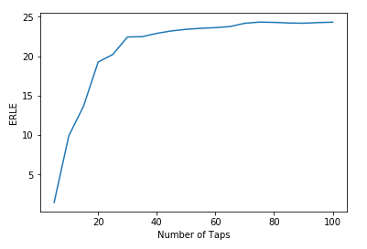

Fig. 7. ERLE curve

The Fig. 7 presents the ERLE changing over the number of taps from 5 to 100. The trend of ERLE start goes fast from 5 to 40, then become stable and grows slowly at around 25 from taps range of 40 to 100. We can also see the best performance for is when the number of taps equal to 100.

In order to get better performance, the process of weight update has been iterated for 20 times. At each time, as we can figure out from Fig. 8, the RELE grows up. The curve in figure looks decrease with slow rate after 6th iteration. But the ERLE don’t decrease too much till the end.

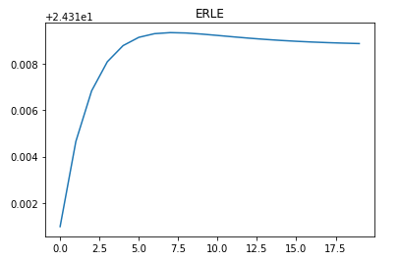

Fig. 8. ERLE when iterate training for 20 times(M=100)

### ERLE as function of the feedback parameter

In this part, ERLE will be discussed with feedback parameter. Because the feedback parameter $μ$ is smaller than 1 and larger than 0, So, I set $μ$ from 0.1 to 0.9 in step of 0.1. calculate those 9 ERLEs to each value of $μ$. Discuss the trend and find the best $μ$ for this filter.

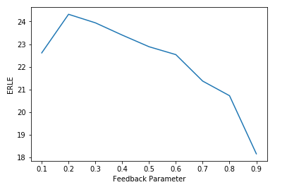

Fig. 9. ERLE as function of the feedback parameters

As the figure shows, when $μ=0.2$, system have the best performance for filtering. After this point the value of ERLE is going down which means the quality of output signals are bad.

So, I choose 0.2 as my IIR filter feedback parameter in the future comparison with FIR filter

### Weight track & learning curve

Following content shows the weight changed through training, the number of taps and feedback parameters are set to 100 and 0.2.

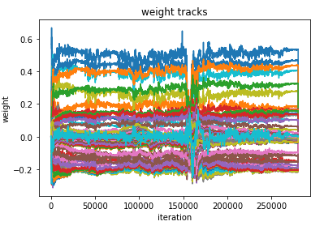

Fig. 10. Weight tracks

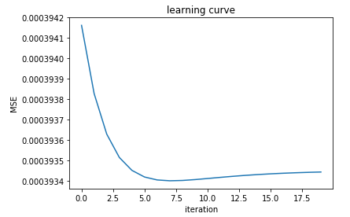

Fig. 11. Learning curve (M = 100, $μ=0.2$)

The weight is stable as training go by, and the mean square error goes down rapidly along with the time of iterations. We can see clearly from the Fig. 11.

# Discussion

In this part I am going to discuss the performance of FIR and IIR filter which are set to be the best performance of its own. To do so, learning curve, the value of ERLE and a short description after I listen the error signal are going to be discussed for comparison.

## Learning curve

Compare the Fig. 11 with Fig. 6. (d), we can find out which filter is faster and more accurate. When talk about the speed of training, Fig. 6 (d) shows us the MSE is going to the lowest value after 2nd iteration while the Fig. 11 shows the MSE decrease relatively slower to reach the lowest value of MSE. We can conclude that the FIR filter is faster than IIR filter.

But when we see the value of MSE, two filters are not comparable. The largest value of MSE by IIR filter is even much smaller than the smallest value of MSE by FIR filter. So, the IIR filter is much accurate than the FIR filter but slower.

## ERLE comparison

The ERLE value is shown in TABLE II.

TABLE II

|  |  |  |
| --- | --- | --- |
| Type of Filter | FIR | IIR |
| ERLE | 22.07 | 24.3188 |

It is obvious from TABLE II that the ERLE value of IIR is larger than FIR which can also to be seemed as the performance of IIR filter is better than the FIR filter.

## Error audio comparison

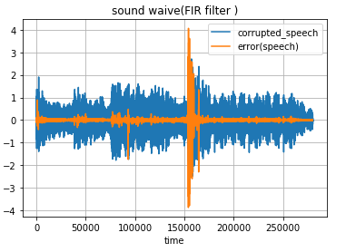

Fig. 12. Sound Waive (FIR filter)

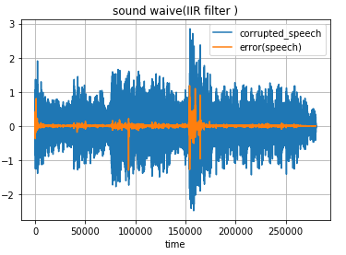

Fig. 13. Sound Waive (IIR filter)

Compare Fig. 12 with Fig. 13, the speech sound wave provided by IIR filter seems have better filter performance than FIR filter did. After listen to those two sounds, the answer is clear for me.

The filtered sound by FIR filter didn’t cancel all the music echo. I can still hear music as background sound. The only word I can hear from the audio is ‘darkness’. At some area around 150000, the noise is even louder than the corrupted speech.

On the other hand, the audio provided by IIR filter is much better than formal audio. Even I cannot hear the whole speech. I can still hear several words more than one. And the most of the music have been eliminated by filter.

# Conclusion

Compare those two filters, IIR filter can provide better performance than FIR filter but slower. Still even I can heat several words from audio provided by IIR filter, the performance is not satisfied to recover the whole speech. It might because the speech was corrupted too bad to recover. Or a better filter can be developed from IIR filter in the future.

# Reference

[1] https://en.wikipedia.org/wiki/Least_mean_squares_filter

[2] J. C. Principe, B. de Vries and P. G. de Oliveira, "The gamma-filter-a new class of adaptive IIR filters with restricted feedback," in IEEE Transactions on Signal Processing, vol. 41, no. 2, pp. 649-656, Feb 1993.doi: 10.1109/78.193206

[3] Infor Session Power point

1. .