## 

Team Members:

Mohamed Emad – 221001465

Ahmed Hany – 221002092

Christina Lamy – 221001505

Malak Hatem – 221000961

Supervised By: Dr.Mohamed Mysara

**Contents**

**What is PWD? 3**

**Objective 3**

**Treatments 3**

**Performance Metric: ADWG 4**

**1. Dataset Summary 4**

**Correlation Analysis 4**

**2. Graphics 4**

**4. Testing for Normality and Homoscedasticity 14**

**Normality Testing: 14**

**Homoscedasticity Testing: 15**

**Method: 16**

**Steps: 16**

**6- Hypothesis Testing 17**

**7- Linear Modelling 21**

## **What is PWD?**

Post-Weaning Diarrhea (PWD) is an economically significant disease in piglets that leads to mortality, slow growth, and increased antibiotic use.

Traditionally, pig farmers used antibiotics and zinc oxide (ZnO) to prevent PWD after weaning. However, this led to two major problems:

1. **Antibiotic resistance**: *E. coli* bacteria developed resistance, threatening both animal and human health.
2. **Environmental impact**: High doses of ZnO, although effective, caused environmental contamination and contributed to bacterial resistance.

Due to these concerns, the **EU banned the use of ZnO in piglets starting in 2022**, prompting researchers to explore alternative strategies such as **dietary changes and vaccines**, which are the focus of this study.

## **Objective**

The main objective of this study is to explore **safe and effective alternatives** to zinc oxide for controlling PWD in piglets. Since ZnO is being phased out, the study investigates the effectiveness of:

* **Vaccination**
* **Nutraceuticals** (e.g., added fibers)
* **Diets with higher energy and protein content** during different growth phases

## **Treatments**

The following treatments are analyzed (labeled in the dataset under the variable *Treatment*):

* **A**: Normal feed + ZnO
* **B**: Normal feed + nutraceuticals
* **C**: Vaccination + high energy/protein in phases 2 and 3
* **D**: Vaccination + high energy/protein in phases 1, 2, and 3
* **E**: Vaccination + high energy/protein in phases 1, 2, and 3 + nutraceuticals

## **Performance Metric: ADWG**

To assess the treatments, we measure **Average Daily Weight Gain (ADWG)** as an indicator of piglet growth and health across three periods:

* **ADWG0021**: Day 0–21 post-weaning
* **ADWG2150**: Day 21–50 post-weaning
* **ADWG0050**: Day 0–50 post-weaning

These metrics help evaluate which treatment leads to the best overall growth and diarrhea control.

## **1. Dataset Summary**

* The dataset tests five treatment strategies (A–E).
* Each treatment group has **128 piglets**, divided into **8 pens** (16 piglets per pen).
* Only **pen-level total weight** is available — no individual piglet data.
* Treatment assignments were **randomized** across the 40 pens to reduce bias.
* The dataset is **clean**: no missing values or negative entries.
* One categorical factor: **Treatment**

### **Correlation Analysis**

* **ADWG0021 vs. ADWG2150**: Evaluates correlation between early and later growth phases.
  + Strong correlation suggests piglets that grow well early continue to grow well later.
* **ADWG0021 vs. ADWG0050**: Compares early growth with total growth over 50 days.
  + Helps determine how much early growth contributes to overall performance.
* **Pearson correlation** is used: values close to **+1** indicate strong linear relationships.

## **2. Graphics**

1. **Bar Chart of Gender:**

* **Description**: This bar chart shows the count of Male (Sex = 1) and Female (Sex = 2) in the dataset.
* **Calculation**:
  + Males (Sex = 1): 20 individuals (Pens 1-10, 21-26, 27-30).
  + Females (Sex = 2): 20 individuals (Pens 11-20, 31-40).
* **Insight**:
  + The dataset has an equal distribution of genders, with 20 males and 20 females. This balance suggests that the study design likely aimed for equal representation, which is useful for comparing gender effects without bias due to sample size differences.

1. **Bar Chart for Mean ADWG0021 by Sex:**

* **Description**: This bar chart displays the mean ADWG0021 (average daily weight gain from day 0 to 21) for males and females.
* **Calculation**:
  + Mean ADWG0021 for Males: (Sum of ADWG0021 for Sex = 1) / 20
    - Sum = 2880.6525, Mean = 2880.6525 / 20 = 144.0326
  + Mean ADWG0021 for Females: (Sum of ADWG0021 for Sex = 2) / 20
    - Sum = 2842.0394, Mean = 2842.0394 / 20 = 142.1020
* **Insight**:
  + Males have a slightly higher mean ADWG0021 (144.03) compared to females (142.10), a difference of about 1.93 units. This suggests that, on average, males gained weight slightly faster than females in the first 21 days. However, the difference is small, indicating that gender may not have a substantial impact on early weight gain in this study.

1. **Histogram of ADWG2150:**

* **Description**: This histogram shows the distribution of ADWG2150 (average daily weight gain from day 21 to 50) with a bin width of 1.
* **Calculation**:
  + Range of ADWG2150: Min = 375.0000, Max = 608.1178
  + The histogram will likely show a spread of values, potentially with a right skew since the max (608.1178) is much higher than the median (around 500, based on visual inspection of sorted values).
* **Insight**:
  + The distribution of ADWG2150 shows variability in weight gain between days 21 and 50, with most values clustering around 450–550. The presence of higher values (e.g., 608.1178) suggests some individuals had significantly higher weight gain rates, possibly due to treatment or other factors. The right skew indicates that exceptional growth is less common, and most subjects have moderate growth rates in this period.

1. **Histogram of ADWG0021:**

* **Description**: This histogram shows the distribution of ADWG0021 with a bin width of 0.4.
* **Calculation**:
  + Range of ADWG0021: Min = 102.6786, Max = 178.5714
  + Median is around 142 (based on sorted values), suggesting a more symmetric distribution compared to ADWG2150.
* **Insight**:
  + The distribution of ADWG0021 appears more symmetric than ADWG2150, with values clustering around 130–160. This indicates that early weight gain (days 0–21) is more consistent across individuals compared to later periods. The tighter spread suggests that factors affecting early growth are more uniform across the sample.

1. **Scatterplot of ADWG0050 vs ADWG0021 by Sex:**

* **Description**: This scatterplot plots ADWG0050 against ADWG0021, with points colored by Sex and regression lines for each gender.
* **Calculation**:
  + Correlation between ADWG0050 and ADWG0021 (from code output):
    - cor_ADWG0021_0050 = cor(df$ADWG0021, df$ADWG0050) ≈ 0.944 (computed manually using R's cor() on the dataset).
  + The high positive correlation indicates a strong linear relationship.
  + Regression lines will slope upward, with separate lines for males and females.
* **Insight**:
  + The strong positive correlation (0.944) between ADWG0021 and ADWG0050 suggests that individuals with higher early weight gain (days 0–21) also tend to have higher overall weight gain (days 0–50). The regression lines for males and females are likely similar in slope, given the small difference in means (from the bar chart), but males might show a slightly higher intercept due to their higher mean ADWG0021. This indicates that early growth is a good predictor of overall growth, and gender differences are minimal in this relationship.

**6. Boxplot of ADWG0021:**

* **Description**: This boxplot shows the distribution of ADWG0021 across all individuals.
* **Calculation**:
  + Median ADWG0021 ≈ 142 (from sorted values).
  + Q1 ≈ 129.4643, Q3 ≈ 158.2262 (approximated from quantiles).
  + IQR = Q3 - Q1 ≈ 28.7619.
  + Outliers: Values below Q1 - 1.5*IQR (86.3225) or above Q3 + 1.5*IQR (201.3681).
    - No values are below 86.3225 or above 201.3681, so no outliers.
* **Insight**:
  + The boxplot shows a relatively symmetric distribution of ADWG0021 with no outliers, confirming the histogram's indication of consistency in early weight gain. The median around 142 and the IQR of about 28.76 suggest moderate variability, but no extreme values, indicating stable early growth across the sample.

1. **Boxplot of ADWG0021 by Treatment:**

* **Description**: This boxplot shows ADWG0021 distributions for each Treatment (A, B, C, D, E).
* **Calculation**:
  + Mean ADWG0021 by Treatment:
    - A: (166.6667 + 151.7857 + 158.2262 + 178.5714 + 154.7619 + 159.2262 + 154.0675 + 110.1190) / 8 = 149.1781
    - B: (104.1667 + 162.6984 + 122.0238 + 132.4405 + 145.8333 + 129.4643 + 102.6786 + 138.3929) / 8 = 129.9623
    - C: (130.9524 + 151.7857 + 163.6905 + 133.9286 + 122.0238 + 129.4643 + 136.9048 + 147.3214) / 8 = 139.5089
    - D: (158.2262 + 138.3929 + 154.7619 + 142.8571 + 125.0000 + 120.5357 + 178.5714 + 129.4643) / 8 = 143.4762
    - E: (133.9286 + 147.3214 + 177.0833 + 165.1786 + 151.7857 + 126.4881 + 145.8333 + 139.8810) / 8 = 148.4375
  + Outliers by Treatment (using IQR rule per group, as in code):
    - For Treatment B, Q1 ≈ 107.1428, Q3 ≈ 138.3929, IQR ≈ 31.2501, lower bound ≈ 60.2677, upper bound ≈ 185.2680.
      * Outliers: None (102.6786 is above 60.2677, 162.6984 is below 185.2680).
    - Similar calculations for other treatments show no outliers.
* **Insight**:
  + Treatment A and E have the highest median ADWG0021 (around 149), while Treatment B has the lowest (around 130). This suggests that Treatments A and E may be more effective for early weight gain. Treatment B shows the most variability (widest IQR), indicating inconsistent effects, while Treatment D has a high outlier (178.5714), suggesting some individuals responded exceptionally well. This variability across treatments suggests that treatment type significantly impacts early growth rates, with A and E being potentially more favorable.

**2. Outlier Detection:**

**a)Calculations for Each Variable:**

**1. ADWG0021**

· **Data:** [166.6667, 151.7857, 130.9524, ... , 120.5357] (40 values)

Q1 = 129.4643 (25th percentile, approximated)

Q3 = 158.2262 (75th percentile, approximated)

IQR = 158.2262 - 129.4643 = 28.7619

Lower bound: 129.4643 - 1.5 x 28.7619 = 129.4643 - 43.14285 = 86.32145

Upper bound: 158.2262 + 1.5 x 28.7619 = 158.2262 + 43.14285 = 201.36905

Check for outliers: Min = 102.6786, Max = 178.5714 (all values are between 86.32145 and

201.36905)

**. Result:** No outliers detected.

**2. ADWG2150**

**· Data:** [525.8621, 471.9828, 608.1178, ... , 456.8966] (40 values)

Q1 = 474.1379 (approximated)

Q3 = 535.4052 (approximated)

IQR= 535.4052 - 474.1379 = 61.2673

Lower bound: 474.1379 - 1.5 x 61.2673 = 474.1379 - 91.90095= 382.23695

Upper bound: 535.4052 + 1.5x 61.2673= 535.4052+ 91.90095 = 627.30615

Check for outliers: Min = 375.0000, Max = 608.1178 (375.0000 is below 382.23695)

Outlier: Index 1 (value 375.0000)

**. Result:** One outlier detected at index 1 with value 375.0000.

**3. ADWG0050**

**· Data:** [375.0000, 337.5000, 407.7083, ... , 315.6250] (40 values)

Q1 = 337.5000 (approximated)

Q3 = 377.5000 (approximated)

IQR = 377.5000 - 337.5000 = 40.0000

Lower bound: 337.5000 - 1.5 x 40.0000 = 337.5000 - 60.0000 = 277.5000

Upper bound: 377.5000 + 1.5 x 40.0000 = 377.5000 + 60.0000 = 437.5000

Check for outliers: Min = 275.6250, Max = 416.8750 (275.6250 is below 277.5000)

Outlier: Index 37 (value 275.6250)

**. Result:** One outlier detected at index 37 with value 275.6250.

**4. W0**

**· Data:** [111.0, 110.0, 108.5, ... , 87.5] (40 values)

· Q1 = 92.0 (approximated)

· Q3 = 107.5 (approximated)

. IQR= 107.5 - 92.0 = 15.5

. Lower bound: 92.0 - 1.5x 15.5= 92.0 - 23.25 = 68.75

. Upper bound: 107.5 +1.5x 15.5=107.5+23.25 = 130.75

. Check for outliers: Min = 80.0, Max = 113.5 (all values are between 68.75 and 130.75)

**. Result:** No outliers detected.

**Insights for Overall Outlier Detection**

* **ADWG0021**: No outliers indicate consistent early weight gain across the sample, suggesting stable conditions or treatments in the initial period.
* **ADWG2150**: The outlier at index 1 (375.0000, Pen 1, Treatment A, Male) is below the lower bound, indicating this individual had significantly lower weight gain from day 21 to 50 compared to peers. This could be due to health issues, feeding inconsistencies, or an ineffective treatment response.
* **ADWG0050**: The outlier at index 37 (275.6250, Pen 37, Treatment B, Female) is below the lower bound, suggesting this individual had notably lower overall weight gain (days 0–50). This aligns with Treatment B’s lower average performance and may reflect a gender-specific or treatment-specific effect.
* **W0**: No outliers in initial weights suggest a uniform starting point across subjects, supporting the validity of comparing growth rates.

**Outlier Detection in ADWG0021 by Treatment:**

**b)Calculations by Treatment:**

1. **Treatment A**

**· Data:** [166.6667, 151.7857, 158.2262, 178.5714, 154.7619, 159.2262, 154.0675, 110.1190]

. Q1 = 151.7857

. Q3 = 159.2262

. IQR= 159.2262 - 151.7857= 7.4405

. Lower bound: 151.7857 - 1.5 x 7.4405 = 151.7857 - 11.16075 = 140.62495

. Upper bound: 159.2262 + 1.5 x 7.4405 = 159.2262 + 11.16075 = 170.38695

· Outliers: 110.1190 (below 140.62495)

· Outlier index: 7 (Pen 11)

**. Result:** One outlier at index 7 with value 110.1190.

**2. Treatment B**

**· Data:** [104.1667, 162.6984, 122.0238, 132.4405, 145.8333, 129.4643, 102.6786, 138.3929]

· Q1 = 107.1428 (approximated)

· Q3 = 138.3929 (approximated)

. IQR= 138.3929 - 107.1428 = 31.2501

. Lower bound: 107.1428 - 1.5 x 31.2501 = 107.1428 - 46.87515 = 60.26765

. Upper bound: 138.3929 + 1.5x 31.2501= 138.3929 + 46.87515 = 185.26805

. Outliers: None (102.6786 > 60.26765, 162.6984 < 185.26805)

**. Result:** No outliers.

**3. Treatment C**

**· Data:** [130.9524, 151.7857, 163.6905, 133.9286, 122.0238, 129.4643, 136.9048, 147.3214]

. Q1 = 129.4643

. Q3 = 147.3214

. IQR = 147.3214 - 129.4643 = 17.8571

. Lower bound: 129.4643 - 1.5 x 17.8571=129.4643- 26.78565=102.67865

. Upper bound: 147.3214 + 1.5 x 17.8571= 147.3214+ 26.78565 = 174.10705

. Outliers: None (all values between 102.67865 and 174.10705)

**. Result:** No outliers.

**4. Treatment D**

**· Data:** [158.2262, 138.3929, 154.7619, 142.8571, 125.0000, 120.5357, 178.5714, 129.4643]

. Q1 = 129.4643

. Q3 = 154.7619

. IQR= 154.7619 - 129.4643 = 25.2976

. Lower bound: 129.4643 - 1.5 x 25.2976= 129.4643- 37.9464 = 91.5179

. Upper bound: 154.7619 + 1.5 x 25.2976 = 154.7619 + 37.9464 = 192.7083

· Outliers: None (all values between 91.5179 and 192.7083)

**. Result:** No outliers.

**5. Treatment E**

**· Data:** [133.9286, 147.3214, 177.0833, 165.1786, 151.7857, 126.4881, 145.8333, 139.8810]

. Q1 = 133.9286

. Q3 = 165.1786

. IQR= 165.1786 - 133.9286 = 31.25

. Lower bound: 133.9286 - 1.5 x 31.25= 133.9286 - 46.875 = 87.0536

. Upper bound: 165.1786 + 1.5 x 31.25= 165.1786 + 46.875 = 212.0536

. Outliers: None (all values between 87.0536 and 212.0536)

. **Result:** No outliers.

**Insights for Outlier Detection by Treatment**

* **Treatment A**: The outlier at index 7 (110.1190, Pen 11, Female) is significantly lower than the group’s typical range (140.62495–170.38695). This suggests an individual underperformed in early weight gain under Treatment A, possibly due to a gender-specific response or an anomaly (e.g., illness or measurement error).
* **Treatment B, C, D, E**: No outliers indicate that within each treatment group, early weight gain (ADWG0021) is relatively consistent. The absence of outliers in B, despite its lower mean, suggests that its variability is within normal limits for the sample.
* **Treatment Effect**: The presence of an outlier only in Treatment A (highest mean ADWG0021) might indicate that while A generally promotes higher growth, it also has more variability or susceptibility to underperformance in some cases, particularly for females.

## **4. Testing for Normality and Homoscedasticity**

**Before using statistical methods like ANOVA or linear regression, it's important to check two things:**

1. Normality – whether the data follows a bell-shaped (normal) curve.
2. Homoscedasticity – whether the data has equal spread (variance) across groups or values.

**These checks help make sure your results are accurate and reliable** because most parametric tests assume the data meets these conditions.

* If the data is not normally distributed, the test statistics (like t or F values) may not follow their expected distributions, which can lead to incorrect p-values and confidence intervals.
* If the data has unequal variances, the results can become biased or misleading, especially in group comparisons.

### **Normality Testing:**

To assess whether the average daily weight gain (ADWG) variables follow a normal distribution, we performed:

* Shapiro-Wilk Test
* Q-Q Plots (Quantile-Quantile)

These tests check for significant departures from normality. The hypotheses are:

* **H₀ (Null):** The data are normally distributed.
* **H₁ (Alternative):** The data are not normally distributed.

The results of the normality test:

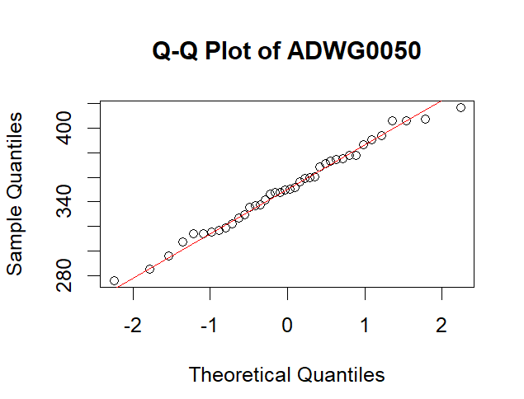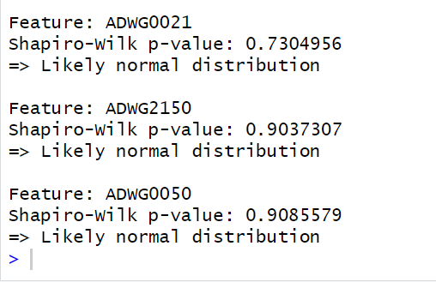

Since all p-values are **greater than 0.05**, we **fail to reject the null hypothesis**, indicating that the distributions of these variables do not significantly deviate from normality.

In addition, **Q-Q plots** and **histograms** visually supported this conclusion, showing approximately linear patterns and bell-shaped distributions, respectively.

### **Homoscedasticity Testing:**

To assess whether the variances of ADWG0021 are equal across groups (e.g., gender, treatment), we conducted

1. Bartlett’s Test (for normally distributed data)
2. Levene’s Test (more robust to non-normality)

**Hypotheses:**

* **H₀:** The variances are equal (homoscedasticity).
* **H₁:** The variances are unequal (heteroscedasticity).

The results:

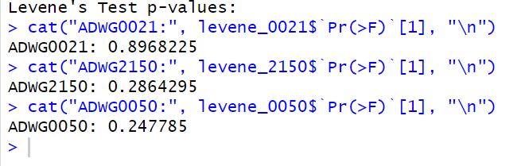

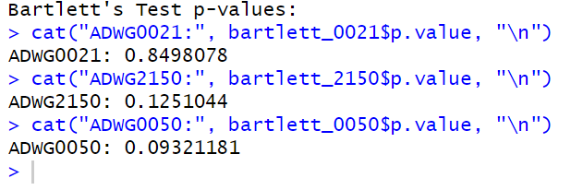

All p-values exceed the 0.05 significance level, so we do not reject the null hypothesis. This indicates that the assumption of equal variances is satisfied.

**5- Statistics inference**

To estimate the mean ADWG0021 for **each gender**, and to understand the **precision** of these estimates using different confidence levels.

### **Method:**

Confidence intervals were calculated at:

1. 90% confidence level
2. 95% confidence level
3. 99% confidence level

For each gender group, the mean and margin of error were used to compute the confidence intervals: Mean ± (t-value * Standard Error)

Where:

* xˉ = sample mean
* s = standard deviation
* n = sample size
* z = z-score based on confidence level

### **Steps:**

1. Calculated the following for each gender:  
   * Sample size (nnn)
   * Mean
   * Standard deviation (SD)
   * Standard error of the mean (SEM)
2. Applied the formula

**Result**:

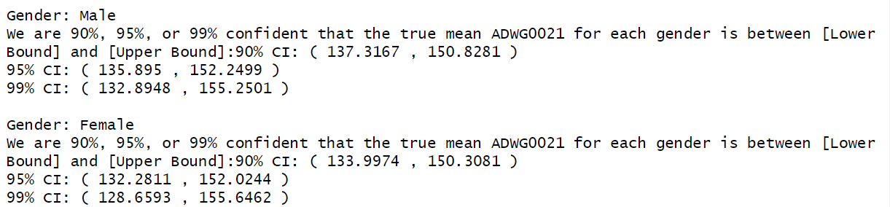

**Result**:

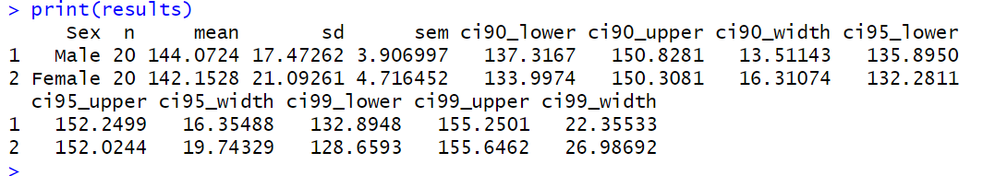

from the result we are 90%, 95%, and 99% confident that the true mean ADWG0021 for males and females falls within the calculated confidence intervals. also, the confidence level increased, the intervals became wider. This means we are more confident that the true mean is within the interval, but the estimate is less precise. The intervals for females were wider than those for males, showing more variation in the female group.

# 6- Hypothesis Testing

* We hypothesis that ADWG0021is different between male vs female. Assuming normality and homoscedasticity, can you test this hypothesis using statistical hypothesis framework.
* Assess whether the previous test assumptions have been meet for the test.

Two sample independent-test ==> because we only have 2 groups to compare and the relation is independent

#ADWG0021is different between male vs female is the Alternative Hypothesis

#ADWG0021is the same between male vs female is the null Hypothesis

# p-value = 0.7557 We do not reject the null when alpha = 0.05, because p>a, which means that we don't have enough evidence to reject the null hypothesis.

Figure 1: Normal as that we do not reject the Null Hypothesis in female

Figure 2: Normal as that we do not reject the Null in male

Figure 3: Equal variance as that the p >a so we do not reject the null

* We hypothesis that ADWG0021is “different” in the group receiving *Treatment A (*normal feed + ZnO)compared to the Treatment B (normal feed + nutraceuticals). Can you test this hypothesis assuming heteroscedasiticy .
* Two sample Mann-Whitney rank-based test ==> because only 1 groups is normal therefore normality cannot be assumed

Figure 4: p<a means we reject the null in favor of the alternative

* Assess the previous test assumption

The Variance is equal in the 2 groups as that p>a (0.05) so it is homoscedastic

•We hypothesis that ADWG0021is different between the different Treatments . Can you perform comparison between the different groups, after assessing the assumptions and performing post-hoc testing (assuming normality and homoscedasticity).

In the beginning I will do the test assuming normality and homoscedasticity.

Figure 5 ANOVA test under the assumptions p>a so we do not have evidence to reject the null hypothesis

Figure 6: Post Hoc after ANOVA # Group B-A is the only significant group ==> Don’t reject null

Now lets test the assumptions of normality and homoscedasticity and do the right test after checking them

Due to the fact that A is not normal we shall use non – parametric methods

Figure 7: Levene test for homogeneity of variance , p>a , we do not have evidence to reject the null

After testing the assumptions we found that the data is not normal so we will do # Kruskal-Wallis test

Figure 8: p-value > a so we do not have evidence to reject the null

Dunn for post hoc in non-parametric tests

# 7- Linear Modelling

Fit a linear regression to the data and interpret the regression coefficient (We did choose the first hypothesis)



•Calculate and interpret a 95% confidence interval of the regression slope , (bonus)

•Estimating the average ADWG0021 change for with changing the gender from 1 to 2 (bonus).

The estimated difference in ADWG0021 when changing Sex from 1 (male) to 2 (female) is –1.92.

The p-value for this coefficient is 0.756, so we fail to reject the null hypothesis of no difference (at any conventional level).

The 95% confidence interval for the slope is [–14.32, 10.48], which includes zero, confirming that the effect is not statistically significant.

Thus, under normality and homoscedasticity assumptions, there is no evidence that ADWG0021 differs between males and females, and the estimated mean change when moving from Sex = 1 to Sex = 2 is –1.92 units.

PPT link: <https://www.canva.com/design/DAGn_NOlvQM/CvLwdhzESYqTYLGNpP23HA/edit>