The BEST Run SAP Hackathon Problem

Table of ContentS

problem overview 3

Warehouse characteristics 3

Storage unit 3

Internal transfers through storage units 4

Articles 4

Constraints 5

Deliveries 5

Warehouse Constraints 5

Key Performance Indicators (KPIs) 6

Data 6

Support infrastructure 6

Requirements 8

Interface with the data API (10 points) 8

Visualization of warehouse content (20 points + 10 bonus points) 8

Simulation of warehouse operations (30 points) 8

Calculate required KPIs (30 points) 8

Analytics and visualization (40 points + 35 bonus points) 9

Forecast of deliveries (30 bonus points) 9

Labeling (20 points) 9

Product availability optimization (40 points) 9

Deploy on SAP Cloud Platform (20 bonus points) 9

Log performed action to remote API (10 points) 10

Content of presentation/pitch 10

Glossary 10

# problem overview

Owning a gigantic retail business requires a lot of planning, dedication and hard work, but most of all, an organised warehouse to send all their deliveries on time.

One of the SAP’s biggest customers hired your team to help them create an application in order to help them manage their smart warehouse and optimize its storage and orders’ delivery time.

# Warehouse characteristics

The warehouse consists of four storage areas which are labeled with letters from A to D, each one having the following characteristics:

* “A”: in this area all the individual deliveries are made (one article per order)
* “B”: this area it is used to supply the A area with pallets (full units) of articles
* “C”: in this area pallets of articles are delivered to customers
* “D”: this area stores product excess (measured in pallets); it is considered to have unlimited capacity and space

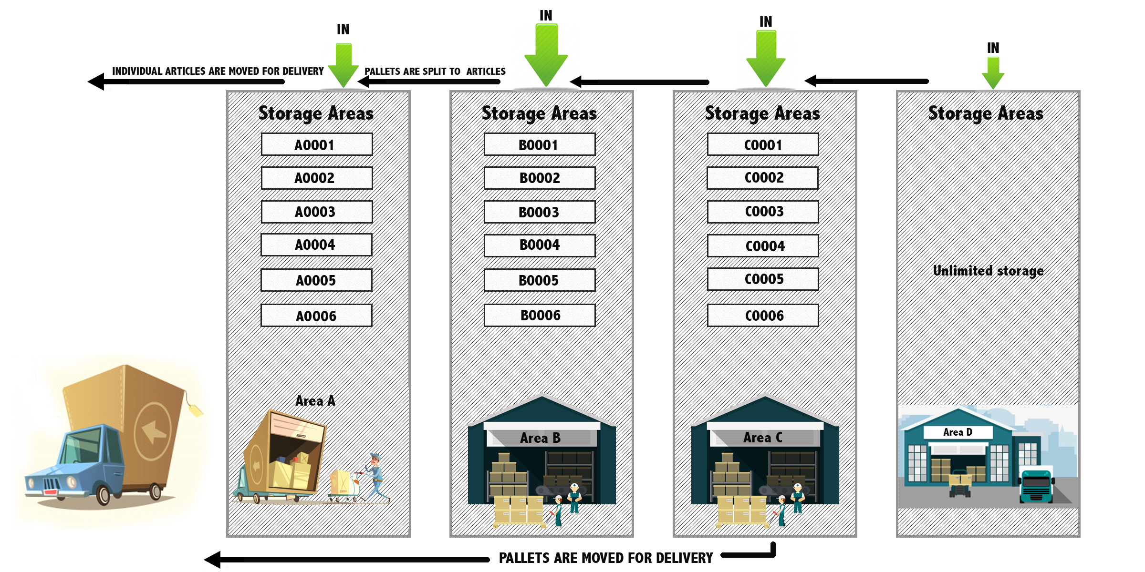

## Storage unit

Each storage area is organized into storage units, each one being defined by the following attributes:

* Unique ID
* Storage area label (A, B, C, D)
* Capacity, measured in items (possible values: individual articles – single units, pallets – full units)
* Maximum Weight (kg) and maximum volume (m3) for each type of product type: single unit or full unit

The “D” area has only one storage unit.

## Internal transfers through storage units

All the storage units are connected through a transport network (replenishment chains), and the transfer of the pallets can only be made unidirectional as described below:

* From “D” type storage unit we can transfer objects in all the other areas
* From the “C” type storage units, articles can be transferred only in the “B” and “A” areas
* From “B” type storage units we can only send articles to “A” area
* Upon arriving in the “A” type storage unit, the full units (pallets) are separated into single units (individual articles).

The transfer times between the storage units can be defined by the following relations:

TDA = TBA + TCB + TDC

TDB = TCB + TDC

TBA <= TCB < 10 * TDC

## Articles

One article can be described by the following characteristics:

* Unique Id
* Total number of items in a pallet (number of single units in a full unit) – totalQ
* Article (single unit) weight (kg)
* Article (single unit) volume (m3)
* Pallet (full unit) weight
* Pallet (full unit) volume

Each article is allocated to one supply chain composed of exactly 4 steps (storage unit), each corresponding to one of the four areas. We can allocate one article to one storage unit with the following parameters:

* **allocated storage unit**
* **minQ** = the minimum required quantity of the article which must exist in the storage unit (as number of single units)
* **maxQ** = the maximum allowed quantity of one article in the storage unit (as number of single units);
* **maxCap** = the maximum allowed capacity for an article in the storage unit (as number of single units). The difference between maxCap and maxQ represents a space buffer for incoming deliveries;

The parameters respect the following conditions:

* minQ, maxQ and maxCap are strictly positive or infinite
* minQ < maxQ <= maxCap
* the condition (if totalQ = 1, then minQ = maxQ = 1) is valid
* minQ, maxQ and maxCap are always infinite for the “D” area
* maxQ and maxCap are multiples of totalQ
* for “A” area the following relations are valid:
  + maxQ = maxCap
  + minQ = 1 + n*totalQ, for n>=0
* for “B” and “C” areas we have the following relation:
  + minQ = n*totalQ, for n>=1

## Constraints

Constraints in the allocation of an article:

* the maximum allowed weight for a storage unit is always greater or equal to the:
  + article’s single unit weight in the “A” area
  + article’s full unit weight for the other areas
* the maximum allowed volume for the storage unit is always greater or equal to the:
  + article’s single unit volume in the “A” area
  + article’s full unit volume for the other areas

### Deliveries

The only allowed actions in the warehouse are the deliveries, which can be defined by the following attributes:

* Type:
  + IN: inbound delivery (stock entry)
  + OUT: outbound delivery (stock removal)
* Article Code
* Quantity (single units)
* Timestamp of the delivery request

For outgoing deliveries, the following rules apply:

* If N is the requested quantity, then the delivery is split into two separate deliveries:
  + N MOD totalQ – for item deliveries
  + (N DIV totalQ) * totalQ – for pallet deliveries
* Single unit deliveries can be made only to the “A” area
* Full unit (pallet) deliveries can be made, from either C, B, A or D zones, in that order, if the quantity is available.
* Partial deliveries are not accepted, the whole quantity being delivered into only one storage unit. If the required delivery quantity is not available into one of the storage areas, a replenishment request is issued. A replenishment request it is considered an internal delivery which requires additional time for transfer. The initial delivery will be put on hold until the required quantity is available in the destination storage area.

For incoming deliveries, the following rules are valid:

* The quantity is expressed in full units.
* We call a direct put-away an incoming delivery in which all the required quantity can be stored in one of the “A”, “B” or “C” areas. The constraint is given by the available capacity (max capacity – current stock). Otherwise, the delivery is put into the D storage type.

## Warehouse Constraints

Inside the warehouse we meet the following constraints:

* For each product, inside each storage area, the current stock of the article must be between minQ and maxCap.
* The total stock sum in a storage area cannot be greater than 95% of the total capacity of the storage unit.

## Key Performance Indicators (KPIs)

* Product availability which is measured at product and warehouse level, considering the OUT deliveries
  + Product availability = immediately delivered quantity (without needing a replenishment and without putting the stock below minQ) / requested quantity
* Direct put-away, measured at product and warehouse level, considering IN deliveries
  + Directly stored quantity in the “A”, “B”, ‘C” areas/ Total quantity delivered
* Filling degree, calculated by storage unit and warehouse
  + Sum of stocks /Total storage capacity
* Goods movement effort
  + Total sum of transfer times for deliveries processing

## Data

The data is stored in the client’s API and contains the following information:

* ~50 articles and their attributes
* Transport network involving 19 storage units
* Initial product storage allocation and stocks and their attributes
* Deliveries for one year (2018) : ~870 000 records

# Support infrastructure

The structure and content of the warehouse can be accessed through the following [API](https://thebestrunsap2018z3d3pet6df.hana.ondemand.com/ro/sap/hackathon/cleandata/service.xsodata):



The warehouse is organized into areas, as described above. The areas A-C each have many storage areas, which are subdivisions of the areas. The articles you can find in the warehouse are of two types: either unit articles, or pallets. A pallet is a group of unit articles, packaged together.

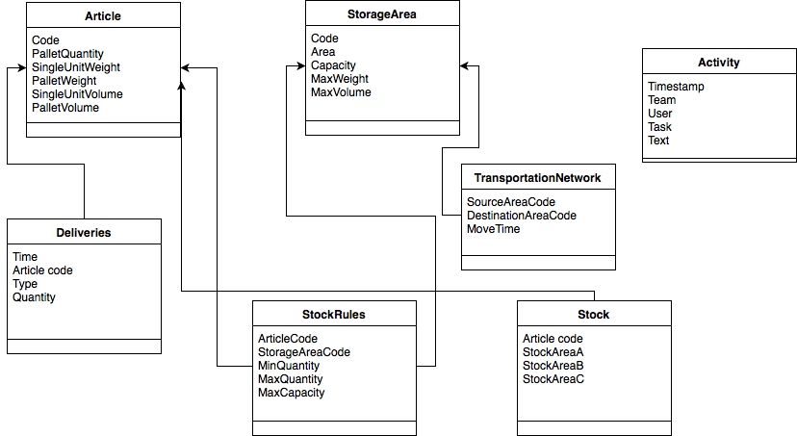

# Requirements

## Interface with the data API (10 points)

Implement the client needed to connect and retrieve data from the provided API.(MANDATORY).

Evaluate the optimal option to work with the data.

## Visualization of warehouse content (20 points + 10 bonus points)

Implement a warehouse interface for the end user with the following functionalities:

* Visualize the warehouse structure, and the articles you can find in each storage units (10 points)
* Search articles through the warehouse based on different criteria: e.g., article id, storage unit (10 points)
* Implement additional visual representations of your choosing (10 bonus points)

## Simulation of warehouse operations (30 points)

Develop a warehouse simulator which will include the deliveries and update the stocks according to the defined rules and constraints described in the document.

Input data:

* Simulation time interval (start date, end date)
* Initial state (initial stocks and parameters allocations)
* Delivery list

Output data:

* Daily average stocks on each combination of article and allocated storage unit
* Daily successful picks on each article, expressed as number of single units
* Daily picks (number of single units requested to be delivered) on each article
* Daily successful put-away quantities (number of single units stored directly in zones A, B or C) on each article
* Daily incoming quantities (number of single units delivered through incoming deliveries) on each article
* Daily goods movement effort on each article

## Calculate required KPIs (30 points)

* Product availability on each article (3 points)
* Aggregated product availability on warehouse (3 points)
* Direct put-away indicator on each article (3 points)
* Aggregated direct put-away indicator on the warehouse (3 points)
* Filling degree on each storage unit (3 points)
* Aggregated filling degree on the warehouse (3 points)
* Goods movement effort on each article (3 points)
* Aggregated Goods movement effort on the warehouse (3 points)
* Filling degree on each storage unit (3 points)
* Aggregated filling degree on the warehouse (3 points)

All KPIs are calculated first for each day, as averages, then averaged for the whole planning interval, given as parameter. The source data is generated by the simulator (successful delivered quantities direct putaway quantities, internal replenishment time effort, delivery serving time effort).

These KPIs must be implemented for a given allocation plan (initial or optimized).

## Analytics and visualization (40 points + 35 bonus points)

* Display the KPIs defined above as numbers / tables as required (15 points)
* Display the KPIs defined above as time series (20 points)
* Visualize the top 5 most delivered articles in the warehouse (5 points)
* Implement drill-down capabilities on displayed values (15 bonus points)

Use reporting parameters as (20 bonus points):

* Granularity, for time aggregations (day, month, year)
* Time interval
* Article code
* Storage unit
* Storage area

## Forecast of deliveries (30 bonus points)

Taking into account a 6-month window of deliveries, generate a forecasted list of delivery for the next two months.

## Labeling (20 points)

Generate a barcode (QR code) for each article (10 points)

Option 1 The barcode keeps the following information about an article: article id, weight, pallet size. This data is displayed as text when the QR code is read.

Option 2 The barcode keeps a link which points to an article details page on your application (e.g., the host is your machine IP; the mobile and your application are in the same network, or hosted some place else)

Display QR codes for your articles in the application (5 points)

Every QR code on the page should be readable by a mobile phone using a QR reading application (5 points)

## Product availability optimization (40 points)

Implement an optimization algorithm for the minQ parameter, for each product’s allocation in each of the A, B and C storage units, in order to maximize the product availability.

The objectives of this algorithm are the following:

* + The fast moving articles must be prioritized to the slow moving articles.
  + All warehouse constraints (capacities of storage units, volume and weights) are fulfiled at any time.
  + Filling degree of each storage unit is capped to 95%, while considering average stock levels
  + Constraints governing minQ, maxQ and maxCap are fulfilled at each moment
  + Proposed plan is returned as a map between articles and their replenishment chains with optimized parameters.

## Deploy on SAP Cloud Platform (20 bonus points)

Use your SCP Cloud Foundry trial account to deploy your application in SCP.

You can create a new trial account in SCP here <https://account.hanatrial.ondemand.com/cockpit>

You can choose from two different landscape types: neo & cloud foundry. You will find documentation on how to do this here: <https://help.sap.com/viewer/65de2977205c403bbc107264b8eccf4b/Cloud/en-US/c2fec62b49fa43b8bd945c85ecc2e5bd.html> - depending on your language of choice, you can find specific information on how this can be used (e.g., for deploying Java applications <https://help.sap.com/viewer/65de2977205c403bbc107264b8eccf4b/Cloud/en-US/765096674bcb4752b75afd5bad4eac9a.html>)

## Log performed action to remote API (10 points)

Using the REST API, add in the activity table the main tasks that were triggered.

# Content of presentation/pitch

At the end of the hackaton, you will have to present and demo your implementation. You will use the provided PowerPoint template and it will contain the following points:

* Implemented tasks
* Technologies used for implementation
* Solution architecture
* DEMO

Time limit is 10 minutes, including questions.

# Glossary

|  |  |
| --- | --- |
| Article | Physical product, such as laptops, processors, digital cameras, screws, cables, connectors etc. |
| Storage area | Grouping of storage units on terms of accessibility and item retrieving effort (A, B, C and D). Think of them as warehouse buildings. |
| Storage unit | Physical storage of articles. Think of them as rows of shelves in a storage area. |
| Single unit | One physical article, packaged individually. |
| Full unit (pallet) | One or more identical physical articles, packaged together. |
| Article allocation | The storage unit where an article is allocated. Also the storage constraints (the minimum stock available and the maximum stock to be stored) |
| Stock | The number of articles stored in a storage unit, for an article, at a given time |
| Outgoing delivery | A delivery request for an article, in a quantity, a stock removal from the warehouse |
| Ingoing delivery | A delivery of a quantity of an article to the warehouse, a stock entry to the warehouse |
| Internal delivery (internal replenishment) | An internal transfer of stock between two storage units, with the objective of maintaining the required minimum stock. |
| Filling degree | A percent expressing how full a storage unit or the warehouse is |
| Product availability | A percent expressing how often an outgoing article delivery request is processed right away, without need for replenishment |
| Direct putaway | A percent expressing how often an incoming article delivery request is stored in a non-D storage unit. |
| Goods movement effort | Expression of the time effort needed to process deliveries in a given time interval, for an article or for the warehouse. |

**www.sap.com/contactsap**

© 2018 SAP SE or an SAP affiliate company. All rights reserved.

No part of this publication may be reproduced or transmitted in any form or for any purpose without the express permission of SAP SE or an SAP affiliate company.

The information contained herein may be changed without prior notice. Some software products marketed by SAP SE and its distributors contain proprietary software components of other software vendors. National product specifications may vary.

These materials are provided by SAP SE or an SAP affiliate company for informational purposes only, without representation or warranty of any kind, and SAP or its affiliated companies shall not be liable for errors or omissions with respect to the materials. The only warranties for SAP or SAP affiliate company products and services are those that are set forth in the express warranty statements accompanying such products and services, if any. Nothing herein should be construed as constituting an additional warranty.

In particular, SAP SE or its affiliated companies have no obligation to pursue any course of business outlined in this document or any related presentation, or to develop or release any functionality mentioned therein. This document, or any related presentation, and SAP SE’s or its affiliated companies’ strategy and possible future developments, products, and/or platform directions and functionality are all subject to change and may be changed by SAP SE or its affiliated companies at any time for any reason without notice. The information in this document is not a commitment, promise, or legal obligation to deliver any material, code, or functionality. All forward-looking statements are subject to various risks and uncertainties that could cause actual results to differ materially from expectations. Readers are cautioned not to place undue reliance on these forward-looking statements, and they should not be relied upon in making purchasing decisions.

SAP and other SAP products and services mentioned herein as well as their respective logos are trademarks or registered trademarks of SAP SE (or an SAP affiliate company) in Germany and other countries. All other product and service names mentioned are the trademarks of their respective companies. See [www.sap.com/copyright](https://www.sap.com/copyright) for additional trademark information and notices.