ITPR7.508

Team Bee

Eastern Institute of Technology

Business Application Programming

Contents

Introduction: 1

Development Methodology: 1

Teamwork and its effects on the product: 1

Significant features and consequences for the client: 1

# Introduction:

This project is a property booking application requested by Haukainga Home Winds and built using WordPress and the PHP language. The user set requirements for the final application, which we have done our best to meet. Most of the functionality for this product has been achieved through custom plugins written in PHP and implemented into WordPress by short code. We have functions that display all properties that have been listed through the admin dashboard, and another page that displays the properties that have been booked under your name. This was done through an account system, which makes every session unique to the person that is logged in.

# Development Methodology:

We used agile methodology. This allowed for flexibility, collaboration, and iterative development for the project. However, we only had one iteration or a sprint. This was due to the lack of time we had for our deadline. This allowed us to give feedback to each other for each task. This helped improve/solve any problems to improve the overall project.

# Teamwork and its effects on the product:

This was a team project, which meant that the various tasks were allocated between the two team members rather than being taken on by an individual. These tasks were assigned based on time and difficulty but were also flexible for any occurrences that came up later in development. For example, if a task took longer than was originally planned then future tasks may be handed off to the other team member to ensure the project wasn’t getting too far behind. Communication was an important part of teamwork, which we achieved through online tools. Discord was primarily used for our means of communication. On this platform we talked about tasks, issues and scheduled team meetings. Because of this it helped boost overall team communication. This affected factors such as confusion on tasks. Reduced chance of a team member being lost/confused. Overall, the biggest effect teamwork had was splitting the workload, lifting some of the weight and stress that would be caused by taking on such a big project alone. Every little bit helped, which ended up resulting in a more complete product.

# Significant features and consequences for the client:

The business has requirements that it must meet to provide their customers with the service that has been offered. Our features have been made to meet these requirements. One of the biggest features included in the final product is the property system. From the admin side, they have access to a list of properties that are currently stored in the database. Every listing on here can be edited or deleted by simply clicking a button. Properties can also be added from this same page, allowing the admin to enter property details into the various input fields.

Once the database contains properties up for listing, they can then be viewed on the public website. They’re displayed in a table format, containing an image, address, city, and button to expand for more information. There’s also a search bar at the top of the page, allowing users to type cities to narrow down the listings.

While most features are available to anyone that visits the website, properties cannot be booked without an account without an account. There’s an accounts page in the navigation bar, where users can create new accounts and sign into them. Once signed into an account, the user is then free to click the book button on any property they want. They will be asked to select their arrival and departure date, both of which must be valid. For example, neither can be set before the current date, and departure can’t be set before arrival. The user is also notified of unavailable dates, caused by other bookings. When they’ve submitted to valid dates accepted by the system, they’ll be brought to the checkout. After entering payment information, which at the current time would just be placeholder information for testing purposes, the booking data will be processed, and the user will be returned to the properties page. If the user goes to the booking page, they’ll see any bookings with their userID tied to them. This will contain important information needed for the booking, such as address, city, and dates they will be staying. The user is also free to cancel their booking, which will remove it from the system and make those dates available again.

A result/consequence of these significant features is that the client has been provided with an application that achieves the functionality that is required for their business. While some areas of the product could potentially use improvements and added features, our application is still functional for their specific requirements.

# Product demonstration:

**Home page:**

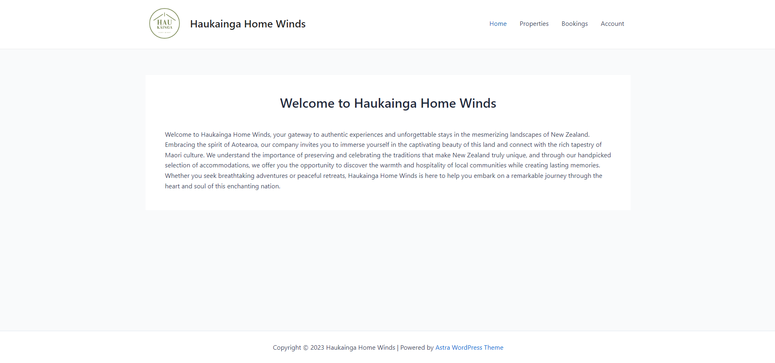

**Properties Page:**

**Bookings Page:**

# Transfer product resources:

The final application has been saved to a wpress file on the GitHub repository, as well as the most updated versions of the plugins being stored on the repository as well. It won’t be necessary to add them individually, as the wpress file contains the application, plugins, and database. Also on the GitHub repository are the various files containing documentation.