

System Design  
Absolute Basics

# Basics

## How to Attempt A System Design Question?

### Problem Scoping

* Don’t make assumptions.
* Ask clarifying questions to understand the constraint and use cases.
* Steps:
  + Requirements Clarifications
  + System Interface Definition

### Abstract Design Sketch

* Building blocks of the system.
* Relationships between them.
* Steps:
  + Back-off the envelope estimation
  + Defining the data model
  + High Level Design

### Bottlenecks Addressing and Identification

* Use fundamental principles of scalable system design.
* Steps
  + Detailed design
  + Identifying and resolving bottlenecks

# Horizontal vs Vertical Scaling of Systems

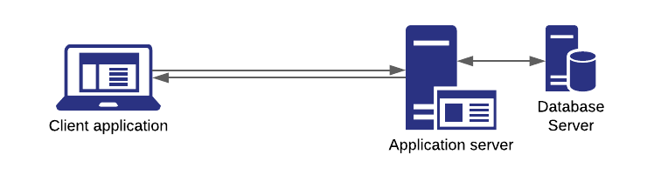

As the user base increases, there are probably two ways to scale our system:

1. **Vertical Scaling:** Increase the server configuration to increase throughput.

**Characteristics of vertical scaling:**

* + 1. Upper hardware limit ✖
    2. Single point of failure ✖
    3. Consistent ✔
    4. Resilience ✔
    5. Inter Process Communication ✔

1. **Horizontal Scaling**: Add multiple servers of same configuration for serving the application.

**Characteristics of horizontal scaling:**

* + 1. Load Balancing required
    2. Network Call (RPCs)
    3. Data Consistency Required
    4. Proportional to users

# System Design Pizza Parlour Analogy

Let’