1.

-6 5 -18 7 -2 -3



2 -3 -13 15 -1 3

10 -5 0 0 4 5/2



8 -9 0 0 -2 -3

2.

2 5 3 2 1 0 0 0



0 20



3.

1 2 0 7 2 -6 1 0 0

0 2 3 -3 -1 3 0 1 0



1 3 1 2 1 -2 0 0 1

7 2 -6 1 2 0 1 0 0

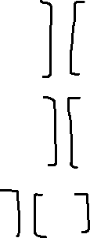

-3 -1 3 0 2 3 0 1 0



2 1 -2 1 3 1 0 0 1

4.

3 4 3 4 1 0



-2 -3 -2 -3 0 1

5.



1 -2 1 1 -2 1 1 0 0



2 -1 5 0 3 3 -2 1 0



1 1 4 0 3 3 -1 0 1

1 -2 1 1 0 0



0 3 3 -2 1 0



0 0 0 1 -1 1



B.

1 2 3 1 0 0 1 2 3 1 0 0

0 1 4 0 1 0 0 -4 -15 -5 0 1



5 6 0 0 0 1 0 0 1 -5 4 4

1 2 0 16 -12 -12 1 0 0 102 36 37

0 -4 0 70 60 61 0 1 0 -70/4 -15 -61/4



0 0 1 -5 4 4 0 0 1 -5 4 4

6.

1 0 2 x 0 1 0 2 1 0 0

2 -1 3 y 3 0 -1 -1 -2 1 0

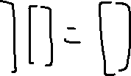

4 1 8 z -4 0 1 0 -4 0 1

1 0 0 -11 2 2 -11 2 2 0

0 0 1 6 -1 -1 -4 0 1 3

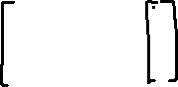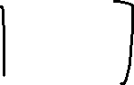

0 1 0 -4 0 1 6 -1 -1 4

0 x

-9 y

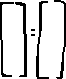

16 z

7.

-1 -1 2 1 0 0 -1 -1 2 1 0 0

-1 0 1 0 1 0 0 -1 1 1 -1 0



2 1 -2 0 0 1 0 -1 2 2 0 1

-1 -1 2 1 0 0 -1 0 2 1 -2 -1

0 -1 1 1 -1 0 0 0 1 1 -3 -1



0 1 0 0 -2 -1 0 1 0 0 -2 -1

1 0 0 1 -4 -1

0 0 1 1 -3 -1



0 1 0 0 -2 -1

1 -4 -1 5 13

0 -2 -1 -3 2



1 -3 -1 4 -12

8.

2 1 -1 2 1 -1 2 1 -1

-1 -3 2 0 -5 3 0 -5 3



4 -3 1 0 5 -3 0 0 0

The planes intersect on a line

9.

AT = 2 1 2x3 3x2 2x2 3x3

3 -4



-5 6

10.

1/ad-bc 2 -1



-5 3