ENGR101

Cover Sheet

Assignment 3

Name: **Jordan Withell**

ID Number: **67307220**

Username: **jwi179**

Workshop Number: **8**

Due Date and Time:

**Declaration**I confirm that the submission attached to this cover sheet is entirely my own work (apart from general verbal discussion with other students).

Signed:

**Return of work after marking (TICK ONE ONLY)**

|  |  |
| --- | --- |
| **□** | I agree to this work being returned to me in a pool of other students’ work, with the markers’ comments and mark being hidden from casual view. |
| **□** | I request that this work be treated as strictly confidential between the Department and me, and returned directly to me, upon providing suitable identification. |

**Marking Schedule**

**Summary (Report Section 3)** 3 marks

Self-contained, includes objective, methodology, major results, concluding remark etc. 3

**Introduction/Background/Theory (Report Sections 5-6)** 7 marks

Defined success and identified the basic problem criteria. 2

Constraints and specifications. 1

Gathered background information from a variety of sources. Fully referenced. 4

2

**Experimental Methods (Report Section 7)** 5 marks

Provided at least two figures that show the testing conditions and the paper flying model

with basic details and dimensions 2

Description of the model construction and testing procedure   
Must have details so it can be repeated. 3

**Results, Discussion and Conclusions (Report Sections 8-9)** 10 marks

Carried out at least two quantitative tests on the model with outcomes clearly

in tabular form. 2

The model was fully evaluated with reference to the design criteria. Discuss the results and

compare the model to the definition of success 6

Conclusions 2

**Appendix A: Figure/Table of “Objective 2”** 5 marks

A completed figure of a projectile motion trajectory (Objective 2) and a table that shows

all the data calculated using the given formulas in the Excel template 5

**Communication and Presentation** 5 marks

Report presented concisely and clearly with good grammar. 4

All other pages, such as cover sheet, title page, table of contents, etc. are included. 1

**Penalties: exceed the page limit (> 10 pages: -1, > 12 pages: -2)**

**Total Mark /35**

Marker’s initials:

Paper flying model

Jordan Withell

ENGR101

Foundations of Engineering

2021

University of Canterbury

# Summary

A successful paper gliding model would be one that can consistently travel 6m. Testing the design on launch angle and the angle of attack of the wings. The launch angles tested were 0°, 15°, 30°, 45° and 60°. The angle of attack angles tested were 30°, 0° and -30°. The results found that a launch angle of 60° was optimal and an angle of attack of 30° was optimal.

Table of Contents

Summary i

Introduction 1

Theory 1

Experimental Methods 1

Results 3

Discussion 4

Conclusion 5

References 6

# Introduction

A paper flying model must be designed to glide at least 6m consistently, thrown from head height and on level ground. It must be mainly made from paper and the cost of materials must be under $20 NZD, this price does not include recycled materials. For a paper glider to be successful, it would need to consistently glide over 6m. The model should be as cheap as possible, fly as far as possible and be simple to make.

It is believed that the Chinese, who invented paper, were the ones to create the first paper plane, who made inflatable paper balloons. Paper was invented in 105AD, but it is unclear when they made paper planes. In the 1700’s, the Montgovier brothers made paper hot air balloons in France. Human carrying hot air balloons were made in 1783 and were made from a paper-lined cloth. The Wright brothers designed the first planes off research from paper planes. Paper planes have been used to research aerodynamics of large-scale planes easily.

# Theory

To find a successful solution, the angle of attack the wings from horizontal at the nose of the model will need to be at an optimal angle. The optimal launch angle will also need to be found through tests. One study found that 45 was the optimal launch angle (Issei Nemoto, Akito Hatai, Masato Horie, Tsubura Sakai, Maika Kodato, Shione Nakajima, 2016). The optimal angle of attack is below the critical angle of attack where stalls occur, and the glider has no airspeed. The paper glider will not be able to adjust its angle of attack, therefore the angle of attack is linked to the launch angle. A positive angle of attack above the horizontal is optimal for high launch angles ((paperplanes, n.d.)).

# Experimental Methods

One specification was that the cost of the paper flying model must not exceed $20 NZD. This is shown in **Table 1**

**Table 1:** *List of costs of materials used to construct the paper flying model.*

|  |  |
| --- | --- |
| Item/Material | Cost per paper flying model |
| Paper | $0.00 |
| Tape | $0.00 |
| Total | $0.00 |

An a4 piece of paper was folded several times to create a glider shape. The glider shape had a flat body and wings to create lift. The nose of the model was folded inwards to be stronger. The wings were double layered so they would be stronger and stay in the same shape. One improvement to the model was to add tape to keep the body of the glider together, stopping the model from losing its shape mid-flight, which could alter its trajectory. Glue was considered as an improvement instead of tape, but due to the tape’s lightweight properties and aerodynamics, tape was preferred over glue. 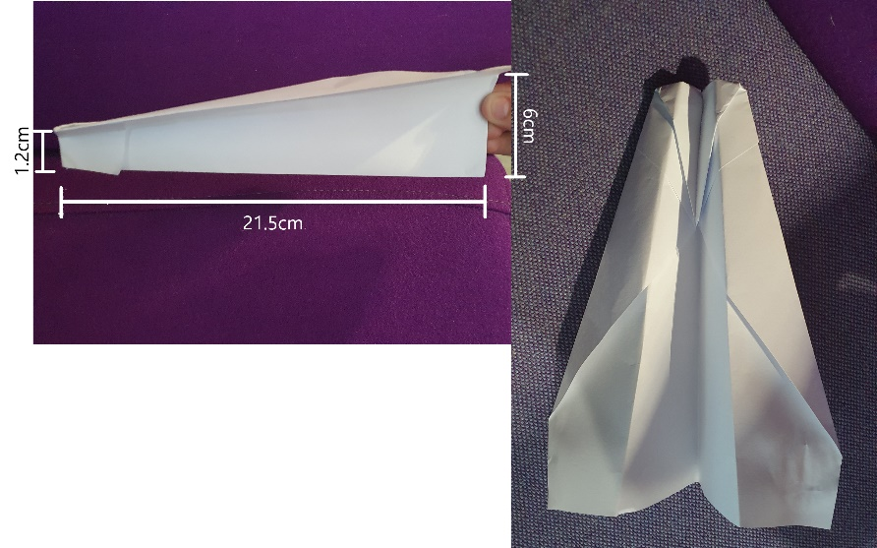The first prototype is shown in **Figure 1.**

**Figure 1:** Photos of 1st prototype

The 1st prototype had a length of 21.5cm. The nose was 1.2cm tall and the end was 6cm tall. The wingspan is 10.5cm at the widest spot. The 2nd prototype had the same dimensions and is shown in **Figure 2**.

**Figure 2:** Photo of 2nd prototype.

Tests were conducted outside on level ground so to not affect the change in height. The ground was a concrete pad which allowed to measure the distance with ease. There was a small back wind which would affect results, but all tests were done together and at the same place to minimise the variation of wind. The paper flying model was thrown from the same place and by the same person to minimise variation of throwing techniques. The flying model was tested to find the optimal launch angle and wing angle from the horizontal. The final design was the only one that was tested for launch angle and the multiple models of the final design with different wing angles were used for wing angle. 7 trials were conducted for each launch angle and wing angle. The wing angle is measured at the nose of plane in relation to the horizontal.

# Results

The experimental results for launch angle are shown in **Table 1**. The target distance was met at angles 45° and 60°.

**Table 2:** Experimental results for different angles against distance

|  |  |  |  |  |  |  |  |  |
| --- | --- | --- | --- | --- | --- | --- | --- | --- |
|  | Distance (m) | | | | | | | |
| Angle (°) | Trial 1 | Trial 2 | Trial 3 | Trial 4 | Trial 5 | Trial 6 | Trial 7 | Average |
| 0 | 5.04 | 4.26 | 4.06 | 4.24 | 4.26 | 4.5 | 4.26 | 4.37 |
| 15 | 6.01 | 5.53 | 5.34 | 5.48 | 5.54 | 5.78 | 5.44 | 5.58 |
| 30 | 7.56 | 6.55 | 6.45 | 6.67 | 6.45 | 6.89 | 6.64 | 6.74 |
| 45 | 11.21 | 7.86 | 7.55 | 8.85 | 8.84 | 8.54 | 7.96 | 8.68 |
| 60 | 11.26 | 12.01 | 12.98 | 11.78 | 12.54 | 11.75 | 12.45 | 12.11 |

­­The experimental results for the wing angle are shown in **Table 2**. The target distance was met for wing angles of -30° and 0° above the horizontal.

|  |  |  |  |  |  |  |  |  |
| --- | --- | --- | --- | --- | --- | --- | --- | --- |
|  | Distance (m) | | | | | | | |
| Wing angle above the horizontal (°) | Trial 1 | Trial 2 | Trial 3 | Trial 4 | Trial 5 | Trial 6 | Trial 7 | Average |
| -30 | 5.92 | 6.34 | 6.12 | 5.78 | 6.27 | 5.23 | 5.65 | 5.90 |
| 0 | 7.54 | 8.32 | 7.98 | 8.12 | 7.67 | 8.43 | 8.43 | 8.07 |
| 30 | 12.43 | 11.38 | 13.08 | 12.27 | 13.34 | 11.78 | 12.89 | 12.45 |

**Table 3:** Experimental results for different wing angles

# Discussion

The final flying model design was a successful design because the results more than doubled the target distance of 6m reaching average distances of 12.11m for a 60° launch angle and 12.45m for a 30° above the horizontal. The design cost $0 NZD which is under the $20 NZD budget constraint. The design was also mainly made from paper. Wind was a factor in the tests which could have affect the distance by providing more lift. The launch velocity was also a factor because they were thrown by hand and not with a launcher.

This approach worked well as the variables that were changed made a big difference. This approach could be improved by using a launcher to launch the plane to make the results more accurate. The environment for the testing could be inside to eliminate wind but finding an area inside large enough could be a challenge. Making success a higher target as the design easily passed the target in the tests.

# Conclusion

The results support the hypothesis that a higher launch angle increases distance but found that the optimal angle was 60° instead of the hypothesised 45°. This might have been caused from external factors including the launch velocity or the shape of the flying model. The results also support that an angle above the horizontal from the nose of the model is optimal.. The assignment objectives have been met as a successful solution was designed that complies with the constraints and limitations stated in define success.

# References

Iowa, T. U. of. (n.d.). *Learn the History of Paper Airplanes*. LiveAbout. https://www.liveabout.com/brief-history-of-paper-airplanes-2540753

‌https://www.facebook.com/thespruceofficial. (2019). *Paper Folding in China Has Similarities With Origami*. The Spruce Crafts. https://www.thesprucecrafts.com/origami-and-paper-folding-in-china-2540680

‌

*Helicopter by Leonardo da Vinci*. (n.d.). Www.leonardo-Da-Vinci.net. http://www.leonardo-da-vinci.net/helicopter/

‌

Issei Nemoto, Akito Hatai, Masato Horie, Tsubura Sakai, Maika Kodato, Shione Nakajima. (2016, December 2). *Relationship of paper airplanes and angle of launch*. http://www.omiyakita-rtdp.org/2016/12/02/relationship-of-paper-airplanes-and-angle-of-launch/#more-365

‌

FAA. (2013). *Glider Handbook, Chapter 3: Aerodynamics of Flight*. https://www.faa.gov/regulations_policies/handbooks_manuals/aircraft/glider_handbook/media/gfh_ch03.pdf

‌

paperplanes. (n.d.). *PAPERPLANE AERO*. [online] Available at: https://www.paperplane.org/copy-of-books.

‌