1.

a

For each job, choose lowest available contractor

W: b - 3

X: c - 4

Y: f – 8

Z: e – 9

Overall cost = 3+4+8+9 = 24

B.

No, you can swap Y and Z around and get same overall cost.

2

A is a subset of X and A is in I

B is any subset of A

Since B is a subset of A, the size of B is less than or equal to the size of A.

Since the size of A is less than or equal to K, so is B

Therefore, B is in I.

A and B are subsets of X, where A is in I and B is a proper subset of A.

3

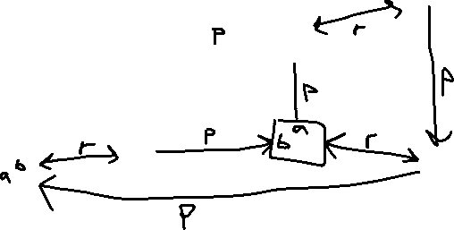

iii.

it makes a square shape for each reflection