

A BUSINESS ANALYSIS OF CYBERCOACHING PLATFORMS
STRATEGIES FOR CUSTOMER ATTRACTION AND REVENUE OPTIMISATION

A CASE STUDY OF TRYHACKME

by
BAY03A1 GROUP (4):
XG 223164009, TM 223086387
K 223086387, LH 222217788
M 223070310, KC 223222161

submitted in accordance with the requirements for the diploma of

BUSINESS INFORMATION TECHNOLOGY

in the subject

BUSINESS ANALYSIS

at the

UNIVERSITY OF JOHANNESBURG
PROMOTOR: DR SHOPEE DUBE
MAY 2026

DECLARATION:

We hereby declare that this group assignment titled is our own original work. All information used from other sources has been properly acknowledged and referenced in accordance with academic standards.
We confirm that this work has not been submitted for any other module or qualification at any institution. All members of the group contributed to the completion of this assignment.
We understand that plagiarism and academic dishonesty are serious offences and we take full responsibility for the content of this report.

Student Initials | Student Number | Signature
TM | 223086387 | TM Makhoba
XG | 223164009 | XG Kanaomang
K | 223086387 | K Mashiloane
LH | 222217788 | LH Msibi
N | 223070310 | N Mahlaba
KC | 223222161 | KC Okeke

Date: 2026/05/06

EXECUTIVE SUMMARY
This report evaluates the business processes, strategies, and performance of a cybercoaching business using TryHackMe as the primary case study. The study examines how the platform attracts users, delivers cybersecurity training, creates customer value, and generates revenue within the rapidly growing digital learning industry. The report highlights current strategies such as gamified learning, hands-on labs, flexible self-paced training, subscription-based services, and practical skill development that improve user engagement and career readiness.
The report also analyses competitors including Hack The Box, LetsDefend, EC-Council, Datacentrix, SANS Institute, and CompTIA to identify best practices and competitive strategies. UML Activity Diagrams and Swimlane Diagrams were used to map the current (“as-is”) and improved (“to-be”) business processes. The proposed improvements include AI-driven personalisation, automated career pathway recommendations, stronger employer integration, and enhanced customer engagement systems to improve learning outcomes, user retention, and revenue generation. In addition, Key Performance Indicators (KPIs), dashboards, analytics tools, and the Balanced Scorecard approach were discussed as methods for monitoring and improving long-term business performance and sustainability.

Table of Contents
DECLARATION: 2
EXECUTIVE SUMMARY 4
LIST OF ABBREVIATIONS 5
1. INTRODUCTION 7
1.1 Background of the Study 7
1.2 Purpose of the Report 8
1.3 Problem Statement 8
1.4 Objectives of the Study 9
1.5 Scope of the Study 9
2 MAIN BODY 10
2.1 Method 10
2.2 Results and Discussion 11
2.2.1 Current Strategies 11
2.2.2 MONETIZATION STRATEGIES 12
2.2.2.1 Revenue Model of SANS Institute: 12
2.2.3 Value Proposition of SANS Institute 13
2.2.4 STRATEGIES USED BY TRYHACKME 13
2.2.5 MONETIZATION STRATEGIES 14
VALUE PROPOSITION 15
Current Processes (As-Is) 15
(a) UML Activity Diagram – As-Is Process 16
(b) Swimlane Diagram - As-Is Process 17
3. Competitor Analysis 18
3.1 STRATEGY USED BY COMPETITORS 18
4.1 To-Be Enhanced Processes 23
(a) UML Activity Diagram – To-Be Enhanced Process 23
(b) Swimlane Diagram - To-Be Enhanced Process 24
5. Performance Assessment and Monitoring 25
5.1.1 Key Performance Indicators (KPIs) 25
5.1.2 Monitoring Methods 27
REFERENCES 30

LIST OF ABBREVIATIONS
Abbreviation | Meaning
KPI | Key Performance Indicator
SOC | Security Operations Centre
MRR | Monthly Recurring Revenue
AI | Artificial Intelligence
ANSI | American National Standards Institute
AWS | Amazon Web Services
B2B | Business-to-Business
CEH | Certified Ethical Hacker
CHFI | Computer Hacking Forensic Investigator
CNSS | Committee on National Security Systems
CTF | Capture the Flag
ECSA | EC-Council Certified Security Analyst
EDR | Endpoint Detection and Response
EDRP | EC-Council Disaster Recovery Professional
ENSA | Ethical Network Security Analyst
GIAC | Global Information Assurance Certification
ICT | Information and Communications Technology
IT | Information Technology
Linux | Open-Source Operating System
LPT | Licensed Penetration Tester
NSA | National Security Agency
NPS | Net Promoter Score
P&L | Profit and Loss
SEO | Search Engine Optimisation
SOAR | Security Orchestration, Automation, and Response
UML | Unified Modeling Language
US | United States
YoY | Year-over-Year

LIST OF FIGURES
Figure 1 page 19
Figure 2 page 21
Figure 3 page 28
Figure 4 page 29

LIST OF TABLES
Table 1 page 15
Table 2 page 31

1. INTRODUCTION

1.1 Background of the Study
The rapid growth of digital technology and online learning platforms has transformed the way people acquire skills, access education, and develop professional careers. One of the fastest-growing areas within digital education is cybersecurity training, driven by the increasing number of cyber threats affecting organisations, governments, and individuals worldwide. Cybersecurity is the practice of protecting systems, networks, programs, and data from online attacks, unauthorised access, or damage. It involves the use of technologies, policies, and security measures to ensure data confidentiality, availability, and integrity while addressing threats such as ransomware, phishing, and AI-powered attacks.
As cyberattacks continue to rise, the demand for skilled cybersecurity professionals has increased significantly. This demand has created opportunities for cybercoaching businesses that provide online coaching, mentoring, practical training, and cybersecurity-related learning services through digital platforms. Unlike traditional classroom-based education, cybercoaching businesses offer flexible and accessible learning experiences that allow users to learn from any location at their own pace. These businesses generate revenue through subscriptions, certifications, premium learning paths, employer partnerships, and specialised training services.
For this report, TryHackMe was selected as the primary case study. TryHackMe is a leading cybercoaching platform founded in 2018 in the United Kingdom. The platform focuses entirely on cybersecurity education and provides browser-based practical learning environments where users can develop real-world cybersecurity skills through gamified exercises, Capture the Flag (CTF) challenges, virtual labs, and structured learning paths. With millions of users across multiple countries, TryHackMe has become one of the most recognised dedicated cybersecurity learning platforms globally.
TryHackMe was selected because it represents a pure play cybercoaching business where education and skills development are the core business functions rather than secondary support services. The platform combines accessibility, affordability, gamification, and practical learning to attract users while generating revenue through premium subscriptions and enterprise solutions. As a group planning to establish a cybercoaching business, analysing TryHackMe provides valuable insight into how successful digital learning platforms operate, attract customers, create value, and maintain competitiveness within the rapidly evolving digital education industry.

1.2 Purpose of the Report
The purpose of this report is to analyse the business processes, strategies, and operational performance of TryHackMe as a cybercoaching business. The report evaluates how the platform attracts users, delivers cybersecurity training, creates customer value, and generates revenue through various monetisation strategies. In addition, the study analyses the current (“as-is”) business processes used by TryHackMe and identifies opportunities for improvement to increase competitiveness and profitability.
The report further compares TryHackMe with competitors such as Hack The Box, SANS Institute, and CompTIA to identify successful strategies that can be incorporated into improved (“to-be”) business processes. UML Activity Diagrams and Swimlane Diagrams are used to illustrate the sequence of activities, decision points, and actors involved within the business processes.
The report also discusses methods for assessing and monitoring business performance using Key Performance Indicators (KPIs), analytics systems, feedback mechanisms, and the Balanced Scorecard approach. The findings and recommendations are intended to improve efficiency, customer engagement, competitiveness, and long-term sustainability within the cybercoaching industry.

1.3 Problem Statement
Although cybercoaching businesses are growing rapidly due to increased demand for cybersecurity skills, the industry has become highly competitive. Many online learning platforms struggle to attract and retain users while simultaneously generating sustainable revenue. Existing business processes may lack personalisation, effective engagement systems, or competitive features needed to satisfy changing customer expectations.
Furthermore, some platforms focus heavily on theoretical learning without providing sufficient practical experience, reducing the effectiveness of their training services. As competitors continue to introduce innovative technologies such as artificial intelligence, gamification, adaptive learning, and career integration systems, cybercoaching businesses must continuously improve their processes to remain relevant and competitive.
This report therefore seeks to analyse the current processes used by TryHackMe and identify opportunities for improvement by incorporating competitor strategies and enhanced digital solutions.

1.4 Objectives of the Study
The main objective of this report is to analyse the operations of TryHackMe as a cybercoaching business and identify ways to improve its business processes and competitiveness.
The specific objectives are:
- To identify and explain the current strategies used by TryHackMe to attract users and generate revenue.
- To analyse the value proposition offered by TryHackMe to its customers.
- To identify and evaluate the current (“as-is”) business processes used to attract traffic and monetise the platform.
- To represent these processes using UML Activity Diagrams and Swimlane Diagrams.
- To analyse competitor strategies used by Hack The Box, SANS Institute, and CompTIA.
- To propose improved (“to-be”) business processes for TryHackMe.
- To recommend methods for assessing and monitoring business performance within the cybercoaching value chain.

1.5 Scope of the Study
This report focuses on the analysis of TryHackMe as a cybercoaching business operating within the online cybersecurity education industry. The study specifically examines customer attraction strategies, monetisation methods, value proposition, and operational business processes. It includes both current (“as-is”) and improved (“to-be”) processes represented through UML diagrams.
The report also evaluates competitor strategies and discusses methods for monitoring and assessing business performance. However, the study does not cover technical software development or detailed programming aspects of the platform. Instead, the focus remains on business analysis, process improvement, competitiveness, and performance management within the cybercoaching business environment.

2 MAIN BODY

2.1 Method
This report adopted a qualitative secondary research approach to investigate the operations, business processes, and performance of cybercoaching businesses, with a primary focus on TryHackMe as the selected case study. Secondary data was collected from a variety of credible and publicly available sources, including the official TryHackMe platform and website, competitor websites and documentation, cybersecurity industry reports, academic journals, and literature related to e-learning platforms, business process analysis, cybersecurity training, and performance management frameworks. These sources provided relevant information on customer attraction strategies, monetisation models, learning systems, and competitive practices within the cybercoaching industry.
In addition to secondary research, the TryHackMe platform was directly explored by members of the group to observe the user journey and platform functionality first-hand. This included analysing the registration process, learning paths, gamified activities, practical labs, subscription options, and certification pathways. Observations from the platform helped the group gain a practical understanding of how users interact with the system and how the business delivers value to customers.
Several business analysis frameworks and tools were applied throughout the study. UML Activity Diagrams and Swimlane Diagrams were used to map and analyse both the current (“as-is”) and proposed (“to-be”) business processes. These diagrams illustrated the sequence of activities, decision points, actors involved, and interactions within the platform. The UML diagrams were designed using Visual Paradigm based on observable workflows and publicly documented processes.
Competitor benchmarking was also conducted to compare TryHackMe with major industry competitors, including Hack The Box, SANS Institute, and CompTIA. These competitors were selected because they represent different strategic positions within the cybersecurity training market. Hack The Box was analysed as the closest direct competitor focusing on practical and gamified cybersecurity training, SANS Institute represented the premium certification and instructor-led training segment, while CompTIA represented globally recognised vendor-neutral certification pathways. The benchmarking process helped identify successful strategies and best practices that could be incorporated into improved business processes for TryHackMe.
To evaluate organisational performance and sustainability, the Balanced Scorecard framework was used to assess performance from financial, customer, internal process, and learning and growth perspectives. Key Performance Indicators (KPIs), analytics systems, customer feedback mechanisms, and performance dashboards were also analysed as methods for monitoring and improving business performance within the cybercoaching environment.

2.2 Results and Discussion
CURRENT STRATEGIES AND VALUE PROPOSITION USED BY INDUSTRY LEADERS

2.2.1 Current Strategies
According to SANS Institute, the organisation collaborates with cybersecurity professionals, businesses, and governments from diverse backgrounds to build a resilient global cyber workforce. The organisation focuses on delivering high-quality cybersecurity education through expert-led training, certifications, research programmes, and industry events. SANS also works with experienced industry professionals to provide a wide range of practical and career-focused learning experiences.
Similarly, KnowBe4 uses advanced technologies such as artificial intelligence (AI) to strengthen cybersecurity awareness and workforce security. The company provides attack simulation training, collaboration security, and agent security systems powered by its AI platform called AIDA. In addition, KnowBe4 combines AI systems with human expertise to improve cybersecurity behaviour and reduce organisational security risks caused by human error. This positions the company as a leader in digital workforce security and AI-driven cybersecurity training.
Coursera also applies innovative digital learning strategies by partnering with over 375 universities and industry organisations worldwide to provide courses, professional certificates, and degree programmes. The platform incorporates AI-powered tools such as Coach and Course Builder to deliver personalised, flexible, and accessible learning experiences for users across different skill levels.
These findings show that modern cybercoaching and digital learning businesses increasingly rely on AI technologies, practical training, partnerships, and personalised learning systems to improve user engagement, accessibility, and workforce readiness.

2.2.2 MONETIZATION STRATEGIES

2.2.2.1 Revenue Model of SANS Institute:
Premium Training and Certification
A significant portion of revenue is derived from instructor-led training, which includes both in-person and live online sessions. These programmes are intensive and highly practical, positioning them as a key revenue driver. In addition, SANS offers academic qualifications through the SANS Technology Institute, including specialised undergraduate and postgraduate degrees, typically completed over a period of three to five years.
Corporate Training and Workforce Solutions
SANS also provides enterprise-focused training solutions designed to support workforce development and talent retention. Organisations invest in these services to enhance employee skills and reduce turnover-related costs. Furthermore, SANS offers managed training services, which involve customised and closely supported programmes aimed at assisting organisations in developing and maturing their internal cybersecurity training capabilities.
Sponsorship and Content Marketing
Another revenue stream is generated through partnerships with cybersecurity vendors. SANS collaborates with industry stakeholders to produce and distribute research reports, white papers, and webcasts, which are often sponsored. These initiatives leverage SANS’s strong reputation to provide high-quality lead generation opportunities for sponsors. Additionally, corporate partners purchase sponsorship packages that provide visibility across SANS’s marketing and communication platforms, targeting a specialised audience of cybersecurity professionals.
Strategic Partnerships
SANS maintains strategic alliances with major technology providers, including cloud service companies such as AWS. These partnerships enable the distribution of training programmes through third-party marketplaces, thereby expanding SANS’s reach to broader and more diverse learner populations.

2.2.3 Value Proposition of SANS Institute
The core value proposition of SANS lies in its commitment to delivering credible, industry-relevant cybersecurity education. The organisation provides high-quality knowledge and practical skills through training courses, academic programmes, research outputs, and industry events. All content is developed and delivered by experienced, field-tested cybersecurity experts, ensuring a high standard of professional relevance and practical applicability. SANS further distinguishes itself through its comprehensive offering of courses, cyber ranges, structured programmes, and supporting resources designed to serve learners at all levels of expertise.

2.2.4 STRATEGIES USED BY TRYHACKME
The TryHackMe employs a practical, experiential learning strategy that emphasises hands-on skill development. The platform provides users with instantly deployable virtual machines, enabling them to practise both offensive and defensive cybersecurity techniques within a safe and controlled environment. This approach allows learners to apply theoretical knowledge in realistic scenarios, thereby enhancing job readiness and practical competency.
A key feature of TryHackMe’s strategy is its “learning by doing” methodology, which prioritises interactive labs and scenario-based challenges over purely theoretical instruction. This approach enhances knowledge retention and strengthens applied understanding of cybersecurity concepts. In addition, the platform incorporates gamification elements such as badges, points, and achievement systems to increase learner engagement and motivation.

TryHackMe also offers structured learning pathways tailored to different proficiency levels, ranging from beginners to advanced professionals seeking to update their skills in response to evolving cyber threats. Furthermore, its curriculum covers red team, blue team, and purple team methodologies, ensuring comprehensive exposure to both offensive and defensive cybersecurity practices.

An additional strategic strength of TryHackMe lies in its community-driven model, where user feedback is actively integrated into platform improvements. This continuous feedback loop supports content relevance and quality enhancement. Collectively, these strategies enable TryHackMe to maintain a competitive position within the cyber coaching and cybersecurity education industry.

2.2.5 MONETIZATION STRATEGIES

Revenue Stream | Description
Freemium Subscriptions | A freemium subscription model gives users free access to basic content while advanced features require payment. Cybercoaching businesses use this to attract users and encourage them to upgrade to premium plans.
B2B Business & Teams Plans | These are training packages designed for companies that want to train employees. Cybercoaching businesses use them to provide team training, progress tracking, and generate long-term revenue.
Structured Certification Paths | These are organised learning programs that prepare users for specific cybersecurity roles or certifications. Cybercoaching businesses use them to guide learners and increase the value of their training.
Employer Partnerships | Employer partnerships are collaborations with companies looking for cybersecurity talent. Cybercoaching businesses use them to align training with industry needs and create job opportunities for learners.
Table 1
The TryHackMe operates on a subscription-based revenue model. The platform provides premium subscription tiers that grant users access to advanced functionalities and exclusive learning content beyond the free offerings. In addition, learners may purchase access to more advanced virtual laboratories and structured learning pathways, which facilitate in-depth, hands-on cybersecurity training.
Furthermore, TryHackMe offers corporate and team-based training solutions designed for organisational use. These enterprise packages enable companies to upskill their employees in cybersecurity competencies and typically include features such as progress tracking, performance analytics, and learning management tools. This makes the platform particularly suitable for businesses seeking to develop and monitor the cybersecurity capabilities of their workforce.

VALUE PROPOSITION
TryHackMe provides value by offering practical, real-world cybersecurity skills through hands-on labs and simulations. The platform delivers an engaging and interactive learning experience by combining gamification with real-world challenges, which helps users stay motivated. It is also affordable and accessible, allowing beginners and professionals to learn at their own pace without needing expensive formal education. Furthermore, TryHackMe supports career-focused development by providing structured learning paths that guide users toward specific cybersecurity roles, making it easier for them to build relevant skills for the job market.

Current Processes (As-Is)
The current process used by TryHackMe to attract and convert users follows a structured digital flow. The process begins when a potential user visits the platform through marketing channels such as social media, search engines, or referrals. Once on the website, the user is introduced to the platform through free content, including introductory labs, learning paths, or demo-style challenges that showcase the platform’s capabilities.
After engaging with the free content, the user is encouraged to create an account to access more features and track their progress. At this stage, the platform (rather than a traditional sales team) guides the user through automated prompts and recommendations, highlighting the benefits of upgrading to a premium subscription.
If the user finds value in the platform, they proceed to subscribe to a paid plan, which unlocks advanced labs, structured career paths, and additional learning resources. Following subscription, the user is onboarded into the system through guided learning paths, progress tracking, and interactive challenges that support continuous skill development.

(a) UML Activity Diagram – As-Is Process
The as-is UML Activity Diagram traces the current learner journey within TryHackMe from initial platform discovery through to skills development, premium conversion, and career visibility. The process begins when a prospective learner discovers the platform through one of several traffic acquisition channels, including organic search engine results, social media content, cybersecurity community referrals, YouTube content, or Capture the Flag (CTF) competitions.
After visiting the platform, the learner is presented with free rooms, beginner learning paths, and introductory cybersecurity challenges designed to demonstrate value immediately. The learner then decides whether to register for an account. If the learner chooses to proceed, a free account is created, and access is granted to the platform’s free-tier content.
During the learning phase, the learner completes guided tasks, browser-based practical labs, quizzes, and interactive cybersecurity exercises covering areas such as networking, Linux, penetration testing, and security operations. The platform continuously tracks learner progress through completed rooms, challenge scores, and learning-path progression. To maintain engagement and motivation, the platform’s gamification system awards points, badges, streaks, and leaderboard rankings.
As learners progress through the platform, they reach a decision point where they may either continue using the free tier or upgrade to a premium subscription. Learners who upgrade gain access to advanced learning paths, additional labs, certificate-bearing content, and more structured career-focused training tracks such as SOC Analyst and Junior Penetration Tester pathways.
Premium learners may then choose to pursue advanced assessments and complete specialized learning paths. Upon successful completion, the learner receives digital certificates, badges, and profile achievements that can be shared with potential employers or professional networking platforms. If learners are unsuccessful in completing advanced challenges or assessments, they can revisit learning materials, continue practicing, and retry the activities.
The process concludes when the learner continues engaging with the platform for ongoing skill development or uses their completed learning achievements to support employment and career advancement opportunities.

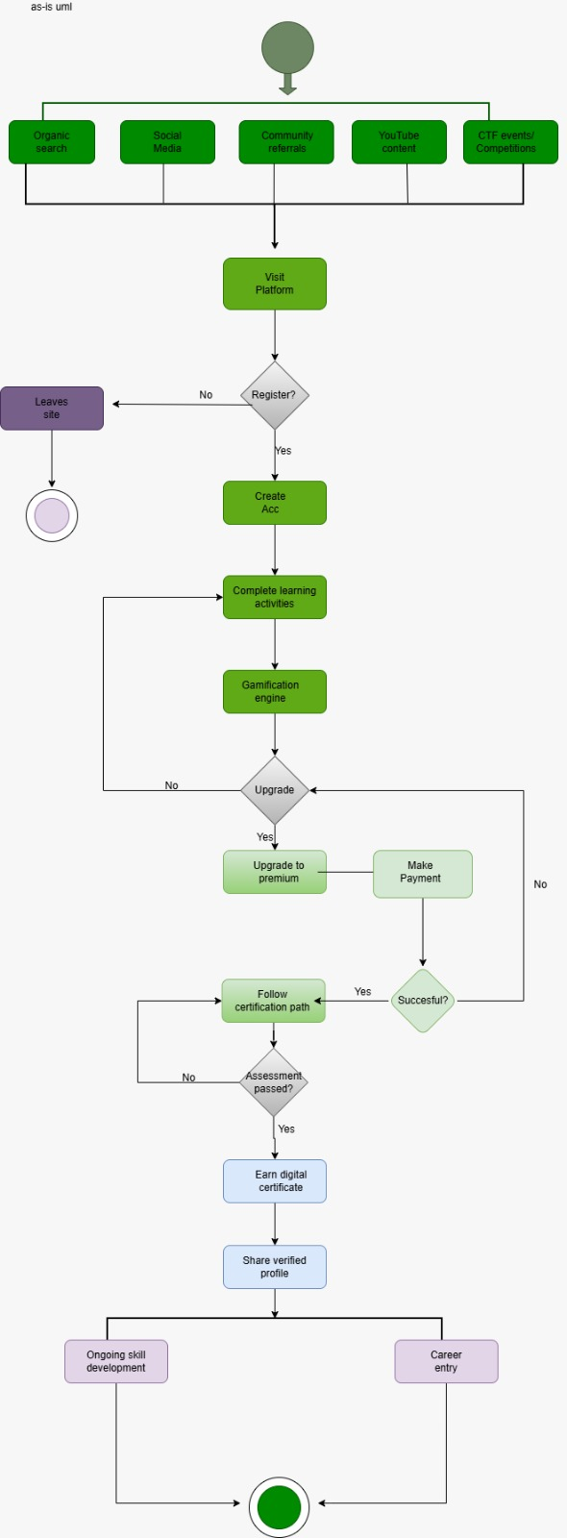 figure 1

(b) Swimlane Diagram - As-Is Process
The as-is Swimlane Diagram maps the learner journey across four actors: the TryHackMe Platform, the Learner, the Platform Assessment System, and the Employer or Recruiter.
The process begins in the TryHackMe Platform Lane, where free rooms, learning paths, SEO content, and social media are used to attract learners. Once a learner registers, responsibility shifts to the Learner Lane, where the learner completes guided tasks, practical labs, quizzes, and cybersecurity learning paths. A decision then determines whether the learner remains on the free tier or upgrades to a premium subscription for access to advanced content and career-focused learning paths.
As activities are completed, the Platform Assessment System tracks learner progress, validates completed learning paths, and awards badges, streaks, and digital certificates. The final hand-off occurs when learners share their achievements and profiles with employers or recruiters for potential career opportunities.

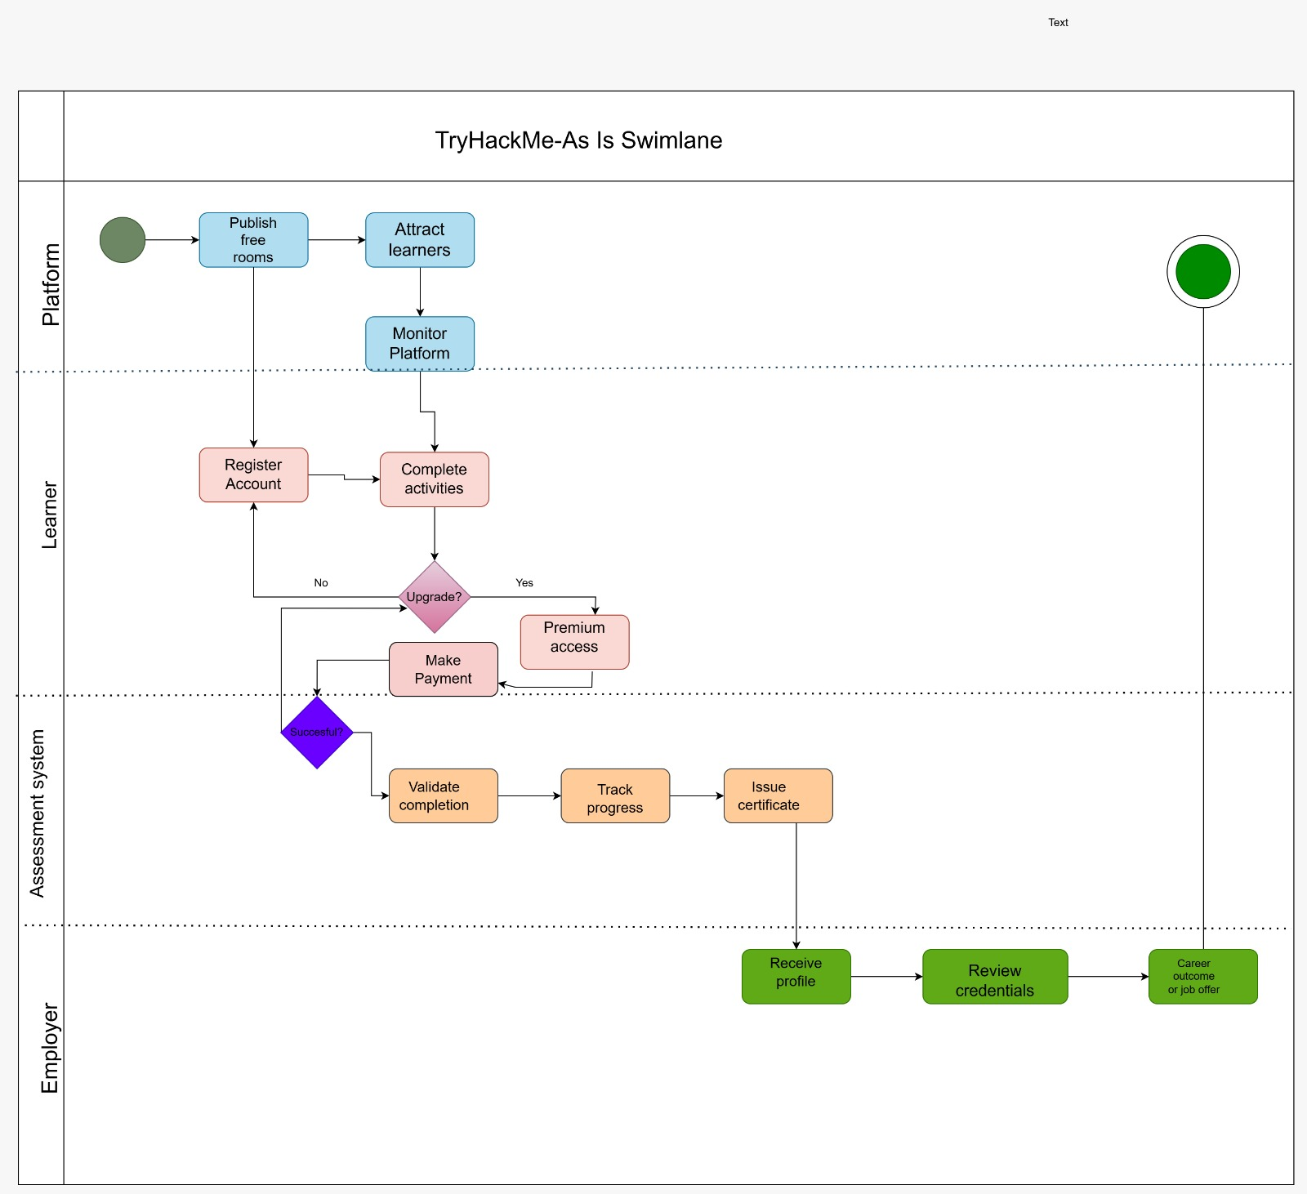figure 2

3. Competitor Analysis
To better understand the strategic position of TryHackMe within the IT certification and cybercoaching industry, it is essential to compare its business model with the most relevant direct and indirect competitors. This analysis focuses on HACK THE BOX, LET’S DEFEND, EC COUNCIL, DATACENTRIX and Certification platforms that operate in the professional IT, networking, and cybersecurity training space.

3.1 STRATEGY USED BY COMPETITORS
HACK THE BOX
The company uses demos that different companies can use to Test their cybersecurity capabilities in a controlled environment and evaluate how their teams respond to real-world threats while identify vulnerabilities within their systems and processes. This approach reduces uncertainty for potential clients, as they can see the value of the service before purchasing. It also builds trust and increases the likelihood of conversion from potential customers to paying clients.
Hack The Box adopts a performance-driven cyber coaching strategy that focuses on building real-world capability rather than theoretical knowledge. The platform emphasizes on the job skill development through role-based learning paths tailored to specific cybersecurity roles such as Security Operations Centre (SOC) analysts, penetration testers, cloud security specialists, and blue teams. A key aspect of this strategy is the integration of short theoretical lessons combined with hands-on labs, Live target environments that simulate real cyberattacks and Assessment systems that mirror real-world attack scenarios.

LET’S DEFEND
Let’s Defend is a hands-on blue team cybersecurity training platform that focuses on developing practical Security Operations Centre (SOC) skills through real-world simulated attack environments. According to LetsDefend, the platform allows users to investigate real cyberattacks in a controlled SOC environment, helping learners understand how cybersecurity teams operate in real organisational settings (LetsDefend, 20). This approach ensures that users gain practical experience by responding to security incidents, analysing alerts, and working through realistic attack scenarios. The platform is designed to bridge the gap between theoretical knowledge and industry practice by simulating day-to-day SOC analyst tasks. As a result, learners are exposed to authentic cybersecurity challenges that prepare them for real workplace environments.
In addition, Lets Defend follows a structured learning strategy that combines theory with interactive, scenario-based training to strengthen cybersecurity competencies. It offers specialised learning paths such as SOC Fundamentals, Phishing Email Analysis, and Web Attack Detection, which focus on real-world cyber threats and investigation techniques (Lets Defend, 20). The SOC Fundamentals course introduces learners to SOC roles, responsibilities, and essential cybersecurity tools such as Endpoint Detection and Response (EDR) and Security Orchestration, Automation, and Response (SOAR). It also develops critical thinking by teaching learners how to detect phishing emails, analyse malicious attachments, and investigate suspicious web activity. Furthermore, the platform emphasises continuous improvement through hands-on labs and incident-based learning, ensuring users build both technical expertise and analytical skills required in modern cybersecurity operations.
CRYBRARY
Cybrary is an online cybersecurity and IT training platform that provides hands-on courses, interactive labs, and career development resources designed to help professionals stay ahead of evolving cyber threats. According to Cybrary, the platform offers flexible learning that allows users to study cybersecurity topics from anywhere and at any time, making it accessible for both beginners and advanced learners (Cybrary, 2026). It focuses on practical, skills-based training that prepares learners for real-world cybersecurity challenges while also helping them reduce the cost of traditional certification pathways. The platform is widely used by individuals and organisations, including a large percentage of Fortune 1000 companies, highlighting its industry relevance and credibility.
Cybrary follows a structured, expert-led training approach that includes certification preparation paths, AI readiness programmes, and role-based cybersecurity training. The organisation aims to shift learners from simply following industry trends to actively shaping cybersecurity and AI strategies through applied knowledge and hands-on experience (Cybrary, 2026). Its certification preparation paths focus on exam-relevant content while building practical skills that improve confidence and performance in professional assessments. Cybrary also promotes a collaborative learning community where users, instructors, and organisations can engage in knowledge sharing and skill development. Through this model, the platform supports continuous career growth by combining technical training, mentorship, and real-world cybersecurity practice.
EC COUNCIL
EC-Council is an international organisation recognised as one of the world’s largest cybersecurity technical certification bodies, focusing on developing globally accepted information security qualifications. According to EC-Council, the organisation operates in over 170 countries and has trained and certified more than 400,000 information security professionals worldwide (EC-Council, 20). It is widely known for developing industry-standard certifications such as Certified Ethical Hacker (CEH), Computer Hacking Forensic Investigator (CHFI), Certified Security Analyst (ECSA), and Licensed Penetration Tester (LPT). These certifications are designed to equip learners with practical cybersecurity skills that are applicable in real-world environments. The organisation plays a major role in shaping global cybersecurity knowledge and improving the skill level of professionals across different industries.
Furthermore, EC-Council’s certification programmes are internationally recognised and have received endorsements from various government and security institutions. These include the US Federal Government through the Montgomery GI Bill, as well as recognition from organisations such as the National Security Agency (NSA) and the Committee on National Security Systems (CNSS) (EC-Council, 20). The certifications align with established security standards, including ANSI accreditation, which strengthens their credibility in the cybersecurity industry. EC-Council also ensures that its training programs meet structured learning frameworks such as CEH, ENSA, and EDRP training standards. Through this strategy, the organisation focuses on professional development, career advancement, and globally recognised cybersecurity competence.
CompTIA
CompTIA helps students, professionals, and people changing careers develop successful careers in technology by providing training resources and industry-recognised certifications. The organisation works closely with schools, governments, training partners, non-profit organisations, and other institutions to help prepare the next generation of technology professionals. CompTIA has built a strong reputation among learners, employers, educational institutions, and governments because its certifications and learning programs are trusted across the technology industry. The organisation focuses on helping individuals gain technical and business skills that improve employment opportunities and career growth. In addition, CompTIA continuously updates its certification and learning content to keep up with industry trends, emerging technologies, and innovation, ensuring that learners develop relevant and practical skills. Through its global partnerships with academic institutions and training organisations, CompTIA is also able to create tailored training programs that address workforce demands and reduce the technology skills gap. This approach allows the organisation to support people at different stages of their career journey, from beginners exploring career opportunities to professionals improving their skills for career advancement.
DATACENTRIX
Datacentric chooses a slightly different approach by not only providing cyber coaching services but also delivering comprehensive cybersecurity and ICT solutions to organizations. This allows the company to combine training, consulting, and technical implementation into a single integrated offering. The company provides end-to-end ICT systems and support services, ensuring seamless computing environments for enterprises. Their strategy focuses on aligning technology solutions with the business goals of their clients, helping organizations achieve outcomes such as improved operational efficiency, secure infrastructure, and digital transformation. A key strength of Datacentric is its emphasis on partnerships with leading global and local technology vendors, strong focus on innovation and continuous improvement and delivery of tailored solutions based on specific business needs.
This approach is effective because it goes beyond basic cyber coaching and provides practical implementation of cybersecurity solutions. Instead of only teaching clients about cybersecurity, Datacentric ensures that systems are properly designed, implemented, and maintained. This results in stronger client trust, long term contracts and recurring revenue and improved business performance for clients.

3.2 STRATEGIES TRY HACK ME CAN ADOPT
Demo-Based Marketing (from Hack The Box )
- Offer free cybersecurity demos or simulations
- Allow clients to test services before purchasing
Hands-On Practical Training (from Hack The Box & LetsDefend )
- Introduce real-world cyberattack simulations
Role-Based Learning Paths (from Hack The Box )
- Use AI-generated personalised learning paths based on user performance and skill level
Scenario-Based Learning (from LetsDefend )
- Use real incident cases for training employees
- Allow users to retry or rejoin training modules after failing assessments
Certification Programs (from EC-Council )
- Provide certification retake opportunities for users who fail exams
Accessibility & Awareness (from Crybaby )
- Provide free or low-cost beginner content
- Use social media and paid advertising to attract more users and increase platform awareness

4.1 To-Be Enhanced Processes
Key Process Changes
AI-Driven Personalisation: Introduces an intelligent learning system that assesses learner skills and recommends customised learning paths based on induvial strength and knowledge gaps
Career Pathway Integration: Learners are guided toward specific job roles such as Network Engineer and Cybersecurity Analyst, improving alignment between training and employment opportunities
Project-Based Learning: Learners complete real-world projects as part of their training, enhancing practical experience and improving employability outcomes.

(a) UML Activity Diagram – To-Be Enhanced Process
The first and most significant enhancement is the introduction of an AI-powered skills diagnostic assessment at the point of registration. In the as-is process, all new users enter the same generic onboarding flow regardless of their prior knowledge or career aspirations. An AI diagnostic resolves this by assessing each learner’s existing knowledge on arrival and dynamically generating a personalized learning path calibrated to their skill level and career goal.
The second enhancement is career pathway alignment from day one. Rather than allowing learners to explore content freely, the enhanced process requires each learner to select a target career role at registration. This approach is inspired by CompTIA’s success in building demand by connecting learning directly to job requirements.
The third enhancement is automated employer integration and job matching. The to-be process replaces the passive profile-share with an AI-driven matching engine that automatically surfaces relevant job opportunities to learners based on their completed certifications and career goals. Employers who partner with the platform can set skill criteria for open roles and receive a shortlist of matched candidates.
The fourth enhancement is a prestige certification tier. Inspired by the community standing of Hack The Box and the employer recognition of GIAC credentials, the to-be process introduces an advanced certification track that requires learners to complete advanced challenges, demonstrate practical skills under exam conditions, and achieve a high-performance threshold.
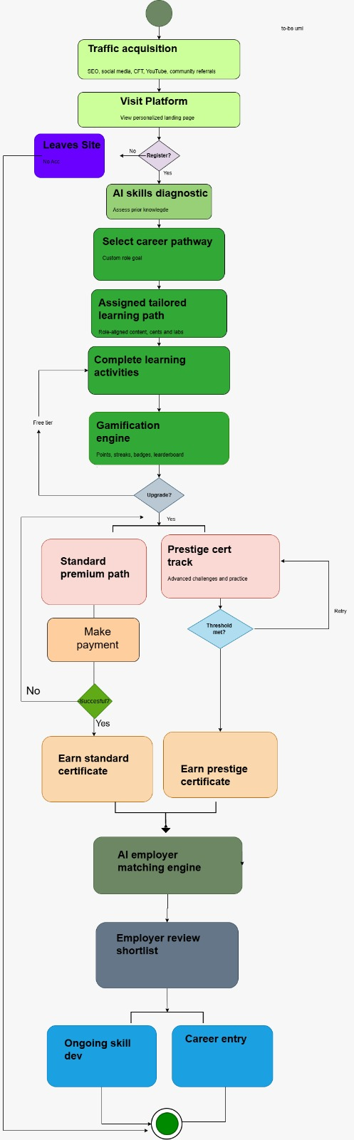figure 3

(b) Swimlane Diagram - To-Be Enhanced Process
The swimlane diagram below divides the same as-is activities across all six actors, showing task ownership and hand-off points between them.
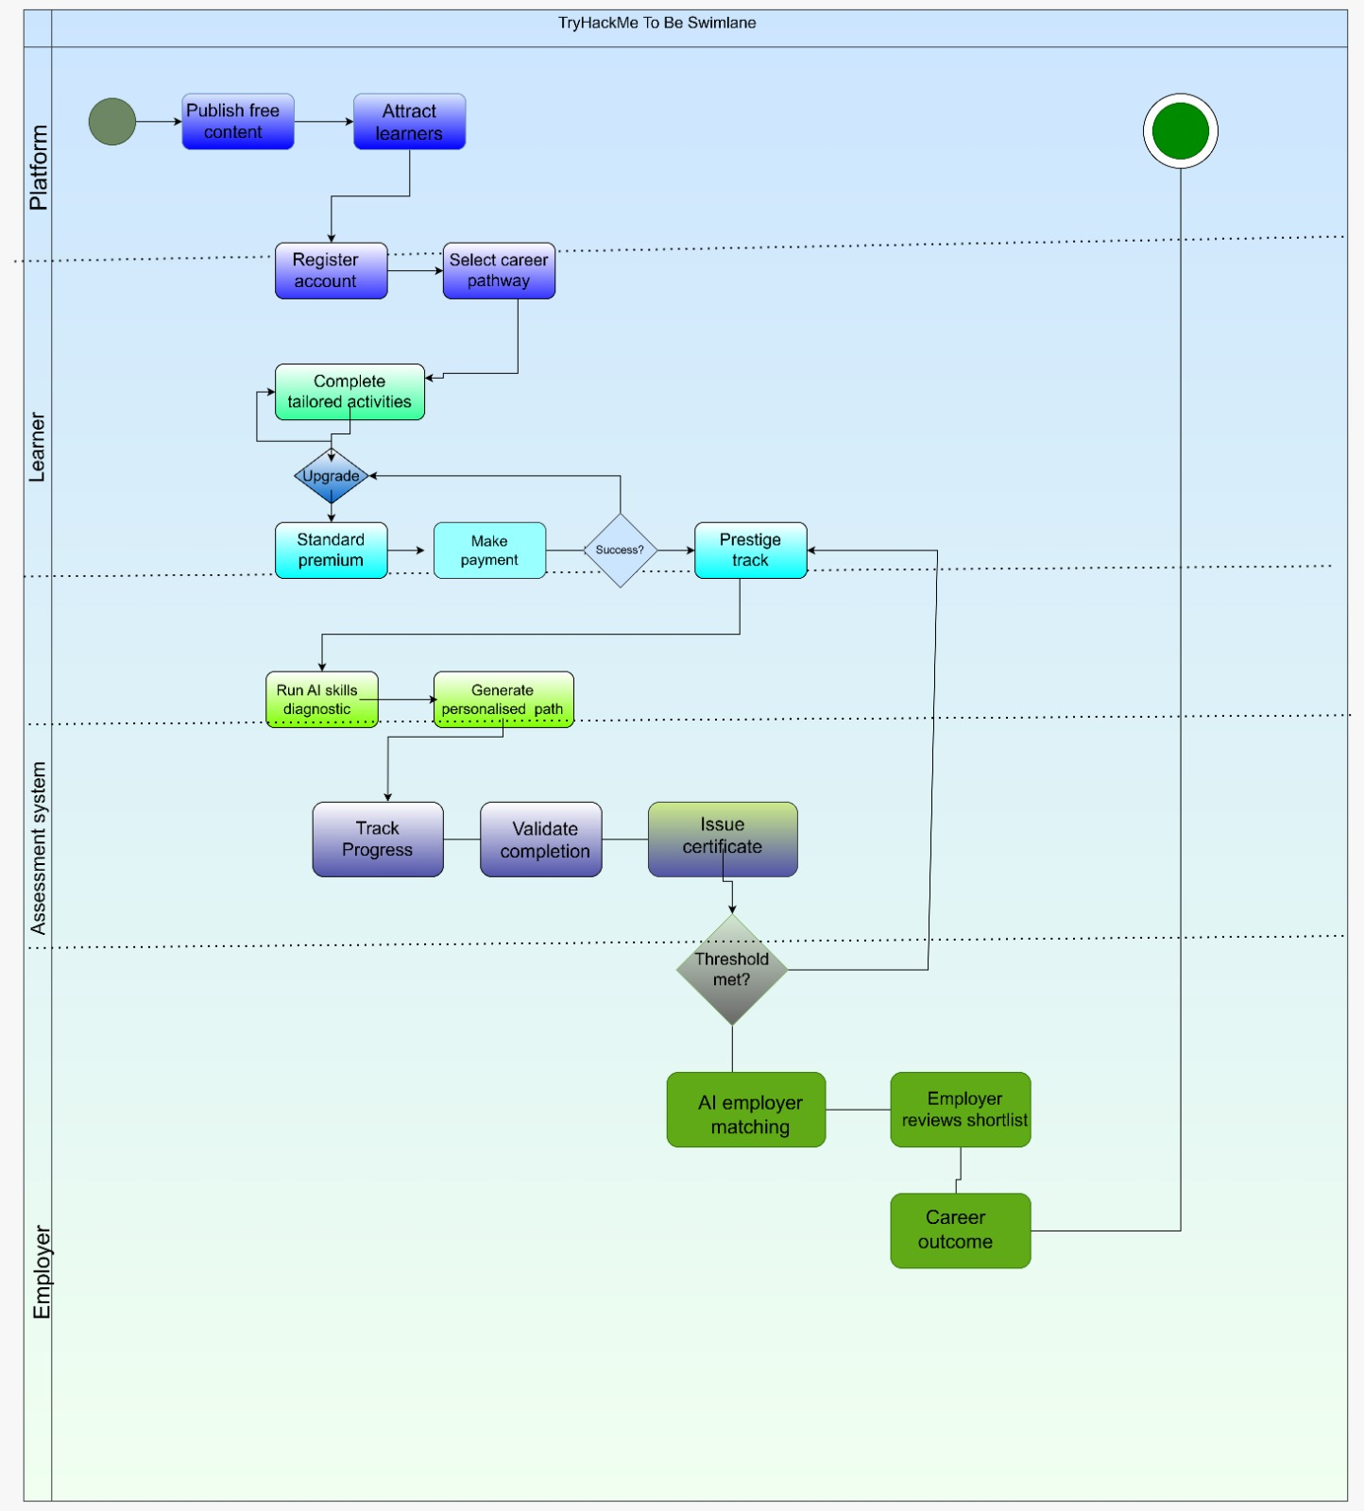 figure 4

5. Performance Assessment and Monitoring
Measuring performance is essential to ensure continuous improvement and long-term sustainability within cybercoaching platforms. For effective performance assessment enables the organisation to evaluate the success of its training programmes, identify areas for improvement, and align its operations with strategic objectives. By implementing a comprehensive performance measurement framework, TryHackMe can ensure that it delivers value to learners.

5.1.1 Key Performance Indicators (KPIs)
The following are the KPIs that are currently being used by Try Hack Me:
User Growth Metrics
These KPIs measure how well the platform attracts new users.
Number of registered users
- Tracks total users signing up on the platform.
- Try hack me currently has 7,484,227 Registered Users
Website traffic
- Measures the number of visitors accessing the platform
- Sign-Up Conversion Rate
- Percentage of visitors who create account
- Try hack me has 7,484,227 total active users
Revenue Metrics
TRY HACK ME estimated annual revenue is currently $764m per annum (growjo.com)
Challenge Success Rate
Measures how many users successfully complete labs.
Completion & Progress
Tracks specific module completion, assignment progress, and team skill levels through a skills matrix
Content Volume
The platform tracks the number of learning "rooms" created, surpassing 200 dedicated offensive and defensive rooms as of early growth milestones
Balanced Scorecard
The Balanced Scorecard organises performance monitoring across four perspectives, ensuring that short-term financial metrics are balanced against longer-term drivers of sustainable growth.

Perspective | Objectives | Measurement Mechanism
Financial | Grow MRR at 15% per quarter; increase B2B share above 30%. | Monthly P&L review; MRR dashboard.
Customer | NPS above 50; employer satisfaction above 4/5. | Post-course and 6-month surveys; quarterly employer reviews.
Internal Process | Free-to-premium conversion above 15%; platform uptime above 99.9%. | Real-time conversion funnel; uptime monitor.
Learning & Growth | Launch 4+ new learning paths per quarter; improve AI personalisation by 10% YoY. | Path-launch tracker; completion rate vs pre-AI baseline.
Table 2

5.1.2 Monitoring Methods
To effectively monitor and evaluate its performance, TryHackMe uses a combination of analytical tools, internal system data, and user feedback mechanisms. Web analytics tools such as Google Analytics are used to track website traffic, user behaviour (including pages visited and time spent), and sign-up conversion rates. This enables the platform to assess the effectiveness of its marketing strategies and user acquisition efforts. TryHackMe relies on platform analytics to monitor user activity directly within its system. This includes tracking the number of labs or rooms completed, user progress through structured learning paths, time spent on exercises, and challenge success rates. These metrics are essential for evaluating user engagement and the effectiveness of the learning experience.
Financial performance is monitored through subscription and revenue tracking systems, which measure monthly recurring revenue (MRR), free-to-paid conversion rates, and subscription renewals or cancellations. This allows TryHackMe to assess its profitability and sustainability as a subscription-based cyber coaching platform. User engagement is further analysed by tracking daily and monthly active users, login frequency, and participation in challenges and competitions. These indicators provide insight into how actively users interact with the platform and how engaging the content is to measure customer satisfaction, TryHackMe collects feedback through user reviews, ratings, in-platform surveys, and support queries.
This feedback helps identify areas for improvement and enhances the overall user experience. Performance dashboards are used to provide real-time insights into individual user progress, team performance (particularly for business clients), and overall platform performance. These dashboards support data-driven decision-making and continuous improvement. Periodic performance reviews are conducted, including monthly performance analyses and quarterly business reviews, to evaluate KPI trends over time. This ensures that TryHackMe remains aligned with its business objectives and continues to meet user needs effectively.

Conclusions and Recommendations
This report has analysed TryHackMe as a reference cybercoaching business to extract the strategic and operational insights needed to build a competitive platform. The analysis confirms that TryHackMe is a genuinely strong cybercoaching business: its freemium model effectively attracts users, its gamification drives engagement, and its combination of B2C subscriptions and B2B corporate training creates a diversified and scalable revenue base.
However, the competitor analysis reveals meaningful gaps. TryHackMe’s onboarding is generic rather than personalized, its career pathway signposting is weaker than it could be, its employer connection is passive rather than automated, and its certifications do not yet carry the employer recognition of GIAC credentials or the universal demand of CompTIA’s Security+. The four to-be enhancements proposed in this report directly address each of these gaps.
Five recommendations follow this analysis:
- Launch with a freemium model to build user base rapidly before monetizing, using conversion data to optimize pricing strategy.
- Align all learning content to specific career roles from registration, ensuring that every learner has a clear and visible path from their current position to their target job.
- Establish employer partnerships before scaling, because certified learner employability is both the platform’s most powerful marketing tool and the foundation of its B2B revenue.
- Invest in AI personalization from the outset, as the cost of building this capability early is significantly lower than retrofitting it onto a mature platform.
- Pursue industry-body partnerships to develop certifications that carry independent employer recognition, removing the platform’s dependence on its own brand credibility to validate learner skills.

Implemented together, these recommendations position the business to compete effectively across all segments of the cyber coaching market: beginner learners seeking accessible entry points, advanced practitioners seeking prestigious credentials, and employers seeking a reliable pipeline of verified talent.

REFERENCES
Coursera. Online courses and career learning platform. Available at: https://www.coursera.org [Accessed 6 May 2026].
Cybrary. Cybersecurity and IT training platform. Available at: https://www.cybrary.it [Accessed 9 May 2026].
Datacentrix. ICT solutions and cybersecurity services. Available at: https://www.datacentrix.co.za [Accessed 6 May 2026].
EC-Council. Cybersecurity certification and training programs. Available at: https://www.eccouncil.org [Accessed 8 May 2026].
Growjo. TryHackMe revenue and company statistics. Available at: https://growjo.com [Accessed 7 May 2026].
Hack The Box. Cybersecurity training and hacking labs. Available at: https://www.hackthebox.com [Accessed 5 May 2026].
KnowBe4. Security awareness training and simulated phishing platform. Available at: https://www.knowbe4.com [Accessed 5 May 2026].
LetsDefend. Blue team cybersecurity training platform. Available at: https://letsdefend.io [Accessed 9 May 2026].
SANS Institute. Cybersecurity training, certifications, and research. Available at: https://www.sans.org [Accessed 7 May 2026].
CompTIA. CompTIA Certifications Overview. Available at: https://www.comptia.org [Accessed: May 2026].
Kaplan, R.S. and Norton, D.P. (1992). The Balanced Scorecard: Measures That Drive Performance. Harvard Business Review, 70(1), pp.71–79.
TryHackMe. Hands-on cybersecurity training platform. Available at: https://tryhackme.com [Accessed 9 May 2026].

