**VIETNAM NATIONAL UNIVESITY**

**INTERNATIONAL UNIVERSITY**



**FINAL GAME PROJECT**

***GROUP MEMBERS:***

Trần Nam Tuấn – ITITIU19230

Phan Hưng Thịnh – ITDSIU19055

Trương Gia Khang – ITDSIU19041

***Name of the game: Candy Crush***

***Language: Java 14***

***Introduction:***

Candy Crush is one of the most popular game which is a free-to-play match-three puzzle video game released by King on April 12, 2012, for Facebook, and another version for iOS, Android, Windows Phone. In this report, we will present more detail of development and implementation of simple Candy Crush game. Candy Crush game consists of graphical user interface, solver and puzzle generator; implemented by using java. We separate three main parts to understand more detail the process of creating simple Candy Crush game of group 63.

* Introducing the game rules of Candy Crush and devices we can use to play Candy Crush game.
* Environment Design.
* Presenting the class diagrams.

1. **What devices we can use to play Candy Crush and How to play this game?**

There are a lot kinds of device that we can use to play Candy Crush. Candy Crush is created for Facebook, and there are many difference version for iOS, Android, Windows. Therefore, we can play Candy Crush game not only with PC or laptop but also, we can play with another mobile device such as tablet, or phone…

And how to play Candy Crush game?

Candy Crush is one of kinds of puzzle game which is played by matching candies to destroy blocked candies or get higher score than the given score in limited turns. There are lots of combos that we can created if we match more than three candies. The candies will crush and shift the candies above them, allowing you to accomplish a series of different goals. We can overcome most levels when we follow below steps.

* Understanding the object: In Candy Crush Saga, your target is usually to clear as many rows and columns as possible in as few moves as possible. By lining up three (or more) in a row, which is done by exchanging pieces of candy to make three of kind, you can clear candy pieces from the board. Within a certain number of moves, the initial aim of Candy Crush Saga is to gain a certain number of points. Other target (such as achieving a certain score within a time limit or clearing all form of candy from the board) will become more popular as you progress through Candy Crush Saga.
* Pay attention to game board: Remember the limited turns we have, the point target or limited time. We can reasonably manage limited turns and limited time to find the fastest way to overcome the game.
* Trying to create combos: We can create a lots of kind of combos when matching more 3 candies in any direction, matching more will both clear the candies from the board and create a special candy that can be used to clear additional candies. The more candies we can match, the more advantages we can get.

1. **Environment Design.**

The design style of Candy Crush is based on cartoon and animation style with lots of cute animals and symbols such as candies, chocolates, dolls, bee…

The game icon of Candy Crush consists of three simple game items: two regular candies and a special one (which owns some special function). Here are some other examples of the design of the icon in the game.

Candy Crush Saga, unlike other games, does not have a highly convincing plot that convinces the participant to take action. True, in the magical world, you ride a little train solving problems, but it is mostly just funny problems, like helping a magical dragon bathe in sugar, which is not effective “I’m doing this because it’s bigger mission than myself.” Instead, game strategies like Beginners Luck, Destiny Child, and having a Free Lunch provide the epic meaning and calling.

1. **Presenting the class diagram of Candy Crush game:**

The class diagram of process creating Candy Crush game is presented below:

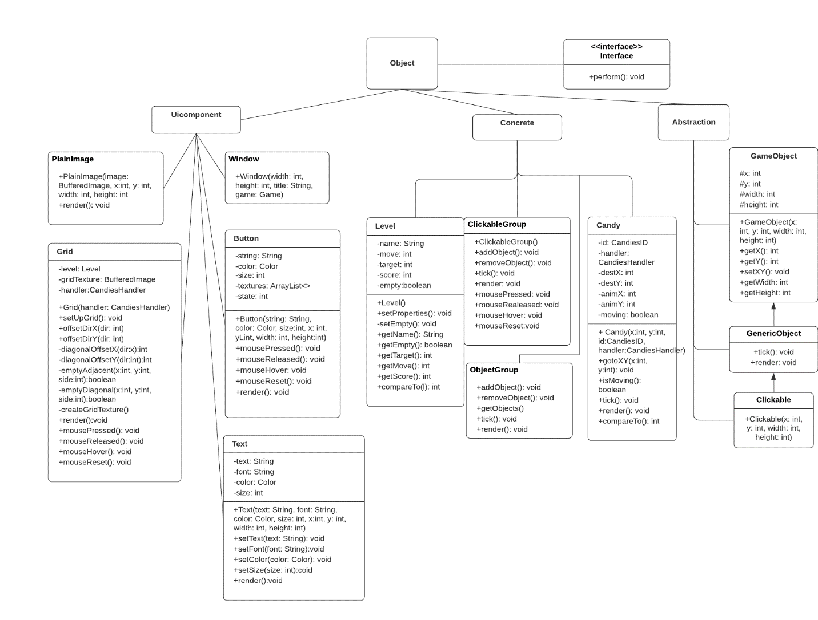

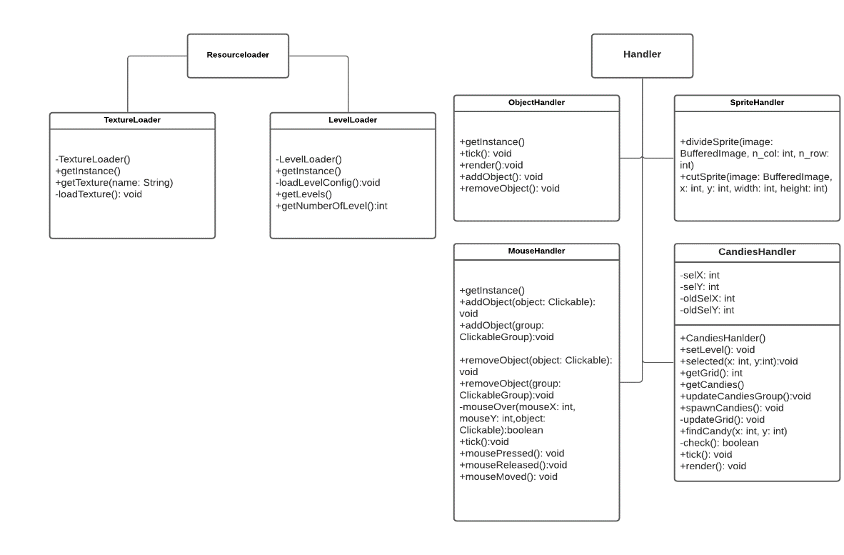

1. **References:**

***Yukaichou.com*: Game Mechanics Research: What Makes Candy Crush so Addicting?**

[**https://yukaichou.com/gamification-study/game-mechanics-research-candy-crush-addicting/**](https://yukaichou.com/gamification-study/game-mechanics-research-candy-crush-addicting/)

***Wikihow.com*:** [**https://www.wikihow.com/Play-Candy-Crush-Saga**](https://www.wikihow.com/Play-Candy-Crush-Saga)

***Wikipedia.com*:** [**https://en.wikipedia.org/wiki/Candy_Crush_Saga**](https://en.wikipedia.org/wiki/Candy_Crush_Saga)