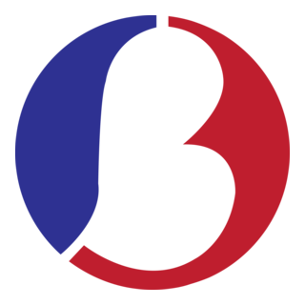 | Republic of the Philippines  National Capital Region  CITY OF MANILA  BARANGAY NO 123 | 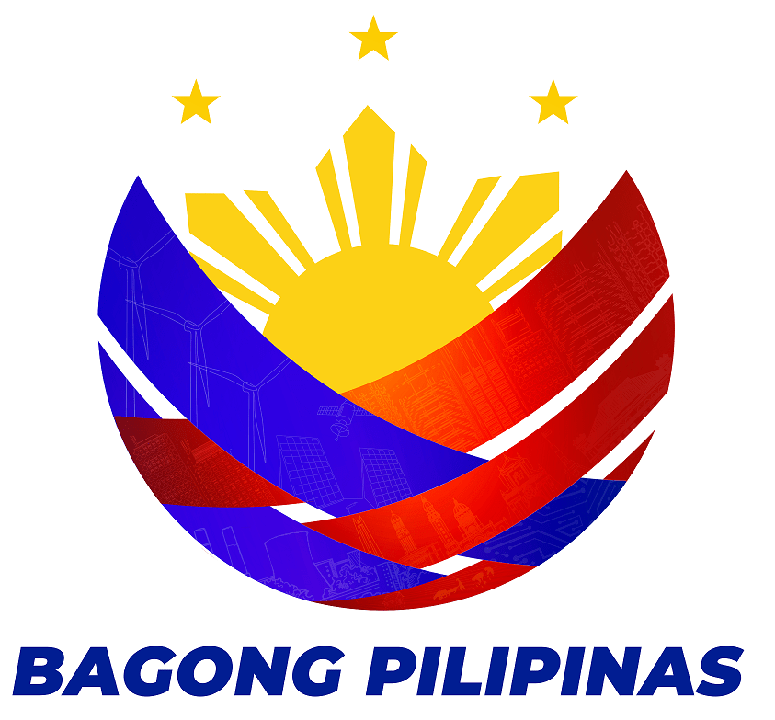

OFFICE OF THE PUNONG BARANGAY

BARANGAY CERTIFICATE

TO WHOM IT MAY CONCERN:

This is to certify that ${fullname}, ${age} years old, ${civil_status}, ${nationality} Citizen is a resident of Barangay No. 123. He/She is known to be person of good moral character and law-abiding citizen in the community.

It is further certify that said person has No Derogatory Records and/or criminal records filled in this barangay.

The certification is hereby issued upon the request of the above person for whatever legal purpose this may serve.

Given this ${day} day of ${month}, ${year} at Barangay No. 123, City of Manila, National Capital Region, Philippines.

HON. BILLY HERINGTON
Barangay Captain

