Flash Loan Arbitrage Bot.

Introduction
This is Flash Loan Arbitrage bot using AAVE protocal V1.
Aave was the first in the space to come up with the idea of a Flash Loan. Before flash loans, you would have to stake an over-collateralized asset to loan another asset. For example, if I wanted to borrow one DAI I would have to deposit another cryptocurrency that exceeded that value. In other words, you had to have money to borrow money. Flash Loans demolished this idea. And they opened up doors for a new loaning system. They did this by allowing users to borrow without putting up anything as collateral.
We can use loan tokens to get profit using arbitrage between Dex platform.
This bot works between Uniswap and SushiSwap Dex platform.

Installation

Deploy smart contract to Ethereum Main net with Remix.
Remix IDE URL : https://remix.ethereum.org/
- Launch Remix, Under Environments, select Solidity to configure Remix for Solidity development, then navigate to the File Explorers view:

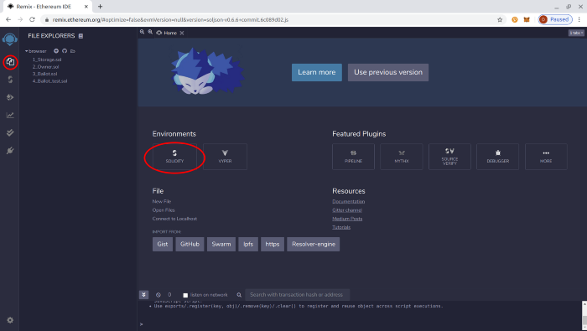

- We will create a new file to save the Solidity smart contract. Hit the + button under File Explorers and enter the name “FlashLoan.sol” into the popup dialog:

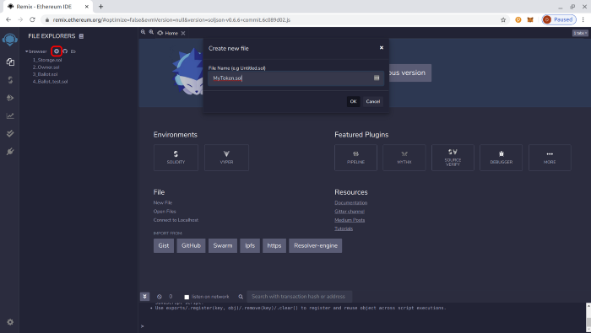

- Now let’s paste the following smart contract into the editor tab that comes up:
Projects : src\contracts\FlashLoan.sol
- Select Flash loan contract in Remix, move to compile tab

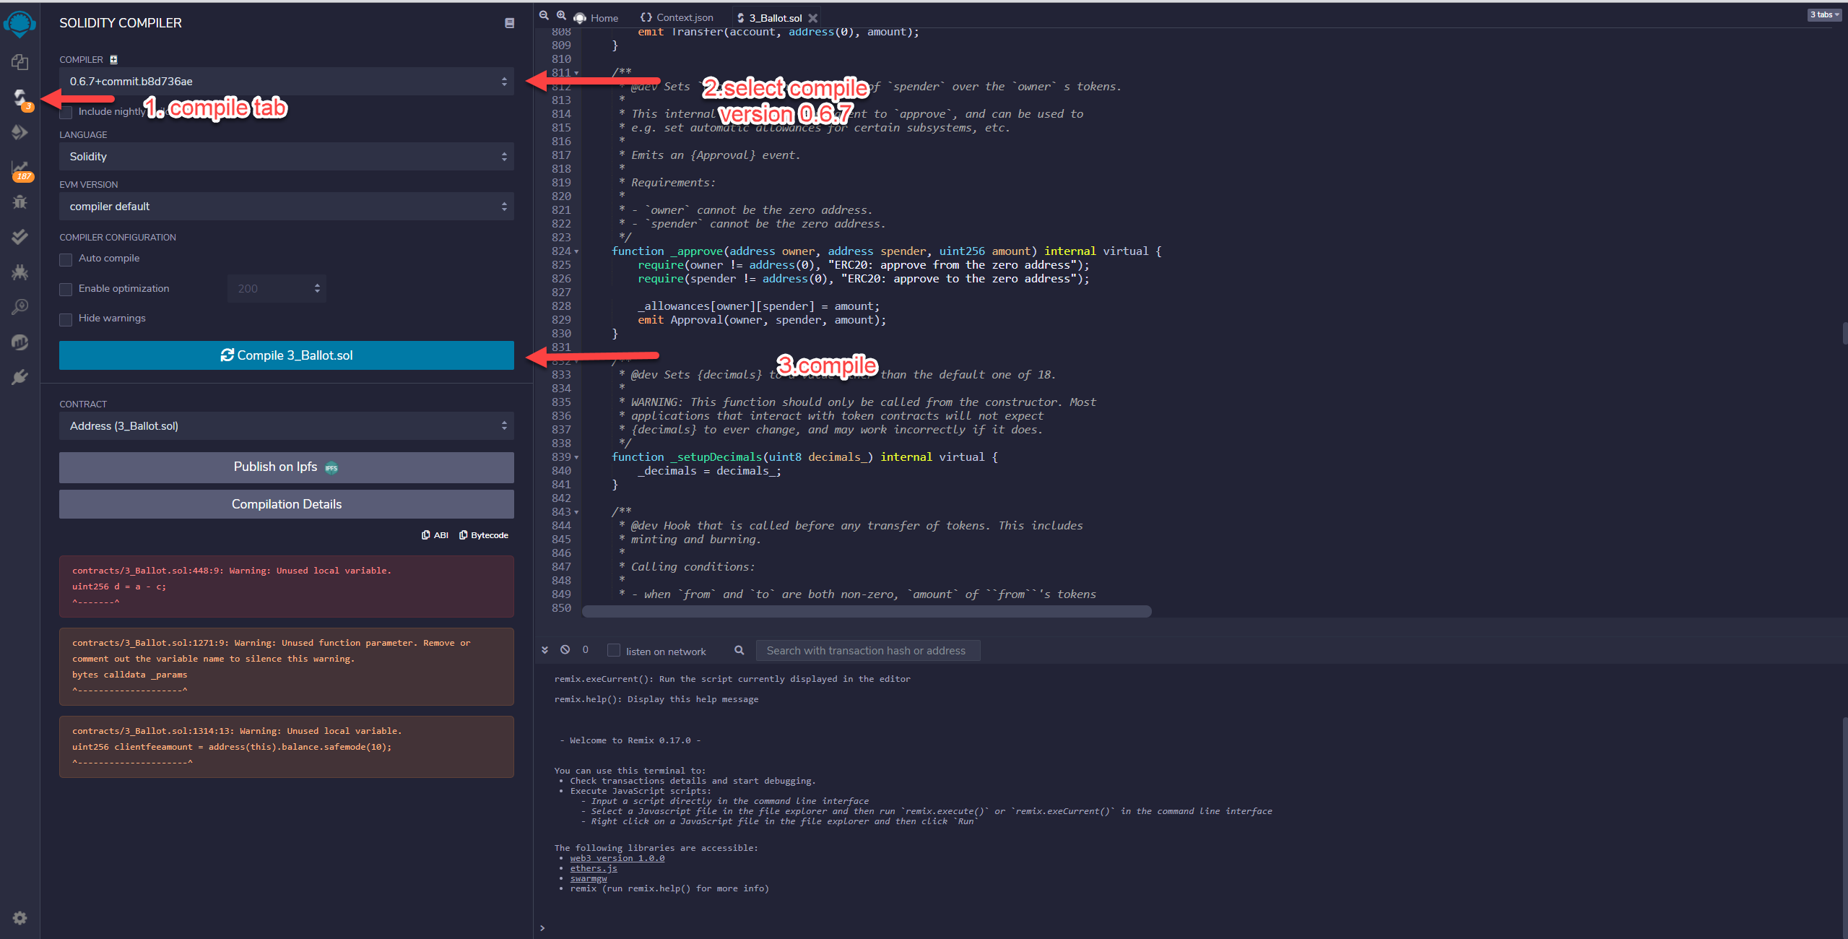

- Deploy smart contract to Ethereum mainnet

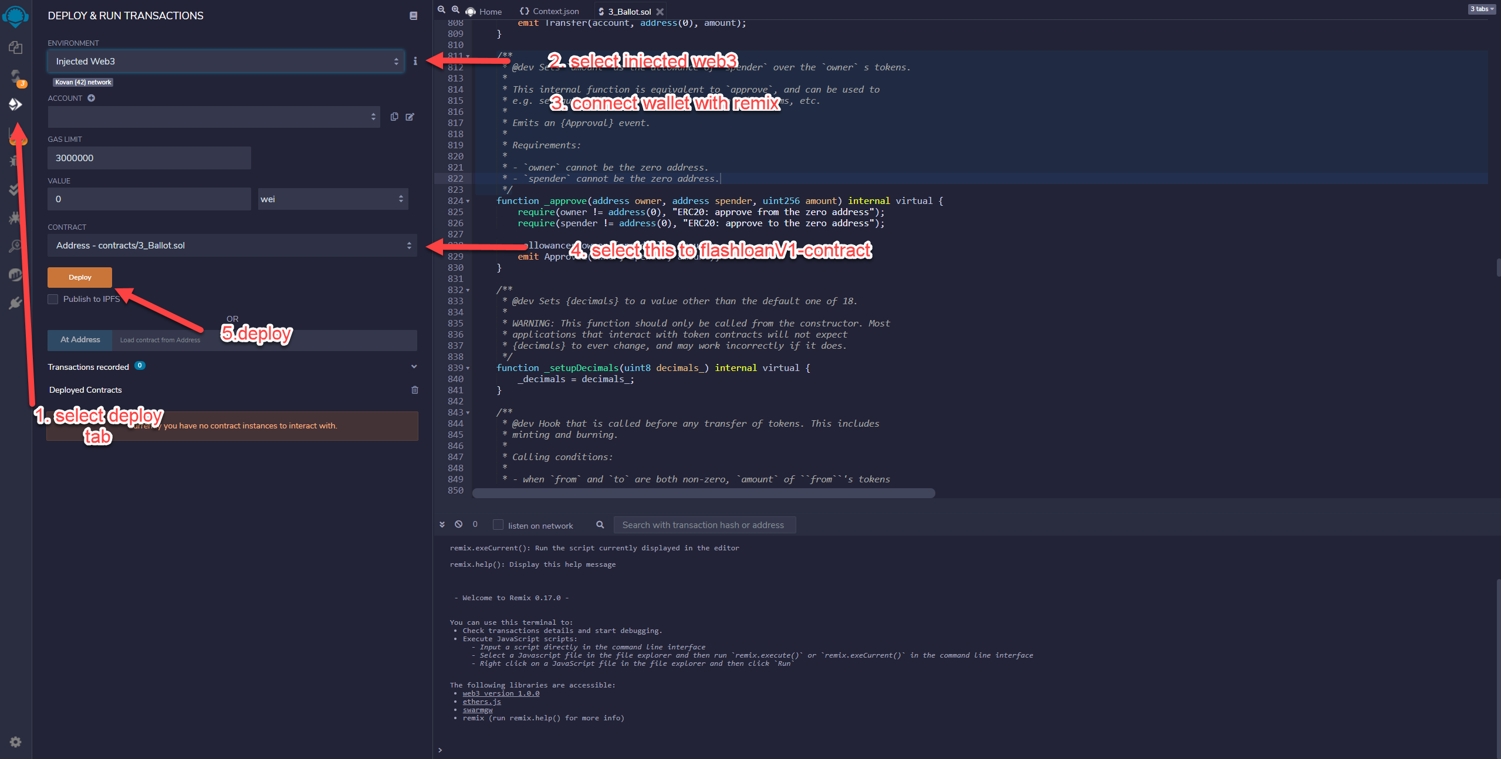

- Copy Deployed smart contract address

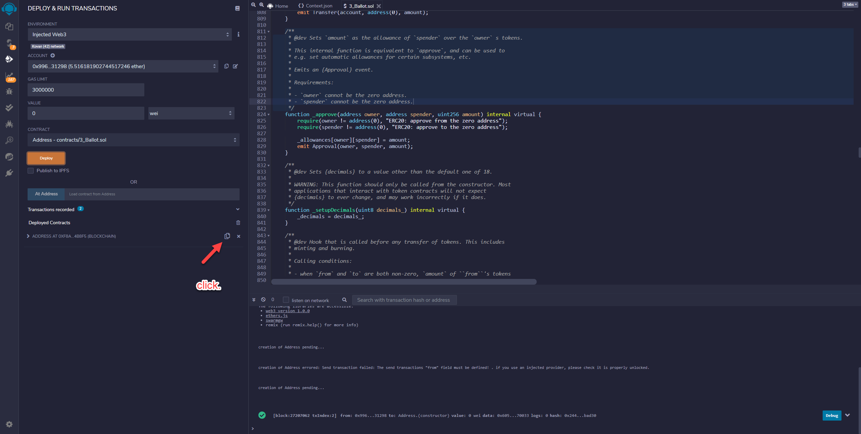

- Paste contract address to
Projects src\components\Display.jsx line 12

const smartContractAddress = "";

Set Web3 RPC URL
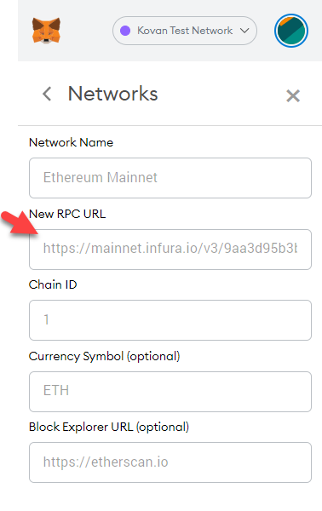
Metamask/setting/networks/ethereum mainnet

Copy RPC url.
Paste url to
Projects src\components\Display.jsx line 28

const web3 = new Web3(new Web3.providers.HttpProvider("https://mainnet.infura.io/v3/9aa3d95b3bc440fa88ea12eaa4456161"));

Install node modules
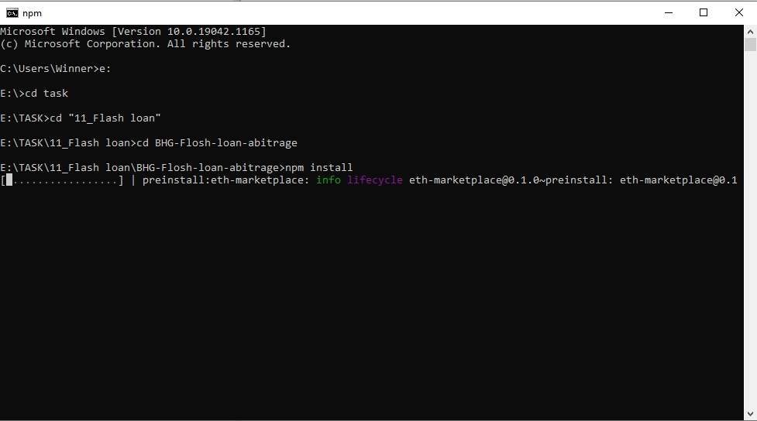

It would be takes 5 minutes.

Run
Same with “3. install node module “ but last instruction is

Npm run start

Usage
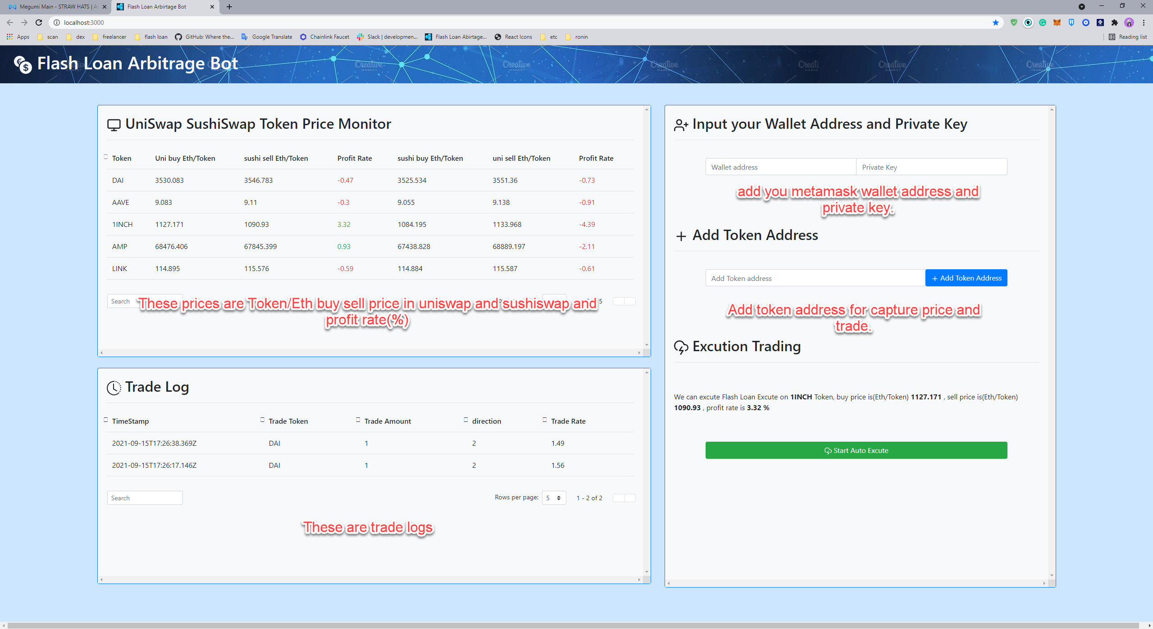

Run Flash loan bot.
- Press Start Auto execute button

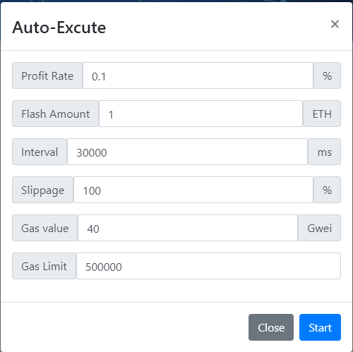

Profit rate is minimum value of profit for trade. Interval value is for Auto trades.

Profit rate value bigger than 0.5,
Flash amount must be integer.
Interval value must bigger than 30000
Gas value value must bigger than 50

If Everything is OK Than Press start.

