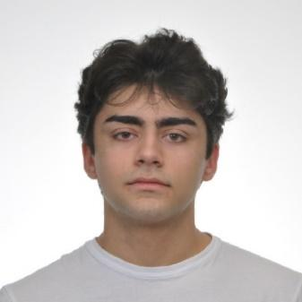
Aleksandar Angelov Yanev
aleksyanev2@gmail.com • +359 876 656 618 • Linkedin

EDUCATION
Sofia University St. Kliment Ohridski, Computer Science  GPA: 5.97/6.00 | Sofia, Bulgaria  October 2023 – Current

HONORS AND AWARDS
- INSAIT Summer Undergraduate Research Fellowship 2024 (SURF)
- Interuniversity mathematics competition 2023, 2024 – Silver medal, Bronze medal
- Open Mathematical Olympiad for University Students 2024 (OMOUS) – Silver medal (ind.), Silver medal (team)
- National Undergraduate Mathematics Olympiad 2024 – Bronze medal
- National Undergraduate Informatics Olympiad 2024, 2025 – 2nd place, 3rd place
- International Autumn Tournament in Informatics 2019, 2022 – Bronze Medal
- Romanian Masters of Informatics 2022 – Bronze Medal
- International Zhautykov Olympiad in Computer Science 2022 – Bronze Medal

RESEARCH & WORK EXPERIENCE
INSAIT - Institute for Computer Science, Artificial Intelligence and Technology Sofia, Bulgaria
Residence researcher in Computer Vision July 2024 – Current
- Researching and developing offline evaluation strategies for VLA models using real-world demonstration data
- Creating inference-time prediction ensembles to improve model performance
Smartsoft Healthcare Varna, Bulgaria
Junior Machine Learning Developer June 2023 – April 2024
- Fine-tuning and optimizing the neural network for analysis of the lumbar spine developed by the company
- Integrating and leveraging partially annotated data to boost the model’s performance
- Collaborating with machine learning experts and biologists to analyze experiments and incorporate insights from complex patient studies for model improvement

PUBLICATIONS
- SPEAR-1: Scaling Beyond Robot Demonstrations via 3D Understanding Paper
N. Nikolov, G. Albanese, S. Dey, A. Yanev, L. V. Gool, J. Zaech, D. Paudel
in Computer Vision and Pattern Recognition (CVPR), 2026
  - Created a pipeline for enriching 2D image data with 3D information which is used to improve the performance of the model
  - Creating inference-time optimizations by applying temporal smoothing for the trajectories, normalizing predictions through multiple sampling, and implementing similarity metrics to improve predictions with multiple action chunks
- InTraGen: Trajectory-controlled Video Generation for Object Interactions Paper | Code
Z. Liu*, A. Yanev*, A. Mahmood, I. Nikolov, S. Motamed, S. Zheng, D. Paudel
in arXiv preprint Nov. 2024
  - Developed synthetic datasets to enhance text-to-video generation models' understanding of physical interactions
  - Exploring diverse control methods to improve interaction comprehension in video generation
  - Working on advancing novel architectures for text-to-video generation models by incorporating the newly developed control methods, with an emphasis on achieving meaningful object interactions
- Utilizing Autoencoders for Analysis and Classification of Microscopic in Situ Hybridization Images Paper
A. Yanev, G. Momcheva, and S. Pavlov
in Proceedings of the Bulgarian Academy of Sciences, 2023

EXTRACURRICULARS
- Teaching Algorithms in Competitive Programming to 10th and 11th graders to prepare them for national and international tournaments at Olympians’ Academy since 2023.
- “Yale Book Award” recipient, Fenced in épée at “Cherno More”, “Benjamin Franklin’s Legacy Program” awardee, Ex-president of the Library and Student Councils at High School of Mathematics

