Github link to project:
- Original CSV and Empty CSV Files
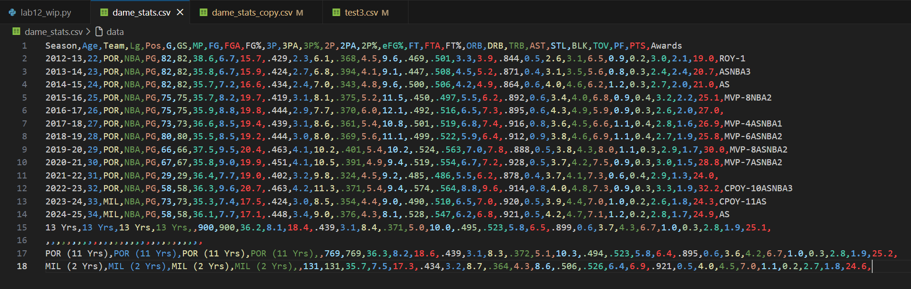
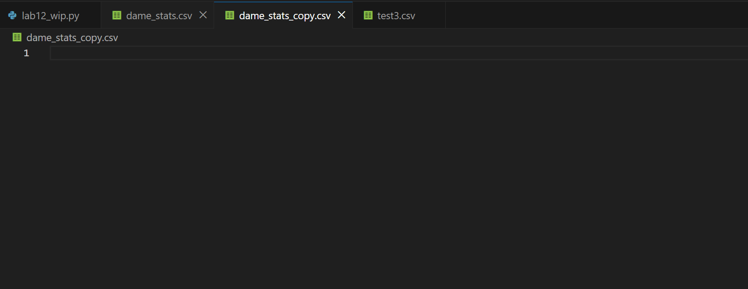
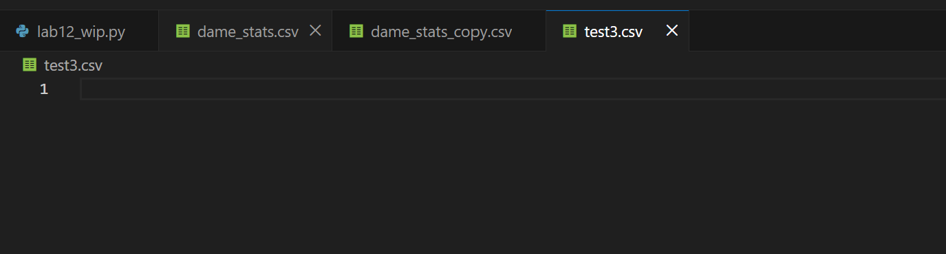

- Program on execution. There’s no user interaction. It just does everything.
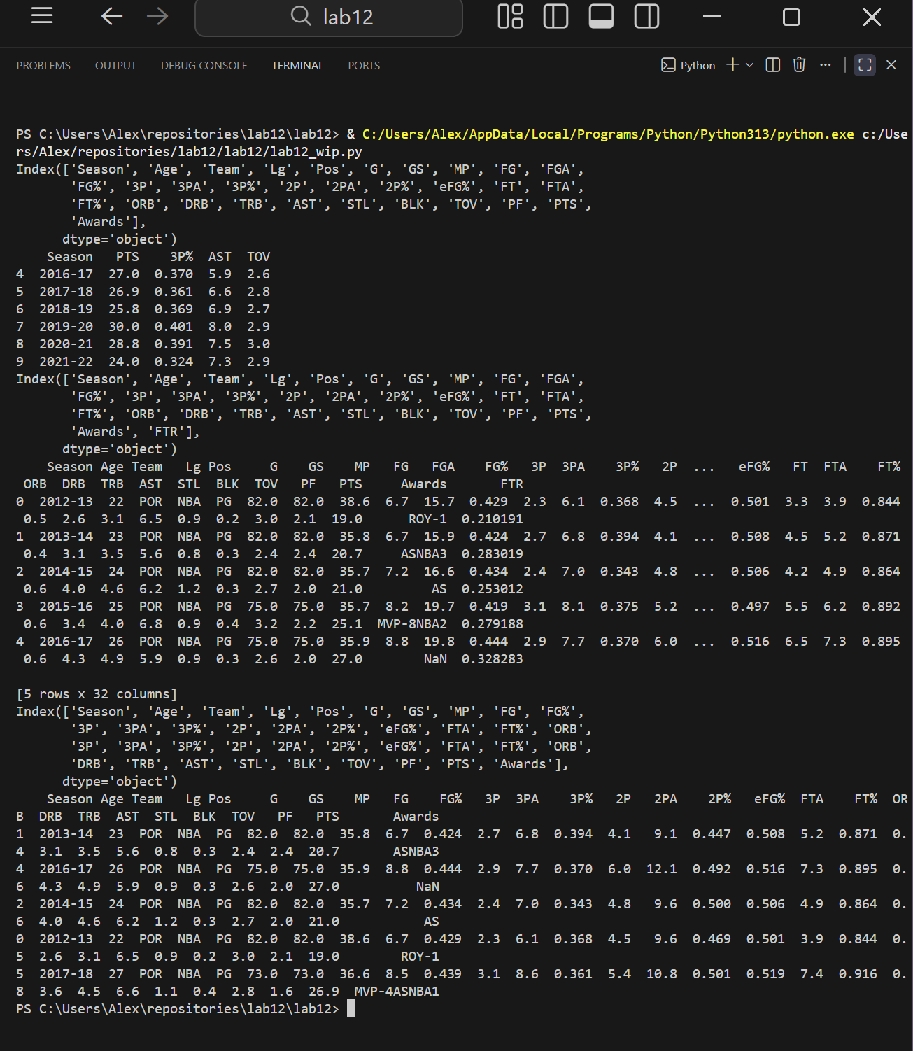

- Modified CSV files. Original data sorted by ‘AST’ column
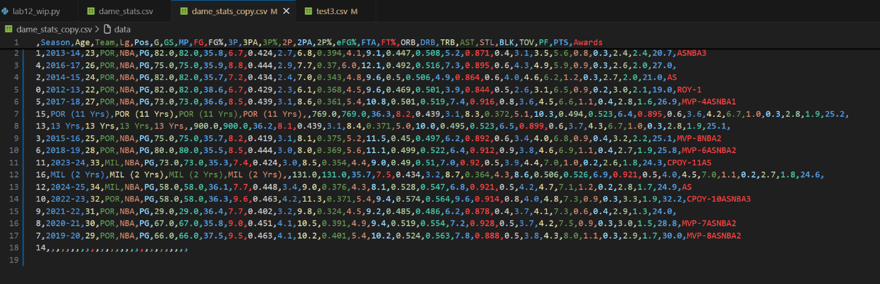
- Additional row (index 12) is added to original list, in a new CSV file
