**LearnIt**

**User’s Manual**

**TheBoys**

**Table of Contents**

**General** **2**

**Signup** **3**

**Login** **4**

**Site’s navigation** **4**

**Creating a course** **6**

**Visualizing created courses** **8**

**Deleting a course** **10**

**Joining a course** **11**

**Adding a course to courses in progress** **12**

**Adding a course to completed courses** **13**

**Visualizing forum threads** **14**

**Adding a reply** **15**

**Starting a forum thread** **16**

### 

### 

### 

### 

### 

### General

The purpose of this document is to provide a user’s guide to the application’s features.

### 

### 

### 

### 

### 

### 

### 

### Signup

In order to access the website’s features a user needs to create an account. In order to create an account, a user needs a username, a valid email and a password of at least six characters consisting of uppercase and lowercase letters and digits.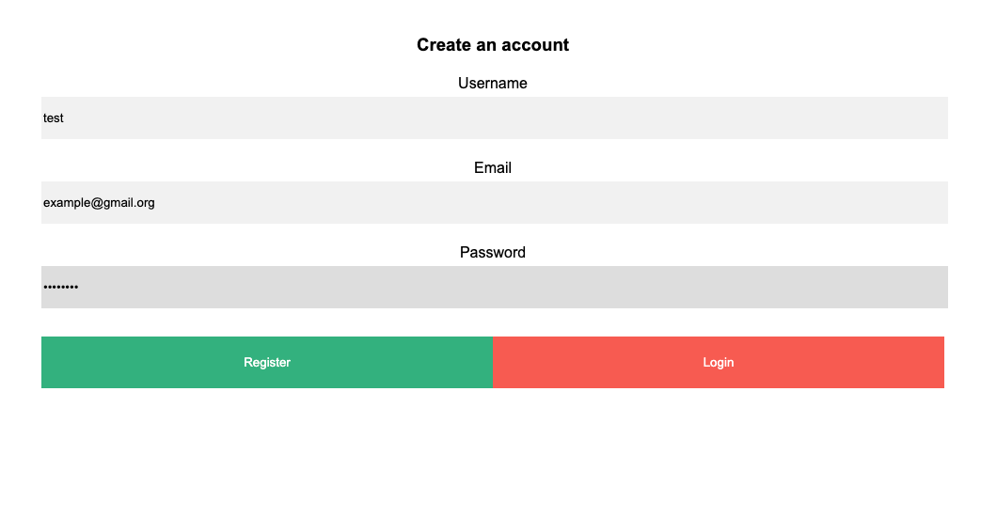

Clicking on the register button will create an account with the provided user information.

The provided username and password now can be used to login into the user’s account.

### 

### 

### 

### 

### 

### Login

Navigate to the login screen and enter your username and password.

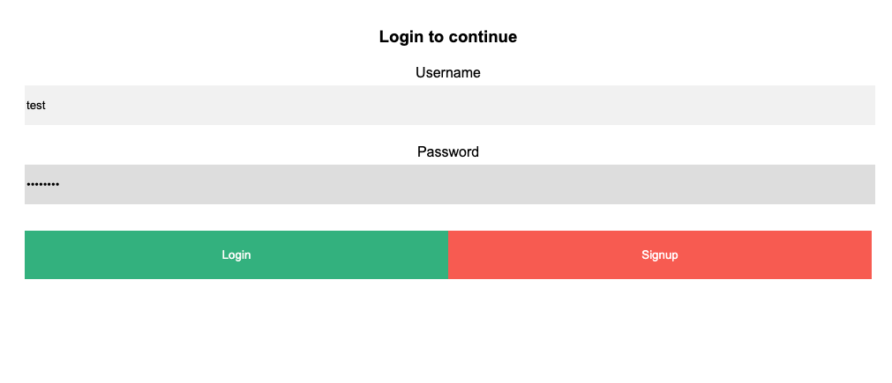

Click on the Login button. If no mistakes have been made in the username or the password the user will be logged into their account.

### 

### 

### 

### 

### 

### 

### 

### 

### Site’s navigation

The LearnIt web-service provides a convenient menu that makes navigating between the site’s features easy. The menu is located on the left hand side of the screen.

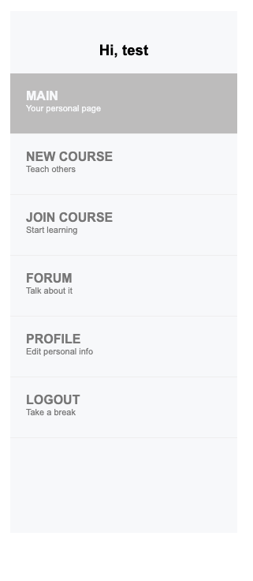

Clicking on a menu item will take the user to the corresponding page.

### Creating a course

A course can be created by filling out a Course Form.

Click on the *New Course* menu item. Enter a title for the course:

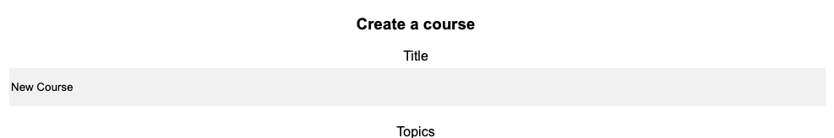

Choose a topic for the course:



Embed a video for the course(optional). Videos need to be hosted on third party video hosting services such as YouTube. In order to embed a video into your course you will need to obtain the embed code for the video from the website the video is hosted on.

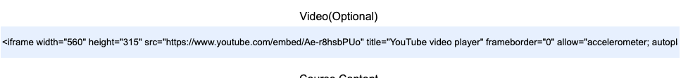

Use the textbox to add your course’s text content.

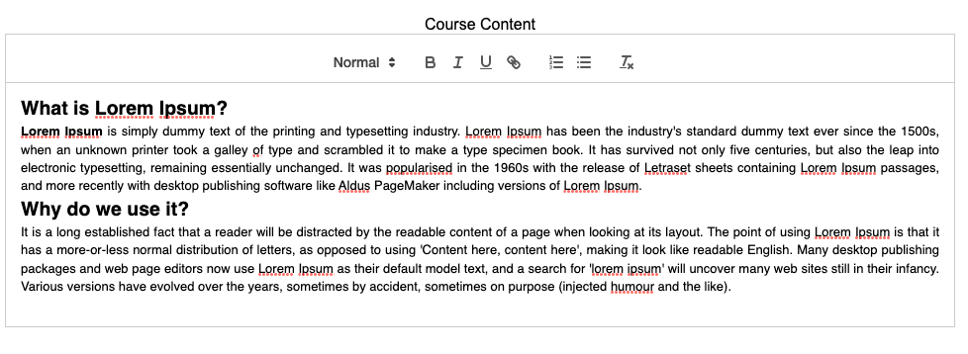

Add a mini quiz at the end of the course:

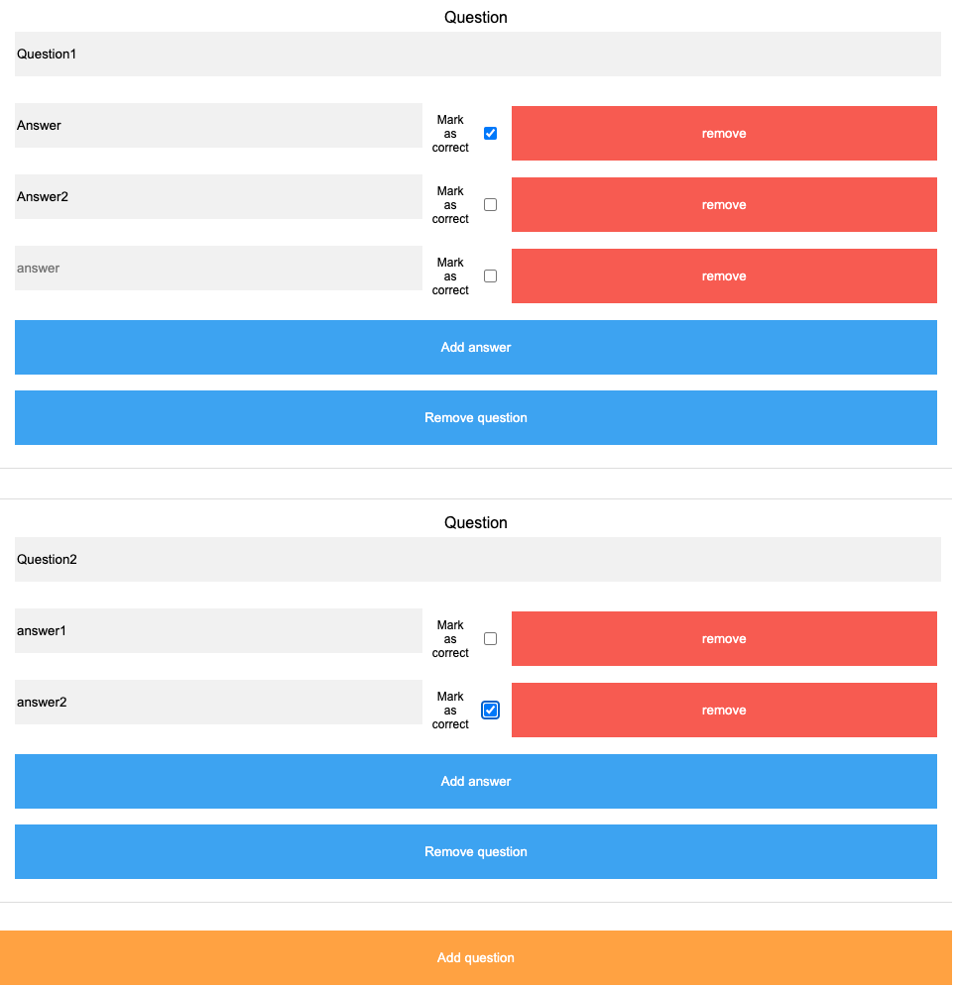

A quiz can contain an unlimited number of questions and answers. When adding questions a course creator needs to remember to add their answers and to mark the correct by checking the answer’s corresponding checkbox. Questions and their answers can be added and removed as necessary during the course creation process.

In order to submit a course click on the *Submit course* button located right below the *Add Question* button.

### Visualizing created courses

Use the side menu to navigate to the Main page. The Main page displays user statistics for three categories:

* Courses Created
* Courses Completed
* Course Saved

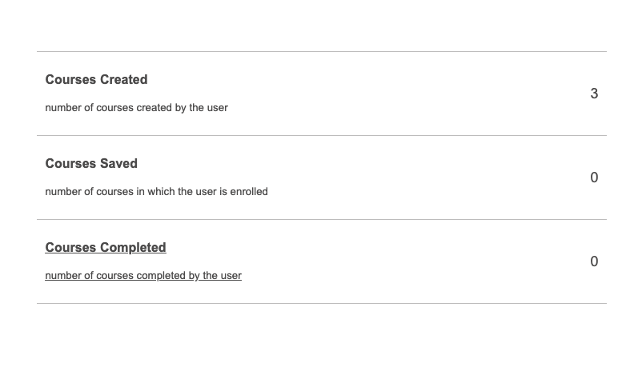

In order to visualize created courses click on the  *Courses Created* section.

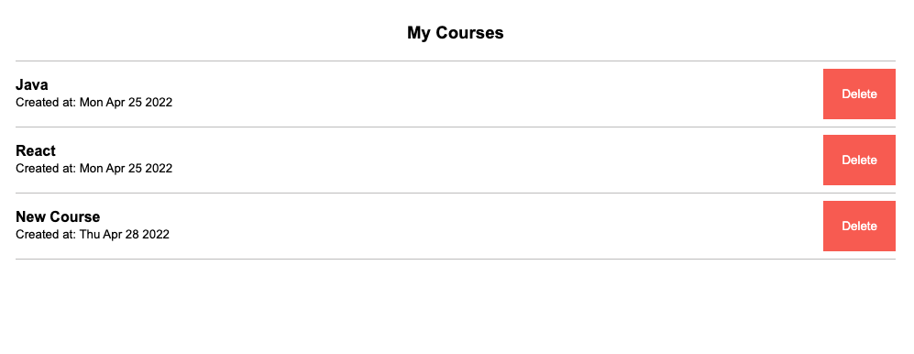

The above shows all courses created by the current user. Clicking on a course will display the full contents of the course.

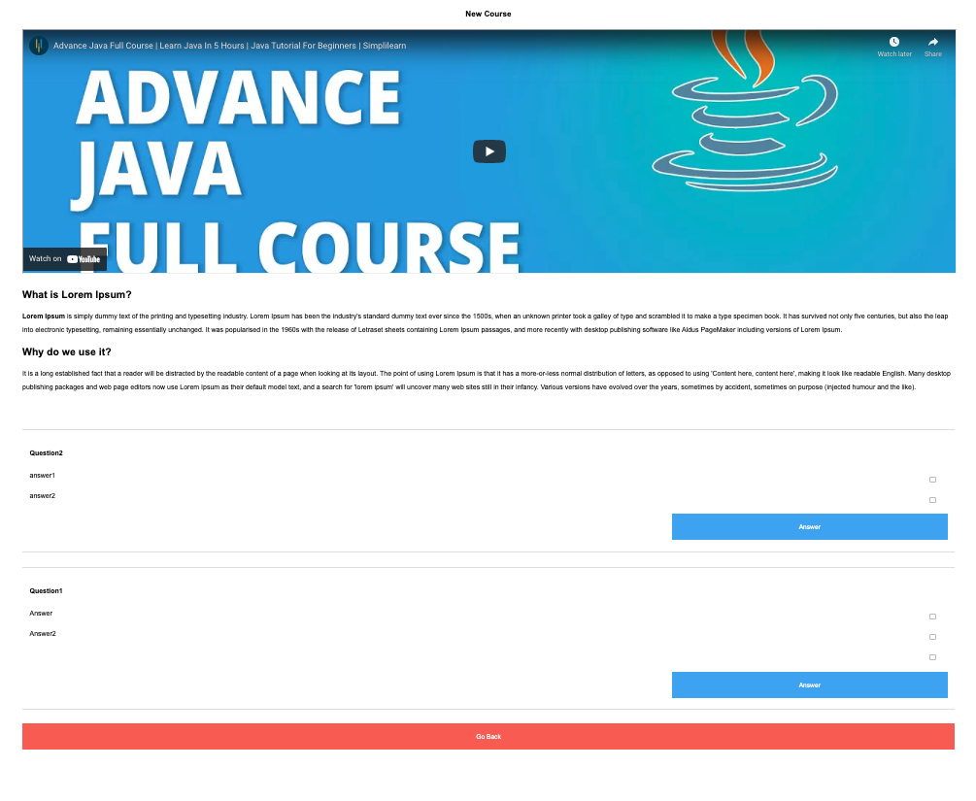

### Deleting a course

A course can be deleted by its creator if needed. In order to do that, click on  *Delete* button corresponding to a course from the courses list

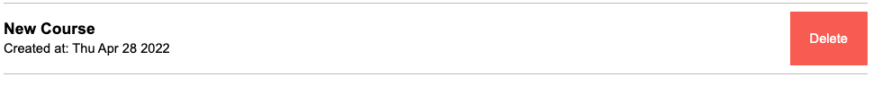

And click *Confirm*

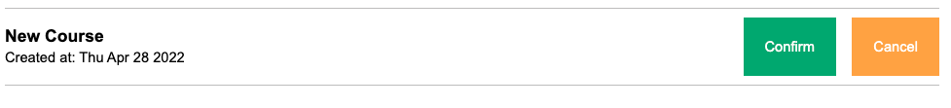

This will permanently delete the course.

### 

### Joining a course

Navigate to the Join Course page. Select the desired course category.



A list of courses will show up

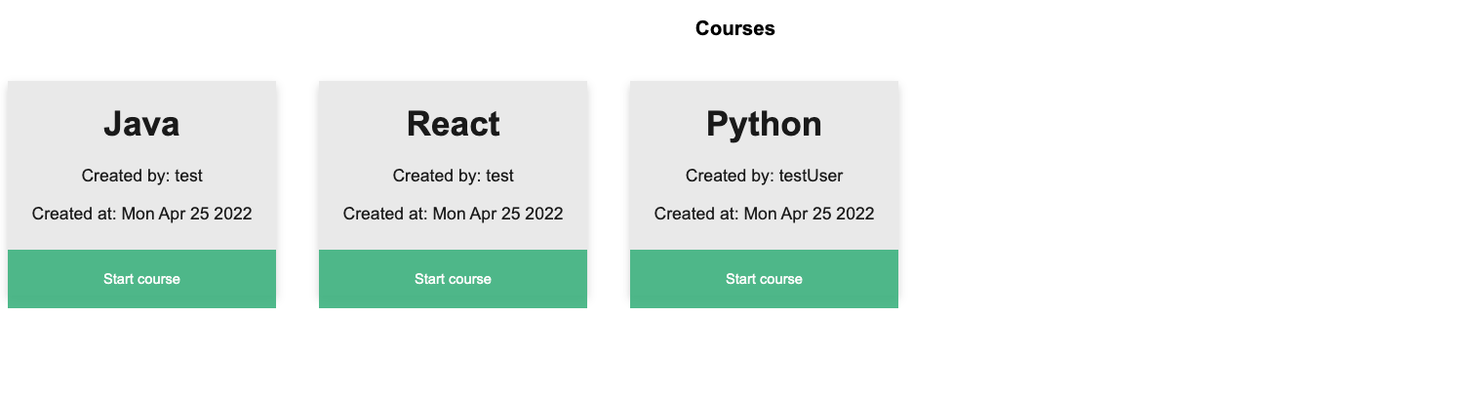

Select a course from the list to start learning.

### Adding a course to courses in progress

A course could be saved to Courses in progress if the user taking it is planning to return to it in the future. It can be done by clicking the  *Add to courses in progress button*  located underneath the course’s body.

Saving a course to courses in progress will update the Saved Courses count on the main page

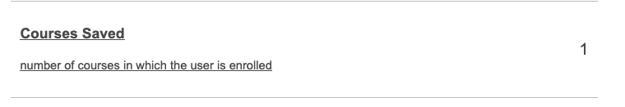

And can be visualized by clicking on this section.

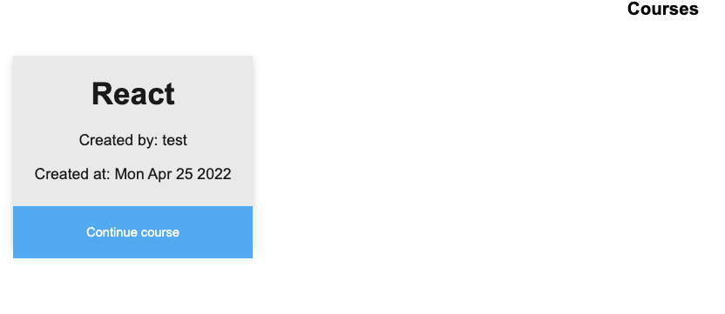

### 

### Adding a course to completed courses

Once a course has been completed the user has the option of adding it to the completed courses category. This will help the user keep track of how many courses have been taken so far and make it easier to retake completed courses in the future if it is ever needed. Marking a course as completed can be done by clicking on the corresponding button located under the course’s body.

Doing so will update the Completed courses count on the main page.

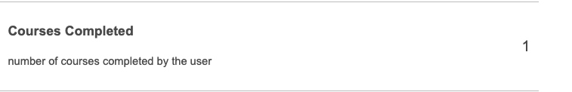

Clicking on this section will reveal all the courses completed by the current user so far.

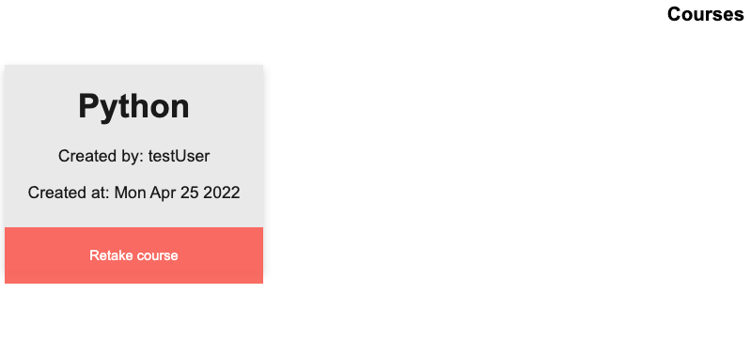

### Visualizing forum threads

Being able to ask questions is an important part of a learning process. LearnIt offers such a possibility through its Discussion forum. Accessing the forum can be done by clicking on the *Forum* item in the menu.

A list of forum threads will be displayed on your screen

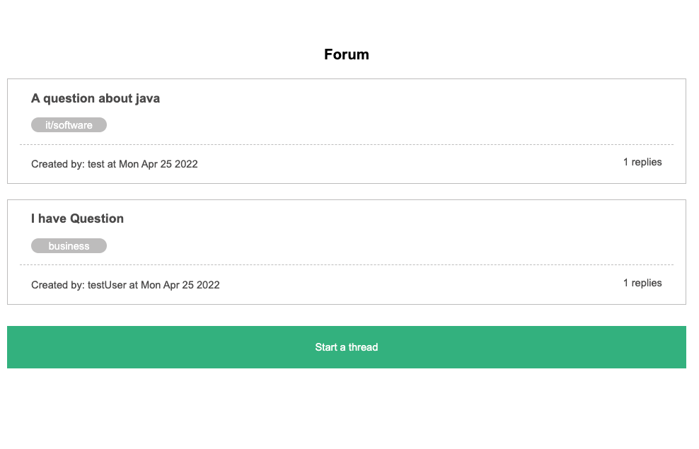

Each thread link features its name, topic, name of the user who created it as well as the number of replies in each thread.

### 

### 

### 

### 

### 

### 

### Adding a reply

Select a thread by clicking on it. Type in your reply and click the *Submit*  button

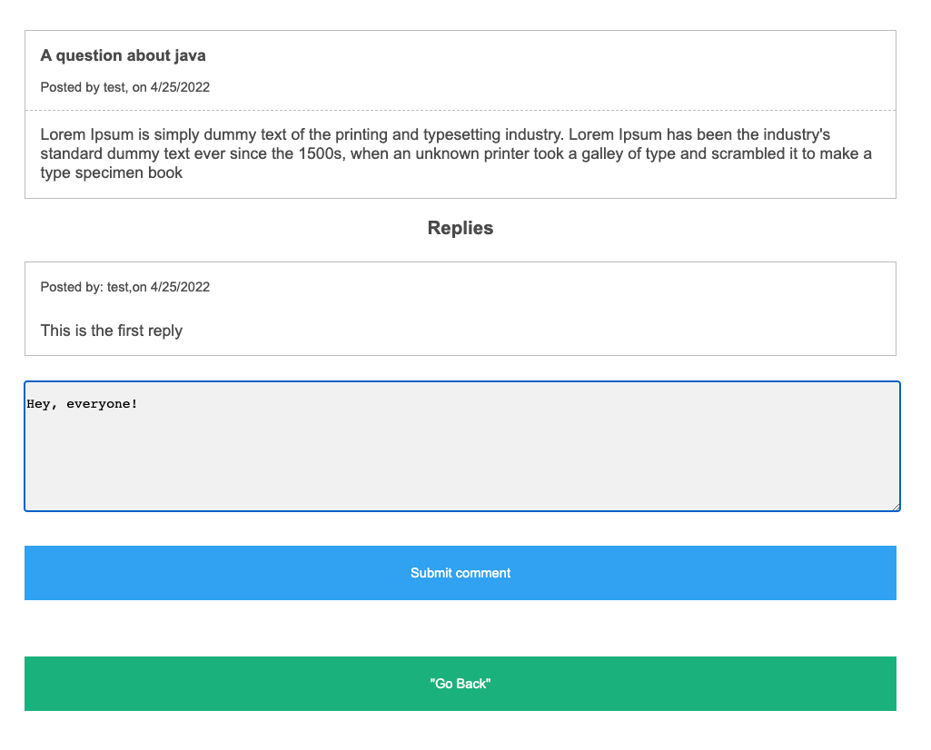

If submission was successful the reply will show up on the screen immediately

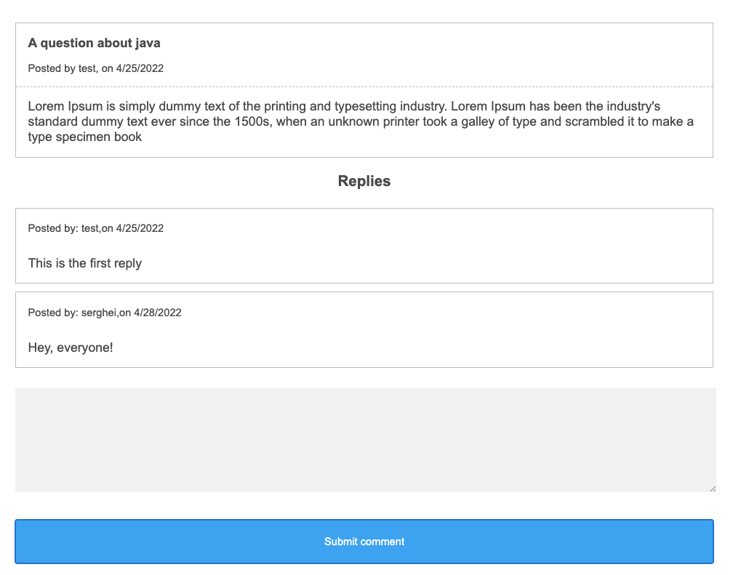

### Starting a forum thread

Any registered user has the ability to start a discussion thread. In order to do that, click on the *Start a thread* button on the forum page

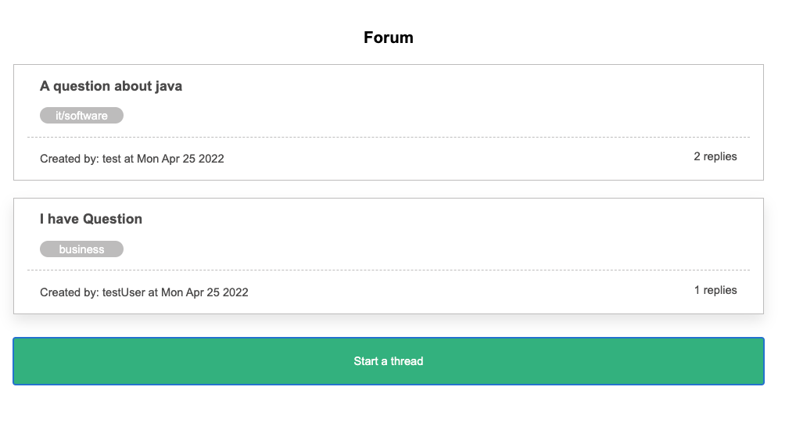

Fill out the form

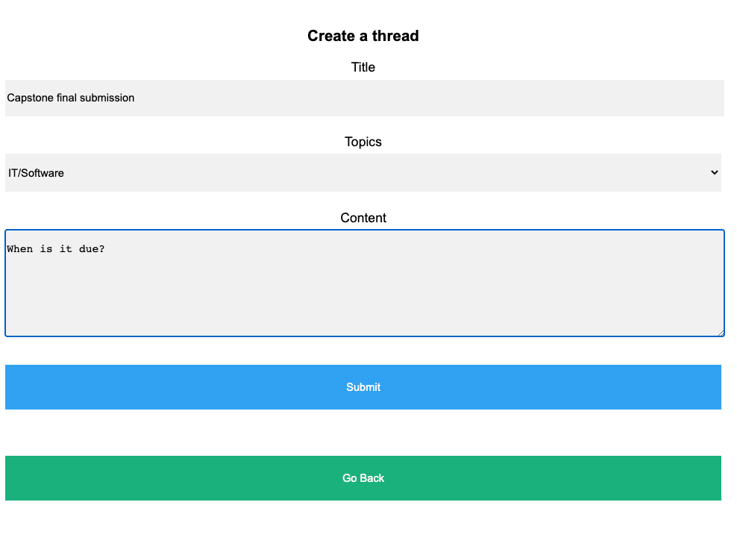

And click on *Submit.* The list of discussion threads will update immediately.

