WMSS Teacher Survey Analysis - Spring 2017

WMSS

2017-04-30

The purpose of the survey was to provide valuable information about the digital tools used in the classroom, the digital projects that are created or would like to be created by students, and the digital needs of both teachers and students.

The survey can be found at here: [WMSS Teacher Technology Survey - Spring 2017](https://forms.office.com/Pages/ResponsePage.aspx?id=LGaFrd9pi0iFpI7ChwIywBwOEpdW4ixFvc3sphI3BmxUOTk2RDdKVFVMTUowUkk4WVhZQkpXSDJPRC4u)

The raw survey results used in this analysis can be found here: [Survey_Results.xlxs](https://www.dropbox.com/s/g73h8qny4pqgwvv/Survey_Results.xlsx?dl=0)

This study is done in a reproducible research manner. All statistical analysis and figures below were created in the open source software package R. The code used to produce this anlysis can be found here: [Analysis.Rmd](https://www.dropbox.com/s/h18fc4ely70owxj/Analysis.Rmd?dl=0)

For the sake of common language, the following term definitions are provided:

Digital Tools:

Any of the applications on Launchpad that the district has put in place/purchased

Digital Projects:

Any visible or tangible creations that are made by students using technology

Digital Needs:

What specific training or programs do you need?

## Summary

Number of Responses as of 2017-04-30: **28**

## Question 1

**What barriers prohibit you from incorporating technology use into your classroom?**

|  |  |  |
| --- | --- | --- |
| Q1 Answers | Frequency | Percentage |
| Not enough devices available | 17 | 0.61 |
| Need support with connections/devices/technology issues | 12 | 0.43 |
| Need more time to develop technology-based lessons after support | 10 | 0.36 |
| Need more technology support | 5 | 0.18 |
| just getting everyone logged on with their own account. They have to type in @brevardschools.org everytime they need Launchpad. | 1 | 0.04 |
| Need grade level appropriate technology | 1 | 0.04 |
| Not in classroom | 1 | 0.04 |
| Since students are younger, having to login to every single device's wifi. | 1 | 0.04 |
| we have mutiple computers but sometimes testing limits labs | 1 | 0.04 |

## 

## Question 2

**Would you incorporate the use of technology in the classroom more often if your students had individual access to a laptop every day (one to one ratio)?**

|  |  |  |
| --- | --- | --- |
| Q2 Answers | Frequency | Percentage |
| Definitely | 24 | 0.86 |
| Most likely | 4 | 0.14 |

## 

## 

## Question 3

**Which of the following BPS supported Digital Tools do you currently use on a weekly basis?**

|  |  |  |
| --- | --- | --- |
| Q3 Answers | Frequency | Percentage |
| Office 365 | 19 | 0.68 |
| Discovery Education for videos/content | 18 | 0.64 |
| Google docs | 18 | 0.64 |
| Google apps (learn and/or share) | 12 | 0.43 |
| The Happy Scientist | 9 | 0.32 |
| Google slides | 7 | 0.25 |
| Discovery Education Boardbuilder | 6 | 0.21 |
| Google classroom | 6 | 0.21 |
| World Book online | 6 | 0.21 |
| Office Sway | 4 | 0.14 |
| Google forms | 1 | 0.04 |
| Microsoft Moviemaker | 1 | 0.04 |
| none--I am using iPads in my classroom and would like to learn more about using them | 1 | 0.04 |
| Office One Note | 1 | 0.04 |
| Power Point | 1 | 0.04 |
| Powerpoint (not weekly) and Brainpop Jr not weekly/Reading series on launchpad frequent | 1 | 0.04 |

## 

## 

[1] "Google Digital Tools (Google Apps, Classroom, Docs, Forms, or Slides) were selected by 22 of 28 respondents (78.57%)."

[1] "Google Digital Tools (Google Apps, Classroom, Docs, Forms, or Slides) were selected 44 of a possible 140 selections (31.43%)."

[1] "Microsoft Digital Tools (Office 365, Office Sway, Office One Note, Office Mix, Microsoft Moviemaker) were selected by 21 of 28 respondents (75%)."

[1] "Microsoft Digital Tools (Office 365, Office Sway, Office One Note, Office Mix, Microsoft Moviemaker) were selected 25 of a possible 140 selections (17.86%)."

[1] "Discovery Education Digital Tools (Boardbuilder, videos/content) were selected by 18 of 28 respondents (64.29%)."

[1] "Discovery Education Digital Tools (Boardbuilder, videos/content) were selected 24 of a possible 56 selections (42.86%)."

## Question 4

**Which of the following BPS supported Digital Tools would you prefer to receive training on?**

|  |  |  |
| --- | --- | --- |
| Q4 Answers | Frequency | Percentage |
| Google classroom | 17 | 0.61 |
| Microsoft Moviemaker | 13 | 0.46 |
| Google forms | 12 | 0.43 |
| Google docs | 11 | 0.39 |
| Google apps (learn and/or share) | 8 | 0.29 |
| The Happy Scientist | 6 | 0.21 |
| Discovery Education-for BoardBuilder | 5 | 0.18 |
| Office Mix | 5 | 0.18 |
| Office One Note | 5 | 0.18 |
| Office Sway | 5 | 0.18 |
| World Book online | 5 | 0.18 |
| Discovery Education-for videos/content | 4 | 0.14 |
| Google slides | 4 | 0.14 |
| Animoto | 1 | 0.04 |
| Ebeam programs and free apps for implementation | 1 | 0.04 |
| I clicked all those Office ones simply because I have no idea what they are. | 1 | 0.04 |
| Performance Matters, Premier Literacy Suite | 1 | 0.04 |
| presentations | 1 | 0.04 |
| Prezi | 1 | 0.04 |

## 

## 

[1] "Google Digital Tools (Google Apps, Classroom, Docs, Forms, or Slides) were selected by 23 of 28 respondents (82.14%)."

[1] "Google Digital Tools (Google Apps, Classroom, Docs, Forms, or Slides) were selected 52 of a possible 140 selections (37.14%)."

[1] "Microsoft Digital Tools (Office 365, Office Sway, Office One Note, Office Mix, Microsoft Moviemaker) were selected by 19 of 28 respondents (67.86%)."

[1] "Microsoft Digital Tools (Office 365, Office Sway, Office One Note, Office Mix, Microsoft Moviemaker) were selected 29 of a possible 140 selections (20.71%)."

[1] "Discovery Education Digital Tools (Boardbuilder, videos/content) were selected by 6 of 28 respondents (21.43%)."

[1] "Discovery Education Digital Tools (Boardbuilder, videos/content) were selected 9 of a possible 56 selections (16.07%)."

## Question 5

**Based on the previous question, what would you say is a priority for you to receive training on first?**

|  |  |  |
| --- | --- | --- |
| Q5 Answers | Frequency | Percentage |
| Google classroom | 10 | 0.36 |
| Google Apps | 4 | 0.14 |
| Microsoft Moviemaker | 4 | 0.14 |
| Google forms | 3 | 0.11 |
| Different and new kinds of technology avaliable for me and my students to use in the classroom. | 1 | 0.04 |
| Google Classroom uses for music! | 1 | 0.04 |
| Google docs | 1 | 0.04 |
| Haven't heard of either, but I feel like they are related? | 1 | 0.04 |
| I just need the time to play with them without distractions. Jodi has done a great job training the kids as well as us | 1 | 0.04 |
| K-2 Free apps for Ipads, Ebeam Primary ideas, Whether we have authorization to download apps on IPADs etc | 1 | 0.04 |
| Microsoft moviemaker | 1 | 0.04 |
| Premier Literacy Suite | 1 | 0.04 |
| The Happy Scientist | 1 | 0.04 |

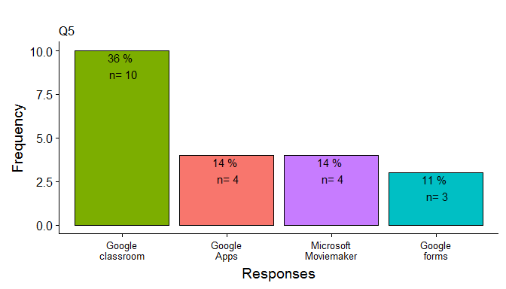

## 

## Question 6

**When would technology training on the above mentioned Digital Tool be most convenient for you?**

|  |  |  |
| --- | --- | --- |
| Q6 Answers | Frequency | Percentage |
| Wednesdays at early release | 21 | 0.75 |
| During a faculty meeting | 12 | 0.43 |
| During planning | 7 | 0.25 |
| Optional after school (bi-weekly) | 6 | 0.21 |

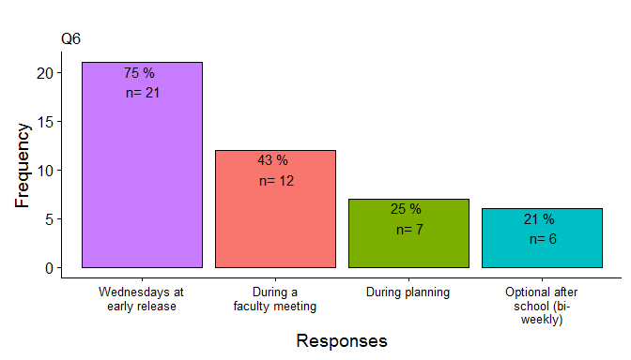

## 

## Question 7

**What type of Digital Projects that you believe incorporate technology creatively do your students CURRENTLY create using any of the BPS Digital Tools?**

|  |  |
| --- | --- |
|  | Q7 Answers |
| 1 | Boardbuilder for SS reports, Google slides for presentations |
| 2 | None using BPS Digital Tools; not user friendly for younger students |
| 3 | Creating prezis detailing information that they have learned from a text. |
| 4 | NA |
| 5 | The students research a topic and create a presentation with any tool learned. |
| 6 | Photo Stories, Videos |
| 7 | My students are using technology to read books - IStation, Tumblebooks, Xtra math |
| 8 | My students use an app called Show Me on the iPad. |
| 9 | stop motion shorts |
| 10 | None |
| 11 | google share/learn |
| 12 | Powerpoint lessons that include speaking and listening, reading, social studies content. Sharing of writing stories, Justification of math answers, songs written on content area or concepts-Doc cam |
| 13 | Google classroom - Science fair |
| 14 | None |
| 15 | My students create writing projects using the show me app on ipads. |
| 16 | I currently create sways, and sways. |
| 17 | Boardbuilder |
| 18 | Using Power Point to write and illustrate stories |
| 19 | Boardbuilder, Google Slides, Prezi, Animoto, IMovie |
| 20 | animoto, google slides, powerpoint |
| 21 | Slides |
| 22 | presentations using google slides, research on line and saving on googledocs |
| 23 | My students do not currently create digital projects in math at this time |
| 24 | They create performance recordings on the IPAd and movie maker app. |
| 25 | Google Docs Reports and Google Slides Presentations, Animoto presentations |
| 26 | Google Slides |
| 27 | My students create presentations using Google Docs, Google Slides, and Microsoft Sway. In addition, my students answer questions using Google Classroom. My students have completed research reports using Microsoft Sway and Google Slides. |
| 28 | Creating student generated math tutorials. |
| Q7  WORD | FREQ |
| google | 13 |
| slides | 9 |
| students | 9 |
| create | 6 |
| presentations | 5 |
| math | 4 |
| animoto | 3 |
| app | 3 |
| boardbuilder | 3 |
| reports | 3 |
| research | 3 |
| stories | 3 |

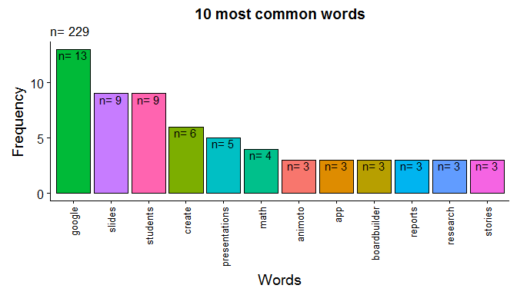

## 

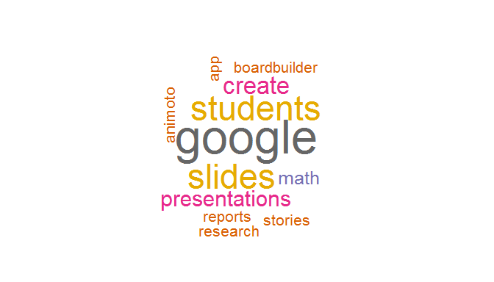

## Question 8

**What type of Digital Projects that you believe incorporate technology creatively WOULD your students create using any of the BPS Digital Tools if you had a 1:1 student to laptop ratio?**

|  |  |
| --- | --- |
|  | Q8 Answers |
| 1 | Movies using Movie Maker; Sway presentations |
| 2 | Google forms, google slides |
| 3 | Research projects, stories, informational books/newsletters, digital storytelling, other |
| 4 | None |
| 5 | Same as #7. They also would benefit from learning to type properly :) |
| 6 | Videos and Public Service Announcements for CCTV |
| 7 | They would be able to use technology for word work activities, creating stories, writing stories, etc. |
| 8 | I believe they could use google classrooms and documents to work on projects together. |
| 9 | endless...presentations, prezis, stop motion films, interviews, etc. |
| 10 | None |
| 11 | google share/learn |
| 12 | I could have students recording their individual reading and fluency. They could then watch themselves to evaluate and work on their individual feedback and progress. They could then have a recording from beginning of the year, mid year, and end of the year. Each child could store/save this when there are multiple laptops and memory that would be a small amount of storage to one laptop. Then they could see and have record of progress and have reflection opportunities. We know this is effective through research. |
| 13 | Moviemaker |
| 14 | None |
| 15 | I could have all of my students work on show me at the same time in order to publish their writing. |
| 16 | I would create Microsoft moviemaker, and board builder. |
| 17 | Google Classroom, Microsoft Moviemaker |
| 18 | Story summaries using movie maker |
| 19 | Access to programs to practice and use skills and strategies. Google Docs/Classrooms. Presentations |
| 20 | movie maker. google slides |
| 21 | docs/ forms |
| 22 | movies, more projects using current affairs since technology will be readily available |
| 23 | they would create games for students to review concepts, movies to teach a concept and flip a classroom |
| 24 | Research projects embedded with music clips/photos for better understanding/sharing of knowledge on composers and history of music. |
| 25 | Instead of working with partners or teams, a 1:1 ratio would enable the students to collaborate more online when doing projects in Google Slides and Google Docs Reports. At this time without a 1:1 ratio, not everyone is engaged because one might be waiting, or another student might 'take over' and do it all on the computer without conferring with their teammates. Also there is a technology literacy gap with students, so usually the students who know how to navigate computers well will take over and do it quickly, leaving the 'slower' with technology students without any more experience with the tools. It increases the gap as the quicker students get more practice where the slower students get left out and get less practice. |
| 26 | Google Classroom, SWAY, Google Slides, Google Forms, Discovery Board Builder, Google Docs, video making, Kahoot, quizlet etc... |
| 27 | Presentation of learned material using Board Builder or Microsoft Sway. Jigsaw to teach material using Google Docs, Google Draw, Google Slides, or Microsoft Sway. |
| 28 | More research, compare/contrast projects, finding evidence in solving problems. |
| Q8  WORD | FREQ |
| google | 16 |
| students | 9 |
| projects | 6 |
| slides | 5 |
| docs | 4 |
| microsoft | 4 |
| research | 4 |
| sway | 4 |
| technology | 4 |
| work | 4 |

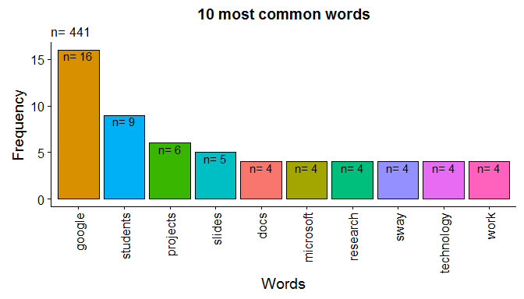

## 

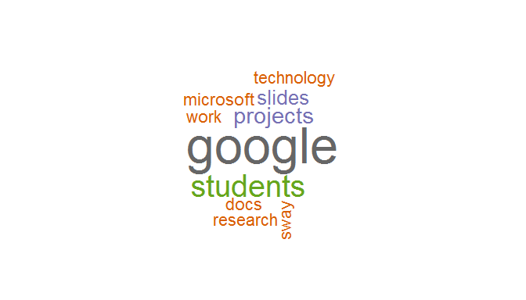

## Question 9

**What Digital Needs do you have in order to make these Digital Projects a success?**

|  |  |
| --- | --- |
|  | Q9 Answers |
| 1 | training on MovieMaker |
| 2 | An easier way to login students into the wifi on laptops |
| 3 | Training, time to implement and more laptops. |
| 4 | None |
| 5 | I like the 1 to 1 idea |
| 6 | More laptops |
| 7 | Technology that works everyday. laptops that have apps for my students to use. |
| 8 | 1:1 student to laptops ratio. |
| 9 | that depends - if we don't have 1:1 laptops then I don't have any digital needs because it is hard to make the projects a success. |
| 10 | Laptops/Desktops |
| 11 | google share/learn |
| 12 | Having tools not tied up to FAIR testing, IStation, and FSA makes more flexibiliity and greater potential for project possibilities |
| 13 | training |
| 14 | None |
| 15 | More Ipads and laptops. |
| 16 | more laptops for each student |
| 17 | enough laptops for each student |
| 18 | More mini Ipads (I have two, it would be nice to have at least 4 more.) |
| 19 | Laptops and Ipads |
| 20 | discovery, google classroom |
| 21 | laptops with longer battery life for use through out the day. |
| 22 | We do not have enough laptops. We need enough computers so that they are readily available to all our students. |
| 23 | access to laptops daily |
| 24 | Ipads or laptops. |
| 25 | More laptops, iPads, tablets. Training on how to use digital assessment tools to tally 88 responses in a quicker manner. |
| 26 | I need laptops for each student, time and training |
| 27 | I need 7 additional laptops to have 1 to 1 computer to student ratio. To have 1 to 1 laptop ratio I would need 12 laptops. For each laptop I need mice. I have been purchasing mice from Ebay and Goodwill for my students out of my own pocket because the school does not have any mice. |
| 28 | 22 computer laptops with efficient Wi-Fi access |
| Q9  WORD | FREQ |
| laptops | 19 |
| ipads | 5 |
| need | 5 |
| student | 5 |
| training | 5 |
| students | 4 |
| enough | 3 |
| mice | 3 |
| ratio | 3 |
| use | 3 |
|  |  |
|  |  |
|  |  |
|  |  |
|  |  |
|  |  |
|  |  |
|  |  |
|  |  |
|  |  |
|  |  |
|  |  |
|  |  |
|  |  |
|  |  |
|  |  |
|  |  |
|  |  |
|  |  |
|  |  |
|  |  |
|  |  |
|  |  |
|  |  |
|  |  |
|  |  |
|  |  |
|  |  |

## Question 10

**Are you familiar with Blended Learning?**

|  |  |  |
| --- | --- | --- |
| Q10 Answers | Frequency | Percentage |
| No | 14 | 0.50 |
| Somewhat | 10 | 0.36 |
| Yes | 4 | 0.14 |

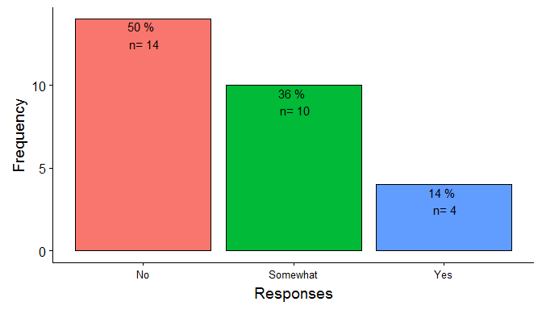

## Question 11

**Would you be willing to be a part of a technology committee at our school?**

|  |  |  |
| --- | --- | --- |
| Q11 Answers | Frequency | Percentage |
| No | 16 | 0.57 |
| Yes | 10 | 0.36 |

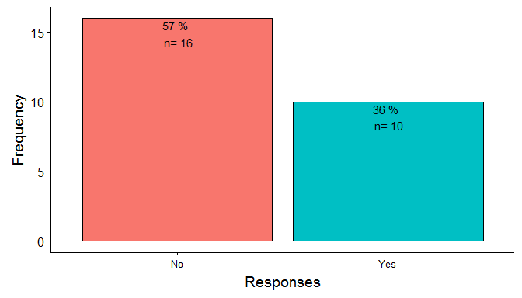

## Question 12

**Are you interested in a technology integrator conducting a workshop on some innovative ways to integrate technology?**

|  |  |  |
| --- | --- | --- |
| Q12 Answers | Frequency | Percentage |
| Yes | 19 | 0.68 |
| No | 9 | 0.32 |

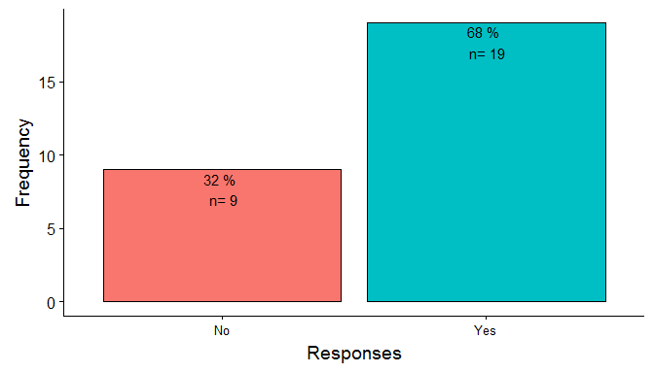

## Analysis

The survey was sent out in April of 2017 to all WMSS teachers and administrators and had 28 respondents. If all respondents were classroom teachers, that is a 100% response rate with a 0% margin of error. If all respondents are not classroom teachers, we can assume a population size of 35 (28 classroom teachers and 7 specialty teachers) and at the 95% confidence level, we would have a 9% margin of error. The survey was an anonymous survey, so it is currently unknown if all respondents were classroom teachers. It is anticipated to send the survey out again in the fall of 2017 to get additional input from the teachers.

Over half (61%) of the respondents identified *a lack of devices* as number one barrier to incorporating technology in the classroom. The following issues were also chosen respectively: (43%) - *need support with connections/devices/technology issues*, (36%) - *Need more time to develop technology-based lessons after support*, (18%) - *Need more technology support*. Combining items 2 and 4 as *technology support issues* (13/28 or 46%) would bring that item to the 2nd most important issue. 100% of respondents responded that they would *definitely* or *most likely* incorporate the use of technology in the classroom more often if students had individual access to a laptop every day (one to one ratio).

Respondents identified Digital Tools that they currently use on a weekly basis in the classroom. Office 365 (68% of respondents), Discovery Education for videos/content (64%), and Google Docs (64%) were identified as the top three tools used by teachers. The Google *suite* of Digital Tools (22/28 or 79% of respondents) was used most on a teacher-by-teacher basis followed by Microsoft (21/28 or 75%) and Discovery Education (18/28 or 64%). For overall use, the Discovery Education *suite* of Digital Tools (24/56 or 43%) were selected as the most widely used tools followed by Google (44/140 or 31%) and Microsoft (24/140 or 18%).

In response to requests for training on the BPS Digital Tools, respondents identified a need for training in the Google *suite* of Digital Tools as the top priority. Google Classroom (61% of respondents) was the most requested followed by Microsoft Moviemaker (46%), Google Forms (43%), Google Docs (39%), and Google Apps (29%). On a teacher-by-teacher basis, training on the Google *suite* of Digital Tools (23/28 or 82% of respondents) was most requested, followed by Microsoft (19/28 or 68%), The Happy Scientist (6/28 or 21%), and Discovery Education (6/28 or 21%). Survey-wide, the Google *suite* of Digital Tools was selected 52 of a possible 140 selections (37.14%), followed by Microsoft (29/140 or 21%) and Discovery Education (9/56 or 16%). The Google *suite* of Digital Tools was also identified as the highest priority for training by the respondents. Google Classroom was chosen by 10 of 28 respondents (36%) as the highest priority followed by Google Apps (4/18 or 14%, Microsoft Moviemaker (4/28 or 14%), and Google Forms (3/28 or 11%).

Respondents identified *Wednesdays after early release* (21/28 or 75%) as the best time to receive training on Digital Tools. *During a faculty meeting* (12/28 or 43%), *During planning* (7/28 or 25%), and *Optional after school* (6/28 or 21%) were the following choices by the respondents.

When asked to identify the types of *creative* Digital Projects that students **CURRENTLY** create using the Digital Tools, *Google slides and presentations* were identified as the most common type. Math, animoto, boardbuilder, and story-based projects were also identified as being popular among teachers. These project types were identified using a common word search algorithm. A thorough reading of the responses to Question 7 is advised to get a better understanding of these results.

Respondents were also asked to identify the types of *creative* Digital Projects that students **WOULD BE ABLE** to create using the Digital Tools, if they had a 1:1 student to laptop ratio. Teachers again identified Google Digital Tools-based project such as slide and presentations. Respondents also identified projects types such as Microsoft Tools-based projects and increased research and technology-based projects. These project types were also identified using a common word search algorithm. A thorough reading of the responses to Question 8 is advised to get a better understanding of these results.

Respondents were asked to identify any Digital Needs that that might have in order to make previously mentioned Digital Projects a success. The respondents consistently identified *laptops* as the number one need (17 of 28 respondents or 61%). Other Digital Needs identified included tablets, training, computer mice, and a 1:1 student to laptop ratio. A thorough reading of the responses to Question 9 is advised to get a better understanding of these results.

Fifty percent of respondents were NOT familiar with Blended Learning and the other fifty percent were *familiar* or *somewhat familiar* with the concept.

Most respondents (57%) were NOT willing to be a part of a technology committee at WMSS. 10 of the 28 respondents (36%) were willing to be a part of a technology committee at WMSS. We should seek these respondents out for more information.

19 of 28 respondents (68%) were interested in a technology integrator conducting a workshop on some innovative ways to integrate technology at WMSS. We should follow up on this and get training based upon the needs identified in this survey.