Week 2

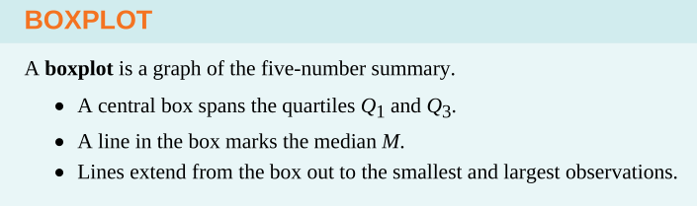
Fig 1. a description of what box plots are.

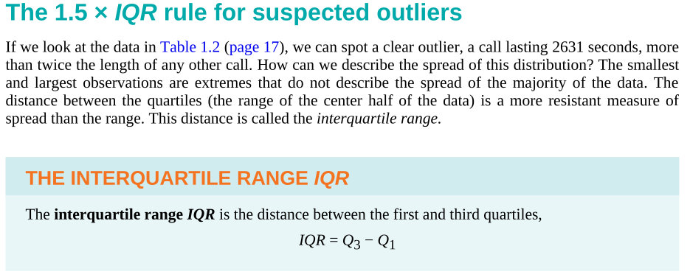
Q1 is the lower fence/bound. Or the 25%.
Q3 is the upper fence/bound. Or the 75%.
Anything outside these bounds are considered outliers.

* Can’t draw a box plot without first stating our outliers.
The rule is the the outlier = 1.5 * IQR.
We need the lowest outlier and the highest outlier, and these are at the very ends of our box plots.

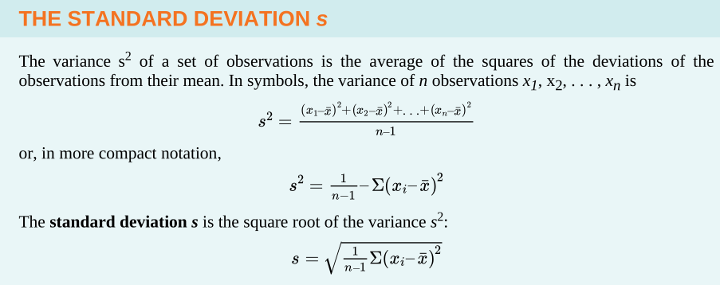
* Usually, the compact notation is used in academics.
We square the function in the summation because it is smooth (Machine Learning) as opposed to an abs value.
Mean and std are used to describe the spread of the data.
For skewed data, we use the 5-number summary.

In statistics, we can stretch or shrink our data, just like in Algebra/Calculus.

Density Curve
1.) Plot data
2.) outliers
3.) calculations for a numerical summary
4.) re-do
A density curve is always equal to 1 and the area is computed as a decimal (e,g,. 0.245 or 24.5%).
The area under the curve is also considered the probability.
Right skew: Median < Mean. Half observations are less than the mean.
Left skew: Mean < Median. Half the observations are greater than the mean.

Normal Distribution
N(M, SD)

Standard Normal Distribution
N(0,1)

A Normal Distribution can be transformed into a Standard Normal Distribution using a z-score.

=======================================================================
======= 2025-08-28=======================================================
Three sigma rule: Outlier > 3sigma + mu & Outlier < 3sigma + mu
sigma is used as a standard deviation on the Normal Distribution.
This is a good way to detect outliers.

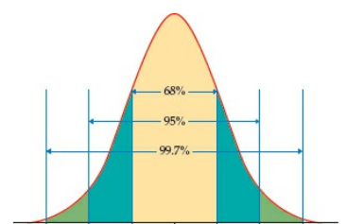

1 – Whatever is shaded / 2 = the probability you want.
For example, you want to know the probability of the green area. You want to consider the blue and yellow, then subtract by 1, then divide.

For any raw data, you can find a standard distribution by converting them to a z-score.
Sigma = SD
Mew = Mean

Note to self: Search up linear transformation. Z = bx + a

More about z-tables:
Covers the Standard Normal Distribution

0.percentage = P(Z <> z-score)
e,g. 0.0028 = P(Z > 2.77)
0.percentage is the probability

It is easier to think of negative values and positive values as absolute values, however we will subtract from 1 dependent on if the goal is to see the probability as greater than or less than the z-score we are testing.

Z can take any real number.
We also have to use the z-table score that is the closest to the z score we are testing against.

The area in between two z scores is. The first z-score minus the second z-score = the area in between.

Or 1 - (1st z-score + 2nd z-score) = area in between

0.1 = P(X{this is just a random data point} < x*)
We can do some algebra on the z calculations to get z(sigma)+mu = x value.

So, if your data is normally distributed, you can also draw a line (fact check this plz).

Ex)
When plotting a z-table, you can plot like (z,x). So basically, you want to fetch the x-score first, do the z-score conversion, then plot the data (we place z on the x-axis, and x on the y-axis).

Q-Q plot, is like a scatter plot?

A normal QQ plot will look like a straight line, and a skewed QQ plot will show a curve, a uniform distribution will show an s-curve (keep in mind that it is a scatterplot-style, being that it will plot each z-score according to the previous example).

