**Quick** **Start Tutorial**

English

**Comic Book Reader**

**http://wfpbookreader.codeplex.com/**

Table of Contents

[Introduction 3](#_Toc330490701)

[Warning 3](#_Toc330490702)

[Start… 4](#_Toc330490703)

[The home page 4](#_Toc330490704)

[Create a library… 5](#_Toc330490705)

[Read a book … 5](#_Toc330490706)

[Open a book 6](#_Toc330490707)

[Naviguate in a book 6](#_Toc330490708)

[The mouse 6](#_Toc330490709)

[The keyboard 7](#_Toc330490710)

[Optimize your reading 7](#_Toc330490711)

[Full screen mode 7](#_Toc330490712)

[Page adjustment 7](#_Toc330490713)

[Double page mode 8](#_Toc330490714)

[Continue with the books… 8](#_Toc330490715)

[Organize your library 9](#_Toc330490716)

[The views 9](#_Toc330490717)

[Grid 9](#_Toc330490718)

[Simple preview 10](#_Toc330490719)

[Detailed preview 10](#_Toc330490720)

[Explorer commands 11](#_Toc330490721)

[Sorting 11](#_Toc330490722)

[Grouping 11](#_Toc330490723)

[Filter 11](#_Toc330490724)

[The documents 12](#_Toc330490725)

[CBR/CBZ 12](#_Toc330490726)

[XPS 12](#_Toc330490727)

[ePUB 13](#_Toc330490728)

[The File tab 14](#_Toc330490729)

[Convert files… 14](#_Toc330490730)

[The source 15](#_Toc330490731)

[The destination 15](#_Toc330490732)

[Options 15](#_Toc330490733)

[Define preferences 16](#_Toc330490734)

[The most common 16](#_Toc330490735)

[Extended 16](#_Toc330490736)

[Display 17](#_Toc330490737)

[Behaviour 17](#_Toc330490738)

[Registering 17](#_Toc330490739)

[Proxy 18](#_Toc330490740)

[Dynamic properties 18](#_Toc330490741)

[Manage RSS … 19](#_Toc330490742)

[…and use the RSS navigator 19](#_Toc330490743)

[Work with external devices 21](#_Toc330490744)

[Configure… 21](#_Toc330490745)

[Use it… 22](#_Toc330490746)

# Introduction

CBR was originally a trial project of WPF that starting a few years ago. Faced with growing success, and many features that make it up now, it has become increasingly widespread.

However, despite all the quality that we make, it will always be free software made in our spare time. So he will suffer some shortcomings compared to the "products" but we do not despair of making your favorite tool for reading your e-publications.

Happy reading.

The CBR team

# Warning

This manual is subject to change and do not necessarily reflect the current state of the CBR program.

Despite its features, the authors do nothing to encourage the use and dissemination of illegal content.

Thank you for your understanding.

# Start…

At the start of CBR, the main interface consists of a window with the ribbon with tabs (like Microsoft Office 2012). On the left, Explorer displays the contents of your libraries. Downstairs, the status bar provides contextual information and access to the zoom function. The center will display the home page and your various documents.

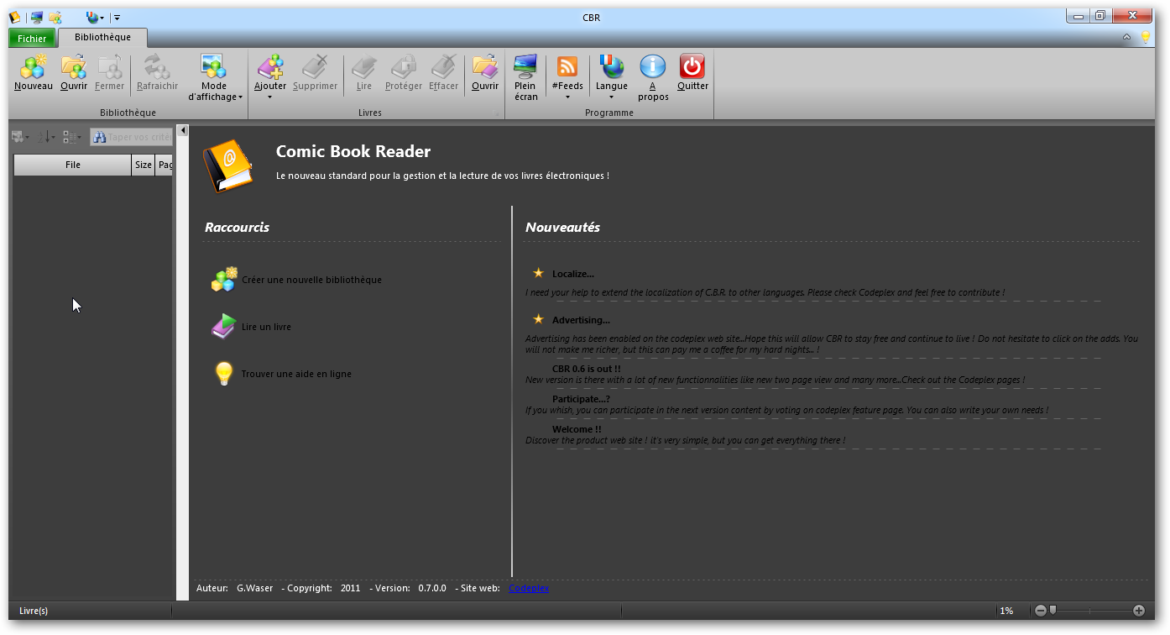

Zoom

Status bar

Explorer

Ribbon

# The home page

It will appear every time you start the application and contain three shortcuts on the left: New library, read a book and get help online.

Center is dedicated to CBR flow in which you find important information such as updates.

Below is a reminder of the current version and different information.

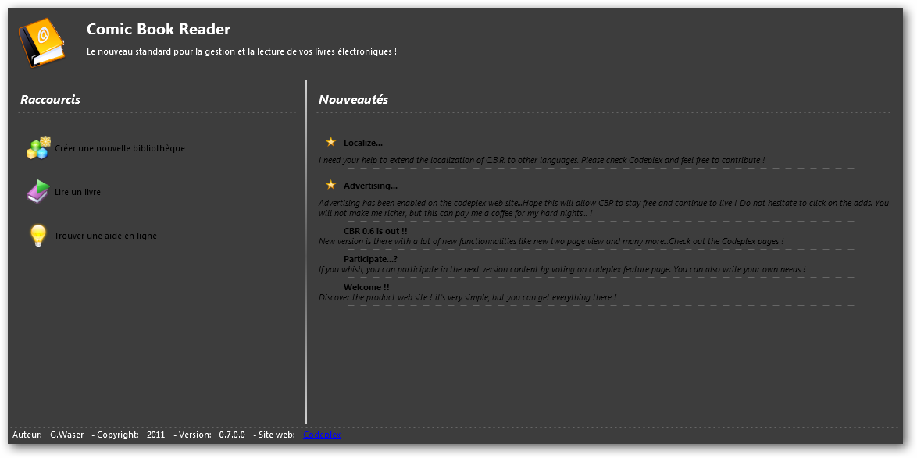

Rss

Title

Shortcuts

Informations

# Create a library…

In the library tab, click the button new D:\PROJECTS\CBR\CBR\Resources\Images\32x32\library_new.png

A dialog box appears to define a location and file CBL (Comic Book Bookstore).

Then two choices available to you:

* Add File
* Add entire contents of a directory recursively

Click the Add button in the group books D:\PROJECTS\CBR\CBR\Resources\Images\32x32\book_add.png

Select from the menu, the entry of your choice. The library browser is updated as and when the discovery of content.

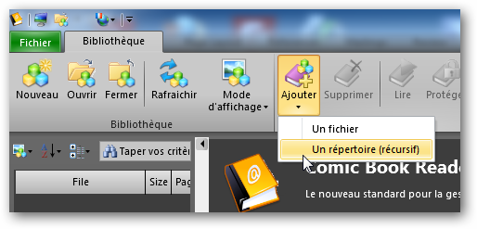

Add

New

 Tip: You can also go through the backstage - File tab of the ribbon - that contains the file management features. We return to this feature later in this tutorial.

# Read a book …

CBR is compatible with both CBR / RAR, CBZ / ZIP, XPS and ePUB for direct reading.

 Tip: CBR supports drag and drop system so you can take a file in your file explorer for the file on the CBR interface. All supported formats and CBL will open

# Open a book

Once created your library, use the button D:\PROJECTS\CBR\CBR\Resources\Images\32x32\book_read.png in the group read book if an item is selected in the explorer.

Otherwise you can also use the command read from the context menu with a right mouse click on an item in your library, or a double click

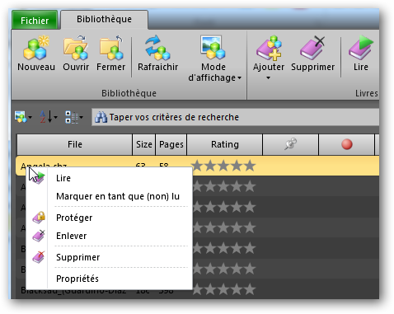

Menu : Read

Read

## Naviguate in a book

CBR allows navigation through your book with the mouse and keyboard.

### The mouse

1. Wheel

🡺 Scroll top and bottom

1. CTRL + Wheel

🡺 Change zoom

1. Left button click and mouse move

🡺Catch and move the image

1. CTRL Left button click and mouse move

🡺 Display and move the magnifier

### The keyboard

With the focus on the document arrow keys up / down and page up / down will scroll through the pages

 Tip: CBR is composed of a complex interface with the various elements are likely to revisit your part identical commands. The keyboard will work so different so if you give focus to the document reader, to tape or such to the zoom control.

## Optimize your reading

Once an open book, you can optimize your reading surface to your liking with a few clicks. CBR does not clutter your screen with unnecessary functions

### Full screen mode

Click the full screen button D:\PROJECTS\CBR\CBR\Resources\Images\32x32\action\full_screen.png to enlarge the document to take up space on your screen. This mode retains the default browser and ribbon.

Tip: CBR contains an option in File Options 🡺 behavior ranges 🡺 Use the full screen optimized. This option retains the document in full screen mode. Then use the key to escape back to normal mode

### Page adjustment

During playback, you can adjust the page dimensions of the window in the width direction D:\PROJECTS\CBR\CBR\Resources\Images\32x32\fit_width.png , the height D:\PROJECTS\CBR\CBR\Resources\Images\32x32\fit_height.png or in free mode D:\PROJECTS\CBR\CBR\Resources\Images\32x32\fit_no.png taking the zoom into account

 Tip: CBR contains an option in File 🡺 Options 🡺 adjustment mode by default. This choice is used all the default time as you do not click a button reading group

### Double page mode

The double page mode D:\PROJECTS\CBR\CBR\Resources\Images\32x32\book_two_page.png is available for books like CBx / XPS only. The CBR / Z support the ability to turn pages with the mouse by grabbing the corners of pages and has 3D effect.

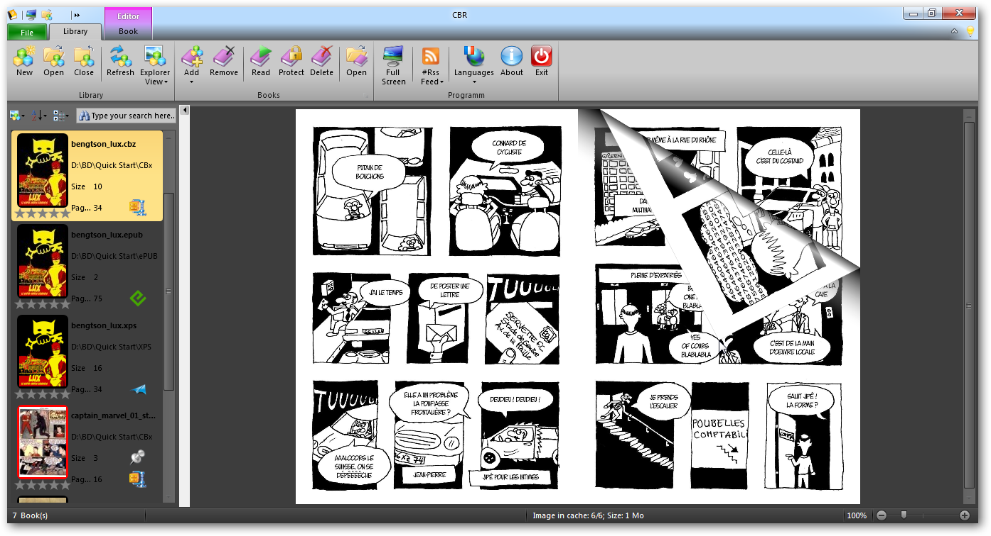

Les coins

### Continue with the books…

CBR offers even more functions associated with the books in order to facilitate reading and organizing your library. In short, you can:

D:\PROJECTS\CBR\CBR\Resources\Images\32x32\book_delete.png Completely remove a book from the library (and your disk)

D:\PROJECTS\CBR\CBR\Resources\Images\32x32\book_remove.png Remove a book from the library (but not the file)

D:\PROJECTS\CBR\CBR\Resources\Images\32x32\book_protect.png Protect a file with password

Put a mark D:\PROJECTS\CBR\CBR\Resources\Images\32x32\page_mark.png on the current page, remove it D:\PROJECTS\CBR\CBR\Resources\Images\32x32\page_clear_mark.png or move to it D:\PROJECTS\CBR\CBR\Resources\Images\32x32\page_goto_mark.png. Note that this command will open a book if.

The reading group in the Ribbon also contains navigation features that can replace the mouse or keyboard. You can move to the next page D:\PROJECTS\CBR\CBR\Resources\Images\32x32\page_next.png or previous D:\PROJECTS\CBR\CBR\Resources\Images\32x32\page_previous.png, at the beginning D:\PROJECTS\CBR\CBR\Resources\Images\32x32\page_first.png of the book or at the end D:\PROJECTS\CBR\CBR\Resources\Images\32x32\page_last.png

# Organize your library

CBR allows different way to organize your library: the views of the explorer, the commands sort and group as well as the dynamic properties.

## The views

In the Library tab, select the display mode command, then one of three modes available

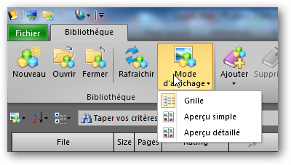

Mode

This command D:\PROJECTS\CBR\CBR\Resources\Images\32x32\library_view.png is also found directly in explorer with the sort command, group and filter

 Tip: CBR contains an option to change the default view. File 🡺 Options 🡺 Extended Display 🡺 Default view to explore

### Grid

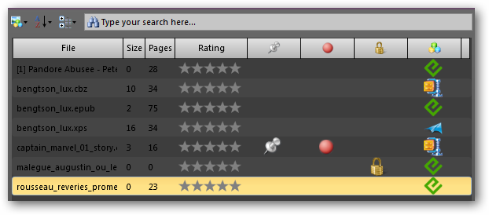

### Simple preview

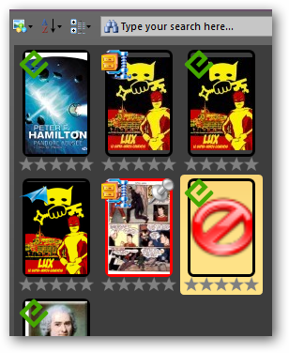

Read = Red

Note

### Detailed preview

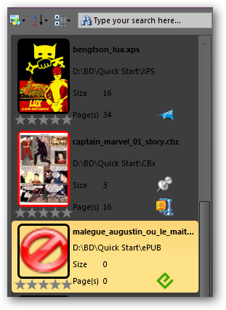

Bookmark

Type

Protected

Read

## Explorer commands

In addition to the command of view, the explorer has three other options for formatting your library.



### Sorting

The sort command D:\PROJECTS\CBR\CBR\Resources\Images\16x16\sort_alpha.png displays a menu of all the properties that can be sorted.

### Grouping

The group command D:\PROJECTS\CBR\CBR\Resources\Images\16x16\sort_category.png displays a menu of all the properties that can be grouped. Example below show a directory grouping.

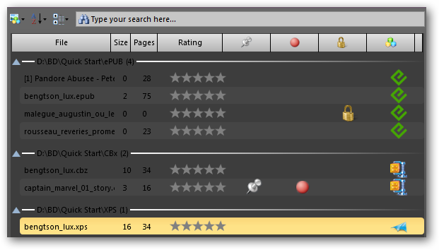

Goup

### Filter

The box filter is used to enter text that will filter the book titles.

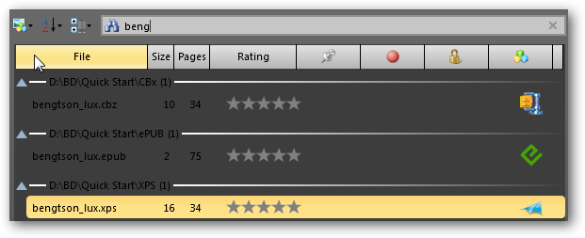

Filter

# The documents

CBR provides a window type for each type of supported format. Whenever possible, we maintain a consistency in behavior, display and controls

## CBR/CBZ

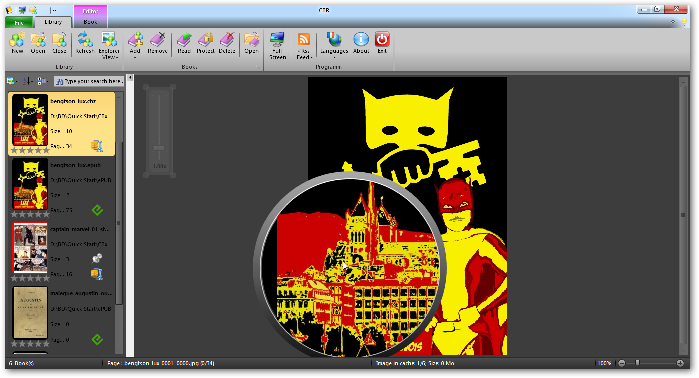

Magnifier

Zoom

Liaison

## XPS

View XPS is a little different view of a CBR / Z. It shows all the pages in a row on one or two pages wide and contains no magnifying glass.

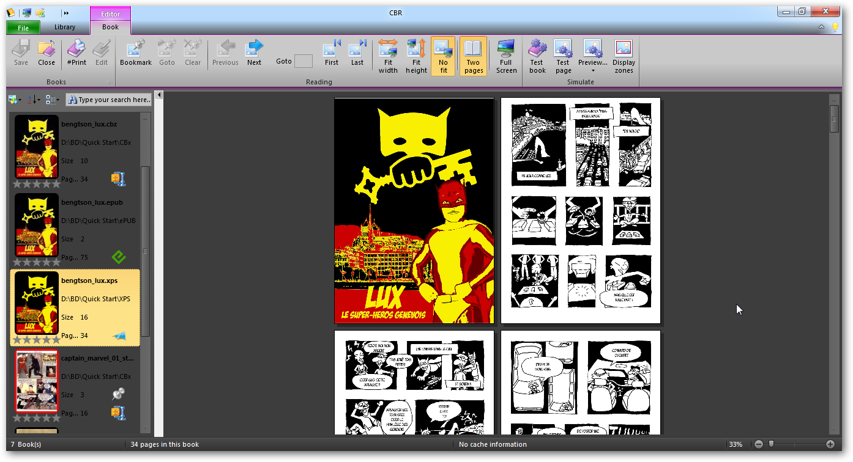

Zoom

## ePUB

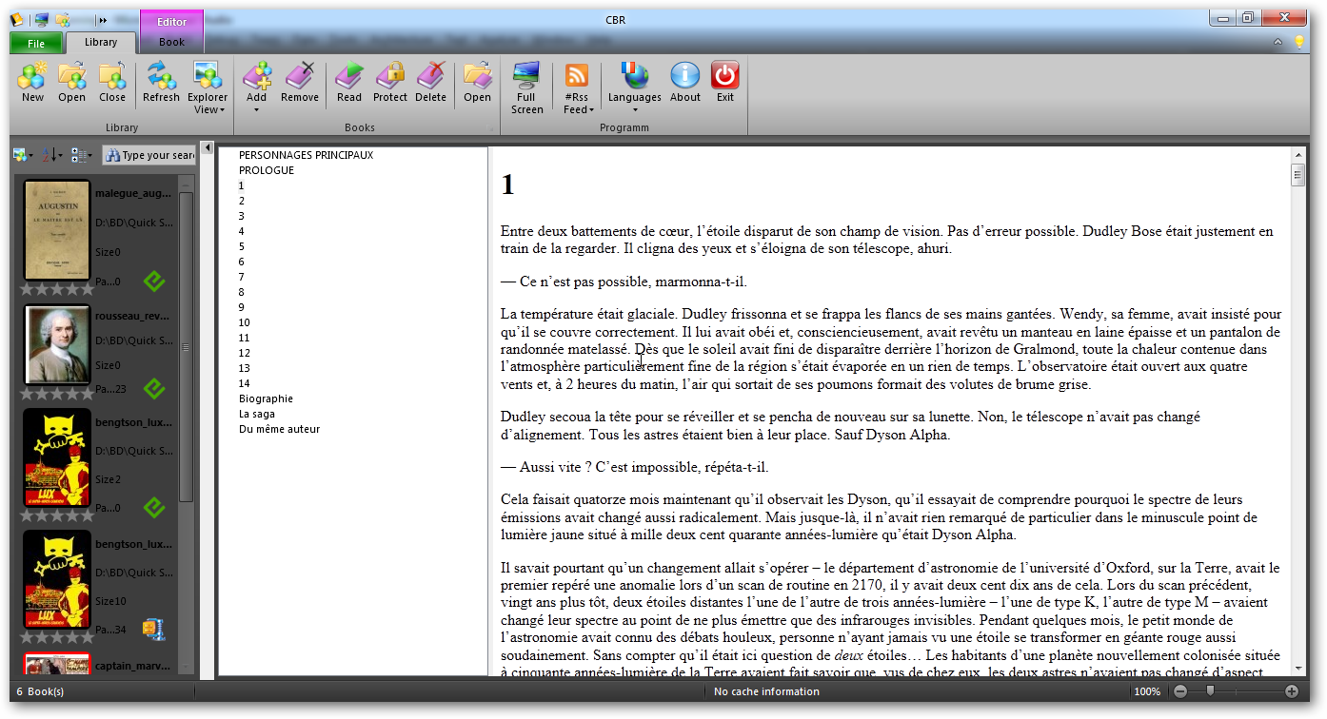

# The File tab

Like Microsoft Office, this tab contains options and program management functions. It contains commands to direct commands for the management of libraries or to exit CBR. Others display a management window.

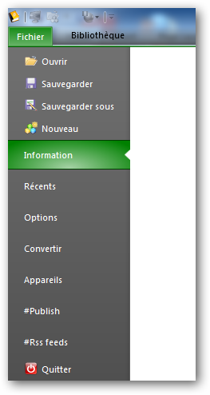

Library management

Options

Quit

Devices

RSS

Convert

Recent files

Book informations

The panel **information** displays complementary information on the book selected in the explorer or opened in CBR.

The **recent** panel displays two columns in the latest files and read the latest libraries used

# Convert files…

CBR offers advanced file conversion through the conversion panel available on the File tab.

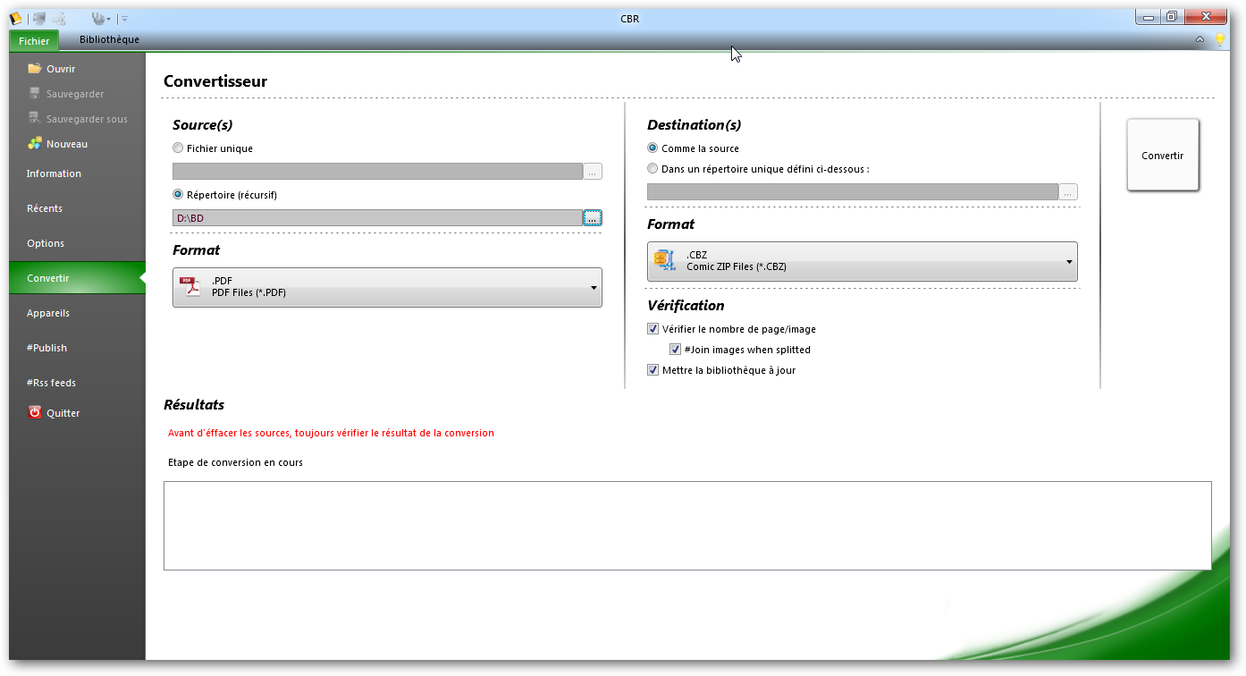

The destination

The results

The source

Options

## The source

The source is defined by

* either a file, then the source format is deduced from the extension
* or through a directory, then we must choose in the list format that you want to convert

## The destination

The destination is defined by

* either the same directory as each source
* either in a single directory for all destination file

Then select the destination format - depending on the source format.

## Options

With options, we can verify that the number of pages is equal to the number of image and update the library automatically after conversion

 Tip: Often the PDF to image are composed of several images per page. You have to use the advanced fusion!

Click the **Convert** button to start the job and the list below shows the current step of the conversion and synthesis

 As with any automated task, we advise you to check the logs and the conversion result before deleting your original files.

# Define preferences

The application parameters all have default values that you can redefine through the **Options** panel in the **File** tab

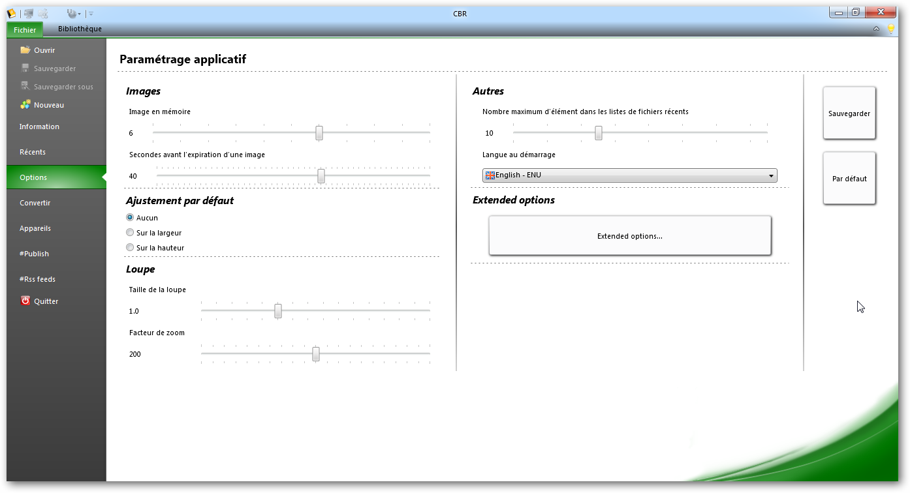

Language and recents

Extended

Magnifier

Ajustement

Cache

## The most common

The most common options are available directly:

* Cache management images
* Default adjustment of pages
* Size and factor of the magnifier
* Number of recent files
* Startup language

## Extended

The less common options are available with the dialog "Extended Options". It comprises five categories: Display, Behavior, Properties, Recording, Proxy

### Display

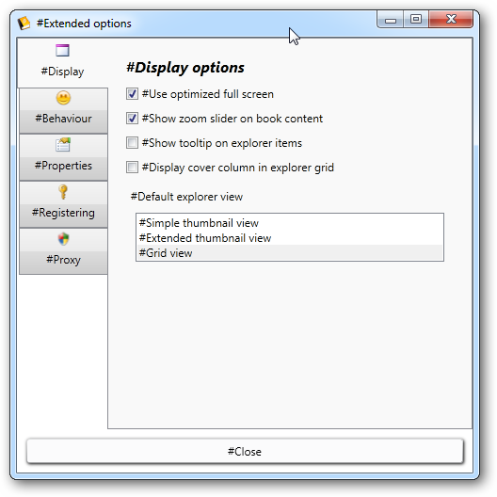

### Behaviour

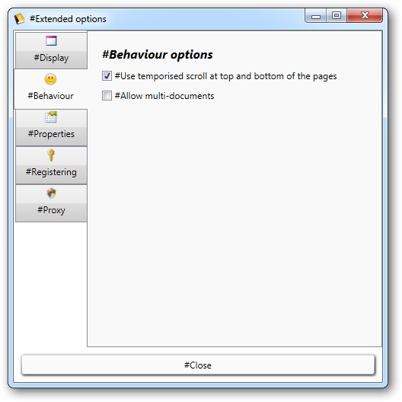

### Registering

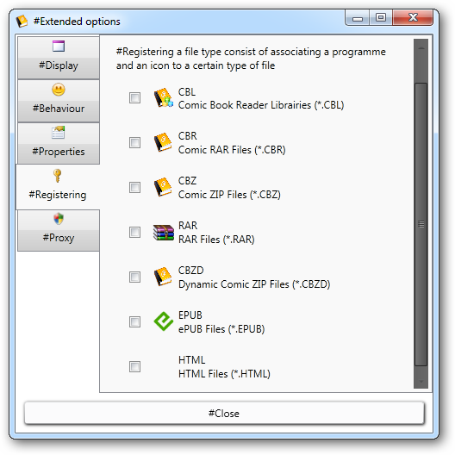

Check the boxes for icons to be stored in the system and to associate file types to CBR when double-clicking a file in your explorer for opening

### Proxy

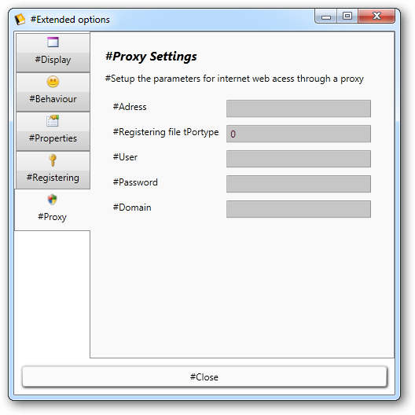

### Dynamic properties

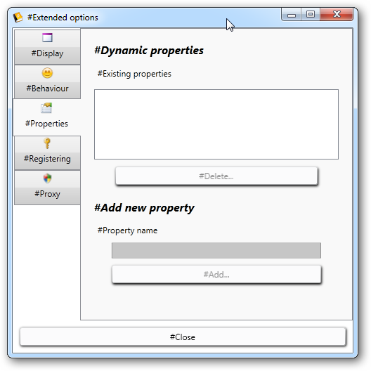

# Manage RSS …

This is a new feature of version 0.7 of CBR and will surely be further enriched in future versions. It can manage RSS feeds specific to the publication of electronic books, and then to go to download free books directly into CBR.

The panel allows the management of its favorite feeds. By default a 20 are available, but nothing prevents you to create, delete or modify.

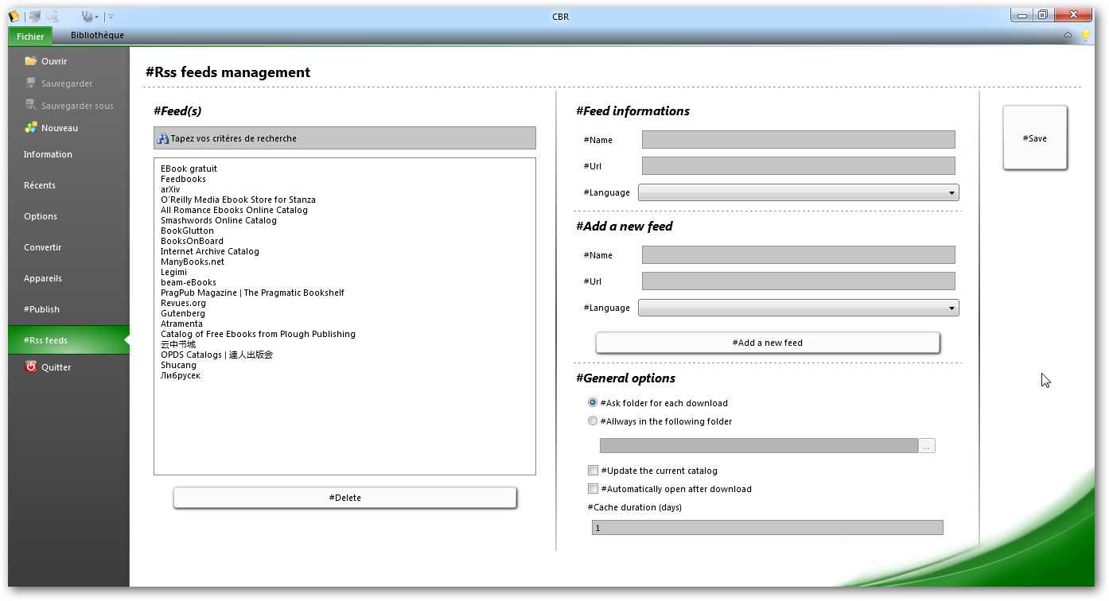

Options

Add

Informations

Delete

Filter & list

Once configured your feeds, you will find in the tab group program library, a control flow D:\PROJECTS\CBR\CBR\Resources\Images\32x32\rss\rss.png with a combo. Selecting an entry will display a new document reading with its own tab.

# …and use the RSS navigator

The tab contains commands specific RSS feeds. The top panel displays information about the flow and the current page. Then there are items in the feed.

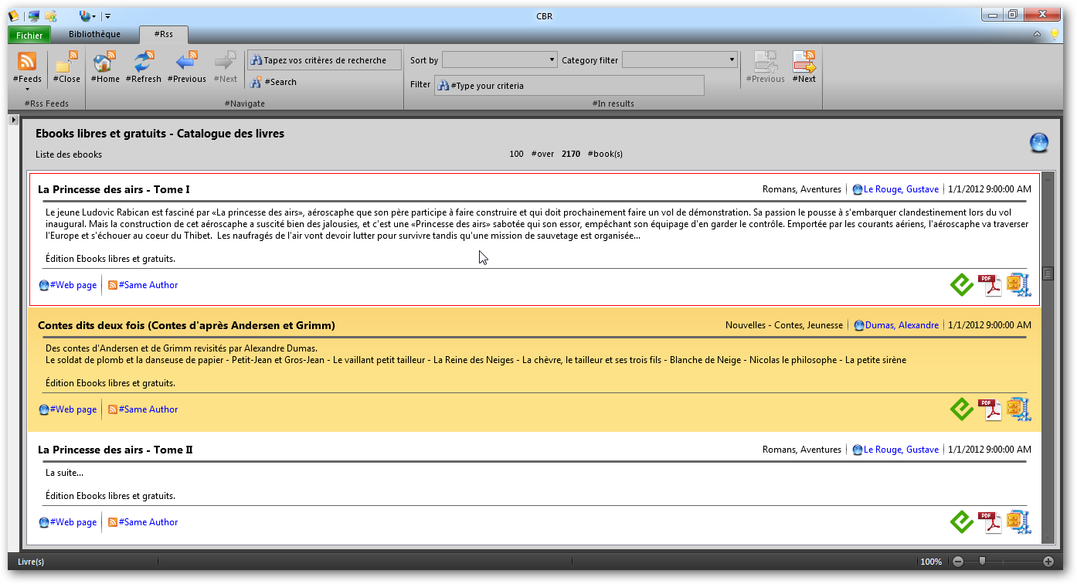

Informations

Items

Ribbon

In the tab, there is the command D:\PROJECTS\CBR\CBR\Resources\Images\32x32\rss\rss.png which opens another stream or go to the panel management and closing the document D:\PROJECTS\CBR\CBR\Resources\Images\32x32\rss\rss_close.png

Then comes the group of navigation with the return to the homepage of the flow D:\PROJECTS\CBR\CBR\Resources\Images\32x32\rss\rss_home.png, flow refresh D:\PROJECTS\CBR\CBR\Resources\Images\32x32\rss\rss_refresh.png and navigation functions with next D:\PROJECTS\CBR\CBR\Resources\Images\32x32\rss\rss_next.png or previous D:\PROJECTS\CBR\CBR\Resources\Images\32x32\rss\rss_previous.png.

The search function D:\PROJECTS\CBR\CBR\Resources\Images\32x32\rss\rss_search.png is not implemented

 Tip: the zoom control is available with the RSS browser!

**Anatomy of an RSS item**

When browsing, the pages are made up of categories (simple elements with title and date) and results or books with much more information. Let's look at an example like below.

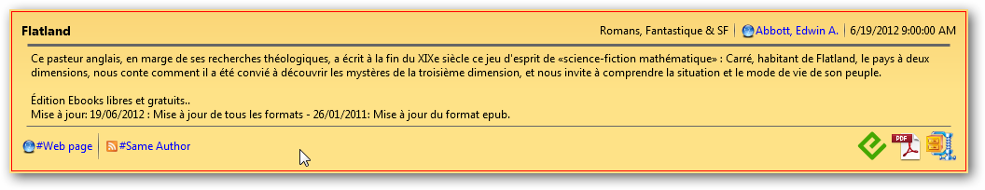

Downloads

Description

Informations

Links

Title

In the display order from left to right:

* The upper part contains the title of the volume, category, author, date.
* The central part contains the description provided by the flow.
* At the bottom, a link to the corresponding web page, a link rss to books by the same author, then the download links for this book in different formats

Note that the links with the logo D:\PROJECTS\CBR\CBR\Resources\Images\32x32\icon\web.png are links to web browser (internet)and links with this logo D:\PROJECTS\CBR\CBR\Resources\Images\32x32\rss\rss.png remain in the navigation RSS

In addition, the tab now contains additional commands for navigating results pages: next D:\PROJECTS\CBR\CBR\Resources\Images\32x32\rss\rss_page_next.png and previous D:\PROJECTS\CBR\CBR\Resources\Images\32x32\rss\rss_page_previous.png

# Work with external devices

CBR manages external devices with USB. It allows their management and their file system.

## Configure…

CBR in the File tab contains an input unit that allows you to configure your eReader or your USB drive simply.

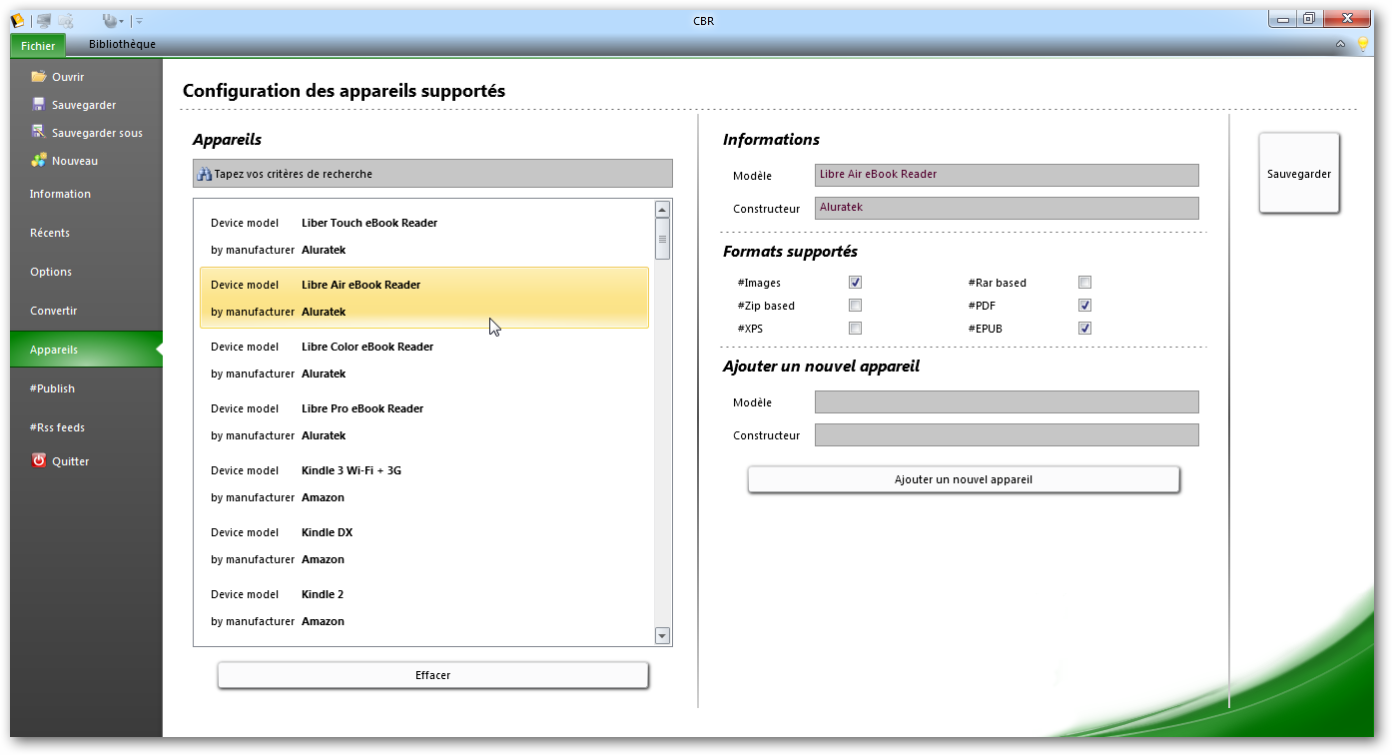

Properties

Add

Delete

List

The list contains all known type devices eReader The Clear button will delete those you do not want to keep The properties display information on the device selected in the list The area can add to complete the list with a new device and after selection to define the supported formats

## Use it…

Once a device is detected, CBR displays a tab in addition to USB. In the tape you will find your unit and type of associated eReader. The right view displays the contents of your device. It is possible to drag and drop your library to a directory of it.

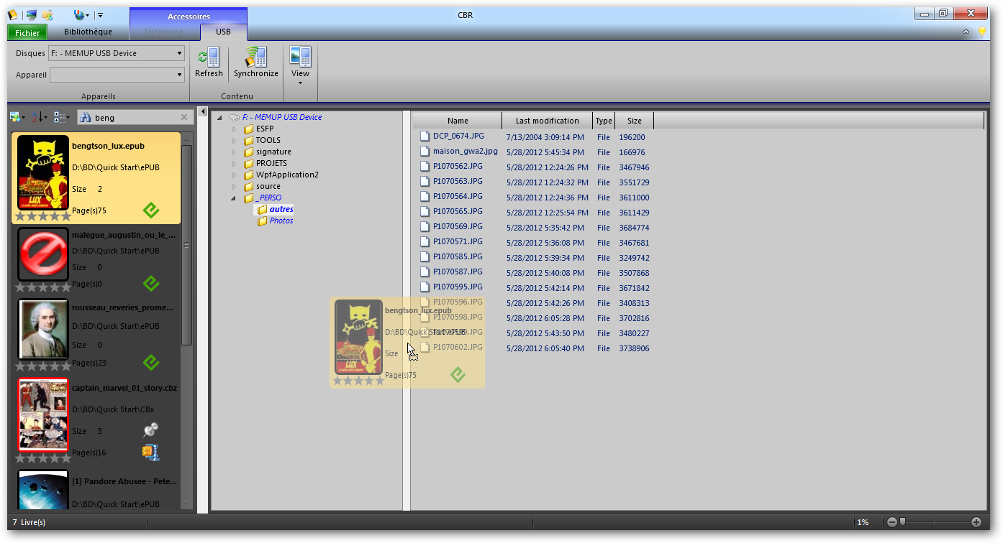

USB

Commands

Drag & drop