OTA Updates MICA

|  |
| --- |
| **Over-The-Air Updates for BLE** |

# C:\Users\ccheney\AppData\Local\Microsoft\Windows\INetCache\Content.Word\MICA Logo Transparent.pngFeatures

* Allows users to easily incorporate OTA functionality with code sharing
* Specific to PSoC 4 BLE devices

# General Description

Over The Air (OTA) Updates allows users to update code wirelessly over a BLE connection. The component supports updating the application as well as updating the BLE stack via code sharing.

# Input/Output Connections

The OTA Updates component has not external terminals.

# Component Parameters

Double click on the OTA Updates component to open the Configure dialog.

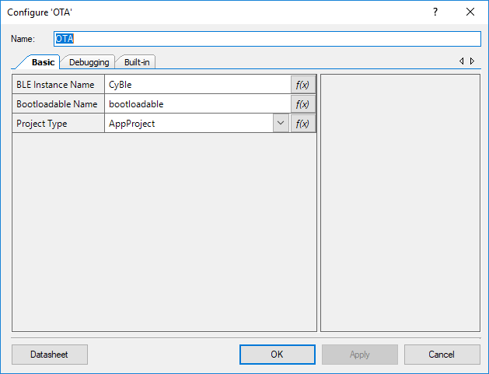

## Basic

The OTA Updates Component has the following parameters.

**BLE Instance Name**

Name of the BLE instance used in the design. This pulls the BLE header file in. This should not end in '.h'.

**Project Type**

Set this to either ‘AppProject’ or ‘StackProject’ depending on what type of project that program is. Both programs need to have the component for proper functionality. If the project type is ‘AppProject’, then the parameter ‘Bootloader Name’ will be hidden.

**Bootloadable Name**

Name of the Bootloadable Component. Used to include and call functions from the Bootloadable. Should not end with '.h'.

**Bootloader Name - \***

Name of the Bootloader component. Used to include and call functions from the Bootloader. Only present when project type is ‘Stack Project’. Should not end with ‘.h’.

## Debugging

**Debug Enable**

A Boolean used to enable printing/logging for testing purposes.

**Debug Print Function**

Name of the function that is called when debugging. Function should have prototype

*void print(char8 *pszFmt, ...)*

**Debug Print Include file**

Name of the header file were the Debug Print Function is defined. Should not end with ‘.h’.

# Application Programming Interface (API)

API routines allows users to control the OTA Updates from software. The default name for the component is “OTA”, which can be changed in the configure dialogue. All functions and constants are generated based on this name.

**Functions**

|  |  |
| --- | --- |
| **Function** | **Description** |
| [OTA_BootUserApp()](#_void_OTA_BootUserApp(void)) | Checks to see if there is a valid user application. If there is, instruct the launcher to boot the app next time the device boots, and immediately reset the device. Only available in Stack Projects. |
| [OTA_AfterStackImageUpdate()](#_void_OTA_AfterStackImageUpdate(void) | Checks if the Stack Self Project Image has been Updated and is running for the first time. If so, and if Bonding data is used then it verifies bonding data and erases bonding data if it is not valid. |
| [OTA_InitializeCodeSharing()](#_void_OTA_InitializeCodeSharing(void) | Triggers initialization of bootloader RAM .bss section. It is required for BLE Stack operation. This function should be called from main() prior BLE component start. Only available in Application Projects. |
| [OTA_AfterAppImageUpdate()](#_void_OTA_AfterAppImageUpdate(void)) | Checks if the Application Self Project Image has been Updated and is Running for the first time. If so, it clears the new image flag. If bonded devices are used, then the bonded data must be cleared. Only available in Application projects. |
| [OTA_EnterBootloadMode()](#_void_OTA_EnterBootloadMode(void)) | Sets the active application to the stack bootloader, and then resets the device. The active application is written in the Flash metadata section. This function will not return. Only available in Application Projects |

## void OTA_BootUserApp(void)

|  |  |
| --- | --- |
| **Description:** | Checks to see if there is a valid user application. If there is, instruct the launcher to boot the app next time the device boots, and immediately reset the device. Only available in Stack Projects. |
| **Return Value:** | This function will never return, as it resets the device. |

## void OTA_AfterStackImageUpdate(void)

|  |  |
| --- | --- |
| **Description:** | Checks if the Stack Self Project Image has been Updated and is running for the first time. If so, and if Bonding data is used then it verifies bonding data and erases bonding data if it is not valid. |

## void OTA_InitializeCodeSharing(void)

|  |  |
| --- | --- |
| **Description:** | Triggers initialization of bootloader RAM .bss section. It is required for BLE Stack operation. This function should be called from main() prior BLE component start. Only available in Application Projects. |

## void OTA_AfterAppImageUpdate(void)

|  |  |
| --- | --- |
| **Description:** | Checks if the Application Self Project Image has been Updated and is Running for the first time. If so, it clears the new image flag. If bonded devices are used, then the bonded data must be cleared. Only available in Application projects. |

## void OTA_EnterBootloadMode(void)

|  |  |
| --- | --- |
| **Description:** | Sets the active application to the stack bootloader, and then resets the device. The active application is written in the Flash metadata section. This function will not return. Only available in Application Projects |
| **Return Value:** | This function will never return, as it resets the device. |

# Component Macros

The OTA Update component does not contain any macros intended for user calls.

|  |  |
| --- | --- |
| **Macro Name** | **Description** |
| *N/A* | *N/A* |

# Change Log

This sections lists changes to the component from previous versions

|  |  |  |  |
| --- | --- | --- | --- |
| **Version** | **Revision** | **Description of Changes** | **Reason for Changes / Impact** |
| v1.0 | r0 | Initial implementation of the component and datasheet |  |