iprintf MICA

|  |
| --- |
| **Simple Printing function** |

# C:\Users\ccheney\AppData\Local\Microsoft\Windows\INetCache\Content.Word\MICA Logo Transparent.pngFeatures

* Minimal printing utility
* Handles decimal, hex, characters, and string

# General Description

iprintf is a simple, API only component that allows for easy conversion of values to ASCII readable outputs

# Input/Output Connections

The iprintf block is an API only and has no connections

# Component Parameters

Double click on the iprintf component to open the Configure dialog.

## Basic

The iprintf Component has the following parameters.

**Include File**

The name of the file that contains the function prototype for the transport function. Do not include “.h” at the end.

**Transport Function Name**

Name of the function to be called when iprintf wants to write out a character.

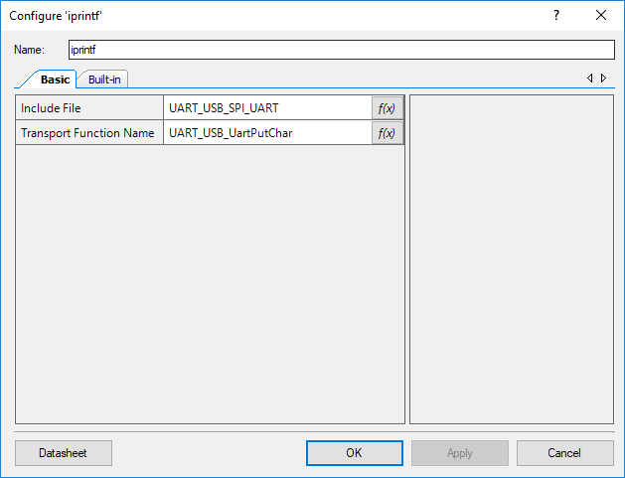

# Application Programming Interface (API)

API routines allows users to control the iprintf from software. The default name for the component is “iprintf” which can be changed in the configure dialogue. All functions and constants are generated based on this name.

**Functions**

|  |  |
| --- | --- |
| **Function** | **Description** |
| [iprintf()](#_void_iprintf(char8_*pszFmt,...)) | Writes out the formatted string over the UART |
| [iprintf_clearScreen()](#_void_iprintf_clearScreen_(void)) | Clears the terminal screen. |

## void iprintf(char8 *pszFmt,...)

|  |  |
| --- | --- |
| **Description:** | Writes out the formatted string over the UART |
| **Parameters:** | **pszFmt**: Pointer to String, zero format. String to display  Accepted vales are:  %d – Decimal  %s – String  %c – Character  %x – Hex |
| **Return Value:** | None |

## void iprintf_clearScreen (void)

|  |  |
| --- | --- |
| **Description:** | Sends a command that clears the terminal screen. Implemented as a function-like macro. |
| **Return Value:** | None |

# Component Macros

The following is a list of macros/constants that a user may find useful for interacting with the component. A component may contain macros not listed here.

|  |  |
| --- | --- |
| **Macro Name** | **Description** |
| None | None |

# Change Log

This sections lists changes to the component from previous versions

|  |  |  |  |
| --- | --- | --- | --- |
| **Version** | **Revision** | **Description of Changes** | **Reason for Changes / Impact** |
| v1.0 | r0 | Initial implementation of the component and datasheet |  |