I2C API MICA

|  |
| --- |
| **MICA I2C communication wrapper** |

# C:\Users\ccheney\AppData\Local\Microsoft\Windows\INetCache\Content.Word\MICA Logo Transparent.pngFeatures

* Software only API for streamlining of SCB I2C implementation

# General Description

The MICA I2C API component provides a simple API for writing to, and reading from, slave devices.

# Input/Output Connections

The I2C API component is software only and has no connections

# Component Parameters

Double click on the I2C API component to open the Configure dialog.

## Required

**I2C Component Name**

Name of the SCB instance that provides the implementation of the functions called by the I2C component

**I2C Include File**

Name of the header file (excluding “.h”) that contains the declarations for the SCB master.

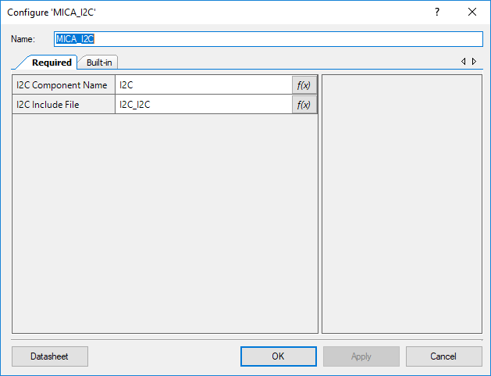

# Application Programming Interface (API)

API routines allows users to control the I2C API from software. The default name for the component is “MICA_I2C” which can be changed in the configure dialogue. All functions and constants are generated based on this name.

**Functions**

|  |  |
| --- | --- |
| **Function** | **Description** |
| [MICA_I2C_Write()](#_uint32_MICA_I2C_Write(uint8_deviceA) | Writes a byte to data to a given register of the target I2C slave. |
| [MICA_I2C_Read()](#_uint32_MICA_I2C_Read(uint8_deviceAd) | Reads a given register of the target I2C device and places that value into the pointer passed in. |

## uint32 MICA_I2C_Write(uint8 deviceAddr, uint8 regAddr, uint8 val)

|  |  |
| --- | --- |
| **Description:** | Writes a byte to data to a given register of the target I2C slave. |
| **Parameters:** | deviceAddr: 7-bit address of the slave to write to.  regAddr: Address of the register in the slave device to write to.  val: Value to write to the register. |
| **Return Value:** | Error returned by operation. Possible values:  MICA_I2C_ERR_OK: Successful write Error from I2C component |
| **Side Effects** | This is a blocking (synchronous) function. |

## uint32 MICA_I2C_Read(uint8 deviceAddr, uint8 regAddr, uint8* readValue)

|  |  |
| --- | --- |
| **Description:** | Reads a given register of the target I2C device and places that value into the pointer passed in. |
| **Parameters:** | deviceAddr: 7-bit address of the slave to write to.  regAddr: Address of the register in the slave device to write to.  readVal: Pointer to value read by the device. |
| **Return Value:** | Error returned by operation. Possible values:  MICA_I2C_ERR_OK: Successful read MICA_I2C_ERR_READ Error from I2C component |

# Component Macros

The following is a list of macros/constants that a user may find useful for interacting with the component. A component may contain macros not listed here.

|  |  |
| --- | --- |
| **Macro Name** | **Description** |
| *N/A* | *N/A* |

# Change Log

This sections lists changes to the component from previous versions

|  |  |  |  |
| --- | --- | --- | --- |
| **Version** | **Revision** | **Description of Changes** | **Reason for Changes / Impact** |
| v1.0 | r0 | Initial implementation of the component and datasheet |  |