<ComponentNAME> MICA

|  |
| --- |
| **<Description>** |

# C:\Users\ccheney\AppData\Local\Microsoft\Windows\INetCache\Content.Word\MICA Logo Transparent.pngC:\Users\ccheney\AppData\Local\Microsoft\Windows\INetCache\Content.Word\ledIcons01.pngFeatures

* <Feature 1>
* <Feature 2>

# General Description

<Generic descriptions of what the component does>

# Input/Output Connections

This section describes all of the virtual connections for the <ComponentName> component.

## <Terminal 1>

<Terminal 1 Description>

## <Terminal 2>

<Terminal 2 Description>

# Component Parameters

Double click on the <ComponentName> component to open the Configure dialog.

## <Tab 1>

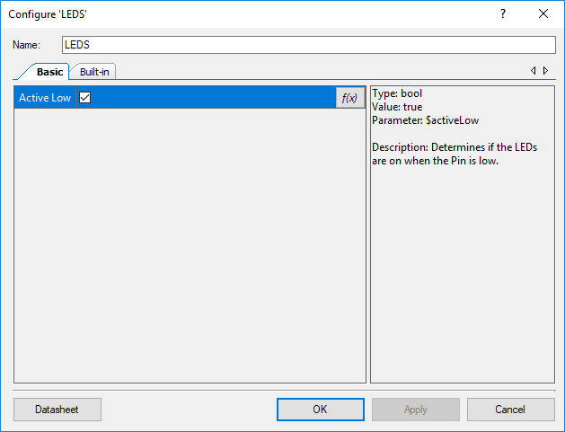

The <ComponentName> Component has the following parameters.

**<Param 1>**

<Param 1 description>

# Application Programming Interface (API)

API routines allows users to control the <ComponentName> from software. The default name for the component is “<defaultName>”, which can be changed in the configure dialogue. All functions and constants are generated based on this name.

**Functions**

|  |  |
| --- | --- |
| **Function** | **Description** |
| [<funtion](#_uint8_LEDS_Write(uint8_state))1> | <Description of function1> |
| [<function2>](#_uint8_LEDS_Read(void)) | <Description of function2> |
| [<function3>](#_void_LEDS_Sleep(void)) | <Description of function3> |

## <returnType> LEDS_<function1>(<params>)

|  |  |
| --- | --- |
| **Description:** | Sets the state of the LED control register, setting the color of the LEDs on the board. |
| **Parameters:** | uint8: The new state mask to write to the control register. It is recommended that users only pass the color macros defined by the component. |
| **Return Value:** | uint8: Value of the control register after it was written. |

# Component Macros

The following is a list of macros/constants that a user may find useful for interacting with the component. A component may contain macros not listed here.

|  |  |
| --- | --- |
| **Macro Name** | **Description** |
| <macro1> | <Description of Macro 1> |

# Change Log

This sections lists changes to the component from previous versions

|  |  |  |  |
| --- | --- | --- | --- |
| **Version** | **Revision** | **Description of Changes** | **Reason for Changes / Impact** |
| v1.0 | r0 | Initial implementation of the component and datasheet |  |