|  |  |  |  |  |  |
| --- | --- | --- | --- | --- | --- |
| Student Name: | Chandler Tyrrell | Student Number: | S00226588 | Class Group: | MBUSI_H08 |

## <https://github.com/TheChandalorian/Website>

## 1. Index Page

With a clear nav bar for easy navigation, and links to top and bottom of the page to make it user friendly, they also have a footer to use as well.  
I included a background image of the proposed salon, as well as adding a link to a proposed location to the salon and a image of a service.  
The 4 images at the top of the page, as the mouse hovers over them, become opaque, so they stand out more. Clicking on them, opens the services page.

There is also an external link to Sligo, to provide users information about the salons town location.

Layout is similar to my first design, except I added in a block quote instead of unordered list, as lists are used throughout other pages on the site.

|  |
| --- |
|  |

## 2. About Page

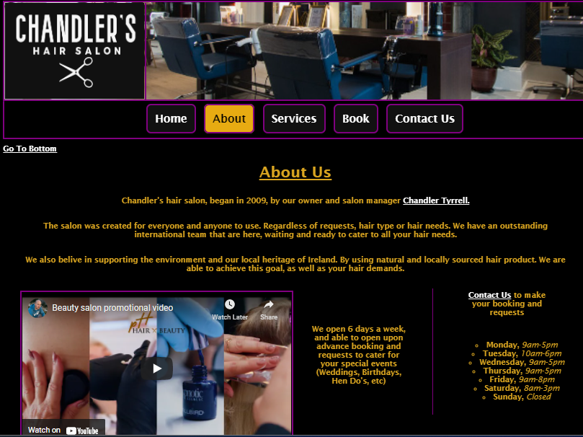

Shared uniformed layer throughout all pages, with images, nav bar and footer.

Opening times in a unordered list, with alternative bullet points, positioned in a column.

An external video link shared on the page to show salon services offered, as well as external links throughout the employees names to social media pages.

Internal links, sending user to book page, and with a button, that changes when highlighted, again to encourage the user to book an appointment.  
Multiple options to get to booking page to improve changes of services/revenue.

Images uniformed throughout the page for professionalism

## 

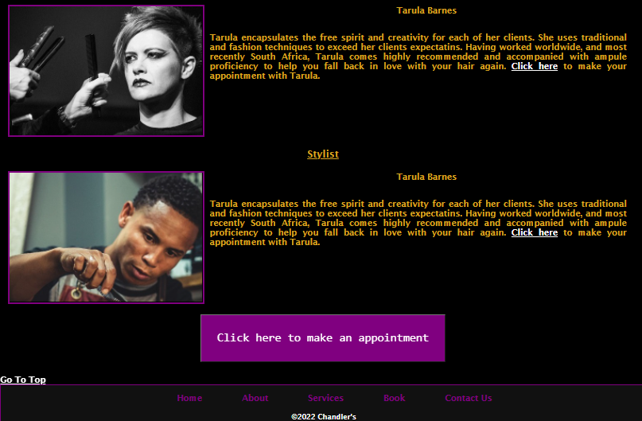

## 3. Services Page

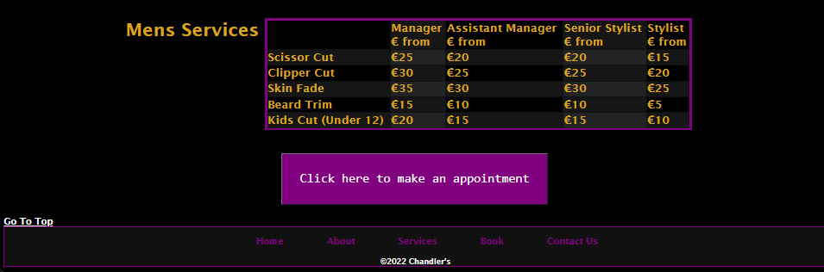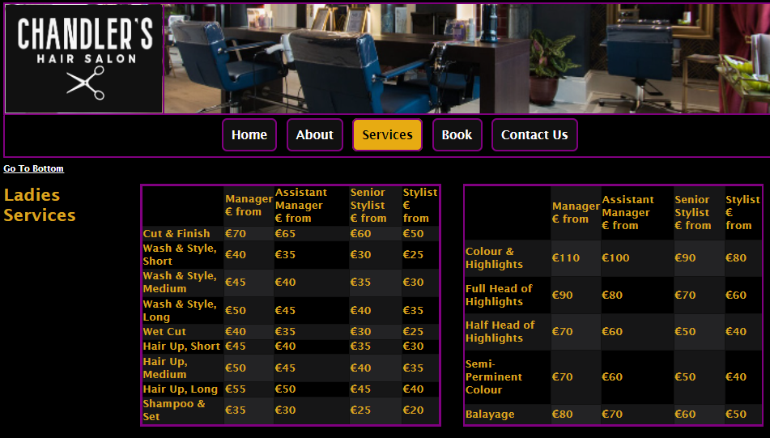

3 tables, presenting pricing, services and stylists offered in the salon.

Used 2 lots of nth child code, for internal style sheet, to create an array of options to separate the information in the table, that may otherwise be confusing/dull for the user if all the same background.

Appointment button used again, to increase option of booking,

## 4. Book Page

Ordered, with roman numerals, for how the user can contact and book in the salon.

Simple image shared on page, again uniformed to colour scheme and border.  
No top and bottom nav on this page, as small information.

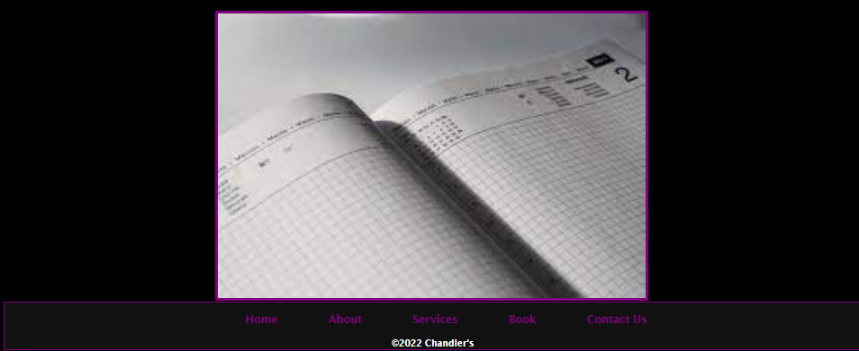

## 5. Contact Page

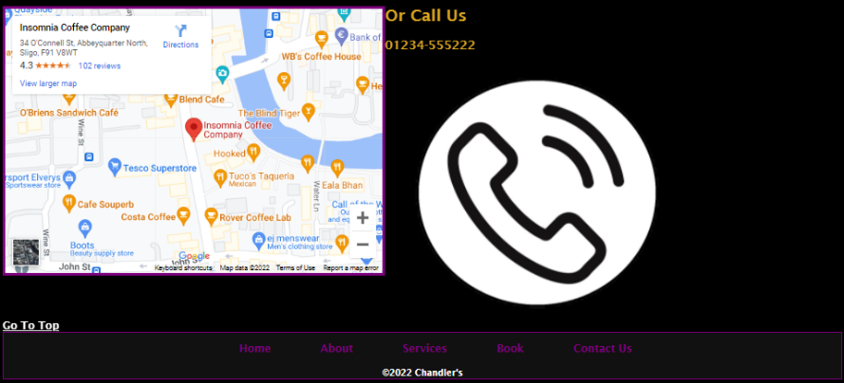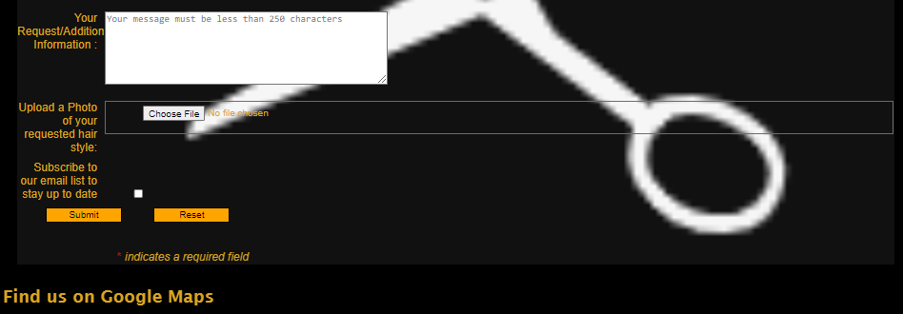

Background image on contact form, salons logo.

Tool tip on the sections to clarify information for user to enter.

Radio, drop down options and open text for different options on the page, depending on section needed to complete.

User also able to upload an image, of their requested/preferred hair cut.

Option to subscribe to email newsletter from salon, and a submit and reset button also.

Google map, and image at the bottom, for user to find and contact salon also.

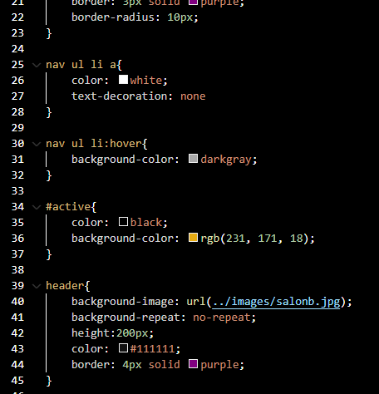**6. Style Sheet**

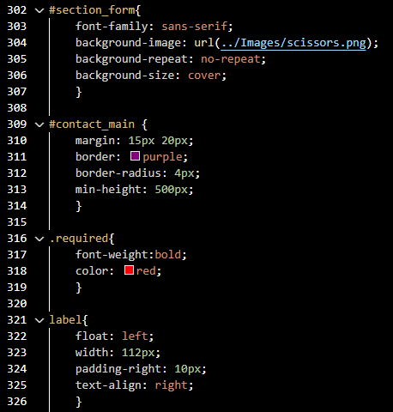 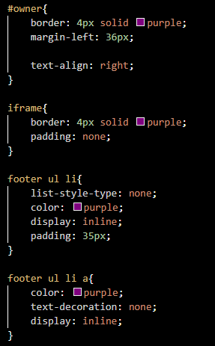

Some extracts of the style sheet

In order of pages and items used on the page, eg 1-50 on style sheet is nav bar and index page items, page 2 is about etc.

Class, ID, and global identification used for items. Housing/Uniformed for font family, colour and margins/borders.

Absolute used to allow changes, and also url for images used throughout.

Sections all clearly labeled, and titles close/relative to item they are selecting. This makes it easy to access and if ang changes are required.

**7. Conclusion**

Enjoyed making the hair salon website, using items from class, but also from own research from the recommended reads.

Soma alterations from my original designs (see below) but changes made to improve functionality for user and make appealing also.

In the future, for my next website, I will place the navigation bar on the left-hand side on all pages for a change, but kept at the top for this project, as this is familiar with most users, but also easily accessible.

I am also continuing to develop my skills and learning Javascript, so I a able to be more creative and personalize a website, along with html and css.