  - File: q4.c
  - Author: Hubert Bao
  - Student ID: 169077248
  - Date: 2026-01-26

Output Screenshot

students_q3.csv
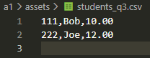

students_q4.csv
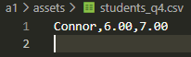

Terminal
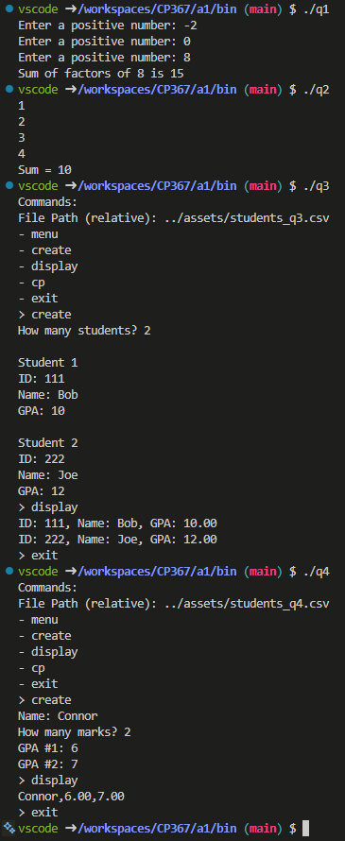

Output Text

students_q3.csv
111,Bob,10.00
222,Joe,12.00

students_q4.csv
Connor,6.00,7.00

Terminal
vscode ➜ /workspaces/CP367/a1/bin (main) $ ./q1
Enter a positive number: -2
Enter a positive number: 0
Enter a positive number: 8
Sum of factors of 8 is 15
vscode ➜ /workspaces/CP367/a1/bin (main) $ ./q2
1
2
3
4
Sum = 10
vscode ➜ /workspaces/CP367/a1/bin (main) $ ./q3
Commands:
File Path (relative): ../assets/students_q3.csv
- menu
- create
- display
- cp
- exit
> create
How many students? 2

Student 1
ID: 111
Name: Bob
GPA: 10

Student 2
ID: 222
Name: Joe
GPA: 12
> display
ID: 111, Name: Bob, GPA: 10.00
ID: 222, Name: Joe, GPA: 12.00
> exit
vscode ➜ /workspaces/CP367/a1/bin (main) $ ./q4
Commands:
File Path (relative): ../assets/students_q4.csv
- menu
- create
- display
- cp
- exit
> create
Name: Connor
How many marks? 2
GPA #1: 6
GPA #2: 7
> display
Connor,6.00,7.00
> exit
vscode ➜ /workspaces/CP367/a1/bin (main) $

