  - File: tests.docx
  - Author: Hubert Bao
  - Student ID: 169077248
  - Date: 2026-02-12

Output Screenshots

Q1
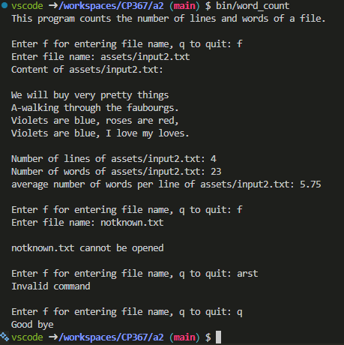

Q2
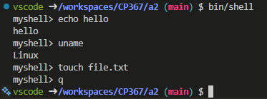

Output Texts

Q1
vscode ➜ /workspaces/CP367/a2 (main) $ bin/word_count
This program counts the number of lines and words of a file.

Enter f for entering file name, q to quit: f
Enter file name: assets/input2.txt
Content of assets/input2.txt:

We will buy very pretty things
A-walking through the faubourgs.
Violets are blue, roses are red,
Violets are blue, I love my loves.

Number of lines of assets/input2.txt: 4
Number of words of assets/input2.txt: 23
average number of words per line of assets/input2.txt: 5.75

Enter f for entering file name, q to quit: f
Enter file name: notknown.txt

notknown.txt cannot be opened

Enter f for entering file name, q to quit: arst
Invalid command

Enter f for entering file name, q to quit: q
Good bye

Q2
vscode ➜ /workspaces/CP367/a2 (main) $ bin/shell
myshell> echo hello
hello
myshell> uname
Linux
myshell> touch file.txt
myshell> q

