  - File: tests.docx
  - Author: Hubert Bao
  - Student ID: 169077248
  - Date: 2026-03-26

Output Texts

e1.sh
vscode ➜ /workspaces/CP367/a6/src (main) $ ./e1.sh
Initialized empty Git repository in /workspaces/CP367/a6/src/exer/.git/
[main (root-commit) 9292281] Init
1 file changed, 0 insertions(+), 0 deletions(-)
create mode 100644 file.txt
[main 099a58d] Modify file.txt
1 file changed, 1 insertion(+)
[main 3bd956b] Add file1.txt
1 file changed, 0 insertions(+), 0 deletions(-)
create mode 100644 file1.txt
On branch main
Untracked files:
(use "git add <file>..." to include in what will be committed)
file2.txt

nothing added to commit but untracked files present (use "git add" to track)
[main e723ef3] Add all files
2 files changed, 0 insertions(+), 0 deletions(-)
create mode 100644 file1.txt
create mode 100644 file2.txt

e2.sh
vscode ➜ /workspaces/CP367/a6/src (main) $ ./e2.sh
Initialized empty Git repository in /workspaces/CP367/a6/src/exer/.git/
[main (root-commit) 8c841a4] Init
1 file changed, 0 insertions(+), 0 deletions(-)
create mode 100644 file.txt
[main 4213089] Modify file.txt
1 file changed, 1 insertion(+)
[main 42369c0] Add file1.txt
1 file changed, 0 insertions(+), 0 deletions(-)
create mode 100644 file1.txt
On branch main
Untracked files:
(use "git add <file>..." to include in what will be committed)
file2.txt

nothing added to commit but untracked files present (use "git add" to track)
[main 46a81dd] Add all files
2 files changed, 0 insertions(+), 0 deletions(-)
create mode 100644 file1.txt
create mode 100644 file2.txt
This system has been minimized by removing packages and content that are
not required on a system that users do not log into.

To restore this content, including manpages, you can run the 'unminimize'
command. You will still need to ensure the 'man-db' package is installed.
This system has been minimized by removing packages and content that are
not required on a system that users do not log into.

To restore this content, including manpages, you can run the 'unminimize'
command. You will still need to ensure the 'man-db' package is installed.
On branch main
Untracked files:
(use "git add <file>..." to include in what will be committed)
.gitignore

nothing added to commit but untracked files present (use "git add" to track)
3 Thu

e3.sh
vscode ➜ /workspaces/CP367/a6/src (main) $ ./e3.sh
Cloning into 'sandbox'...
remote: Enumerating objects: 5, done.
remote: Counting objects: 100% (5/5), done.
remote: Compressing objects: 100% (2/2), done.
remote: Total 5 (delta 0), reused 5 (delta 0), pack-reused 0 (from 0)
Receiving objects: 100% (5/5), done.
[main 556273e] Add README
1 file changed, 1 insertion(+)
create mode 100644 README.md
Enumerating objects: 4, done.
Counting objects: 100% (4/4), done.
Writing objects: 100% (3/3), 259 bytes | 23.00 KiB/s, done.
Total 3 (delta 0), reused 2 (delta 0), pack-reused 0 (from 0)
To https://github.com/TheChroniclerr/sandbox.git
afe059f..556273e main -> main

Output Screenshots

e1.sh
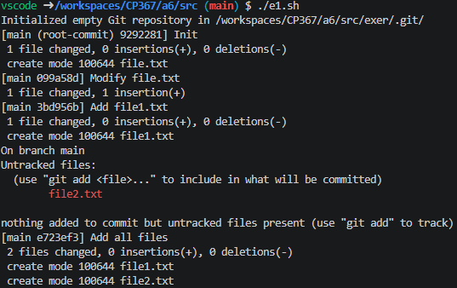

e2.sh
Note ` git log --help` and `git diff --help`did not show up because it is not installed in my container. In general, it will print the documentations.
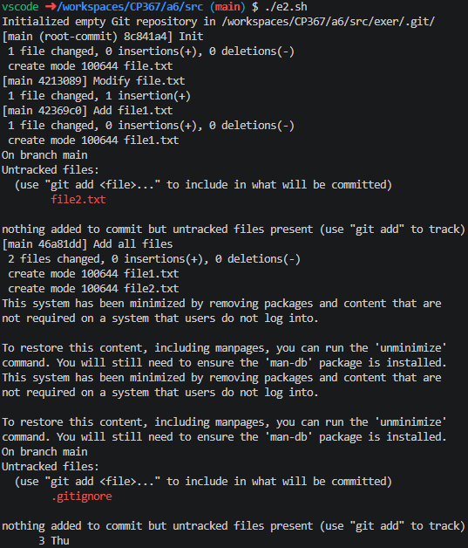

e3.sh
