  - File: tests.docx
  - Author: Hubert Bao
  - Student ID: 169077248
  - Date: 2026-03-12

Output Texts

text_to_array.sh
vscode ➜ /workspaces/CP367/a4/src (main) $ ./text_to_array.sh input.
txt
Array elements:
We
will
buy
very
test
my
loves
vscode ➜ /workspaces/CP367/a4/src (main) $ ./text_to_array.sh
Usage: ./text_to_array.sh <filename>
vscode ➜ /workspaces/CP367/a4/src (main) $ ./text_to_array.sh dne.txt
Error: File 'dne.txt' not found.

check_directory.sh
vscode ➜ /workspaces/CP367/a4/src (main) $ ./check_directory.sh .
Number of regular files in directory '.': 3
vscode ➜ /workspaces/CP367/a4/src (main) $ ./check_directory.sh . sh
Number of regular files in directory '.': 2
vscode ➜ /workspaces/CP367/a4/src (main) $ ./check_directory.sh . txt
Number of regular files in directory '.': 1

vscode ➜ /workspaces/CP367/a4/src (main) $ ./check_directory.sh

Usage: ./check_directory.sh <directory> [extension]

vscode ➜ /workspaces/CP367/a4/src (main) $ ./check_directory.sh arst

Error: Directory 'arst' does not exist.

input.txt
We will buy very test, . . . my loves

Output Screenshots

text_to_array.sh
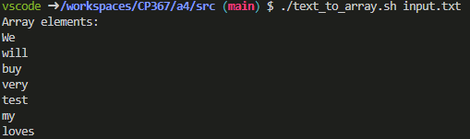
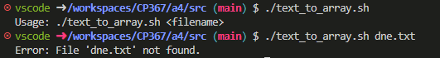

check_directory.sh
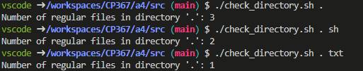
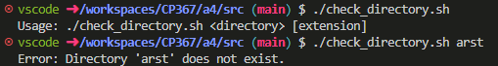

input.txt
