  - File: tests.docx
  - Author: Hubert Bao
  - Student ID: 169077248
  - Date: 2026-02-26

Scripts

Part I
# File: part_I.sh
# Author: Hubert Bao
# Student ID: 169077248
# Date: 2026-02-26

sed 's/ *, */,/g' logs.csv \
| sed -E 's/^(([^,]*,){2})([a-z]+)/\1\U\3/' \
| sed '$!N;/^\(.*\)\n\1$/!P;D' \
| sed 's/,$/,0/' \
| sed 's/,200,/,SUCCESS,/g' \
> cleaned.csv

Part II
# File: part_II.sh
# Author: Hubert Bao
# Student ID: 169077248
# Date: 2026-02-26

awk -F, '{print $2, $4}' cleaned.csv > q6.txt

awk -F, '$5 != "SUCCESS" {errors++} END {print errors}' cleaned.csv > q7.txt

awk -F, '{sum += $6} END {print sum/NR}' cleaned.csv > q8.txt

awk -F, '{
requests[$2]++
} END {
for (ip in requests)
print ip, requests[ip]
}' cleaned.csv > q9.txt

awk -F, '{
traffic[$2] += $6
} END {
max = 0
for (ip in traffic)
if (traffic[ip] > max) {
max = traffic[ip]
max_ip = ip
}
print max_ip, max
}' cleaned.csv > q10.txt

awk -F, '{
if ($6 > max) {
max = $6
ip = $2
}
} END {
print ip, max
}' cleaned.csv > q11.txt

awk -F, '{requests[$3]++} END {
for (method in requests)
print method, requests[method]
}' cleaned.csv > q12.txt

awk -F, '{
requests[$2]++
} END {
for (ip in requests)
if (requests[ip] > 3)
print ip
}' cleaned.csv > q13.txt

awk -F, '{
access[$4]++
} END {
max = 0
for (url in access)
if (access[url] > max) {
max = access[url]
max_url = url
}
print max_url
}' cleaned.csv > q14.txt

Output Screenshots

Part I
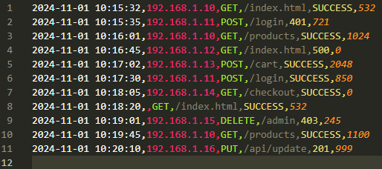

Part II

Q6
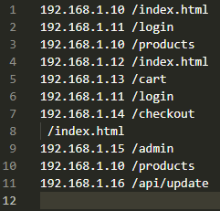

Q7
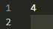

Q8
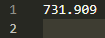

Q9
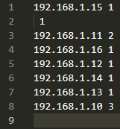

Q10
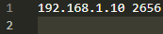

Q11
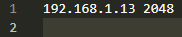

Q12
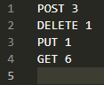

Q13

Q14
