# Data Wiping Bulk Upload - User Documentation

1. Overview

The **Data Wiping Bulk Upload** feature allows you to upload and manage multiple asset records (laptops, devices) along with their wiping certificates in a single batch operation.

What You Can Do:**
- Upload multiple laptop/device records at once using a CSV file
- Attach wiping certificates as a ZIP file
- Verify data validity before submission
- Track upload status and completion

**-File name should be unique for all records

2. Uploading Asset Data (CSV)

Step 1: Download Sample CSV Template

Action:
- Click the **"Download Sample CSV"** button on the upload page
- This file contains the correct column headers and formatting

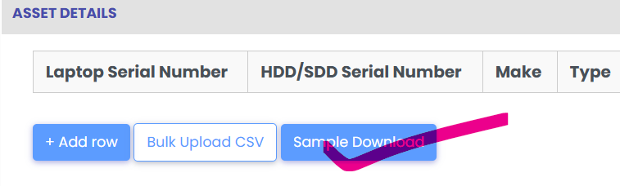

Step 2: Prepare Your CSV File

Open the downloaded CSV in Excel or any spreadsheet application and fill in your data.

Required Fields:*
Laptop Serial No and Wipingdone

**Important Notes:**
- Ensure **Laptop Serial No** is unique (no duplicates)
- Use consistent date format: ** DD -MM-YYYY** (e.g., 20-12-2024)
- *Wiping Completed** must be either "Yes" or "No"
- *Certificate** must match the file name in your ZIP folder exactly
-**File name should be unique for all records
- Do not include special characters in file names
- Leave no rows completely blank
- Remove sample data when uploading your records

Step 3: Upload CSV File

*Action:*
1. Click *"Select CSV File"*
2. Choose your prepared CSV file
3. System validates data automatically
4. Wait for confirmation message

*Expected Result:**
- File accepted
- Table displays all rows with data
- ZIP upload section appears as shown below

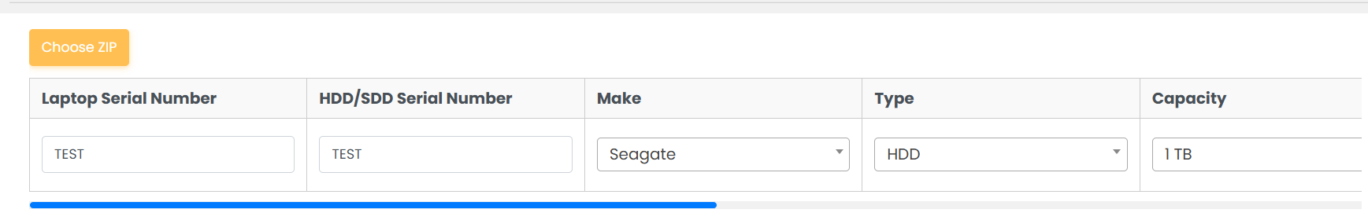

Step 4: Verify Your Data

Review the uploaded data in the table:

- Check all information is correct
- Verify **Laptop Serial No** values
- Confirm **Wiping Completed** status
- Ensure **Certificate** column has file names

*If Data Looks Wrong:*
- Upload again

Step 5: Prepare ZIP File

Create a folder with all your certificate files:

*Folder Structure Example:*

Certificates/
LAP-001-Certificate.pdf
LAP-002-Certificate.pdf
LAP-003-Certificate.pdf
LAP-004-Certificate.pdf

*Steps:*
1. Create a folder with your certificates
2. Save as **certificates.zip** or any name you prefer

**Important:**
- File names must match CSV **Certificate** column exactly
- File names are **case-sensitive** (LAP-001.pdf ≠ lap-001.pdf)
- Do not nest files in subfolders within ZIP

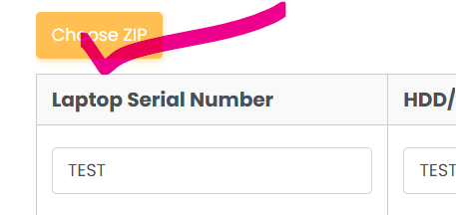

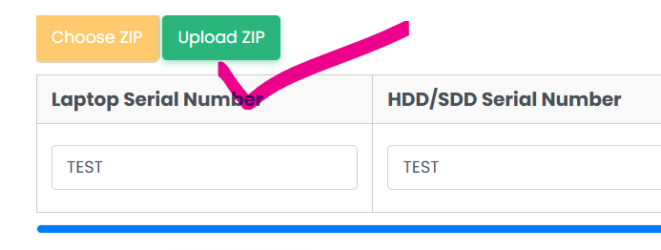
Step 6: Upload ZIP File

Action:
1. Scroll down to *"Wiping Certificates"** section
2. Click **"Select ZIP File"** button
3. Choose your certificates ZIP file
4. Click **"Upload "**
5. Wait for mapping to complete

**What Happens:**
- System reads all files in ZIP
- Matches file names to CSV records
- Displays result for each row:
- ✓ **Green checkmark** = Certificate found
- ✗ **Red warning** = Certificate missing

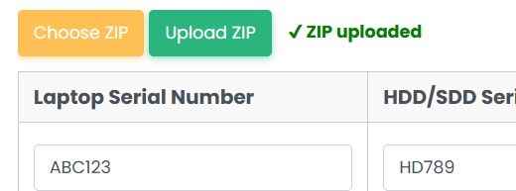

Step 7: Review Certificate Mapping

After ZIP upload, each row shows:

| Status | Meaning | Action |
|--------|---------|--------|
| Green checkmark | Certificate found and attached | None needed |
| Red warning | Certificate file missing | Provide correct file name in ZIP |
| Yellow info | Optional certificate | May skip if not required |

**If Certificates Are Missing:**
1. Check file names in your ZIP match CSV exactly
2. Verify case sensitivity (uppercase/lowercase)
3. Update your ZIP file
4. Upload again

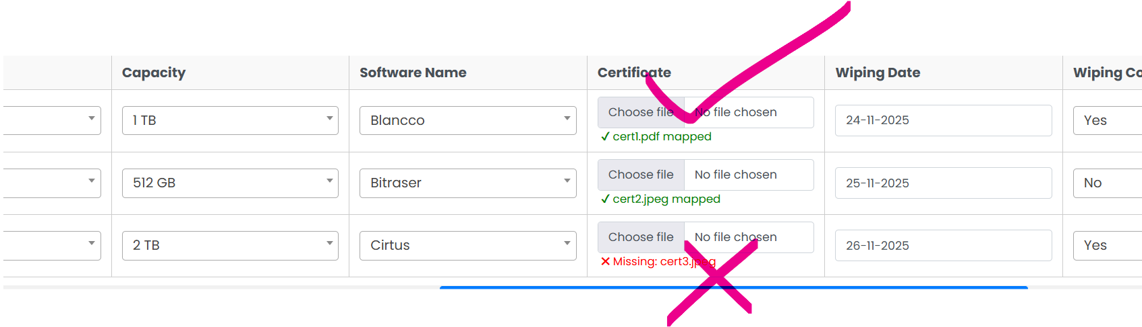

6. Error Messages & Solutions

## Error: "Duplicate Laptop Serial Number"
**Cause:** Same serial number appears twice in CSV
**Solution:**
- Check CSV for duplicate entries
- Ensure each serial is unique
- Update CSV and re-upload

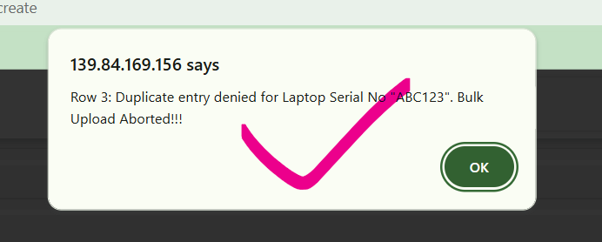

### Error: "Missing Required Field: Wiping Completed"
**Cause:** CSV row missing "Wiping Completed" value
**Solution:**
- Open CSV in Excel
- Fill in all empty cells in "Wiping Completed" column
- Use only "Yes" or "No"
- Re-upload

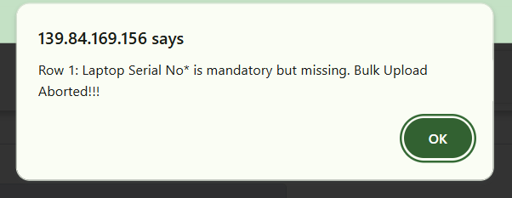

### Error: "Certificate Missing: LAP-001-Certificate.pdf"
**Cause:** ZIP file doesn't contain the expected certificate
**Solution:** Verify certificate file exists on your computer
- Ensure file name matches CSV exactly (case-sensitive)
- Add file to ZIP folder or Re-upload ZIP

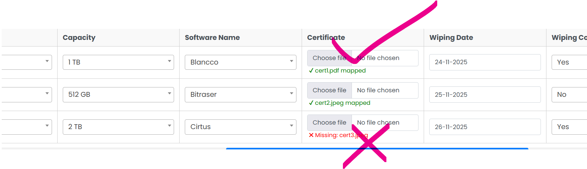
---

### Error: "Empty or Blank Rows Detected"
**Cause:** CSV contains empty rows or rows with only spaces
**Solution:**
- Open CSV in Excel
- Delete completely blank rows
- Ensure every row has at least one value
- Re-upload



## 7. Best Practices

### ✓ Do's

1. **Download the sample CSV** - Use the provided template to ensure correct format
2. **Use consistent date format** - Always use DD-MM-YYYY (20-12-2024)
3. **Keep file names simple** - Use only letters, numbers, hyphens, underscores
4. **Create folder for certificates** - Organize all PDFs in one folder before zipping
5. **Double-check file names** - Certificate names must match CSV exactly
6. **Verify serial numbers** - Ensure each is unique before uploading
7. **Test with small batch first** - Upload 5-10 records to verify process before bulk upload
8. **Keep records organized** - Use consistent naming convention across all uploads

### ✗ Don'ts

1. **Don't leave required fields empty** - All mandatory fields must have values
2. **Don't use special characters** - Avoid @, #, $, %, &, *, etc. in file names
3. **Don't mix date formats** - Don't use 20-12-2024 and 2024-12-20 in same file
4. **Don't nest certificates in subfolders** - Keep all files at ZIP root level
5. **Don't ignore case sensitivity** - "LAP-001.pdf" ≠ "lap-001.pdf"
6. **Don't upload duplicate serials** - Each device serial must be unique
7. **Don't modify downloaded template** - Keep column headers exactly as provided
8. **Don't upload large files** - Keep ZIP under 50MB, CSV under 5MB

