# CLASS Setup - MAC

Standard Java Setup

1. Intel-based Mac OS X 10.7.3(Lion) or later, 64-bit browser, and Administrator privileges for installation.

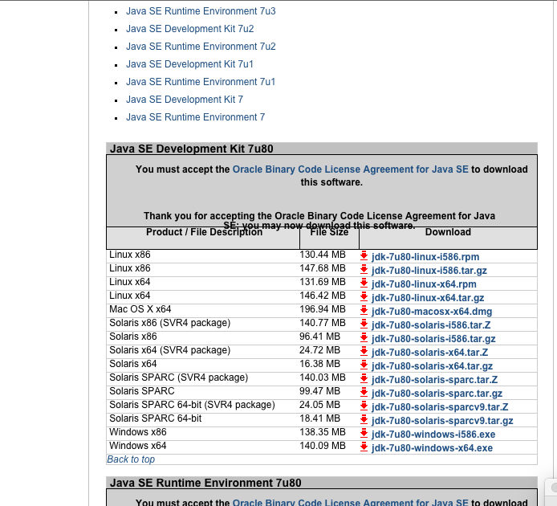

2)      64-Bit web browsers – please install recent versions of both Chrome and Firefox if possible:

a.      Google Chrome – <http://www.google.com/chrome/>

b.      Mozilla Firefox – <http://www.mozilla.org/en-US/firefox/new/>.

*\*Note-     Please also install the Firebug plugin for Firefox, which helps with debugging:* [*http://getfirebug.com/*](http://getfirebug.com/)

1. Java Development Kit – JDK 7 Update 80

***[many versions online and the default version of 7 located in my IDE is 51 ??]***

1. Note: any recent **JDK 7** version will be fine.

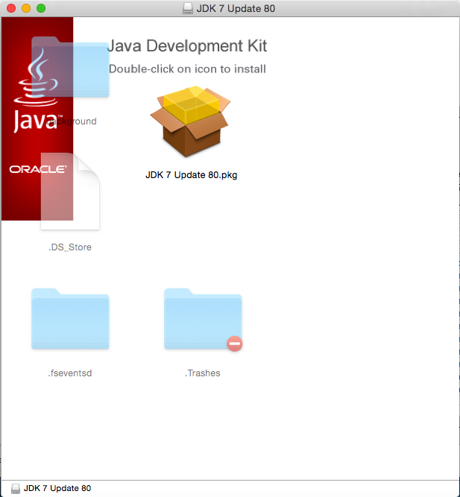

1. From <http://www.oracle.com/technetwork/java/javase/downloads/java-archive-downloads-javase7-521261.html>, please locate and download the installer .dmg file, jdk-7u80-macosx-x64.dmg.

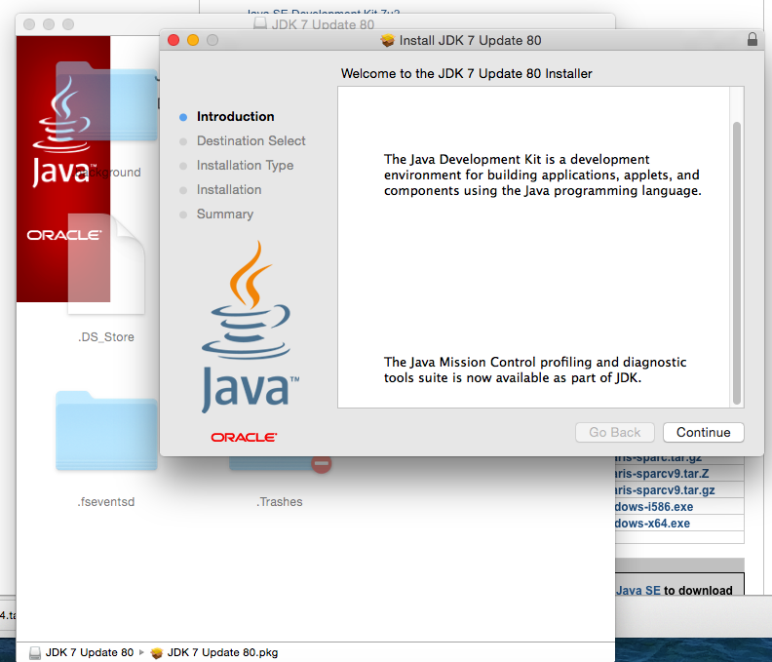

c. Locate and double click the downloaded .dmg file to launch and run the installer with all default settings.

d. Double click on the package icon to launch the installation wizard

e. Click through the installer.

4)      Next, set up the environment variable:

a.      Click the finder, then select Utilities. Once under utilities, double click Terminal to launch a terminal window

b. Once the Terminal window is opened, type the following:

c. export JAVA_HOME=$(/usr/libexec/java_home –v 1.7)

d. export PATH=$JAVA_HOME/bin:$PATH

***e. [verify what’s needed to permanently add to bash shell)***

f. Close the terminal window.

5)      Please test the Java installation and the environment variables:

a.      Click the finder, then select Utilities. Once under utilities, double click Terminal to launch a terminal window

b.      At the prompt, type **javac -version** and press Enter

c.      You should get a message indicating that the Java version is 1.70_80 [or whatever version you have installed]

d.      If all is well, close the command prompt.

**IDE setup**

6)      Eclipse for Java EE Developers.  Eclipse version **4.4 Luna is required** for Java 7 support.

a.      Download Eclipse 4.4.2 for Java EE developers for your operating system from <http://www.eclipse.org/downloads/packages/eclipse-ide-java-ee-developers/lunasr2>

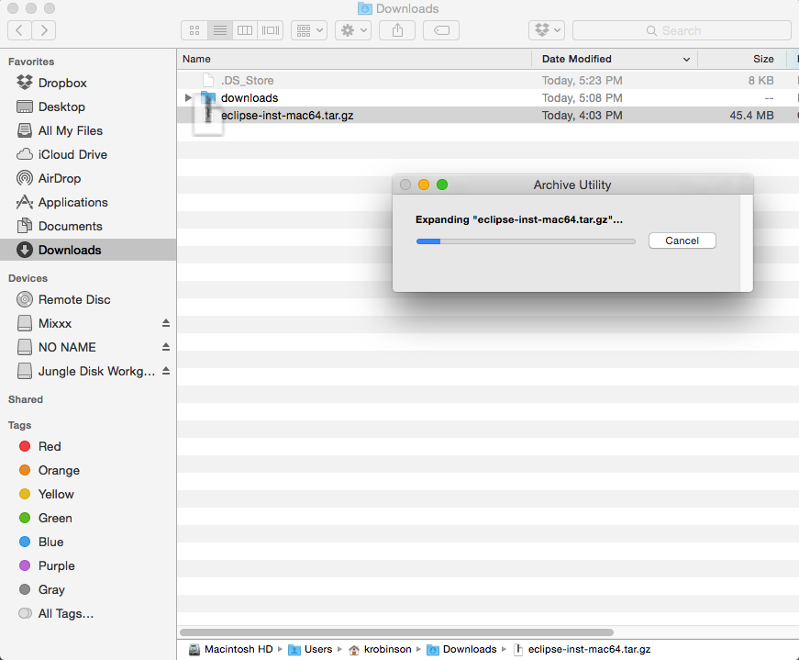

c.      Locate the downloaded file, eclipse-inst-mac64.tar.gz file, which is usually located within your downloads folder and double click the file.

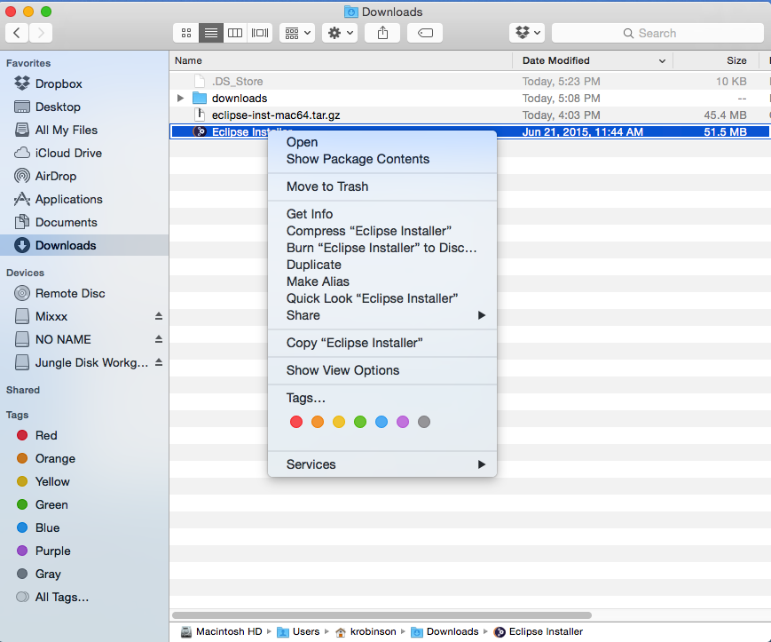

d. This will extract the Eclipse Installer file. Locate this file and double click on it. This will launch the Eclipse installer.

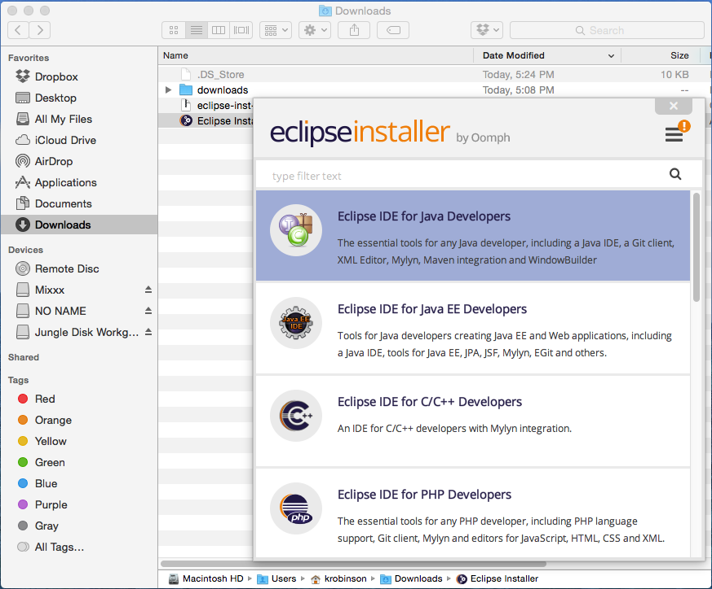

e. Select the first option “Eclipse IDE for Java Developers” and use the default option for the installation directory.

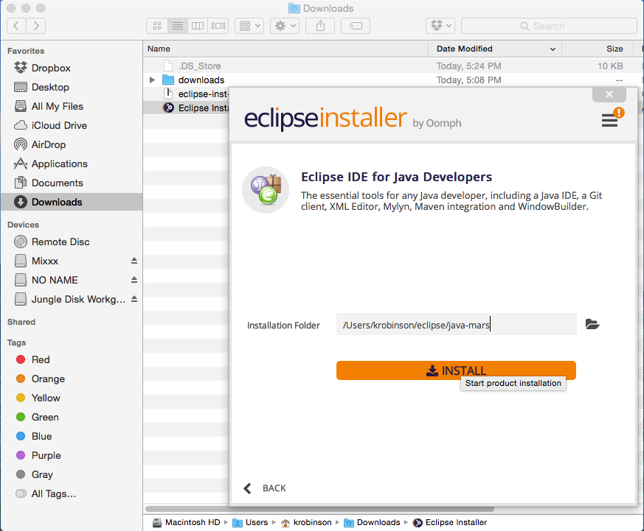

f. Click the “Install” option.

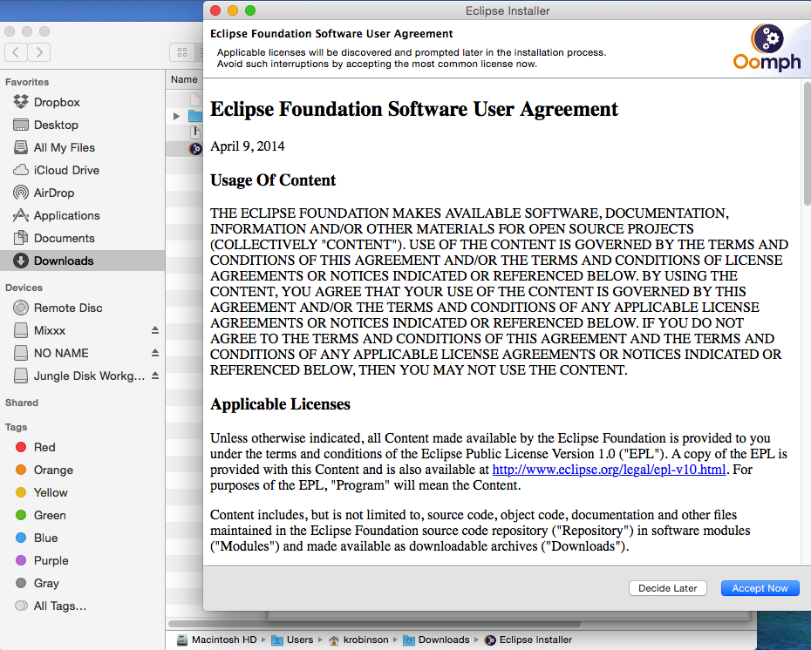

g. Click the “Accept Now” to accept the license agreement.

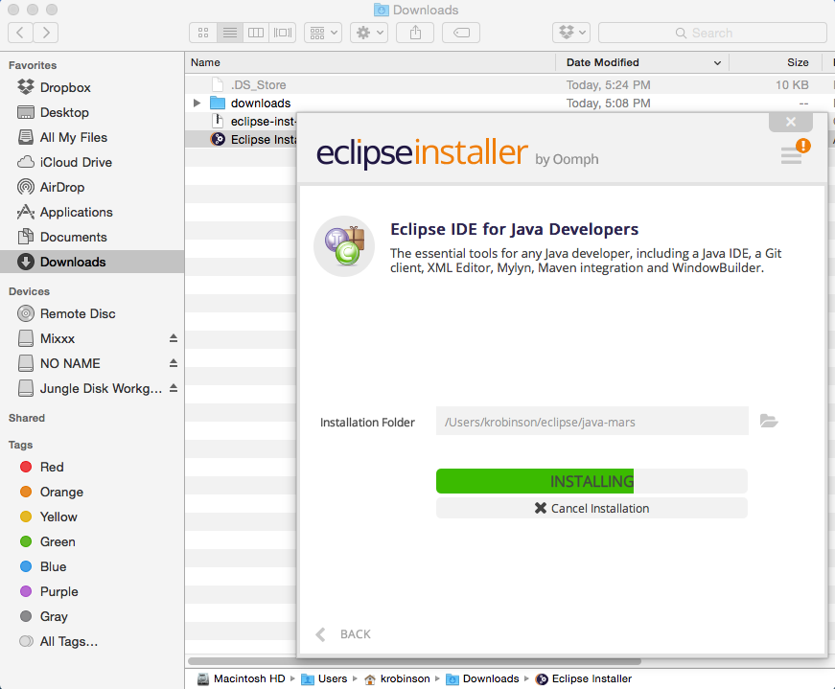

h. The installation process will begin installing the application.

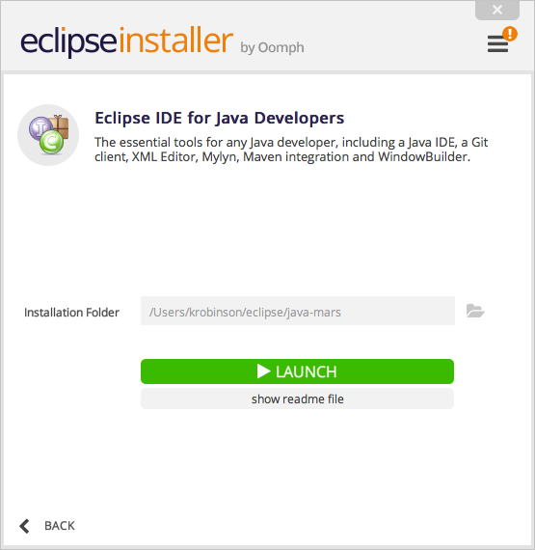

1. When the installation is complete, it will identify the location where the application is installed, make a not of this location

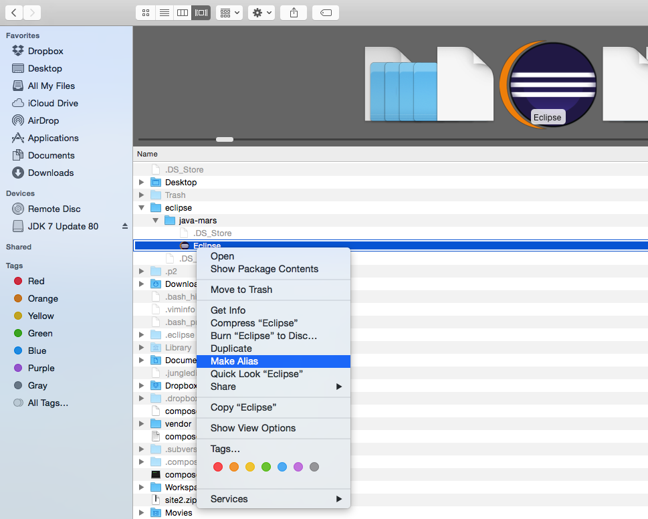

j. Go to the location where Eclipse is installed. Open the Eclipse folder, locate the Eclipse application and hold control and click on the Eclipse icon and select “Make alias” which will make an alias of the Eclipse executable.

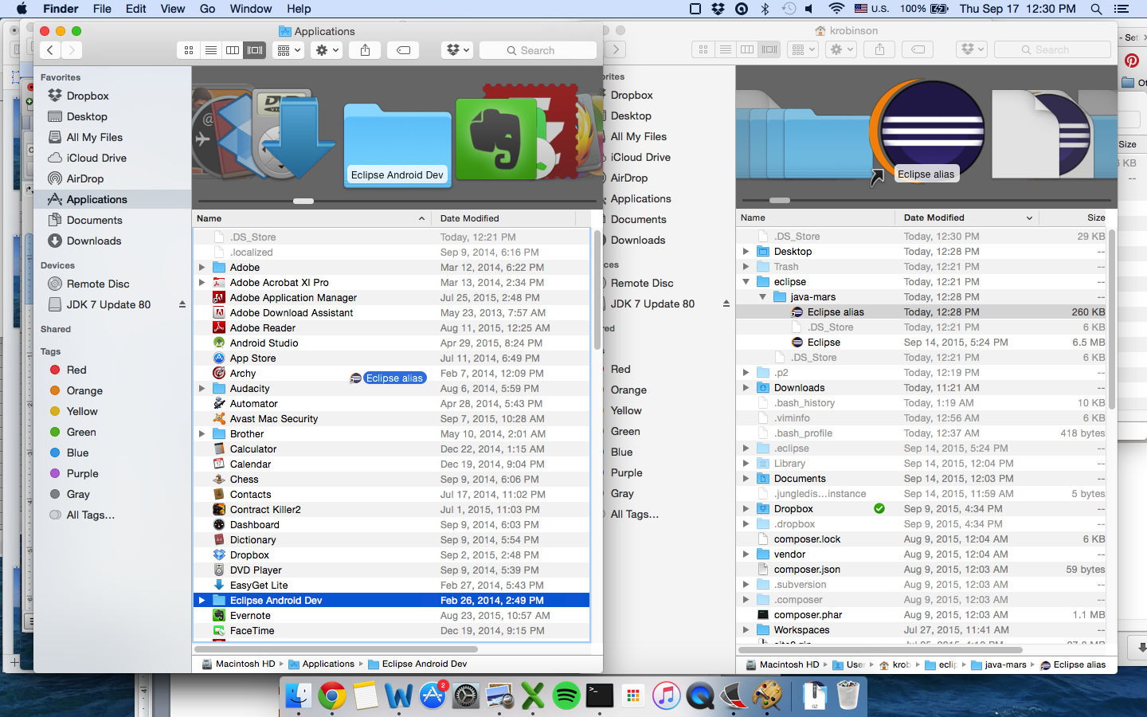

k. Drag this executable to the Applications folder. Moving forward, you can launch the application by visiting Applications and clicking the Eclipse icon.



l. Go back to the Eclipse installer when the process completes, click the “Launch” icon

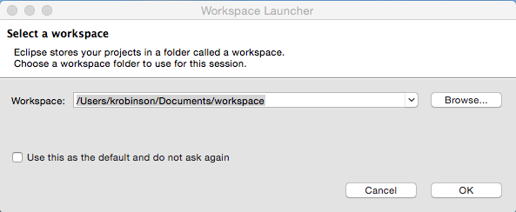

l.      Accept the default workspace, and confirm that it opens successfully to the main window.  If prompted with the Welcome page, click the X to close that, which should bring you to the main screen of Eclipse.