# CLASS Setup

Standard Java Setup

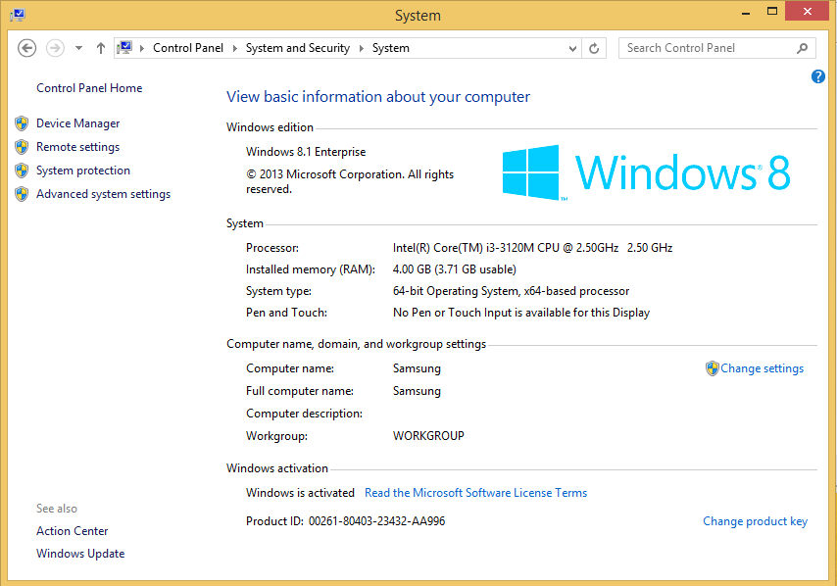

1. Windows (32-bit or 64-bit) with the latest system updates and at least 3 GB RAM

2)      Web browsers – please install recent versions of both Chrome and Firefox if possible:

a.      Google Chrome – <http://www.google.com/chrome/>

b.      Mozilla Firefox – <http://www.mozilla.org/en-US/firefox/new/>

                                                    i.     Please also install the Firebug plugin for Firefox, which helps with debugging: <http://getfirebug.com/>

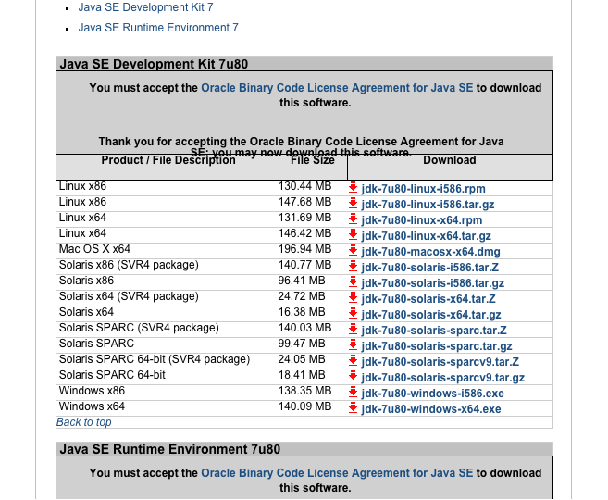

3)      Java Development Kit – JDK 7 Update 80

a.      Note: any recent **JDK 7** version will be fine.

b.      From <http://www.oracle.com/technetwork/java/javase/downloads/java-archive-downloads-javase7-521261.html>, please download the installer for your bitness of Windows (x86 for 32-bit, x64 for 64-bit).

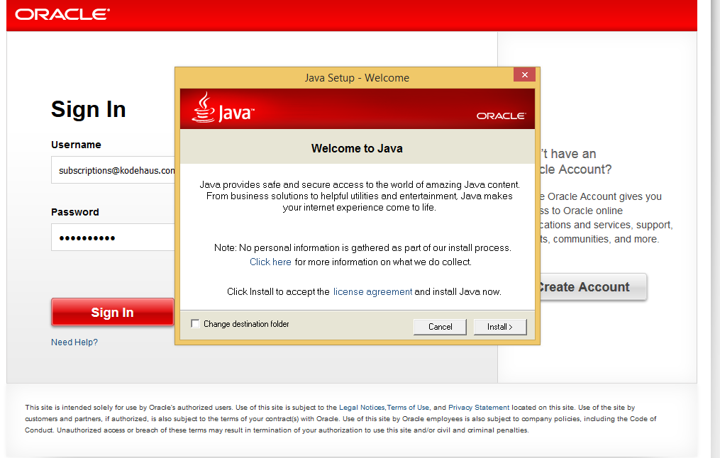

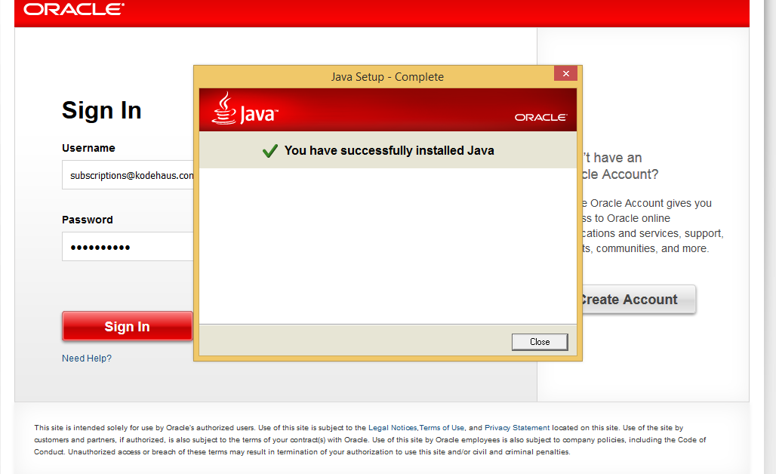

4) Run the installer with all default settings.

5)      Next, please set up one environment variable and modify another:

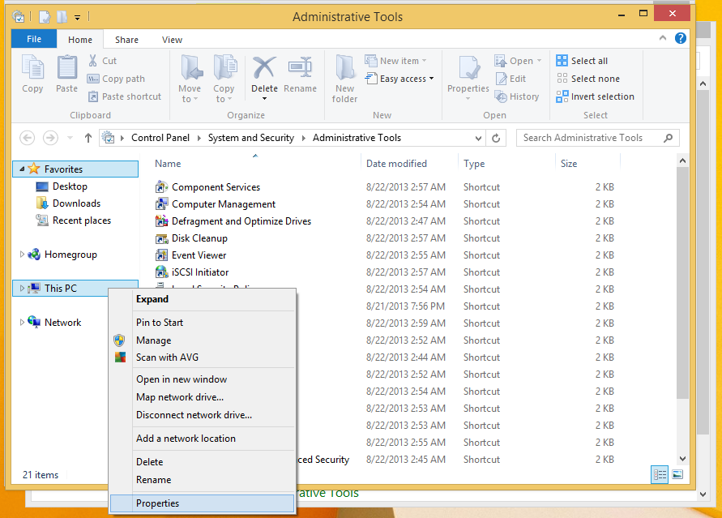

1. Right click My Computer and choose Properties

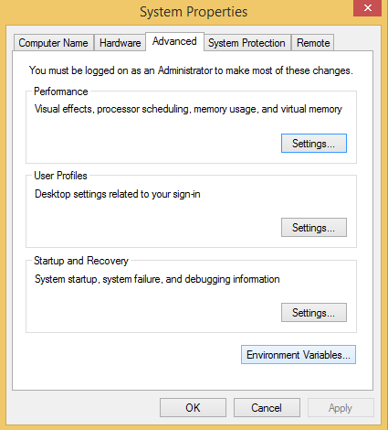

1. Click the Advanced tab then click the Environment Variables button

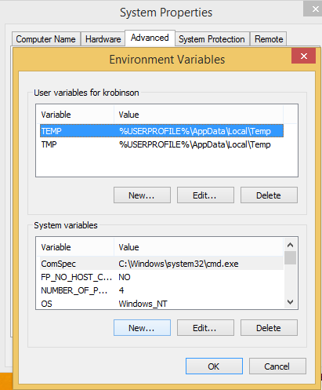

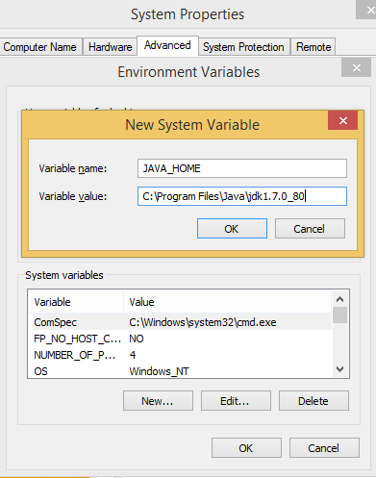

d.      In the bottom half of the dialog, click New to add a new System variable

                                                    i.     Variable name: JAVA_HOME (this is case-sensitive)

                                                   ii.     Variable value: C:\Program Files\Java\jdk1.7.0_80 (or adjust to the actual path where you installed the JDK – please double-check this path – probably best to copy and paste it)

                                                  iii.     Click OK after entering both of these

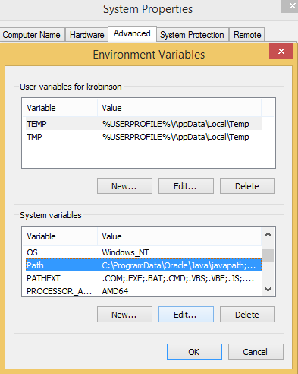

e.      In the bottom half of the dialog, find the Path environment variable, highlight it, and click Edit.

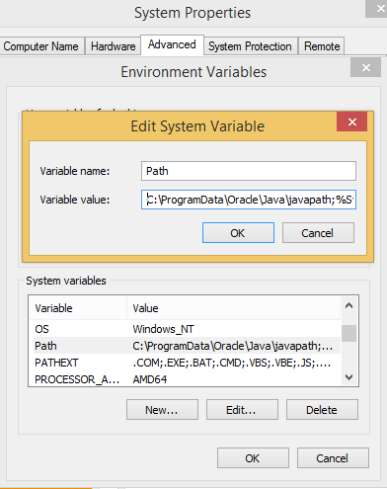

f.       Click in the Variable value field and move your cursor all the way to the left (pressing Home on your keyboard should do this quickly for you)

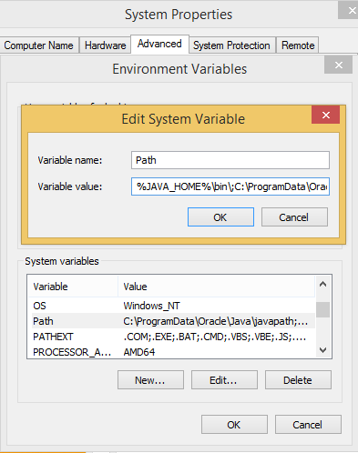

g.      Prepend the following: **%JAVA_HOME%\bin;**   [make sure you get all of this, including the trailing semicolon, with no spaces]

h.      Click OK repeatedly (likely in 3 different dialogs) until all the dialogs close.

5)      Please test the Java installation and the environment variables:

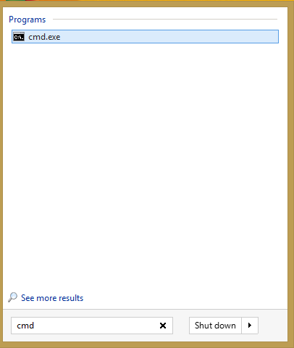

1. Open a Windows command prompt: open the Start menu, enter **cmd** in the search box, and press Enter.

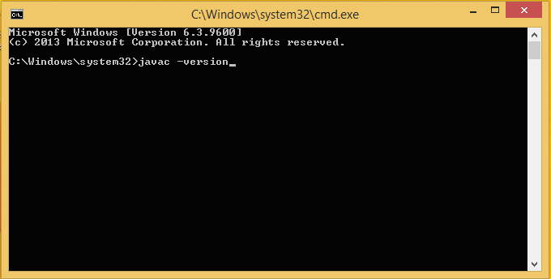

b.      At the prompt, type **javac -version** and press Enter

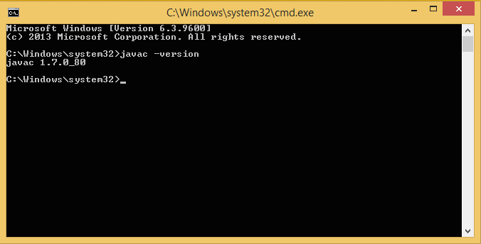

c.      You should get a message indicating that the Java version is 1.70_80 [or whatever version you have installed]

d.      If all is well, close the command prompt.

IDE setup

6)      Eclipse for Java EE Developers.  Eclipse version **4.4 Luna is required** for Java 7 support.

a.      b.      Download Eclipse 4.4.2 for Java EE developers for your operating system from <http://www.eclipse.org/downloads/packages/eclipse-ide-java-ee-developers/lunasr2>

                                                    i.     **Important Note:** Please make sure the bitness of Eclipse matches the bitness of your JDK.  If you mix 32-bit and 64-bit versions, Eclipse may fail to start.

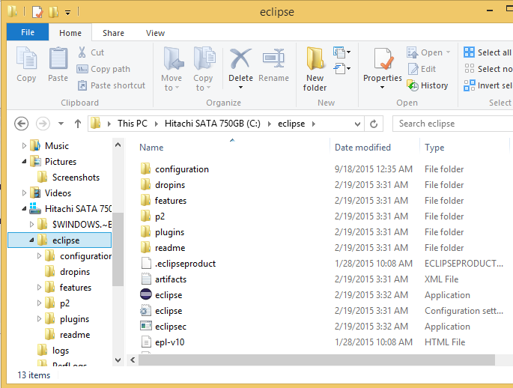

c.      Unzip the file to the root of your C drive, which will create a directory at “C:\eclipse”.

d.      Open the resulting directory, and execute **eclipse.exe**.

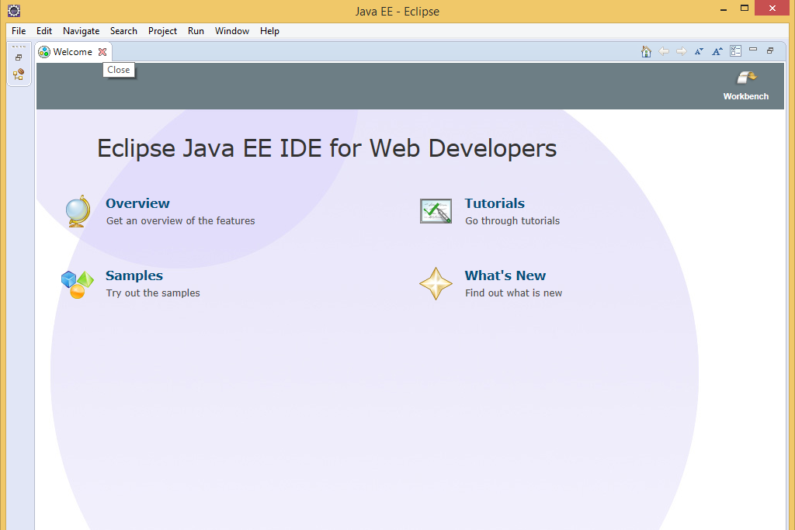

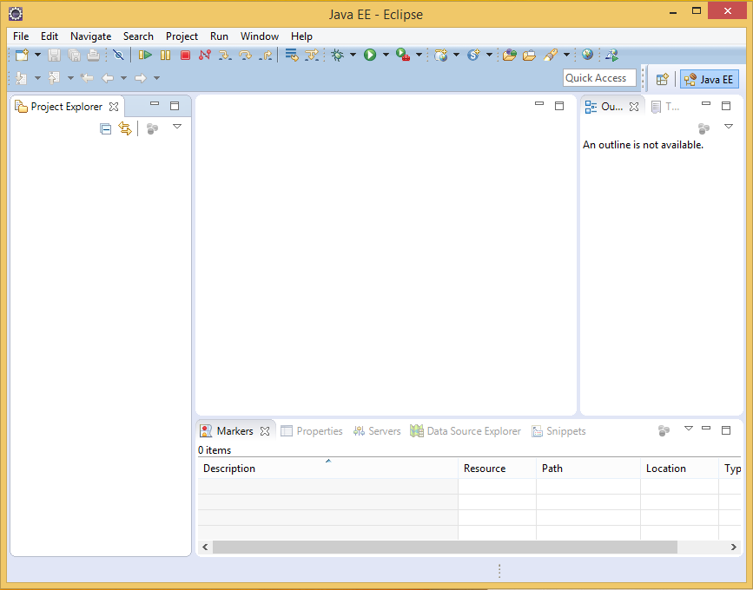

e.      Accept the default workspace, and confirm that it opens successfully to the main window.  If prompted with the Welcome page, click the X to close that, which should bring you to the main screen of Eclipse.