Two-way ANOVA Practical Report – Cholesterol by Sex and Chest Pain Type
Dataset: https://www.kaggle.com/datasets/fedesoriano/heart-failure-prediction
1. Objective
To test whether the mean cholesterol level differs by Sex and Chest Pain Type, and to examine if there is an interaction effect between these two factors.

2. Hypotheses
Main Effects
Sex
- Null Hypothesis (H₀): Mean cholesterol is the same for males and females.
- Alternative Hypothesis (H₁): Mean cholesterol differs between males and females.
Chest Pain Type
- Null Hypothesis (H₀): Mean cholesterol is the same across all chest pain types.
- Alternative Hypothesis (H₁): At least one chest pain type has a different mean.
Interaction Effect
- Null Hypothesis (H₀): No interaction effect between Sex and Chest Pain Type.
- Alternative Hypothesis (H₁): There is an interaction effect.

3. Assumption Checks
3.1 Homogeneity of Variances (Levene’s Test)
Test | F-value | p-value | Decision
Levene | 8.8289 | 1.54 × 10⁻¹⁰ | Variances are not equal

Interpretation: The assumption of equal variances is violated. Results should be interpreted with caution.

3.2 Normality of Residuals (Shapiro-Wilk Test)
Test | W | p-value | Decision
Shapiro-Wilk | 0.91817 | < 2.2 × 10⁻¹⁶ | Residuals deviate from normality

Interpretation: Residuals are not perfectly normal. ANOVA is still robust for large sample sizes (n = 918).

4. ANOVA Results
Source | Df | Sum Sq | Mean Sq | F value | Pr(>F) | Significance
Sex | 1 | 439277 | 439277 | 38.776 | 7.25e-10 | ***
ChestPainType | 3 | 172305 | 57435 | 5.070 | 0.00174 | **
Sex:ChestPainType | 3 | 51263 | 17088 | 1.508 | 0.21084
Residuals | 910 | 10308961 | 11329

Interpretation:
- Both Sex and Chest Pain Type significantly affect cholesterol.
- Interaction effect is not significant.

5. Post-hoc Analysis (Tukey HSD) – Chest Pain Type
Comparison | Mean Difference | 95% CI | p-value | Significance
ATA - ASY | 35.36 | 11.17, 59.55 | 0.0010 | Yes
NAP - ASY | 4.35 | -18.47, 27.18 | 0.9611 | No
TA - ASY | 16.33 | -25.90, 58.55 | 0.7522 | No
NAP - ATA | -31.01 | -59.35, -2.66 | 0.0256 | Yes
TA - ATA | -19.03 | -64.48, 26.41 | 0.7031 | No
TA - NAP | 11.97 | -32.76, 56.71 | 0.9014 | No

Interpretation: Significant differences observed mainly for ATA vs ASY and NAP vs ATA chest pain types.

6. Visualization
Interaction Plot:
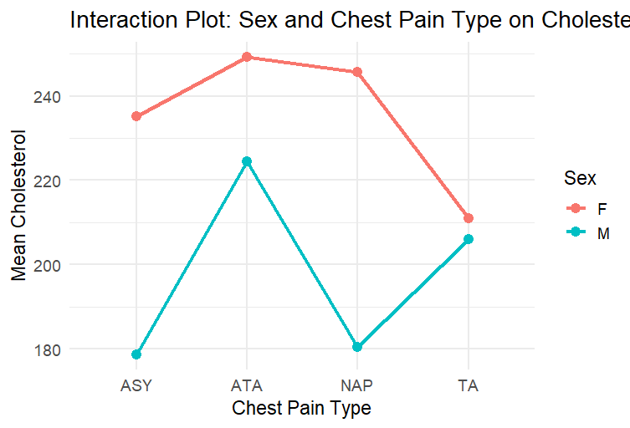

Boxplot:
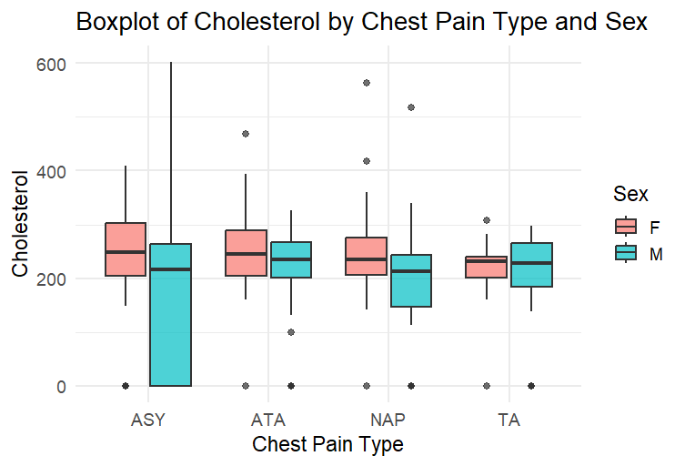
Observation:
- Males generally have higher cholesterol than females.
- ATA chest pain type shows higher mean cholesterol compared to ASY and NAP.
- Lines in interaction plot are mostly parallel → interaction effect is weak.

7. Conclusion
- Sex and Chest Pain Type significantly affect cholesterol levels.
- Interaction effect between Sex and Chest Pain Type is not significant.
- Tukey HSD shows significant differences mainly between ATA vs ASY and NAP vs ATA.
- Despite minor violations of ANOVA assumptions, results are reliable for the large sample size (n = 918).

Screenshots
