Aim :- Performing one-way ANOVA using aov() (R)______(Practical 7).
One-way ANOVA Practical Report – Baseline Value by Fetal Health
Dataset :- https://www.kaggle.com/datasets/andrewmvd/fetal-health-classification
1. Objective
To test whether the mean baseline_value differs among the three fetal_health groups (Normal, Suspect, Pathological).

2. Hypotheses
- Null Hypothesis (H₀): Mean baseline_value is the same across all fetal_health groups.
H0​:μ1​=μ2​=μ3​
- Alternative Hypothesis (H₁): At least one group has a different mean.
H1​:At least one μi​ is differ

3. Assumption Checks
3.1 Homogeneity of Variances (Levene’s Test)
Test | F-value | p-value | Decision
Levene | 9.3392 | 9.157 × 10⁻⁵ | Variances are not equal

Interpretation: The assumption of equal variances is violated. ANOVA is still robust for large sample sizes, but caution is advised.
3.2 Normality of Residuals (Shapiro-Wilk Test)
Test | W | p-value | Decision
Shapiro-Wilk | 0.99624 | 3.807 × 10⁻⁵ | Residuals are not perfectly normal

Interpretation: Residuals deviate slightly from normality. Given the large sample size (n = 2126), ANOVA results are considered reliable.

4. ANOVA Results
Source | Df | Sum Sq | Mean Sq | F value | Pr(>F)
fetal_health | 2 | 24073 | 12036 | 140.6 | < 2e-16 ***
Residuals | 2123 | 181717 | 86 | - | -

Interpretation: The p-value < 0.05 indicates that there is a statistically significant difference in baseline values between at least two fetal_health groups. Therefore, we reject H₀.

5. Post-hoc Analysis (Tukey HSD)
Comparison | Mean Difference | 95% CI | p-value | Significance
2 – 1 | 9.7029 | 8.3316, 11.0742 | 0.0000 | Yes
3 – 1 | -0.2944 | -2.0147, 1.4260 | 0.9151 | No
3 – 2 | -9.9972 | -12.0639, -7.9306 | 0.0000 | Yes

Interpretation of post-hoc results:
- Group 2 (Suspect) has significantly higher baseline values than Group 1 (Normal).
- Group 3 (Pathological) is not significantly different from Group 1 (Normal).
- Group 3 (Pathological) has significantly lower baseline values than Group 2 (Suspect).

6. Visualization
- Boxplot of Baseline Value by Fetal Health
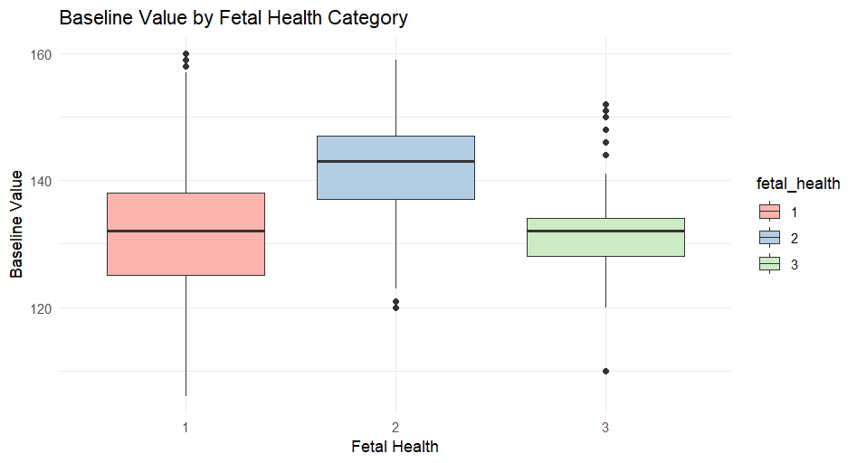

- ANOVA and TukeyHSD output screenshots
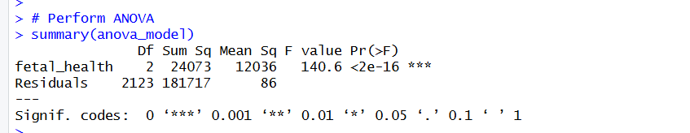
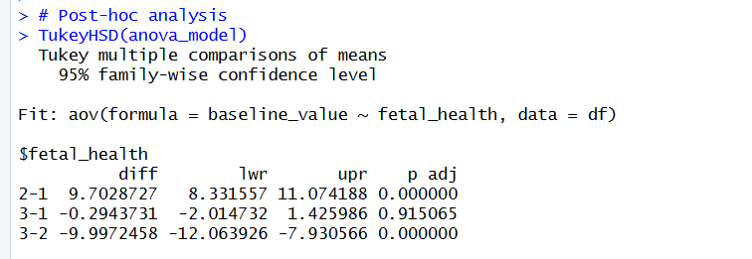

Interpretation from Boxplot:
- Group 2 (Suspect) shows a higher median baseline value.
- Group 3 (Pathological) overlaps with Group 1 (Normal).
- Visual observation aligns with the TukeyHSD findings.

7. Conclusion
The analysis confirms that baseline_value differs significantly across fetal health categories, mainly due to elevated values in the Suspect group (Group 2). The results are consistent across ANOVA and post-hoc TukeyHSD tests, and the boxplot visually demonstrates these differences.
Note: Minor violations of ANOVA assumptions (normality and homogeneity of variances) exist, but given the large sample size (n = 2126), the results are still reliable.

Screenshots

