American Sign Language using CNN, Keras

Ngo Dong Hai - 1610905
Faculty of Electrical and Electronics Engineering
Ho Chi Minh city University of Technology
Ho Chi Minh city, Vietnam
Nguyen Tuan Kiet - 1611701
Faculty of Electrical and Electronics Engineering
Ho Chi Minh city University of Technology
Ho Chi Minh City, Vietnam
Đặng Thành Tín
Faculty of Electrical and Electronics Engineering
Ho Chi Minh city University of Technology
Ho Chi Minh City, Viet Nam

Abstract—This paper describes my first project experience in making a program using open-source software tools such as Python. Eventually, the project focused on recognising hand sign language so that we can communicate with the handicapped without knowing the hand sign. An executable GUI - to capture the frames from the laptop webcam and process through the program. For now, it can just detect some of the gesture and still need improvement.
Keywords— ASL, tensorflow, keras, CNN

Introduction
This document is a final report from my second semester 2019 distributed research experience as an undergraduate student. My mentor, Đặng Thành Tín, Associate Professor Ph. D, from the Falculty of Electrical and Electronics Engineering at the University of Ho Chi Minh city, directed my effort in this project for writing a program, eventually designing and implementing a graphical user interface (GUI) for a human operator to receive an input from camera and show the results.
The program is written in Python and processed through a common laptop. The OpenCV library already provides a code written in Python. First, we collect Dataset, then we import nesscessary Libraries, building the CNN, training our Network and finally, we execute the program. The project is used to help the deaf and the mute to communicate with other people like above. This can improve the social life and bring people back together no matter who you are. It also create new opportunities for the handicapped to work just like others.
At the university of Ho Chi Minh city, there are already a program to recognise American sign language using C/C++ but they just stopped at recognising and displaying American alphabets. So, we continue to improve their Dataset by adding some of the words and trying to form sentences.
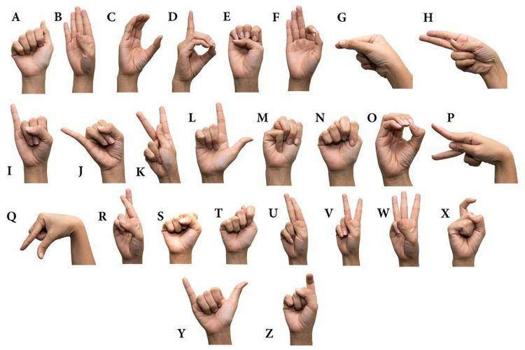
Fig. 1. American hand sign alphabets

Method
Before we make our executable program, first we learned ASL alphabets. Then we continue to select the programing language and we dicided to use python. Eventually, we have finished our program although it content lots of flaws.
Keras is a high-level neural network application interface programing which is written mainly in Python. We choose Keras due to it has a deep learning library that allows us for easy and fast prototyping (through user friendliness, modularity, and extensibility), supports both convolutional neaural networks and recurrent neaural networks, as well as combinations of the two and morever, it can also runs seemlessly on CPU and GPU.
A neuro networks were inspired by the neural architecture of a human brain, and like in a human brain the basic building block is called a Neuron. Its functionality is similar to a human neuron, it takes in some inputs and activate an output. In a purely mathematical terms, a neuron in the machine learning is a placeholder for mathatical function, and its only job is to provide an output by applying function ưhen the inputs provived.
For example in Fig. 2, the left most layer of the nẻural network is called the input layer, and the right most layer is the output layer which only has one node, And the middle layer of node is called the hidden layer because its values are not observed in the training set. We can also say that our neuro network has 3 input units (not counting the bias unit which is 1), 3 hidden units, and 1 output unit
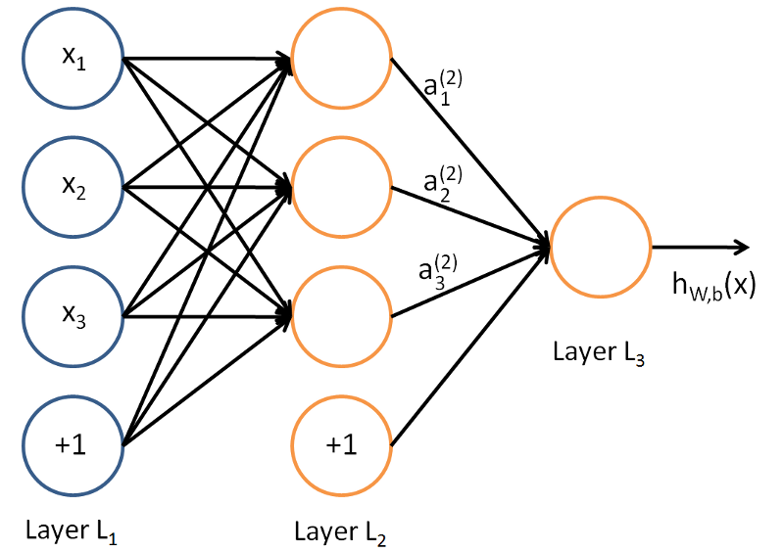
Fig. 2. Neural Networks
Convolutional Neural Networks (CNN) is one of the variants of neural networks heavily used in the field of Computer Vision. It derives its name from the type of hidden layers it consists of. The hidden layers of a CNN typically consist of convolutional layers, pooling layers, fully-connected layers, and normalization layers. Here it simply means that instead of using the normal activation functions, convolution and pooling functions are used as activation functions.

Our Work
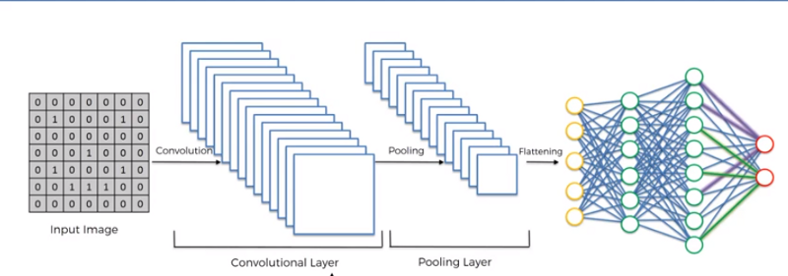
Fig. 3. Convolutional Neural Network

In order to train our machine, we need a huge amount of data so that our model can learn from them by identifying out certain relations and common features related to the hand signs. There are 36 catagogies which 26 of them are alphabets and 16 of them are words which is {about, add, all, America, begin, birthday, butterfly, call me, city, deserve, football, love, my, name, pray, stop, time out}, each of the catagories contain 1750 images for training set and 200 images for testing set to evaluate the accuracy. We took pictures by using the camera and rescaling the images to 64 x 64 pixels.
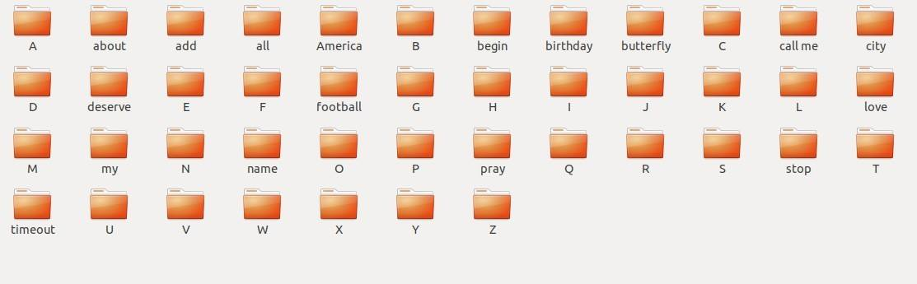
Fig. 4. Train data

We also convert the images to the threshold images for training the machine is a lot easier.

Fig. 5. This is the threshold images of "Time out"

Next step is to build the CNN as we describe above. This is the most important step for our network, we use three main types of layers to build Convolutional Neuro Network architectures: the first one is Convolutional Layer, the second one is Pooling Layer and the third one is Fully-Connected Layer. We will stack these layers to form and build a full Convolutional Neuro Network architecture:
Convolutional Layer is the core of the building block of the CNN. It carries the main portion of the network’s computational load. This layer can perform like a dot product between two matrices, where one matrix is set of learnable parameters otherwise known as a kernel, and the other matrix is the restricted portion of the receptive field. The kernel is spatially smaller than an image, but is more in-depth.
Pooling Layer replaces the output of the network at certain locations by deriving a summary statistic of the nearby outputs. This helps in reducing the spatial size of the representation, which decreases the required amuont of computation and weights. The pooling operation is processed on every slice of the representation indivitually.
There are several pooling functions such as the average of the rectangular neighborhood, L2 norm of the rectanglular neighborhood, and a weighted average based on the distance from the cenral pixel. However, the most popular process is max pooling, which reports the maximum output from the neighborhood.
If we have an activation map of size W x W x D, a pooling kernel of spatial size F, and stride S, then the size of putput volume can be determined by the following formula:
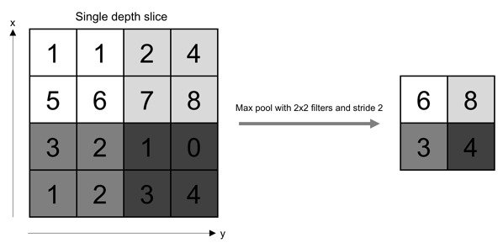
Fig. 6. Pooling layer

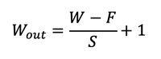

This will yeild an putput volume of size W_{out} x W_{out} x D.
In all cases, pooling provides some translation invariance which means that an object would be recognizable regardless of where it appears on the frame.
Fully-connected (FC) Layer which neurons in this layer have full connectivity with all neurons in the preceding and succeeding layer. This is why it can be computed as usual by a matrix pultiplication followed by a lias effect. The FC layer helps map the representation between the input and the output.
Non-Linearity Layers, since convolution is a linear operation and the images are for from linear, non-linaerity layers are often placed directly after the convolutional layer to introduce non-linearity to the activation function. There are several types of activation function and 6 of them are very common and popular:
- Threshlod or Binary step activation fuction:
This is the simplest function and can be thought of as a yes or no function. If the value of z is above the threshold value the activation is set to 1 or it means yes and the neuron will be activated. If the value of z is below the threshold value the activation is set to 0 or it means no and the neuron will not be activated. They are commonly used for binary classification.
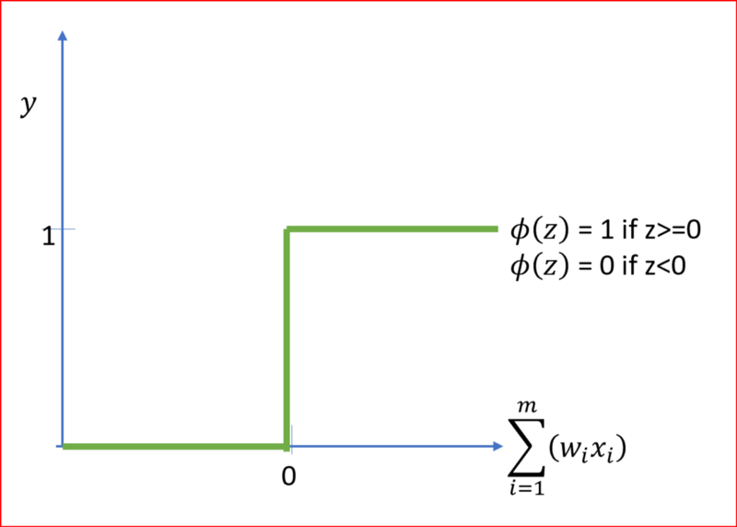
Fig. 7. Threshold or Binary step activation function
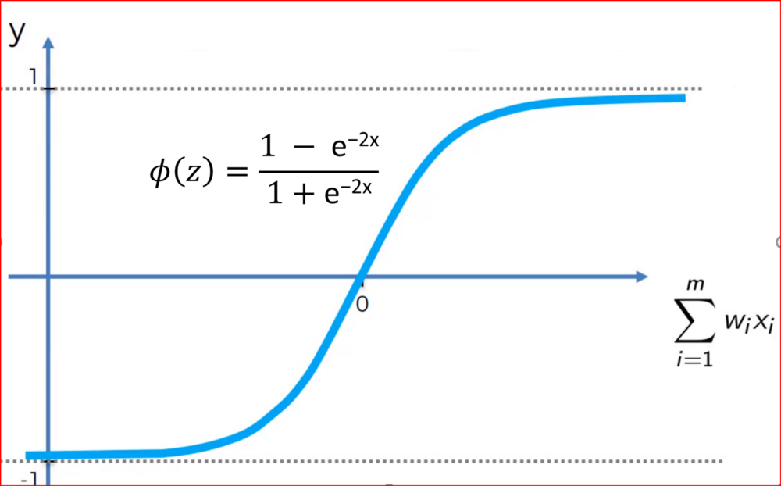
Fig. 9. Tanh Activation Function
- Sigmoid Activation Function.
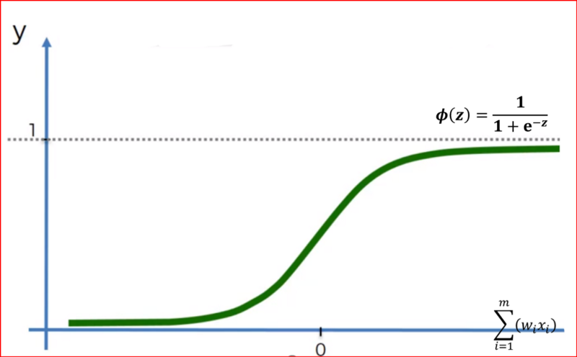
Fig. 8. Sigmoid Activation Function

Sigmoid function is a smooth nonlinear function with no kinds and it's look like S shape. It predicts the probability of an output, hence is used in output layers of a neural network and logisstics regression. Due to the probability ranges from 0 to 1, so sigmoid function value exists between 0 and 1.
- Softmax Activation Function
Sigmoid activation function is used for two class or binary class classification whereas softmax activation function is used for multi class classification and is a generalization of the sigmoid function. In softmax, we get the probabilities of each of the class whose sum should be equal to 1. When the probability of one class increase then the probability of other classes decreases, so the class with highest probability is the output class.
- Hyperbolic Tangent or Tanh Activation Function
For hyperbolic tanh function, the output is centered at 0 and output range is between -1 and +1. Looks very similar to sigmoid. In fact that hyperbolic tanh is scaled from sigmoid function. Gradient descent is stronger for tanh compared to sigmoid, hence is preferred over sigmoid. Advantage of tanh is that negative input will be mapped and seem as strongly negative, zero input will be mapped to near zero which does not happen in sigmoid as the range for sigmoid is between 1 and 0.
- Rectifier Linear Unit-ReLU
- ReLU is non linear in nature which means it slope is not constant. Relu is non linear around zero but the slope is either 0 or 1 and thus having limitation non linearity. All deep learning models use Relu althrough it can be used only for the hidden layer as it can induces sparsity. Sparsity refers to number of null or “NA” (not available) values.
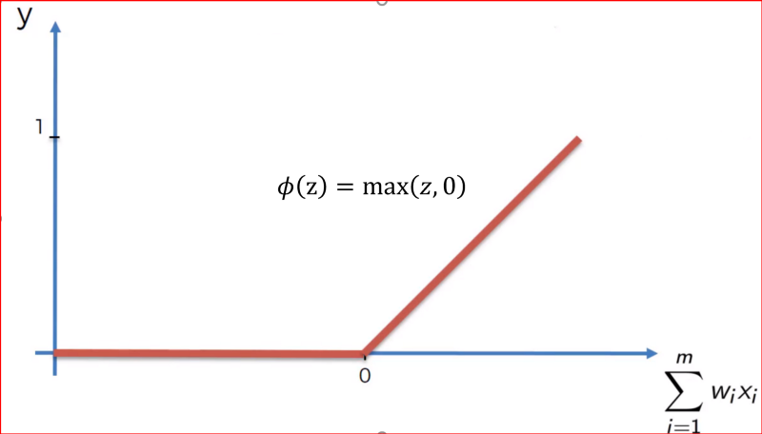
Fig. 10. ReLU
- When the hidden layers are exposed to a range of input values, rectifier function will lead to more zeros resulting in less neurons getting activated and that would mean less interactions across neural network. ReLU turn on and off the neurons more aggressively than sigmoid or tanh activation function. Challenge with Relu is that the negative values become zero decreasing the model’s ability to train the data properly. To solve this problem we have Leaky ReLU
- Leaky ReLu:
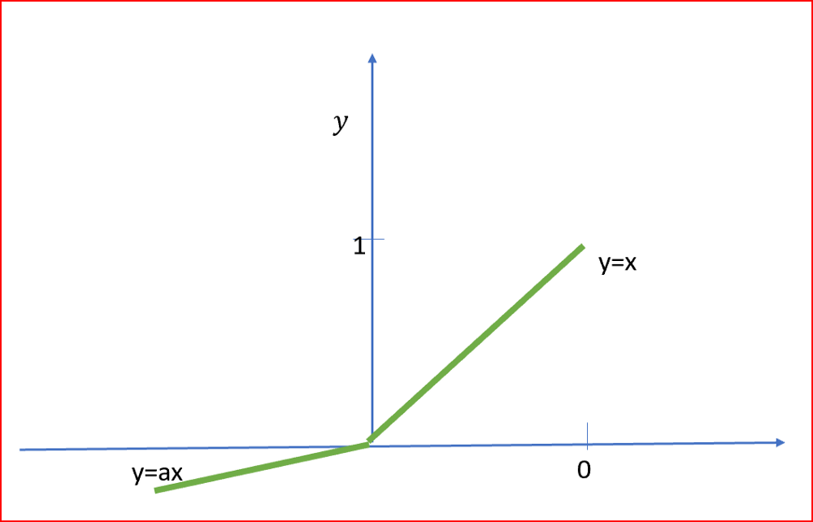
Fig. 11. Leaky ReLU, value of a is usually 0.01
- In leaky ReLU we have a small negative slope so it does not have a zero slope. This will help to speed up the training. Range for Leaky ReLU ranges is from - infinity to + infinity.
So in our CNN model, we chose the ReLU as activation function for the convolutional layer. Then, to improve our model, we use Gradient Descent (GD). GD is an iterative machine learning optimization algorithm to reduce the cost function so that we have models that makes more accurate predictions.
Cost function(C) or Loss function measures the difference between the actual output and predicted output from the model we trained. Cost function are a convex function. In neural network our goal is to train the model that have optimized weights(w) to make better prediction. We get optimized weights using the gradient descent. There are different types of Gradient descents are:
- Batch Gradient Descent (BGD):
In batch gradient we use the entire dataset to compute the gradient of the cost function for each iteration of the gradient descent and then update the weights. Since we use the entire dataset to compute the gradient convergence is slow. If the dataset is huge and contains millions and billions of data points then it is memory as well as computationally intensive.
Advantages of Batch Gradient Descent is theoretical analysis of weights and convergence rates are easy to understand.
Disadvantages of Stochastic Gradient Descent is the perform redundant computation for the same training example for large datasets. It can be very slow and intractable as large datasets may not fit in the memory. As we take the entire dataset for computation we can update the weights of the model for the new data.
- Stochastic Gradient descent (SGD):
In Stochastic gradient descent we use a single datapoint or example to calculate the gradient and update the weights with every iteration. We first need to shuffle the dataset so that we get a completely randomized dataset as we expected. As the dataset is randomized and weights are updated for each single example, update of the weights and the cost function will be noisy jumping all over the place as shown below.
Random sample helps to arrive at a global minima and avoids getting stuck at a local minima. Learning is much faster and convergence is more quickly for a huge dataset.
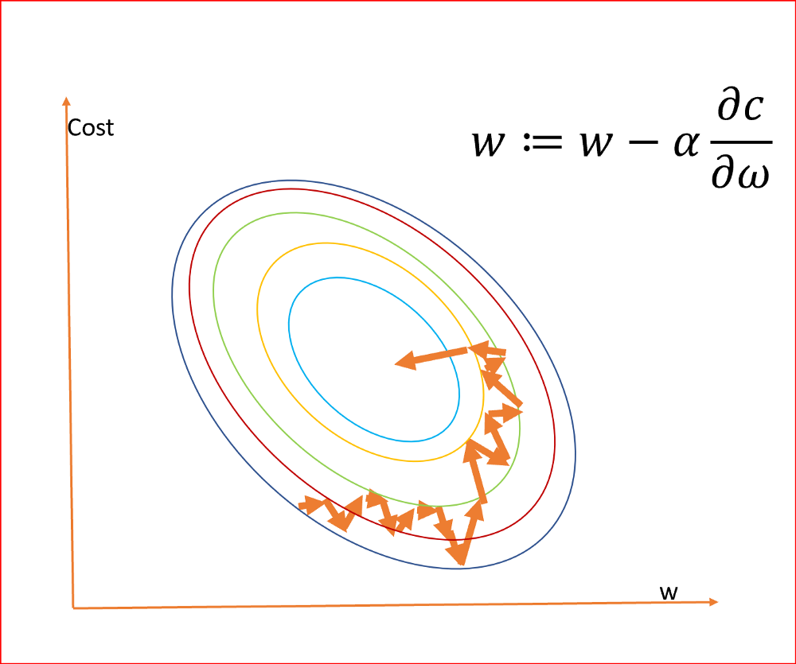
Fig.12. Stochastic Gradient descent
Advantages of Stochastic Gradient Descent can learn much faster than batch gradient descent. Redundancy is computation and is also removed as we take one training sample at a time for computation. Weights can be updated on the fly for the new data samples as we take one training sample at a time for computation.
Disadvantages of Stochastic Gradient Descent is as we frequently update weights, Cost function fluctuates heavily.
- Mini Batch Gradient Descent (MBGD):
Mini - batch gradient is a variation of stochastic gradient descent where instead of single training example, mini-batch of samples is used. It is widely used and converges faster and more stable. Batch size can vary depending on the dataset. As we take a batch with different samples, it can reduce the noise which is variance of the weight updates and that helps to have a more stable converge faster.
Advantages of Mini Batch Gradient Descent: Reduces variance of the parameter update, hence lead to stable convergence, speed the learning, helpful to estimate the approximate location of the actual minimum.
Disadvantages of Mini Batch Gradient Descent: Loss is computed for each mini batch and hence total loss needs to be accumulated across all mini batches
Finally, we completed all the steps of construction and it's time to train our model using classifier.fit_generator with step_per_epoch=800, epochs=30, validation_steps=6500.

Experimental Results

Experimental results is shown as below.

So as we can see in a chart, the train line increased dramatically at epochs 3 and become linear with test line when it reach epochs 28. So if we continue to inscrease the epochs.It will make our data overfitted. Overfitting is the production of an analysis that corresponds too closely or exactly to a particular set of data, and may therefore fail to fit additional data or predict future observations reliably.
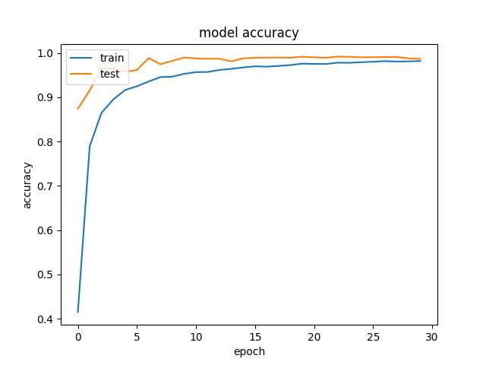
Fig. 13. Model accuracy

Acknowledgment
Thanks to my mentor Dang Thanh Tin for his guidance and thanks to Chan Khoa for his help in fixing codes in the Program. The clarity of his comments in the source code allowed me to understand how to organise the code and how to track error.

References
- Richard A. Tennant, Marianne Gluszak Brown, “The American Sign Language hand shape dictionary” 1998.
- Yash Agawal, "Create your first Image Recognition Classifier using CNN, Keras and Tensorflow backend", July 2018. Available: https://medium.com/nybles/create-your-first-image-recognition-classifier-using-cnn-keras-and-tensorflow-backend-6eaab98d14dd?fbclid=IwAR0NGdLyc8BsGzP8_mWj1dJgbLwWX5dD-C9_00WfeM-sh94Ds6JoYoxcrJE , accessed June 2019.
- Vibhor Nigam, “Understanding Neural Networks. From neuron to RNN, CNN, and Deep Learning”, Sep 2018. Available: https://towardsdatascience.com/understanding-neural-networks-from-neuron-to-rnn-cnn-and-deep-learning-cd88e90e0a90 , accessed June 2019.
- Renu Khandelwal, “Building Neural Network using Keras for Classification”, January 2018 Available: . https://medium.com/datadriveninvestor/building-neural-network-using-keras-for-classification-3a3656c726c1 , accessed June 2019.
- Renu Khandelwal, “Neural Network Simplified”, October 2018. Available: . https://medium.com/datadriveninvestor/neural-network-simplified-c28b6614add4 , accessed June 2019.
- Renu Khandelwal, “Neural Network - Activation function”, October 2018. Available: https://medium.com/datadriveninvestor/neural-networks-activation-functions-e371202b56ff , accessed June 2019.
- Renu Khandelwal, “Machine learning Gradient Descent”, October 2018. Available: https://medium.com/datadriveninvestor/gradient-descent-5a13f385d403 , accessed June 2019.
- Keras documentation, "Keras: the Python Deep Learning library". Available: https://keras.io/ ,accessed June 2019.
- OpenCV-Python. Available: https://opencv-python-tutroals.readthedocs.io/en/latest/ , accessed June 2019.
- Tensorflow. Available: https://www.tensorflow.org/ , accessed 2019.
- Sarfaraz Mascood, Harish CHandra Thuwai, Adhyan Srivastava, "American Sign Language Character Recognition Using Convolution Neural Network". Available: https://www.researchgate.net/publication/320703517_American_Sign_Language_Character_Recognition_Using_Convolution_Neural_Network , accessed June 2019.

Video | Resolution | Frame rate | Experiment |  | Reality
Video | Resolution | Frame rate | Words | Words can be translated | Words | Words can be translated
Person 1 | 640 x 480 | 30 | 43 | 40 | 43 | 35
Person 2 | 640 x 480 | 30 | 43 | 40 | 43 | 32
Table I: Experimental Results

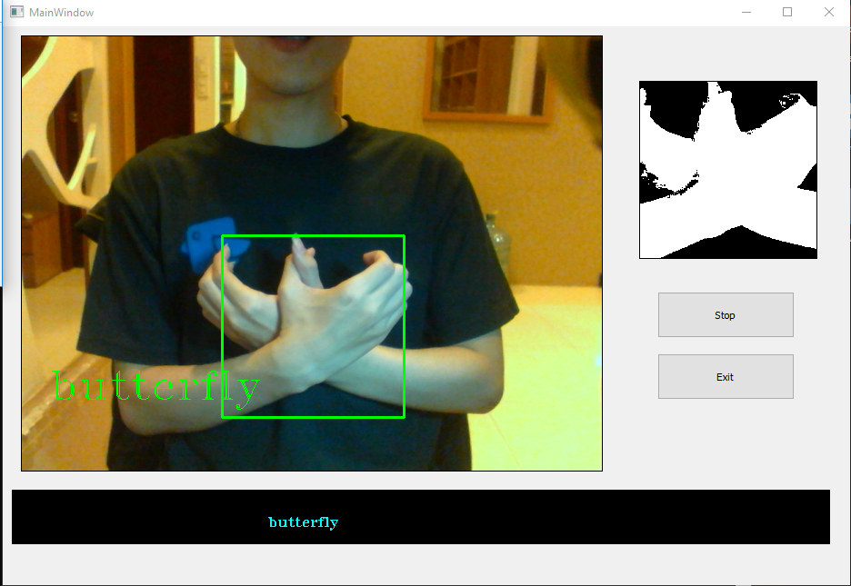
Fig. 14. Word: Butterfly

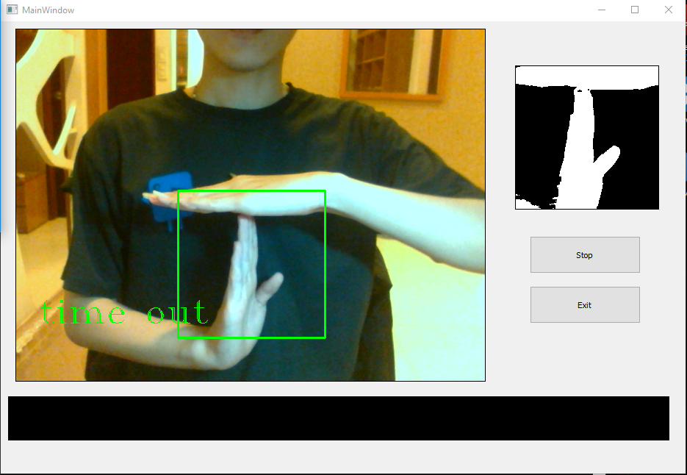
Fig. 15. Word: time out

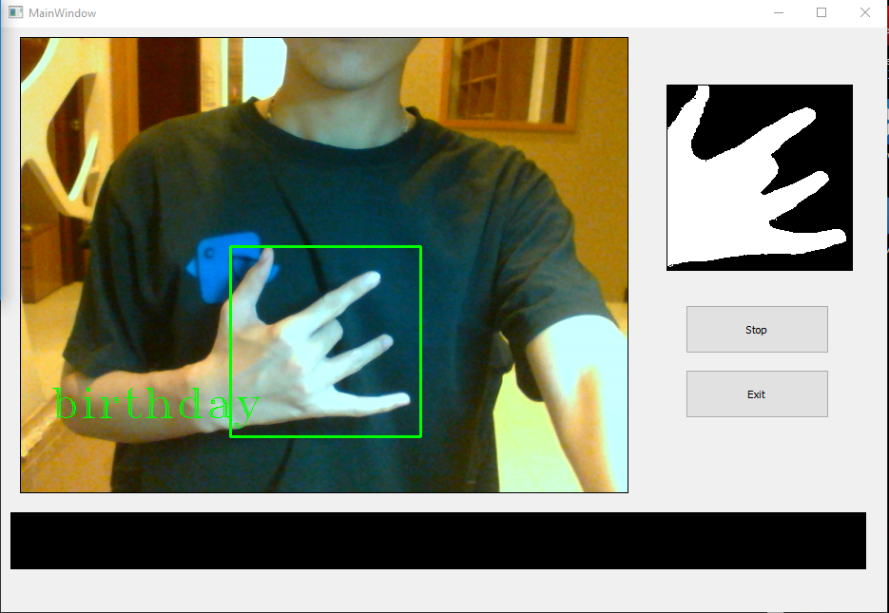
Fig. 16. Word: birthday

