[1]

Smart Water Sprinkler

Sharda Mhase, Rohan Ashra, Mihir Prajapati, Mihir Rabade, Pranav Mohol, Aditya Sarma

Department of Engineering, Sciences and Humanities (DESH)

*Abstract* — *Our Aim is to make a smart water sprinkler, i.e. a water sprinkler coupled with Real time clock Module. This sprinkler would be controlled by the readings of the clock module. At specified time, the sprinkler would be triggered on and would start sprinkling water. This would reduce the load on the farmers to keep watering the plants every now and then. This sprinkler is self-triggered unlike the old conventional ones that need to be manually turned on.*

***Keywords*** *— agriculture, automated, smart, sensor, sprinkler*

# INTRODUCTION

T

HIS project was born from the idea “What if we reduce the burden of irrigating crops from farmers?” And thus, we started gathering required components for the project. We decided on making a smart water sprinkler, using Arduino, time module and soil humidity sensor.

We are using a time module. We can configure it to trigger the sprinkler at specified time.

We are using soil humidity sensor which will trigger the sprinkler on low humidity levels.

Also, we are using Bluetooth module to control the setup wirelessly.

In this way we are automating the irrigating systems and reducing the burden of farmers.

# Literature Review

We have used Arduino module, a time module, 2 pumps, soil humidity sensor, few pipes, a dummy to demonstrate the working action of the complete setup.

# Methodology/Experimental

## Components

1. Arduino board
2. 2 channel Relay
3. 2 pumps
4. Pipes
5. Real time clock Module
6. Soil humidity sensor
7. Dummy environment
8. Bluetooth Module (HC-05)

## Algorithm

1. Setup connection pins, date, time variables.
2. Inside the loop, send date and time.
3. Check whether current time matches to specified sprinkling time. If yes, trigger the pump, if no, switch off the pump.
4. Check whether current soil humidity levels are below expected levels. If yes, trigger the pump, if no switch off the pump.
5. Receive commands via Bluetooth and act accordingly.

## Characterization/Pseudo Code/ Flowchart

1. Time is set in the time module.
2. When the time matches with the scheduled time, the pump switches on.
3. After particular duration, the pump switches off.
4. Then it waits for the next scheduled time.
5. Alongside with time, when soil humidity levels drop, the pump switches on.
6. After particular duration, the pump switches off.
7. And the cycle continues.
8. Using Bluetooth commands, pump can be turned on/off as per requirement.

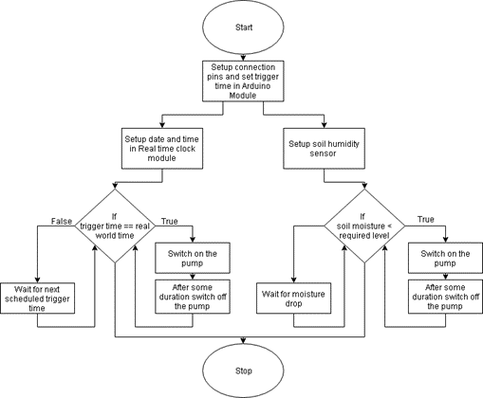

## Circuit diagram

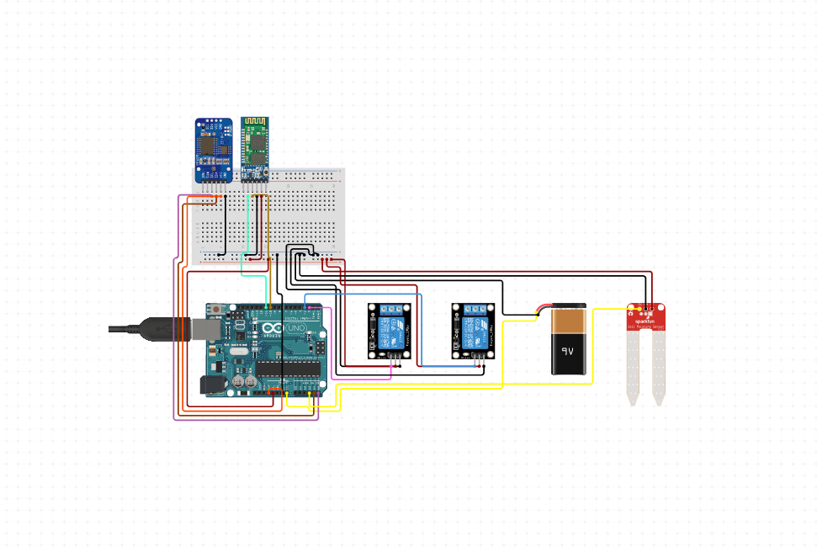

# Results and Discussions

The setup works properly at scheduled time & when soil humidity levels drop below required level. It also responds properly to the commands received from Bluetooth

# Limitations

The setup is prone to water itself, hence it needs to be kept far away from water.

# Future Scope

This project may also automate sprinkling of liquid pesticides. And for leguminous plants, it may also pump Nitrogen gas directly into soil.

# Conclusion

The aim of the project was to reduce burden of irrigation by automating the irrigation process itself, and by this project we have successfully automated the process.

Acknowledgment

We sincerely thank our project guide Prof. Sharda Mhase mam in helping us making this project to come in reality. We are also grateful to our team members without which project wouldn’t been possible. And lastly, we show our gratitude towards institute to provide us with such an opportunity.

References

1. <http://www.rinkydinkelectronics.com/library.php?id=73>

1.